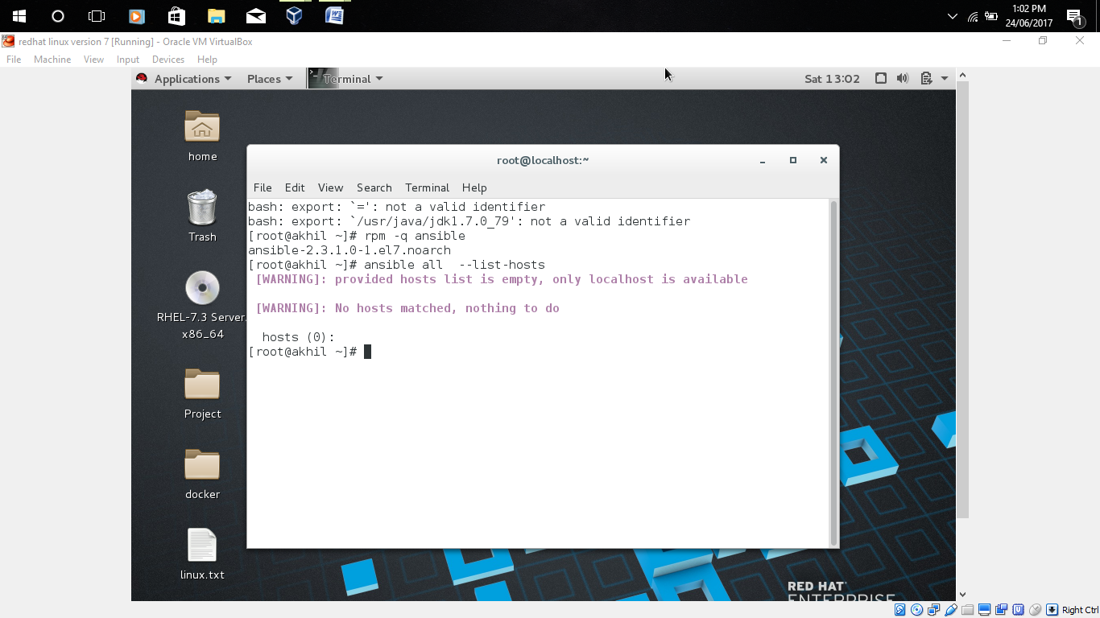

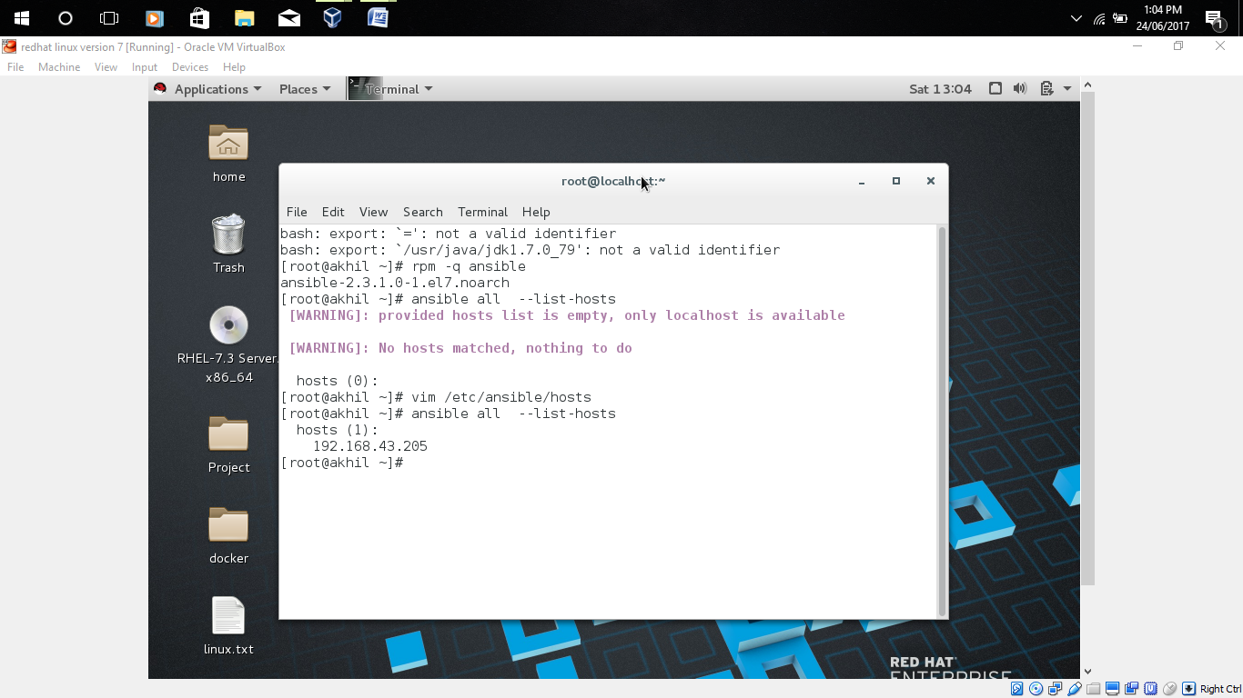

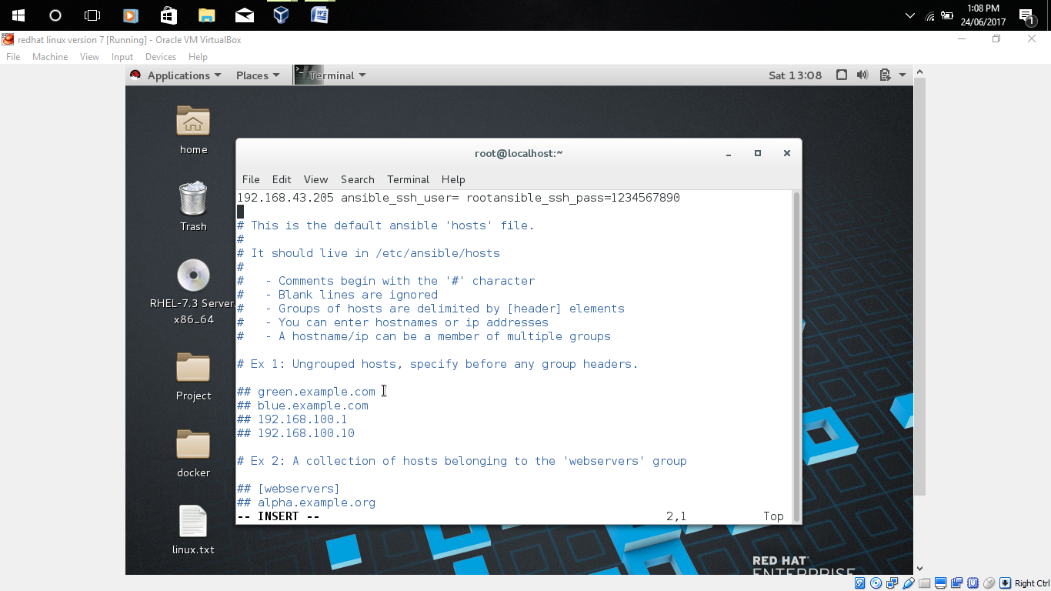

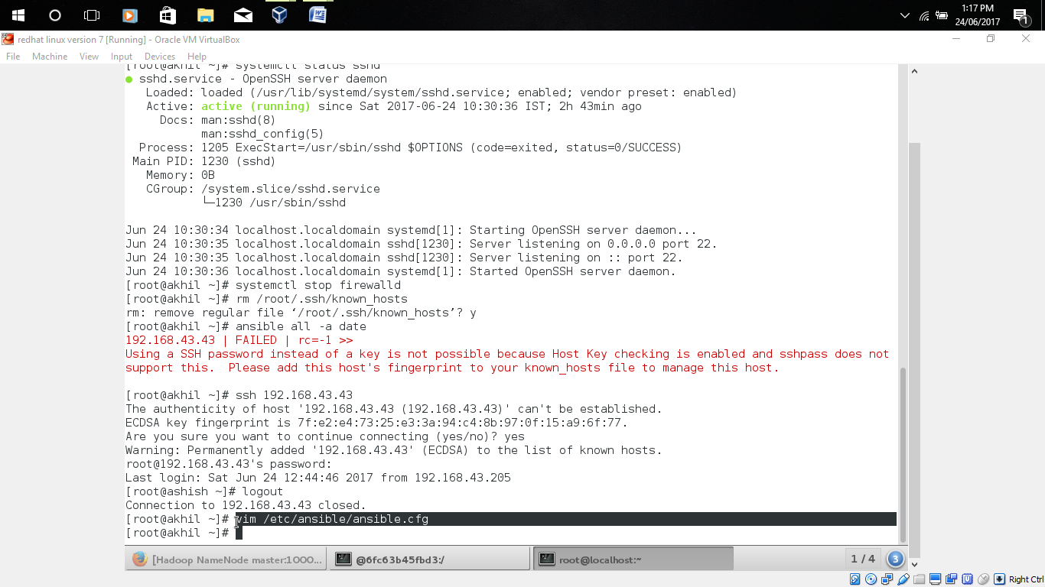

ansible all -m service -a “name=httpd state=restart” -🡪for redhat 6 ,ubuntu

ansible all -m service -a “name=httpd state=stop” -🡪for stop service in redhat 6,ubuntu

ansible all -a systemctl httpd restart -🡪for redhat 7

