**METHEDOLOGY**

In order to correct for color blindness, it is first necessary to create a model of how color blind people perceive the world. The simulation model used in this paper is based on , a simple linear transformation in the LMS color space. The transformation consists of first converting the input RGB image to the LMS color space,

rgb2lms = [ [17.8824,43.5161,4.11935],

[3.45565,27.1554,3.86714],

[0.0299566,0.184309,1.46709] ]

,applying a CVD simulation filter and then reverting the image back to the RGB color space 1b. Specific CVD filter formulas for deuteranope is given below..

CVD(deutranope) = [ [1, 0 , 0 ],

[0.494207, 0 , 1.24827],

[0 , 0 , 1] ]

IMAGE’ = RGB2LMS.INVERSE * CVD(DEUTRANOPE) * RGB2LMS * IMAGE_ORIGINAL

IMAGE’ is the image which a color blind suffering from deutranope saw.As shown below:-

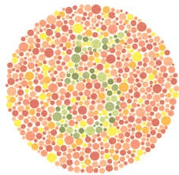 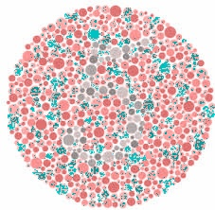

Original Image Image a color blind people see

The baseline method for color correction is given below. It is a simple linear transformation, meant to enhance contrast between colors that are hard to see. It works by subtracting the result obtained with CVD simulation from the original image (giving us colors which are not seen by people with CVD).

Error = original_Image - Image(CVD)

This result is then shifted to a more visible specter by applying the matrix multiplication as shown.

Result = original_Image + [ [0 ,0, 0] , [0.7, 1 , 0], [0, 0.7, 1]] * Error

**Deep Correction:-**

We will use a CORRECTOR - REFREE model to receive the best image that can be properly seen by normal person and person with color vision deficiency.

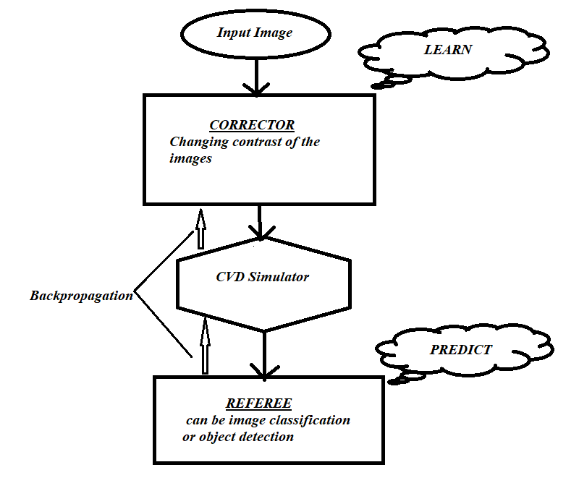

**Model Structure**

Corrector is used to change the contrast of the image using Convolutional neural network.It will consist of several Convolutional hidden layers containing filters of some size depending on the requirement.

The resultant is passes through CVD simulator which will produced the image as seen with person with CVD.

The output of CVD simulator will be flattened and is provided to referee.Referee model is a model that can be any image classification model or object detection model,etc. On the basis of the result of referee we will back-propagate and change our contrast parameter till we achieve a decent accuracy model..