**Design Document**

**System Overview:**

This is a code for a working coffee machine having *n* outlets working in parallel to serve the different kind of beverages.

**Design Considerations:**

**Assumption:** As all the outlets are sharing same resources, only one outlet can access the ingredients as a particular instance of time

**Development Methods:** *Abstract Factory Pattern* is used as a design pattern. *Python* is used as a programming language

**Coffee Machine**

* Design Pattern used is Abstract Factory Pattern
* One factory responsible for creating beverage objects.
* It is easy to introduce the new variants of the beverage without breaking the existing code.
* Objects which we are getting from factory are surely compatible with each other.

**Architecture Diagram:**

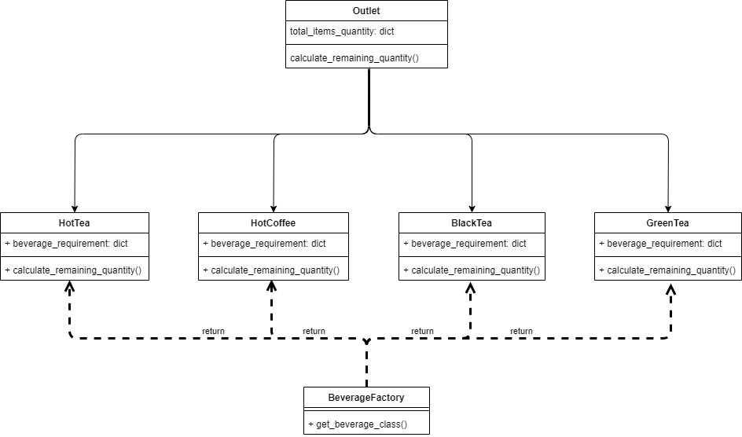

1. Ingredients are shared resources.
2. Only one object can access ingredients at a time.
3. All the outlets can work in parallel, but while accessing the resources, only one object can be executed at a time

**Future Scope:**

1. We can put each ingredient independently into the shared resources. So that multiple outlets can access different ingredient at the same time.
2. Can use multithreading to build a sync and scalable system to access the resources.