READ ME

1.Add all the files in htdocs and import sqldump.sql in mysql with
username – BladeRunner
password – root
dbName – BladeRunner

2.After your servers start, on the browser do
localhost/index.html - this will take you to the landing page of the web application.

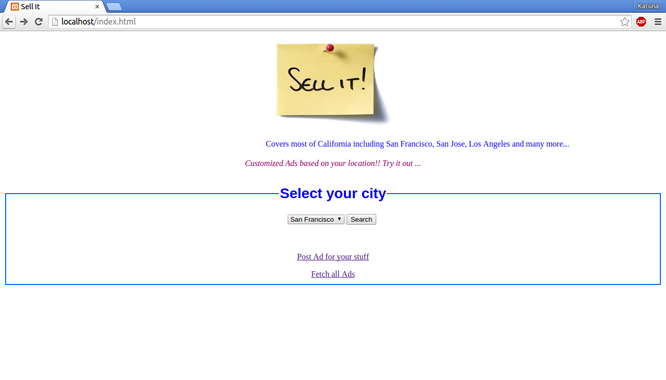
3.You can click on post an Ad hyperlink to see a form which submits all details to the database. Redirect to localhost/postAd.html to localhost/insertInDb.php

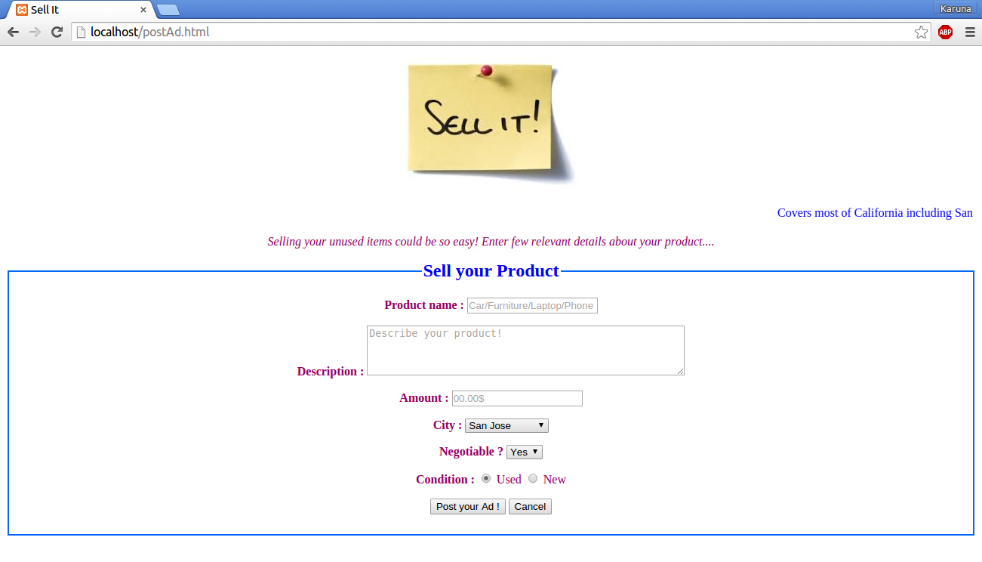

4.Search on Db can be done based on city after selecting from dropdown or full Db search from the two links

When you search based on any city from the dropdown, you get the php file showing the results.

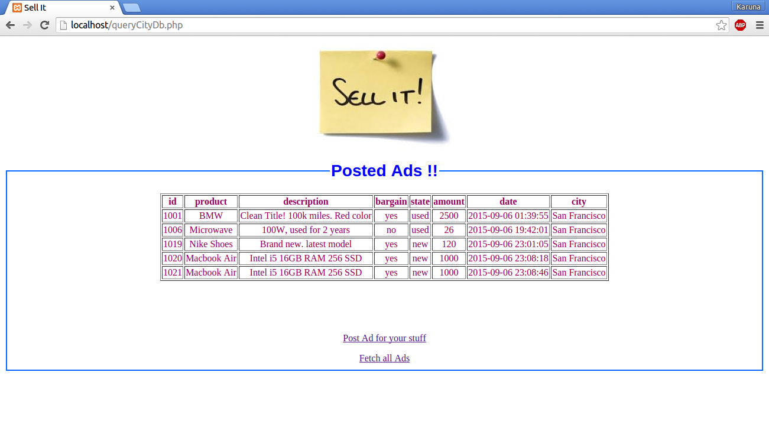
5. If you click fetch all, you get php showing the entire data from the database.

