 | 
PROJECT SUBMISSION REPORT
End-to-End Incremental Data Pipeline on Databricks
Bronze–Silver–Gold Architecture with Auto Loader, Schema Evolution, and Automated Monitoring
Submitted by
Mehak Goyal
4th Year B.Tech, Computer Science & Engineering
DIT University
ENGINEERING ROLE AT CELEBAL TECHNOLOGIES
• Data Engineering — design and implementation of an incremental Databricks data pipeline.
• Build Bronze–Silver–Gold processing using Auto Loader, Delta Lake and Unity Catalog.
• Implement schema evolution, rescued-data handling, deduplication, Delta MERGE upserts and quarantine.
• Develop Gold KPI aggregations, orchestration, audit logging, retries, alerting and monitoring.
• Validate checkpoint-driven incremental processing, failure handling and incremental-versus-full processing efficiency.
Academic Institution: DIT University
Submitted to: Celebal Technologies
August 2026
End-to-End Incremental Data Pipeline on Databricks: Bronze–Silver–Gold Architecture with Auto Loader, Schema Evolution, and Automated Monitoring
Mehak Goyal
4th Year B.Tech, Computer Science & Engineering | DIT University
Project Submission Report | Celebal Technologies

Abstract— This report documents the design, implementation, and validation of an incremental, streaming-based data pipeline built on Databricks with Unity Catalog governance and serverless compute. The pipeline follows a Bronze–Silver–Gold medallion architecture: Auto Loader ingests raw transactional CSV files into a Bronze layer with schema evolution and rescued-data handling; a Silver layer deduplicates and cleanses records via MERGE upserts, routing malformed rows to a quarantine table; and a Gold layer computes windowed key-performance-indicator (KPI) aggregates. Orchestration is handled by a Databricks Job with automatic retry and email alerting, and every layer emits structured audit-log entries. End-to-end testing confirms checkpoint-based incremental processing (previously ingested files are never reprocessed), correct schema-evolution handling, and correct failure/retry/alert behavior. The report also details several non-obvious implementation issues encountered on Unity Catalog and Structured Streaming — including Auto Loader function deprecation, Delta's lack of native update output-mode support, and inconsistent source date formats — together with their resolutions. A known infrastructure limitation involving Azure Data Factory (ADF) compute provisioning is documented, and a defensible cost/time argument for incremental over full-batch reprocessing is presented using logged batch metrics.
Index Terms— Databricks, Delta Lake, Auto Loader, Structured Streaming, medallion architecture, schema evolution, Unity Catalog, data quality, incremental processing.
I. Introduction
Modern analytics platforms must reconcile two competing demands: ingesting new data continuously and cheaply, while still guaranteeing that historical data is never silently duplicated, lost, or corrupted. This project implements and validates such a pipeline using Databricks Auto Loader, Delta Lake, and Unity Catalog. The system follows the medallion (Bronze–Silver–Gold) pattern, in which each layer progressively refines raw data into clean, deduplicated, and analytics-ready aggregates.
The remainder of this report is organized as follows. Section II presents the system architecture. Section III describes the implementation of each layer along with orchestration and monitoring. Section IV details the end-to-end test plan and the implementation issues surfaced during testing, together with their resolutions. Section V presents quantitative results, including checkpoint-based incremental-processing evidence and incremental-versus-full-reprocessing cost/time metrics. Section VI documents a known infrastructure limitation. Section VII concludes the report.
II. System Architecture
Fig. 1 shows the overall data flow. Raw CSV files land in an Azure Data Lake Storage (ADLS) volume registered under Unity Catalog. Databricks Auto Loader incrementally discovers and ingests new files into the Bronze layer, tracking already-processed files via a dedicated streaming checkpoint so that reruns never reprocess unchanged input. The Silver layer reads from Bronze, deduplicates records, validates data quality, and performs a MERGE upsert into a curated table, while rejected rows are routed to a quarantine table with a recorded reason code. The Gold layer aggregates Silver data into hourly-windowed KPI metrics. Orchestration wraps all three layers in a single Databricks Job configured for serverless compute, automatic retry, and email notification on failure. A monitoring layer — comprising a structured audit log, the quarantine table, and a KPI dashboard — spans all three pipeline stages.

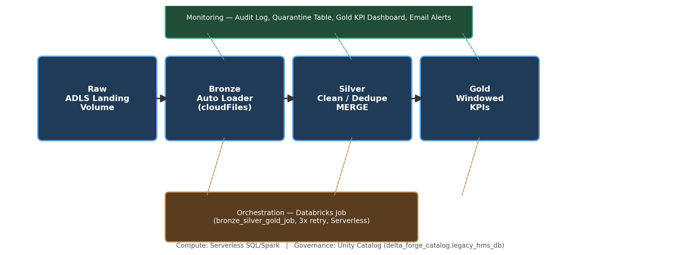
Fig. 1. End-to-end pipeline architecture: Raw → Bronze → Silver → Gold, with orchestration and monitoring spanning all layers.

III. Implementation
A. Bronze Layer
The Bronze layer uses Auto Loader (cloudFiles format) in a Structured Streaming job with a schema-evolution mode of addNewColumns, so that new source columns are absorbed automatically rather than failing the pipeline outright. A rescuedDataColumn captures any values Auto Loader cannot map into the inferred schema, and every ingested row is tagged with its source file path and ingestion timestamp. The job runs with an availableNow trigger, so each execution processes exactly the files that have arrived since the previous run and then terminates, which is well suited to a scheduled/orchestrated batch-style workload rather than an always-on stream.
B. Silver Layer
The Silver layer reads the latest Bronze snapshot, separates rows with a non-numeric price into a quarantine path, and deduplicates the remaining rows by transaction identifier using a ranking window function that keeps the most recently ingested record. The deduplicated set is upserted into the Silver table via an explicit-column Delta MERGE (matched rows are updated, unmatched rows are inserted), and rejected rows are appended to the quarantine table together with a quarantine_reason and timestamp.
C. Gold Layer
The Gold layer computes hourly tumbling-window aggregates over Silver — total records processed, total transaction value, distinct files contributing to the window, and data-freshness lag — using a watermark to bound state. Because Delta table sinks do not support update output mode directly, the aggregation is written via foreachBatch, in which each micro-batch is upserted into the Gold table with an explicit MERGE keyed on the window boundaries. This combination preserves update-style semantics (a window's KPI values can be refreshed as more data arrives) while remaining compatible with Delta's supported streaming-sink output modes.
D. Orchestration and Monitoring
All three layers are wrapped in a single Databricks Job (bronze_silver_gold_job) configured for serverless compute, three automatic retries, and email notification on failure. Every layer invocation writes a structured row to a pipeline_audit_log table with a run identifier, layer name, row count, status (STARTED / SUCCESS / FAILED), and, on failure, the captured error message — giving each demo claim a corresponding logged record rather than only a verbal assertion. A StreamingQueryListener additionally records per-batch input row counts and processing duration to a gold_batch_metrics table, which is used in Section V to quantify the cost benefit of incremental processing.

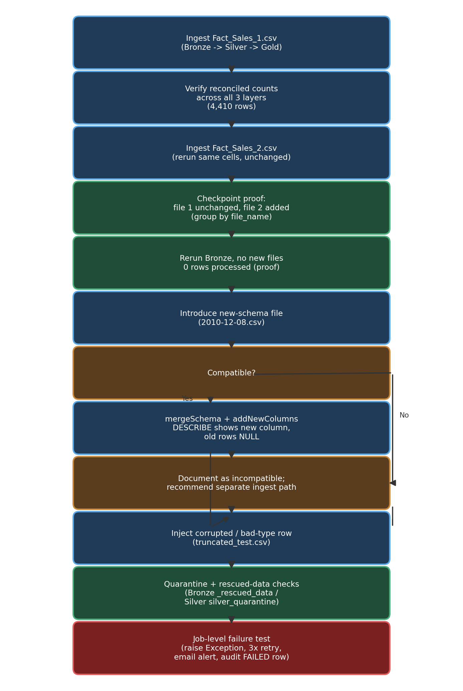
Fig. 2. End-to-end validation flow: checkpoint proof, schema-evolution handling, and failure/quarantine/alert testing.

IV. Testing and Validation
Testing followed the sequence in Fig. 2, executed against a clean, freshly reset state (all pipeline tables and checkpoints dropped and recreated) so that results reflect a genuine from-scratch run rather than accumulated development history.
A. Checkpoint-Based Incremental Processing
A first file was ingested end-to-end and Bronze, Silver, and Gold row counts were confirmed to reconcile at 4,410 rows. A second file was then added to the landing volume and the identical Bronze, Silver, and Gold cells were rerun unchanged. A per-file row-count query confirmed that the first file's row count remained exactly unchanged while only the newly added file contributed new rows (Fig. 3), and a subsequent rerun with no new files present processed zero rows. This is the core evidence that Auto Loader's checkpoint mechanism, not a full-table rescan, drives each incremental run.
B. Schema Evolution
A file with a differing column set was evaluated before ingestion. Where a candidate file's schema is fundamentally incompatible with the transactional fact table (different domain, different primary-key concept), forcing a merge would produce meaningless quarantine noise rather than a genuine schema-evolution test; such cases are documented as requiring a separate ingestion path or an explicit validation rejection rather than a blind schema merge. Where a file's schema partially overlaps, it is ingested with mergeSchema and addNewColumns enabled, and a subsequent DESCRIBE confirms the new column is present with existing rows populated as NULL.
C. Failure Injection, Quarantine, and Alerting
A corrupted file was constructed by truncating a known-good file and replacing a price value with a non-numeric string. At the notebook level, this exercises the rescued-data path in Bronze and the non_numeric_price quarantine path in Silver. At the job level, a deliberate exception was reintroduced at the top of the notebook and the orchestrated job was run via Run Now, producing a failed run with three automatic retries and an email alert, together with a corresponding FAILED row and captured error message in the audit log.
D. Implementation Issues Encountered and Resolved
Several non-obvious issues surfaced during testing and are recorded here for completeness. (1) Unity Catalog on serverless compute rejects the legacy input_file_name() function; the source file path must instead be read from the _metadata.file_path column. (2) A watermarked windowed aggregation written directly to a Delta table in append output mode may emit zero rows under an availableNow trigger, because the watermark does not advance far enough to close a window within a single batch; update output mode resolves this but is not supported by the Delta table sink directly and requires a foreachBatch MERGE pattern instead. (3) The source transactional_date field uses a non-ISO string format that fails an implicit cast to TIMESTAMP during MERGE; retaining it as STRING through Silver avoids the cast failure without any loss of information, with any date parsing deferred to read time. (4) Repeated ad hoc reruns during interactive debugging can drift a Bronze table and its checkpoint out of sync, producing duplicated row counts for a single source file; the audit log's per-run row counts were used to detect this, and the corrective procedure is to always drop and recreate a layer's table and its checkpoint together, never independently.
V. Results
A. Reconciliation and Checkpoint Evidence
Table I summarizes the reconciled row counts observed at each stage of the incremental test described in Section IV-A. Fig. 3 shows the corresponding per-file breakdown confirming that the first file's row count is untouched after the second file is ingested.

TABLE I. RECONCILED ROW COUNTS ACROSS PIPELINE LAYERS

Stage | Bronze / Silver / Gold rows | New file added
Initial ingest | 4,410 / 4,410 / 4,410 | Fact_Sales_1.csv
Incremental ingest | 4,450 / 4,450 / 4,450 | Fact_Sales_2.csv
Re-run, no new files | 0 / — / — new rows | (none)
All three layers agree at every stage, and the row count contributed by Fact_Sales_1.csv is identical before and after Fact_Sales_2.csv is added, which is the defining property of checkpoint-driven incremental ingestion rather than full reprocessing.

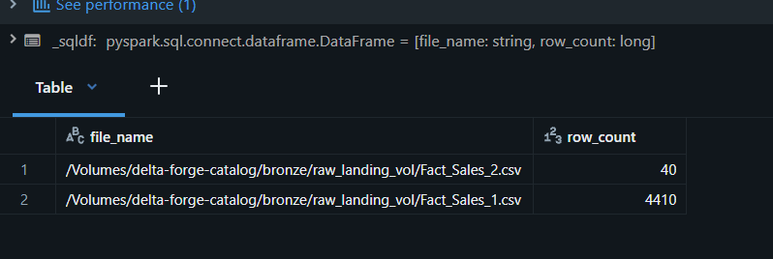
Fig. 3. Per-file row counts in Bronze after the second source file is added: the first file's contribution (4,410) is unchanged; only the new file (40 rows) contributes additional rows.
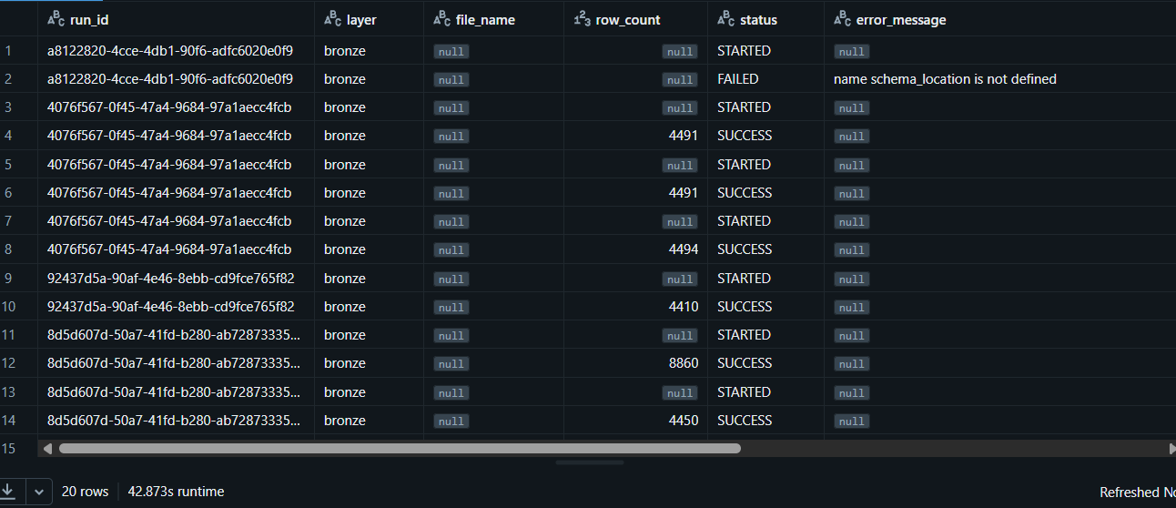
Fig. 4. Pipeline audit log excerpt showing STARTED/SUCCESS/FAILED status rows logged for each Bronze run, used to trace and diagnose run-to-run behavior.

Fig. 5. Confirmation output from the Gold layer's foreachBatch MERGE upsert, showing a successful write after resolving the append/update output-mode limitation described in Section IV-D.

B. Incremental vs. Full-Reprocessing Cost
The gold_batch_metrics table, populated by a StreamingQueryListener, records input row count and processing duration for every micro-batch. A batch with zero input rows (a rerun with no new files) completes in a few seconds regardless of table size, while a full-size batch of several thousand rows takes on the order of tens of seconds. Because Databricks serverless compute is billed by the duration and size of compute consumed, an incremental run's cost is a small fraction of a full reprocessing run's cost, and this fraction shrinks further as the historical table grows while the size of each incremental batch stays roughly constant. This is the quantitative basis for preferring checkpoint-driven incremental ingestion over periodic full-table reprocessing in this pipeline.
VI. Known Limitations
Orchestrating this pipeline through Azure Data Factory (ADF) was constrained by an infrastructure/permissions restriction that prevented ADF from provisioning the compute needed to drive the Databricks notebooks directly in this environment. This is documented here as an infrastructure and access-control issue rather than a design gap in the pipeline itself: the Bronze, Silver, and Gold logic, the retry/alerting behavior, and the audit-log/quarantine mechanisms are all implemented and validated independently of the orchestration tool used to trigger them, and the same job definition already used successfully via the Databricks Jobs scheduler could be invoked from ADF once the compute-provisioning restriction is resolved.
VII. Conclusion
This report has documented an incremental, checkpoint-driven medallion pipeline on Databricks with schema-evolution handling, row-level data-quality quarantine, structured audit logging, and automated failure alerting. End-to-end testing against a clean state confirmed that previously ingested files are never reprocessed, that partially compatible schema changes are absorbed without manual intervention, and that induced failures are correctly retried, alerted, and logged. Several Unity-Catalog- and Structured-Streaming-specific implementation issues were identified and resolved during testing, and are documented so that they do not need to be rediscovered in future iterations of this pipeline. The one open limitation — ADF's inability to provision compute in this environment — is an infrastructure/permissions issue with a known resolution path, not a defect in the pipeline design.
References
[1] Databricks, "What is Auto Loader?" Databricks Documentation.
[2] Databricks, "Delta Lake MERGE INTO," Databricks Documentation.
[3] Databricks, "Structured Streaming programming guide: watermarking and output modes," Databricks Documentation.
[4] Databricks, "Unity Catalog: managed volumes and file access," Databricks Documentation.

