**Project Report**

**Student Id**

1220905569

**Results**

Training Accuracy - 0.868

Training Loss - 0.380

Testing Accuracy - 0.797

Testing Loss - 0.521

**Plots**

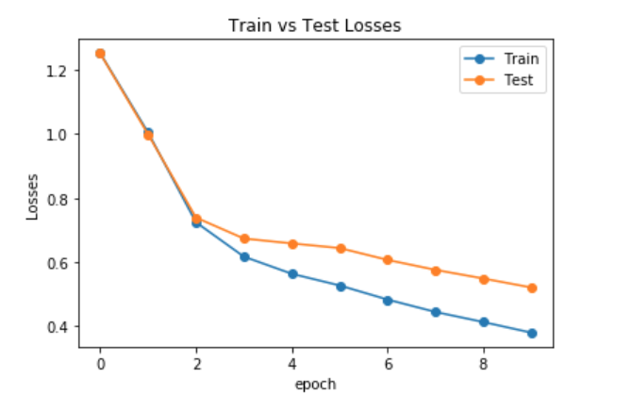

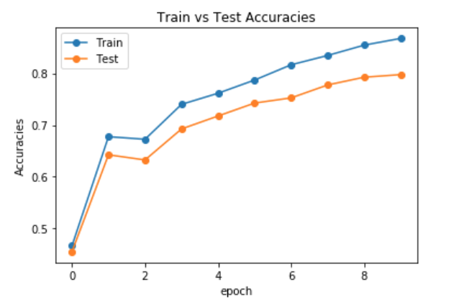

**Approach –**

The project 2 done as part of “CSE571 – Artificial Intelligence” was very helpful to understand the Convolution Neural Network. It helped me to understand the forward propagation for each layer in the CNN architecture and how the output of the previous layer needs to be passed to the next layer. This project also helped me to understand the input data formats.

**Analysis –**

The provided code was helpful to understand the complete flow of the CNN architecture. As I plot the losses and accuracies with epoch it clarified how the network is learning with each epoch, losses are going down and accuracy is improving. The provided code was also helpful in writing the evaluation function. Based on the concepts taught in the lectures, it made clear that we should not do backpropagation in the evaluation function for test data as it is required to adjust weights during training phase of the network.