Week – 1

**Tasks to be performed this week:**

* To create main menu.
* To create menu for each branch.

**Tasks performed this week:**

* MAINMENU()

mainmenu() is designed to select different branches.

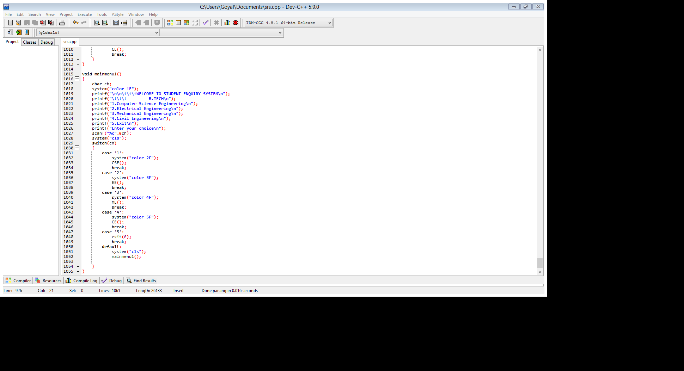

* BRANCH MENU

CSE(), EE(), ME() and CE() are designed.

Fig. CE() coding:

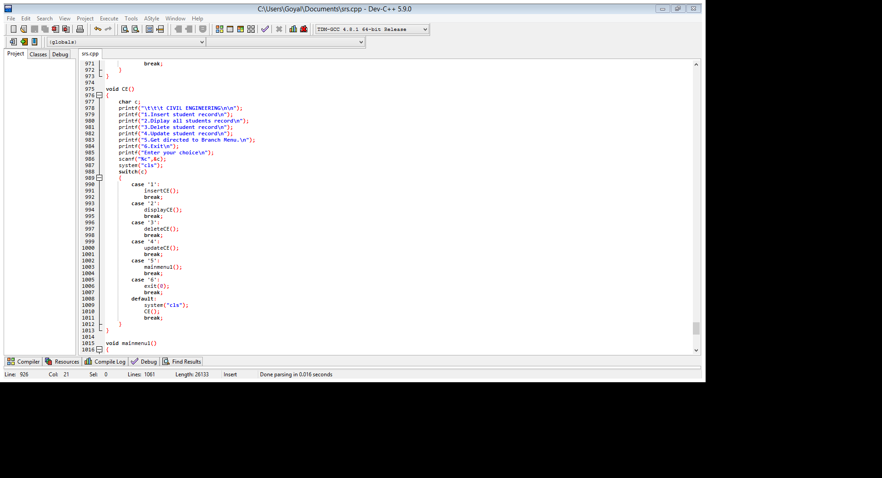

**STATUS:**

We have designed the main menu and branch menu.

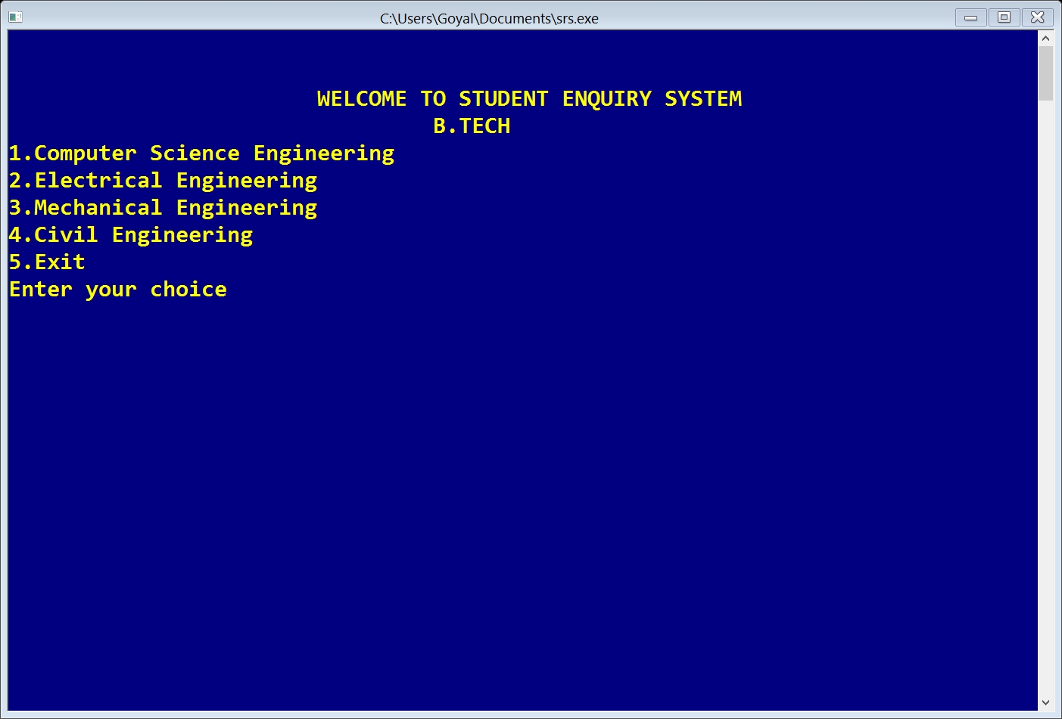

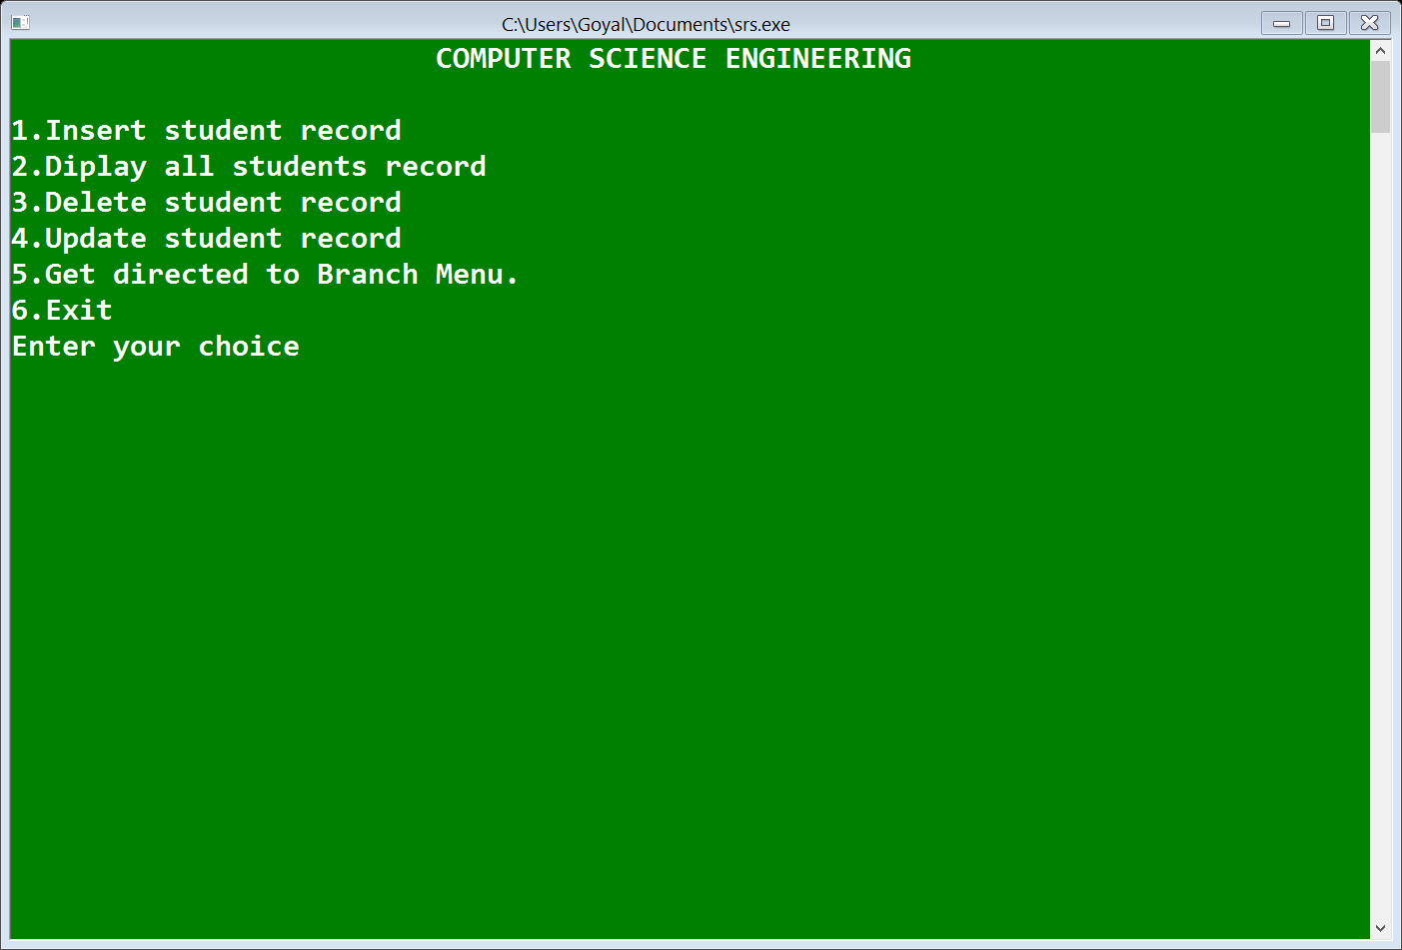

Week – 2

**Tasks to be performed this week:**

* To insert records in branch.
* To display records in branch.

**Tasks performed this week:**

* INSERT RECORDS:

For eg. In EE:

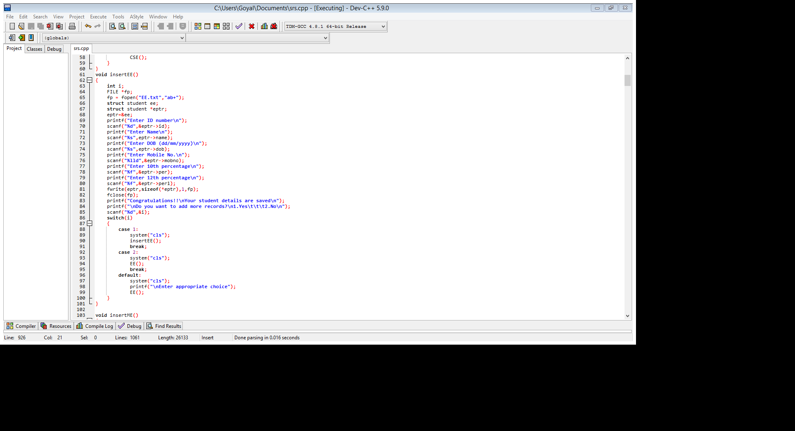

* DISPLAY RECORDS:

In EE:

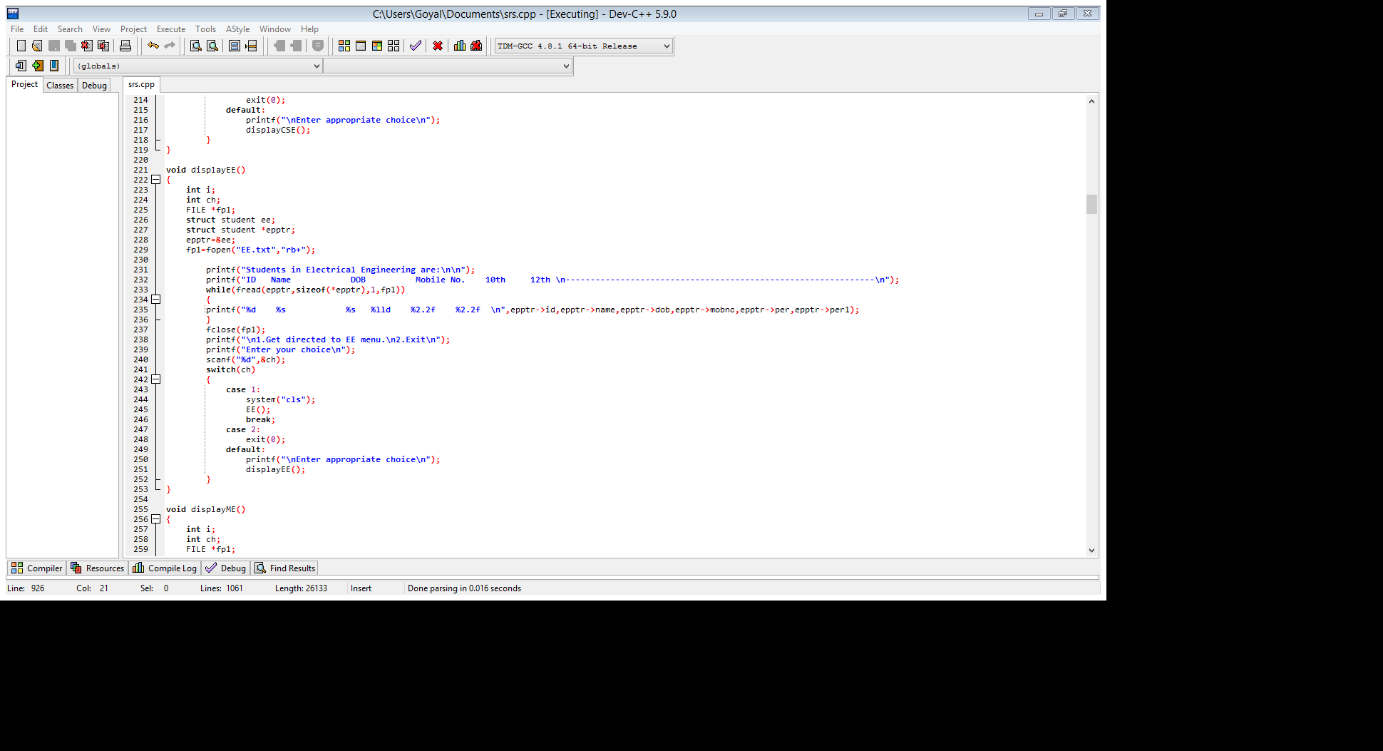

**STATUS:**

We have designed the insert and display windows for each branch.

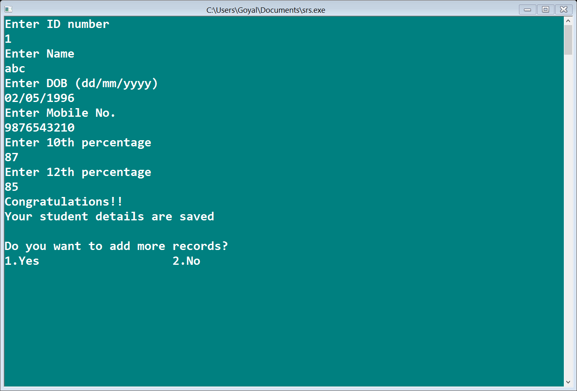

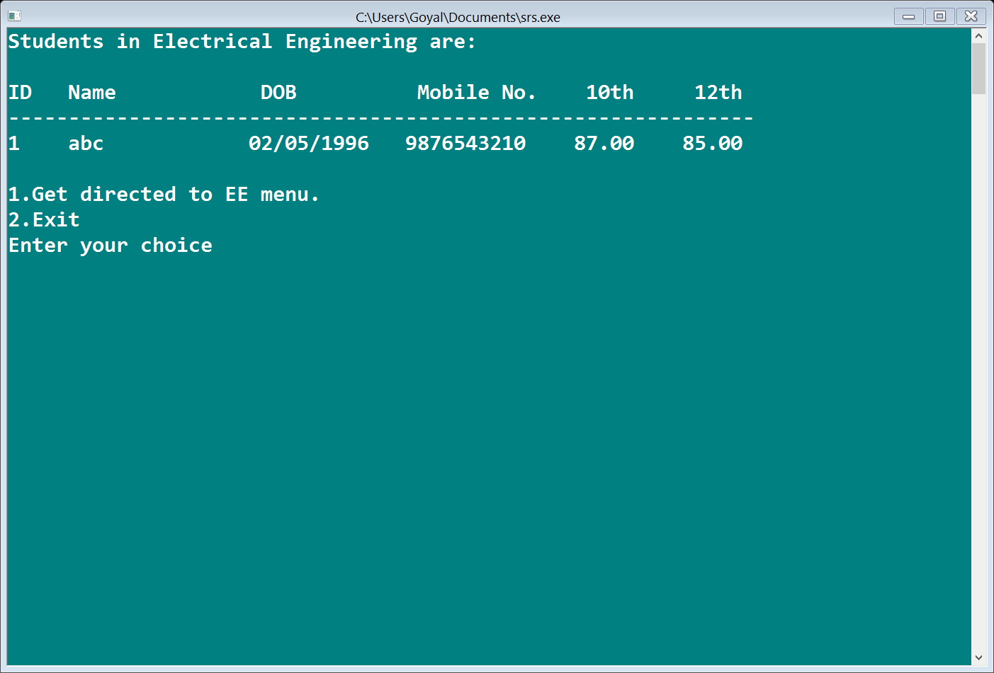

Week – 3

**Tasks to be performed this week:**

* To delete records in every branch.

**Tasks performed this week:**

* DELETE RECORDS:

Records are deleted from the branch using id.

For eg. In ME:

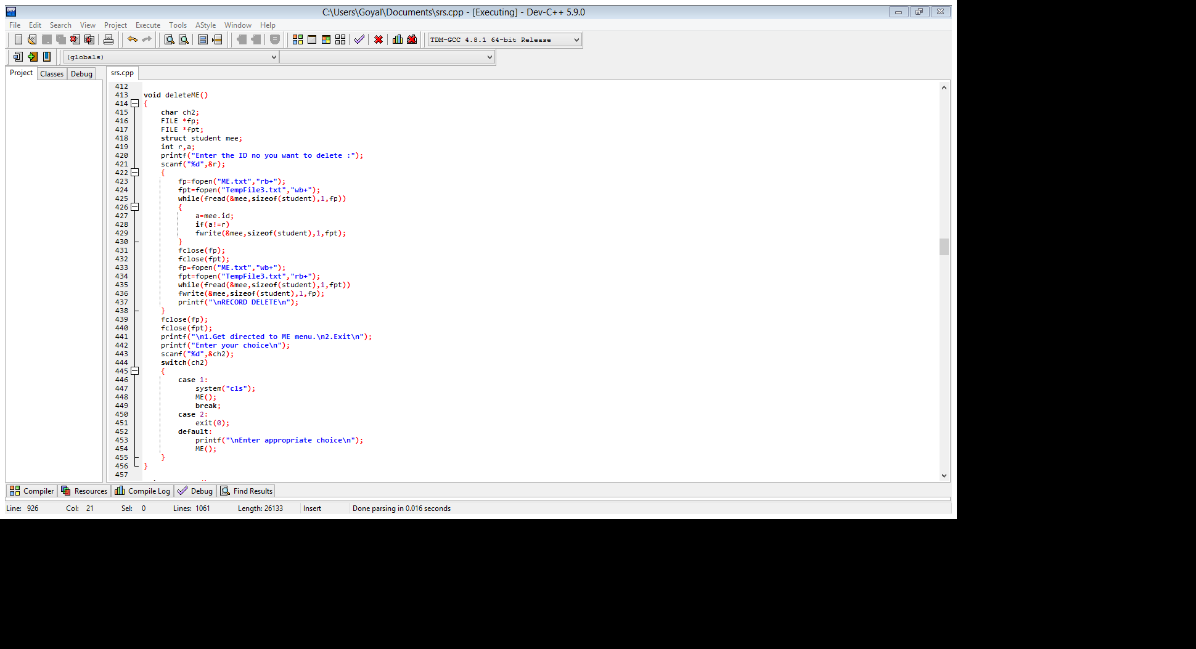

**STATUS:**

We have designed the delete windows for each branch.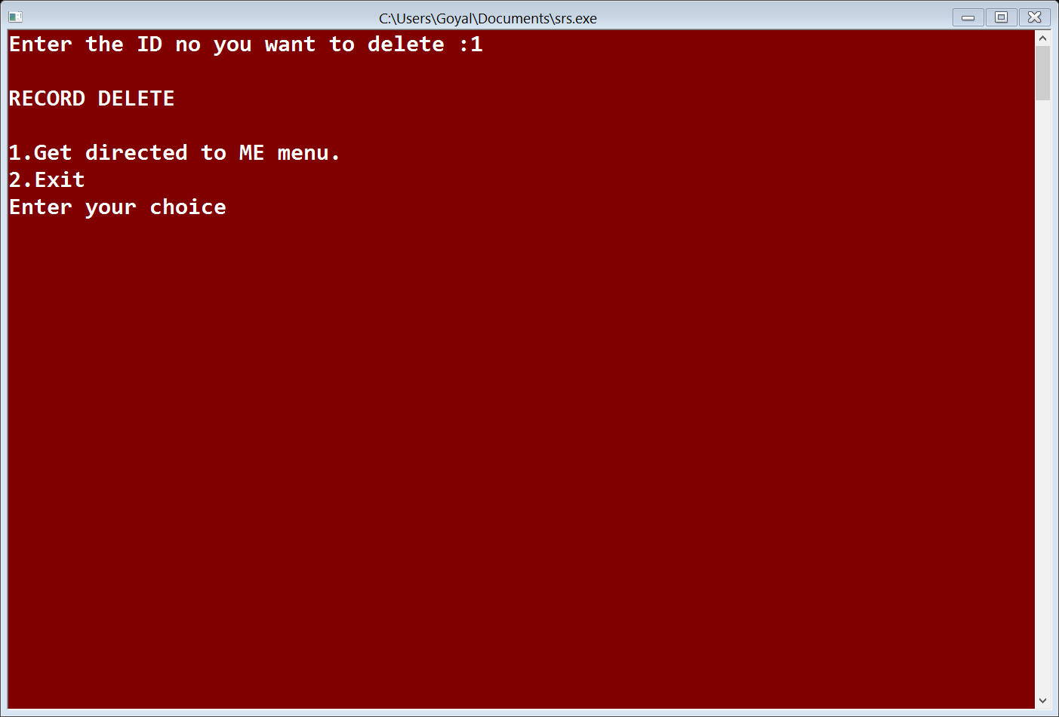

Week – 4

**Tasks to be performed this week:**

* To update records in every branch.

**Tasks performed this week:**

* UPDATE RECORDS:

Records are update from the branch using name.

For eg. In CE:



**STATUS:**

We have designed the update windows for each branch

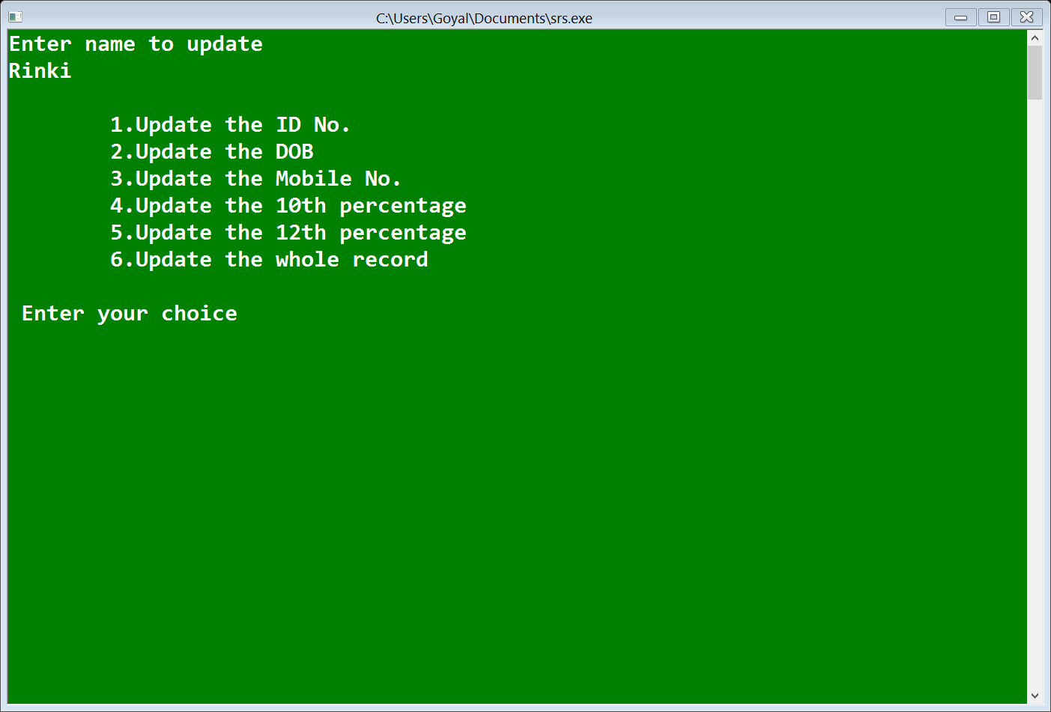

**SOURCE CODE:**

include<stdio.h>

#include<conio.h>

#include<stdlib.h>

#include<string.h>

void mainmenu1();

void CSE();

void EE();

void ME();

void CE();

struct student

{

int id;

char name[20];

char dob[10];

long long int mobno;

float per;

float per1;

};

void insertCSE()

{

int i;

FILE *fp;

fp = fopen("CSE.txt","ab+");

struct student cs;

struct student *cptr;

cptr=&cs;

printf("Enter ID number\n");

scanf("%d",&cptr->id);

printf("Enter Name\n");

scanf("%s",cptr->name);

printf("Enter DOB (dd/mm/yyyy)\n");

scanf("%s",cptr->dob);

printf("Enter Mobile No.\n");

scanf("%lld",&cptr->mobno);

printf("Enter 10th percentage\n");

scanf("%f",&cptr->per);

printf("Enter 12th percentage\n");

scanf("%f",&cptr->per1);

fwrite(cptr,sizeof(*cptr),1,fp);

fclose(fp);

printf("Congratulations!!\nYour student details are saved\n");

printf("\nDo you want to add more records?\n1.Yes\t\t\t2.No\n");

scanf("%d",&i);

switch(i)

{

case 1:

system("cls");

insertCSE();

break;

case 2:

system("cls");

CSE();

break;

default:

system("cls");

printf("\nEnter appropriate choice");

CSE();

}

}

void insertEE()

{

int i;

FILE *fp;

fp = fopen("EE.txt","ab+");

struct student ee;

struct student *eptr;

eptr=&ee;

printf("Enter ID number\n");

scanf("%d",&eptr->id);

printf("Enter Name\n");

scanf("%s",eptr->name);

printf("Enter DOB (dd/mm/yyyy)\n");

scanf("%s",eptr->dob);

printf("Enter Mobile No.\n");

scanf("%lld",&eptr->mobno);

printf("Enter 10th percentage\n");

scanf("%f",&eptr->per);

printf("Enter 12th percentage\n");

scanf("%f",&eptr->per1);

fwrite(eptr,sizeof(*eptr),1,fp);

fclose(fp);

printf("Congratulations!!\nYour student details are saved\n");

printf("\nDo you want to add more records?\n1.Yes\t\t\t2.No\n");

scanf("%d",&i);

switch(i)

{

case 1:

system("cls");

insertEE();

break;

case 2:

system("cls");

EE();

break;

default:

system("cls");

printf("\nEnter appropriate choice");

EE();

}

}

void insertME()

{

int i;

FILE *fp;

fp = fopen("ME.txt","ab+");

struct student me;

struct student *mptr;

mptr=&me;

printf("Enter ID number\n");

scanf("%d",&mptr->id);

printf("Enter Name\n");

scanf("%s",mptr->name);

printf("Enter DOB (dd/mm/yyyy)\n");

scanf("%s",mptr->dob);

printf("Enter Mobile No.\n");

scanf("%lld",&mptr->mobno);

printf("Enter 10th percentage\n");

scanf("%f",&mptr->per);

printf("Enter 12th percentage\n");

scanf("%f",&mptr->per1);

fwrite(mptr,sizeof(*mptr),1,fp);

fclose(fp);

printf("Congratulations!!\nYour student details are saved\n");

printf("\nDo you want to add more records?\n1.Yes\t\t\t2.No\n");

scanf("%d",&i);

switch(i)

{

case 1:

system("cls");

insertME();

break;

case 2:

system("cls");

ME();

break;

default:

system("cls");

printf("\nEnter appropriate choice");

ME();

}

}

void insertCE()

{

int i;

FILE *fp;

fp = fopen("CSE.txt","ab+");

struct student c;

struct student *ceptr;

ceptr=&c;

printf("Enter ID number\n");

scanf("%d",&ceptr->id);

printf("Enter Name\n");

scanf("%s",ceptr->name);

printf("Enter DOB (dd/mm/yyyy)\n");

scanf("%s",ceptr->dob);

printf("Enter Mobile No.\n");

scanf("%lld",&ceptr->mobno);

printf("Enter 10th percentage\n");

scanf("%f",&ceptr->per);

printf("Enter 12th percentage\n");

scanf("%f",&ceptr->per1);

fwrite(ceptr,sizeof(*ceptr),1,fp);

fclose(fp);

printf("Congratulations!!\nYour student details are saved\n");

printf("\nDo you want to add more records?\n1.Yes\t\t\t2.No\n");

scanf("%d",&i);

switch(i)

{

case 1:

system("cls");

insertCE();

break;

case 2:

system("cls");

CE();

break;

default:

system("cls");

printf("\nEnter appropriate choice");

CE();

}

}

void displayCSE()

{

int i;

int ch;

FILE *fp1;

struct student cse;

struct student *cpptr;

cpptr=&cse;

fp1=fopen("CSE.txt","rb+");

printf("Students in Computer Science are:\n\n");

printf("ID Name DOB Mobile No. 10th 12th \n--------------------------------------------------------------\n");

while(fread(cpptr,sizeof(*cpptr),1,fp1))

{

printf("%d %s %s %lld %2.2f %2.2f \n",cpptr->id,cpptr->name,cpptr->dob,cpptr->mobno,cpptr->per,cpptr->per1);

}

fclose(fp1);

printf("\n1.Get directed to CSE menu.\n2.Exit\n");

printf("Enter your choice\n");

scanf("%d",&ch);

switch(ch)

{

case 1:

system("cls");

CSE();

break;

case 2:

exit(0);

default:

printf("\nEnter appropriate choice\n");

displayCSE();

}

}

void displayEE()

{

int i;

int ch;

FILE *fp1;

struct student ee;

struct student *epptr;

epptr=&ee;

fp1=fopen("EE.txt","rb+");

printf("Students in Electrical Engineering are:\n\n");

printf("ID Name DOB Mobile No. 10th 12th \n--------------------------------------------------------------\n");

while(fread(epptr,sizeof(*epptr),1,fp1))

{

printf("%d %s %s %lld %2.2f %2.2f \n",epptr->id,epptr->name,epptr->dob,epptr->mobno,epptr->per,epptr->per1);

}

fclose(fp1);

printf("\n1.Get directed to EE menu.\n2.Exit\n");

printf("Enter your choice\n");

scanf("%d",&ch);

switch(ch)

{

case 1:

system("cls");

EE();

break;

case 2:

exit(0);

default:

printf("\nEnter appropriate choice\n");

displayEE();

}

}

void displayME()

{

int i;

int ch;

FILE *fp1;

struct student mee;

struct student *mpptr;

mpptr=&mee;

fp1=fopen("ME.txt","rb+");

printf("Students in Mechanical Engineering are:\n\n");

printf("ID Name DOB Mobile No. 10th 12th \n--------------------------------------------------------------\n");

while(fread(mpptr,sizeof(*mpptr),1,fp1))

{

printf("%d %s %s %lld %2.2f %2.2f \n",mpptr->id,mpptr->name,mpptr->dob,mpptr->mobno,mpptr->per,mpptr->per1);

}

fclose(fp1);

printf("\n1.Get directed to ME menu.\n2.Exit\n");

printf("Enter your choice\n");

scanf("%d",&ch);

switch(ch)

{

case 1:

system("cls");

ME();

break;

case 2:

exit(0);

default:

printf("\nEnter appropriate choice\n");

displayME();

}

}

void displayCE()

{

int i;

int ch;

FILE *fp1;

struct student cee;

struct student *cepptr;

cepptr=&cee;

fp1=fopen("CE.txt","rb+");

printf("Students in Civil Engineering are:\n\n");

printf("ID Name DOB Mobile No. 10th 12th \n--------------------------------------------------------------\n");

while(fread(cepptr,sizeof(*cepptr),1,fp1))

{

printf("%d %s %s %lld %2.2f %2.2f \n",cepptr->id,cepptr->name,cepptr->dob,cepptr->mobno,cepptr->per,cepptr->per1);

}

fclose(fp1);

printf("\n1.Get directed to CE menu.\n2.Exit\n");

printf("Enter your choice\n");

scanf("%d",&ch);

switch(ch)

{

case 1:

system("cls");

CE();

break;

case 2:

exit(0);

default:

printf("\nEnter appropriate choice\n");

displayCE();

}

}

void deleteCSE()

{

char ch2;

FILE *fp;

FILE *fpt;

struct student cs;

int r,a;

printf("Enter the ID no you want to delete :");

scanf("%d",&r);

{

fp=fopen("CSE.txt","rb+");

fpt=fopen("TempFile1.txt","wb+");

while(fread(&cs,sizeof(student),1,fp))

{

a=cs.id;

if(a!=r)

fwrite(&cs,sizeof(student),1,fpt);

}

fclose(fp);

fclose(fpt);

fp=fopen("CSE.txt","wb+");

fpt=fopen("TempFile1.txt","rb+");

while(fread(&cs,sizeof(student),1,fpt))

fwrite(&cs,sizeof(student),1,fp);

printf("\nRECORD DELETE\n");

}

fclose(fp);

fclose(fpt);

printf("\n1.Get directed to CSE menu.\n2.Exit\n");

printf("Enter your choice\n");

scanf("%d",&ch2);

switch(ch2)

{

case 1:

system("cls");

CSE();

break;

case 2:

exit(0);

default:

printf("\nEnter appropriate choice\n");

CSE();

}

}

void deleteEE()

{

char ch2;

FILE *fp;

FILE *fpt;

struct student eee;

int r,a;

printf("Enter the ID no you want to delete :");

scanf("%d",&r);

{

fp=fopen("EE.txt","rb+");

fpt=fopen("TempFile2.txt","wb+");

while(fread(&eee,sizeof(student),1,fp))

{

a=eee.id;

if(a!=r)

fwrite(&eee,sizeof(student),1,fpt);

}

fclose(fp);

fclose(fpt);

fp=fopen("EE.txt","wb+");

fpt=fopen("TempFile2.txt","rb+");

while(fread(&eee,sizeof(student),1,fpt))

fwrite(&eee,sizeof(student),1,fp);

printf("\nRECORD DELETE\n");

}

fclose(fp);

fclose(fpt);

printf("\n1.Get directed to EE menu.\n2.Exit\n");

printf("Enter your choice\n");

scanf("%d",&ch2);

switch(ch2)

{

case 1:

system("cls");

EE();

break;

case 2:

exit(0);

default:

printf("\nEnter appropriate choice\n");

EE();

}

}

void deleteME()

{

char ch2;

FILE *fp;

FILE *fpt;

struct student mee;

int r,a;

printf("Enter the ID no you want to delete :");

scanf("%d",&r);

{

fp=fopen("ME.txt","rb+");

fpt=fopen("TempFile3.txt","wb+");

while(fread(&mee,sizeof(student),1,fp))

{

a=mee.id;

if(a!=r)

fwrite(&mee,sizeof(student),1,fpt);

}

fclose(fp);

fclose(fpt);

fp=fopen("ME.txt","wb+");

fpt=fopen("TempFile3.txt","rb+");

while(fread(&mee,sizeof(student),1,fpt))

fwrite(&mee,sizeof(student),1,fp);

printf("\nRECORD DELETE\n");

}

fclose(fp);

fclose(fpt);

printf("\n1.Get directed to ME menu.\n2.Exit\n");

printf("Enter your choice\n");

scanf("%d",&ch2);

switch(ch2)

{

case 1:

system("cls");

ME();

break;

case 2:

exit(0);

default:

printf("\nEnter appropriate choice\n");

ME();

}

}

void deleteCE()

{

char ch2;

FILE *fp;

FILE *fpt;

struct student cee;

int r,a;

printf("Enter the ID no you want to delete :");

scanf("%d",&r);

{

fp=fopen("CE.txt","rb+");

fpt=fopen("TempFile4.txt","wb+");

while(fread(&cee,sizeof(student),1,fp))

{

a=cee.id;

if(a!=r)

fwrite(&cee,sizeof(student),1,fpt);

}

fclose(fp);

fclose(fpt);

fp=fopen("CE.txt","wb+");

fpt=fopen("TempFile4.txt","rb+");

while(fread(&cee,sizeof(student),1,fpt))

fwrite(&cee,sizeof(student),1,fp);

printf("\nRECORD DELETE\n");

}

fclose(fp);

fclose(fpt);

printf("\n1.Get directed to CE menu.\n2.Exit\n");

printf("Enter your choice\n");

scanf("%d",&ch2);

switch(ch2)

{

case 1:

system("cls");

CE();

break;

case 2:

exit(0);

default:

printf("\nEnter appropriate choice\n");

CE();

}

}

void updateCSE()

{

FILE *fpo;

struct student cse;

int records = 0;

int ch,ch3;

char r[20];

printf("Enter name to update\n");

scanf("%s",r);

fpo=fopen("CSE.txt","rb+");

while(fread(&cse,sizeof(student),1,fpo))

{

if(strcmp(r,cse.name)==0)

{

printf("\n\t1.Update the ID No.");

printf("\n\t2.Update the DOB");

printf("\n\t3.Update the Mobile No.");

printf("\n\t4.Update the 10th percentage");

printf("\n\t5.Update the 12th percentage");

printf("\n\t6.Update the whole record");

printf("\n\n Enter your choice\n");

scanf("%d",&ch);

system("cls");

switch(ch)

{

case 1:

printf("Enter ID : ");

scanf("%s",&cse.id);

break;

case 2:

printf("Enter DOB : ");

scanf("%s",cse.dob);

break;

case 3:

printf("Enter Mobile No. : ");

scanf("%lld",&cse.mobno );

break;

case 4:

printf("Enter 10th percentage : ");

scanf("%2.2f",&cse.per );

break;

case 5:

printf("Enter 12th percentage : ");

scanf("%2.2f",&cse.per1 );

break;

case 6:

printf("Enter Name\n");

scanf("%s",cse.name);

printf("Enter DOB (dd/mm/yyyy)\n");

scanf("%s",cse.dob);

printf("Enter Mobile No.\n");

scanf("%lld",&cse.mobno);

printf("Enter 10th percentage\n");

scanf("%2f",&cse.per);

printf("Enter 12th percentage\n");

scanf("%2f",&cse.per1);

default:

printf("Invalid Selection");

break;

}

fseek(fpo,sizeof(struct student)*records,SEEK_SET);

fwrite(&cse,sizeof(student),1,fpo);

break;

}

records++;

fclose(fpo);

printf("RECORD UPDATED\n");

}

printf("\n1.Get directed to CSE menu.\n2.Exit\n");

printf("Enter your choice\n");

scanf("%d",&ch3);

switch(ch3)

{

case 1:

system("cls");

CSE();

break;

case 2:

exit(0);

default:

printf("\nEnter appropriate choice\n");

CSE();

}

}

void updateEE()

{

FILE *fpo;

struct student ee;

int records = 0;

int ch,ch3;

char r[20];

printf("Enter name to update\n");

scanf("%s",r);

fpo=fopen("EE.txt","rb+");

while(fread(&ee,sizeof(student),1,fpo))

{

if(strcmp(r,ee.name)==0)

{

printf("\n\t1.Update the ID No.");

printf("\n\t2.Update the DOB");

printf("\n\t3.Update the Mobile No.");

printf("\n\t4.Update the 10th percentage");

printf("\n\t5.Update the 12th percentage");

printf("\n\t6.Update the whole record");

printf("\n\n Enter your choice\n");

scanf("%d",&ch);

system("cls");

switch(ch)

{

case 1:

printf("Enter ID : ");

scanf("%s",&ee.id);

break;

case 2:

printf("Enter DOB : ");

scanf("%s",ee.dob);

break;

case 3:

printf("Enter Mobile No. : ");

scanf("%lld",&ee.mobno );

break;

case 4:

printf("Enter 10th percentage : ");

scanf("%2.2f",&ee.per );

break;

case 5:

printf("Enter 12th percentage : ");

scanf("%2.2f",&ee.per1 );

break;

case 6:

printf("Enter Name\n");

scanf("%s",ee.name);

printf("Enter DOB (dd/mm/yyyy)\n");

scanf("%s",ee.dob);

printf("Enter Mobile No.\n");

scanf("%lld",&ee.mobno);

printf("Enter 10th percentage\n");

scanf("%2f",&ee.per);

printf("Enter 12th percentage\n");

scanf("%2f",&ee.per1);

default:

printf("Invalid Selection");

break;

}

fseek(fpo,sizeof(struct student)*records,SEEK_SET);

fwrite(&ee,sizeof(student),1,fpo);

break;

}

records++;

fclose(fpo);

printf("RECORD UPDATED\n");

}

printf("\n1.Get directed to EE menu.\n2.Exit\n");

printf("Enter your choice\n");

scanf("%d",&ch3);

switch(ch3)

{

case 1:

system("cls");

EE();

break;

case 2:

exit(0);

default:

printf("\nEnter appropriate choice\n");

EE();

}

}

void updateME()

{

FILE *fpo;

struct student me;

int records = 0;

int ch,ch3;

char r[20];

printf("Enter name to update\n");

scanf("%s",r);

fpo=fopen("ME.txt","rb+");

while(fread(&me,sizeof(student),1,fpo))

{

if(strcmp(r,me.name)==0)

{

printf("\n\t1.Update the ID No.");

printf("\n\t2.Update the DOB");

printf("\n\t3.Update the Mobile No.");

printf("\n\t4.Update the 10th percentage");

printf("\n\t5.Update the 12th percentage");

printf("\n\t6.Update the whole record");

printf("\n\n Enter your choice\n");

scanf("%d",&ch);

system("cls");

switch(ch)

{

case 1:

printf("Enter ID : ");

scanf("%s",&me.id);

break;

case 2:

printf("Enter DOB : ");

scanf("%s",me.dob);

break;

case 3:

printf("Enter Mobile No. : ");

scanf("%lld",&me.mobno );

break;

case 4:

printf("Enter 10th percentage : ");

scanf("%2.2f",&me.per );

break;

case 5:

printf("Enter 12th percentage : ");

scanf("%2.2f",&me.per1 );

break;

case 6:

printf("Enter Name\n");

scanf("%s",me.name);

printf("Enter DOB (dd/mm/yyyy)\n");

scanf("%s",me.dob);

printf("Enter Mobile No.\n");

scanf("%lld",&me.mobno);

printf("Enter 10th percentage\n");

scanf("%2f",&me.per);

printf("Enter 12th percentage\n");

scanf("%2f",&me.per1);

default:

printf("Invalid Selection");

break;

}

fseek(fpo,sizeof(struct student)*records,SEEK_SET);

fwrite(&me,sizeof(student),1,fpo);

break;

}

records++;

fclose(fpo);

printf("RECORD UPDATED\n");

}

printf("\n1.Get directed to ME menu.\n2.Exit\n");

printf("Enter your choice\n");

scanf("%d",&ch3);

switch(ch3)

{

case 1:

system("cls");

ME();

break;

case 2:

exit(0);

default:

printf("\nEnter appropriate choice\n");

ME();

}

}

void updateCE()

{

FILE *fpo;

struct student ce;

int records = 0;

int ch,ch3;

char r[20];

printf("Enter name to update\n");

scanf("%s",r);

fpo=fopen("CE.txt","rb+");

while(fread(&ce,sizeof(student),1,fpo))

{

if(strcmp(r,ce.name)==0)

{

printf("\n\t1.Update the ID No.");

printf("\n\t2.Update the DOB");

printf("\n\t3.Update the Mobile No.");

printf("\n\t4.Update the 10th percentage");

printf("\n\t5.Update the 12th percentage");

printf("\n\t6.Update the whole record");

printf("\n\n Enter your choice\n");

scanf("%d",&ch);

system("cls");

switch(ch)

{

case 1:

printf("Enter ID : ");

scanf("%s",&ce.id);

break;

case 2:

printf("Enter DOB : ");

scanf("%s",ce.dob);

break;

case 3:

printf("Enter Mobile No. : ");

scanf("%lld",&ce.mobno );

break;

case 4:

printf("Enter 10th percentage : ");

scanf("%2.2f",&ce.per );

break;

case 5:

printf("Enter 12th percentage : ");

scanf("%2.2f",&ce.per1 );

break;

case 6:

printf("Enter Name\n");

scanf("%s",ce.name);

printf("Enter DOB (dd/mm/yyyy)\n");

scanf("%s",ce.dob);

printf("Enter Mobile No.\n");

scanf("%lld",&ce.mobno);

printf("Enter 10th percentage\n");

scanf("%2f",&ce.per);

printf("Enter 12th percentage\n");

scanf("%2f",&ce.per1);

default:

printf("Invalid Selection");

break;

}

fseek(fpo,sizeof(struct student)*records,SEEK_SET);

fwrite(&ce,sizeof(student),1,fpo);

break;

}

records++;

fclose(fpo);

printf("RECORD UPDATED\n");

}

printf("\n1.Get directed to CE menu.\n2.Exit\n");

printf("Enter your choice\n");

scanf("%d",&ch3);

switch(ch3)

{

case 1:

system("cls");

CE();

break;

case 2:

exit(0);

default:

printf("\nEnter appropriate choice\n");

CE();

}

}

void CSE()

{

char c;

printf("\t\t\t COMPUTER SCIENCE ENGINEERING\n\n");

printf("1.Insert student record\n");

printf("2.Diplay all students record\n");

printf("3.Delete student record\n");

printf("4.Update student record\n");

printf("5.Get directed to Branch Menu.\n");

printf("6.Exit\n");

printf("Enter your choice\n");

scanf("%c",&c);

system("cls");

switch(c)

{

case '1':

insertCSE();

break;

case '2':

displayCSE();

break;

case '3':

deleteCSE();

break;

case '4':

updateCSE();

break;

case '5':

mainmenu1();

break;

case '6':

exit(0);

break;

default:

system("cls");

CSE();

break;

}

}

void EE()

{

char c;

printf("\t\t\t ELECTRICAL ENGINEERING\n\n");

printf("1.Insert student record\n");

printf("2.Diplay all students record\n");

printf("3.Delete student record\n");

printf("4.Update student record\n");

printf("5.Get directed to Branch Menu.\n");

printf("6.Exit\n");

printf("Enter your choice\n");

scanf("%c",&c);

system("cls");

switch(c)

{

case '1':

insertEE();

break;

case '2':

displayEE();

break;

case '3':

deleteEE();

break;

case '4':

updateEE();

break;

case '5':

mainmenu1();

break;

case '6':

exit(0);

break;

default:

system("cls");

EE();

break;

}

}

void ME()

{

char c;

printf("\t\t\t MECHANICAL ENGINEERING\n\n");

printf("1.Insert student record\n");

printf("2.Diplay all students record\n");

printf("3.Delete student record\n");

printf("4.Update student record\n");

printf("5.Get directed to Branch Menu.\n");

printf("6.Exit\n");

printf("Enter your choice\n");

scanf("%c",&c);

system("cls");

switch(c)

{

case '1':

insertME();

break;

case '2':

displayME();

break;

case '3':

deleteME();

break;

case '4':

updateME();

break;

case '5':

mainmenu1();

break;

case '6':

exit(0);

break;

default:

system("cls");

ME();

break;

}

}

void CE()

{

char c;

printf("\t\t\t CIVIL ENGINEERING\n\n");

printf("1.Insert student record\n");

printf("2.Diplay all students record\n");

printf("3.Delete student record\n");

printf("4.Update student record\n");

printf("5.Get directed to Branch Menu.\n");

printf("6.Exit\n");

printf("Enter your choice\n");

scanf("%c",&c);

system("cls");

switch(c)

{

case '1':

insertCE();

break;

case '2':

displayCE();

break;

case '3':

deleteCE();

break;

case '4':

updateCE();

break;

case '5':

mainmenu1();

break;

case '6':

exit(0);

break;

default:

system("cls");

CE();

break;

}

}

void mainmenu1()

{

char ch;

system("color 1E");

printf("\n\n\t\t\tWELCOME TO STUDENT ENQUIRY SYSTEM\n");

printf("\t\t\t B.TECH\n");

printf("1.Computer Science Engineering\n");

printf("2.Electrical Engineering\n");

printf("3.Mechanical Engineering\n");

printf("4.Civil Engineering\n");

printf("5.Exit\n");

printf("Enter your choice\n");

scanf("%c",&ch);

system("cls");

switch(ch)

{

case '1':

system("color 2F");

CSE();

break;

case '2':

system("color 3F");

EE();

break;

case '3':

system("color 4F");

ME();

break;

case '4':

system("color 5F");

CE();

break;

case '5':

exit(0);

break;

default:

system("cls");

mainmenu1();

}

}

int main()

{

mainmenu1();

return 0;

}