B Tech Computer Science and Engineering (Data Science)
-311 Program Semester – II
Academic Year 2024-25
Object Oriented Programming and Design
Mini Project
^{Airlines Management System}
^{“SKY HIGH AIRLINES”}
Developed by
Roll No. – L005, Name – Ruturaj Bannatti
Roll No. – L009, Name – Pranav Bhoj
Roll No. – L019, Name – Ritwik Goyal
Roll No. – L020, Name – Aaryan Harsora

Faculty In charge
Dr. Dhirendra Mishra

SVKM’s NMIMS
Mukesh Patel School of Technology Management and Engineering
Vile Parle West Mumbai-56

Content
Chapter No. | Topics | Page Numbers
1 | Abstract | 3
2 | Introduction | 4
3 | Scope of the Project -Societal need of this project | 5
4 | Organization of project | 6
5 | Research Question | 7
6 | Overall Block diagram of functionalities | 7
7 | Problem Statement and Story Line | 8, 9, 10
8 | List of classes and its members planned | 11, 12
9. | USE CASE Diagram | 13,14
10. | Class Diagram | 15
11. | Activity Diagram | 16,17,18
12. | Sequence Diagram | 19
13. | Object Oriented concepts [Encapsulation, Inheritance, Polymorphism, Friend class/function etc.] to be implemented in the code with justification. | 20,21
14 | Algorithms | 22
15 | Flowcharts | 23,24
16 | Code written in C++ | 25 – 32
17 | Output screenshots of all functions | 33 - 37
18 | List of Errors obtained and its resolution. | 38
19 | Scope of improvements [plans to improve it] | 38
20 | References/List of research papers, books, white papers referred. (in IEEE format) | 38

Project Abstract

The Airline Management System (AMS) is a software solution designed to streamline and automate key operations in airline management, including flight scheduling, passenger reservations, ticket booking, crew management, and aircraft maintenance. Developed using *object-oriented programming (OOP)* principles, the system ensures modularity, scalability, and maintainability.

The system is built using C++ and follows OOP concepts such as encapsulation, inheritance, polymorphism, and abstraction to model real-world entities like plane and user.

This project demonstrates how OOP can be effectively applied to develop a robust and scalable airline management solution, improving operational efficiency and customer satisfaction.

Introduction

The aviation industry relies heavily on efficient management systems to handle complex operations such as flight scheduling, passenger reservations, crew coordination, and aircraft maintenance. Manual management of these processes is error-prone and inefficient, necessitating a *computerized Airline Management System (AMS)*.

This project aims to design and implement an *object-oriented airline management system* that automates core airline operations while ensuring flexibility, security, and ease of use. By leveraging *OOP principles*, the system models real-world entities (e.g., plane, user, reservation, etc.) as objects with well-defined behaviors and relationships.

### Objectives
1. Develop a *modular and scalable* system using OOP concepts.
2. Handle flight scheduling and reservations in a more efficient manner .
3. Manage meal options and special requirements as per user requirements.

5. Ensure data integrity and security through proper encapsulation and data abstractions.

This project highlights the benefits of *object-oriented design* in developing complex real-world systems, providing a practical solution for modern airline operations.

Scope of the Project-Societal need of this project
Air travel is a cornerstone of modern society, enabling global connectivity, economic growth, and cultural exchange. However, inefficiencies in existing booking systems often create barriers to accessibility, frustrate users, and strain airline operations. This project addresses critical societal challenges:

- Inclusivity and Accessibility:
Many passengers with disabilities, dietary restrictions, or medical needs struggle to communicate their requirements through rigid booking platforms. For instance, wheelchair users may face difficulties securing appropriate seating, while travelers with allergies risk receiving unsafe meals. This system prioritizes inclusivity by embedding SpecialRequirements and MealOptions modules, ensuring personalized accommodations are seamlessly integrated into reservations.

- Operational Waste and Environmental Impact:
Airlines frequently overbook flights or mismanage resources, leading to wasted meals, empty seats, and unnecessary fuel consumption. By optimizing seat allocation, meal planning, and flight scheduling, the system reduces environmental waste and promotes sustainable practices.

- User Experience and Efficiency:
Traditional booking systems often overwhelm users with fragmented workflows, unclear pricing, or delayed notifications. This project streamlines the process with intuitive interfaces, real-time updates (e.g., flight delays via FlightSchedule), and dynamic seat maps (Airplane class), minimizing frustration and saving time.

- Economic Accessibility:
Complex pricing models and hidden fees disproportionately affect budget-conscious travelers. The system promotes transparency by displaying costs upfront and offering flexible payment options, democratizing access to air travel.

- Globalization and Crisis Response:
In emergencies (e.g., pandemics, natural disasters), airlines must adapt quickly. The platform’s real-time ReservationSystem allows rapid rebooking and resource reallocation, ensuring continuity during disruptions.

Organization of the Project
The Airplane Booking System is organized into modular, interconnected components designed for scalability, reliability, and user-centric functionality:
- Core Classes and Responsibilities:
  - User: Manages authentication, role-based access (passengers, admins), and user profiles. Passengers can view booking histories, while admins oversee flight adjustments and generate reports.
  - Airplane: Tracks seat layouts, capacity, and airplane models. Integrates with FlightSchedule to update real-time seat availability and prevent overbooking.
  - FlightSchedule: Manages flight itineraries, departure/arrival times, and status updates (e.g., delays). Synced with the ReservationSystem to trigger automatic notifications for affected users.
  - ReservationSystem: The central engine for creating, modifying, or canceling bookings. Validates seat availability, integrates MealOptions and SpecialRequirements, and processes payments.
  - SpecialRequirements: Captures accessibility needs (e.g., wheelchair access, medical assistance) and ensures they are flagged for airline staff.
  - MealOptions: Customizes dietary preferences (e.g., vegan, gluten-free) and aligns choices with flight-specific menus.

- Workflow Integration:
  - A passenger begins by logging into the User portal, searches for flights via FlightSchedule, and selects seats based on Airplane availability.
  - During booking, the ReservationSystem prompts the user to specify meal preferences (MealOptions) and special needs (SpecialRequirements).
  - Admins use the User class to adjust flight details, which automatically updates the FlightSchedule and notifies passengers of changes.

- Technical Architecture:
  - Frontend: A responsive interface for users to interact with flight data, seat maps, and preferences.
  - Backend: APIs connect classes like ReservationSystem and FlightSchedule to ensure data consistency.
  - Database: Stores user profiles, flight details, and reservation records, with encryption for sensitive data.

- Scalability and Future Enhancements:
  - The modular design supports integration with third-party services (e.g., payment gateways, loyalty programs).
  - Machine learning could be added to predict seat demand or optimize pricing dynamically.
Research Question

"How can object-oriented programming principles be effectively applied to develop a robust airline reservation system that efficiently manages user profiles, flight schedules, meal options, and special requirements while ensuring seamless booking experiences?"

Block Diagram
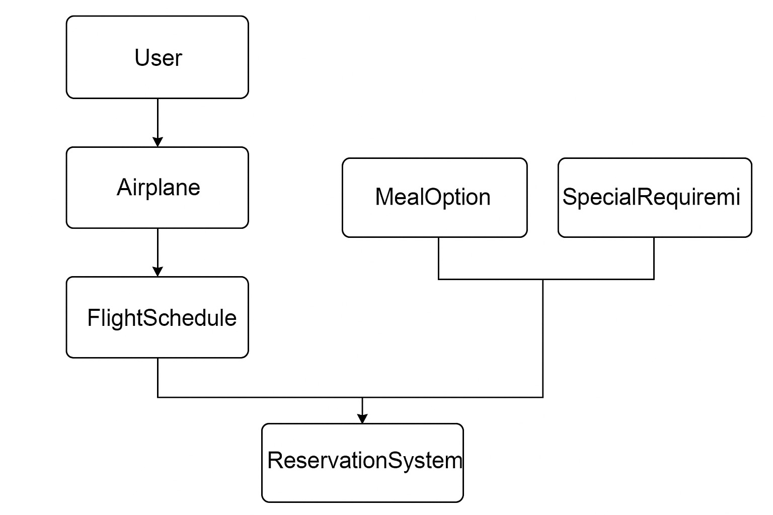

Problem Statement

Modern airline reservation systems must handle complex interconnected data while providing an intuitive user experience. Traditional systems often lack the flexibility to accommodate diverse customer needs and struggle with maintaining relationships between various system components such as user profiles, flight schedules, meal preferences, and special requirements.
This project addresses these challenges by developing a comprehensive airline reservation system using object-oriented programming principles, particularly focusing on inheritance hierarchies and polymorphism. The SkyHigh Airline Reservation System aims to create an integrated platform that efficiently manages multiple flights, provides personalized booking experiences, and handles the entire reservation lifecycle from user authentication to booking confirmation or cancellation.
The system must accommodate multiple flights, various meal options, and special assistance requirements while maintaining data integrity across all operations. By leveraging OOP principles such as encapsulation, inheritance, and polymorphism, we aim to create a modular, maintainable, and extensible system that can be easily adapted to changing business requirements.
Classes and Their Members.

Storyline

Sky High Airlines: A Journey Beyond the Clouds

A gentle hum filled the air as Ethan sat by his desk, scrolling through flights for his long-awaited vacation. Sky High Airlines had always been his go-to, offering a seamless and efficient booking experience. With just a few clicks, he logged into his account, where his profile—complete with his username, email, and contact details—was stored securely. It had been a while since he last traveled, so he took a moment to update his profile, ensuring that his latest contact number was available.

As he navigated the system, Ethan searched for a flight to Santorini, a dream destination he had long wished to visit. The Flight Schedule section displayed various available flights, categorized by arrival and departure locations. He carefully examined his options, considering departure times and layovers, before settling on a direct flight. Excitement bubbled in his chest as he imagined the white-washed houses and the deep blue waters of the Aegean Sea waiting for him.

Before proceeding with the reservation, Ethan took a moment to check the details of the aircraft. The system displayed the Airplane ID, model name, ticket price, seating arrangement, and scheduled flight date. He was relieved to see that the flight would be operated by one of Sky High Airlines’ newest aircraft, known for its comfortable seating and smooth flight experience. The price was within his budget, and with a sense of certainty, he clicked the makebooking() option, securing his seat.

Now that his flight was booked, Ethan explored the Meal Option section. He was a foodie at heart, and nothing excited him more than the idea of enjoying a delicious in-flight meal while watching the clouds drift by. The system presented various choices—vegetarian, non-vegetarian, and even gourmet seafood options. He scrolled through the view_menu() function, reading descriptions of each dish before finally selecting a special Mediterranean meal to get himself in the Santorini spirit. Clicking add_meal(), he confirmed his choice, knowing it would make his journey even more enjoyable.

Just as he was about to log out, Ethan remembered his grandmother’s advice. “Always check for extra baggage allowance,” she had said after one of his trips where he had struggled with excess luggage. Clicking on the Special Requirement section, he entered a request for additional baggage and selected an option for extra legroom. The system allowed him to add_requirement(), ensuring that he would travel with comfort and ease.

Days passed quickly, and soon, the morning of his flight arrived. Ethan found himself at the airport, wheeling his suitcase towards the check-in counter. The airline staff greeted him warmly, confirming his viewbooking() details. His special meal request had been processed, and his extra baggage was approved without a hitch.

As he settled into his seat, the hum of the engines filled the cabin, and the plane slowly taxied onto the runway. Looking out of the window, he felt a surge of excitement. The plane lifted off, climbing steadily into the sky, and Ethan knew—Sky High Airlines had once again delivered a seamless, stress-free experience. With a satisfied sigh, he leaned back, ready to embrace the adventure ahead.

Beyond the clouds, a new journey was beginning.

List of classes and its members planned

1. User Class
Purpose: Base class for user authentication and profile management Members:
- Attributes:
  - userid (int): Unique identifier for each user
  - username (string): User's display name
  - email (string): User's email address for login
  - password (string): User's authentication credential
  - contact (string): User's contact information
- Methods:
  - createProfile(): Creates a new user profile
  - updateProfile(): Updates existing user information
  - viewProfile(): Displays user profile details
  - logIn(): Authenticates user credentials
  - getUserId(): Returns user ID for reference
2. Airplane Class
Purpose: Manages airplane details and inherits from User Members:
- Attributes:
  - airplaneid (int): Unique identifier for each airplane
  - modelname (string): Model of the airplane
  - price (int): Base ticket price
  - area (char array): Area code for the flight
  - Date (int): Flight date
- Methods:
  - AddAirplane(): Adds new airplane details
  - ViewList(): Displays airplane information
  - getAirplaneId(): Returns airplane ID
  - getPrice(): Returns ticket price
3. FlightSchedule Class
Purpose: Manages flight schedules and inherits from Airplane Members:
- Attributes:
  - arrival (string): Arrival time
  - departure (string): Departure time
  - origin (string): Origin location
  - destination (string): Destination location
  - flightNo (string): Flight identification number
- Methods:
  - AddSchedule(): Adds schedule details for a flight
  - ViewSchedule(): Displays flight schedule information
  - getFlightNo(): Returns flight number
4. MealOption Class
Purpose: Independent class for managing meal preferences Members:
- Attributes:
  - mealId (int): Unique identifier for meal selection
  - mealtype (int): Type of meal (vegetarian or non-vegetarian)
  - meal (char array): Specific meal choice
- Methods:
  - viewmenu(): Displays available meal options
  - addmeal(): Records meal preferences
  - getMealId(): Returns meal ID
5. SpecialRequirement Class
Purpose: Independent class for managing special assistance Members:
- Attributes:
  - reqId (int): Unique identifier for special requirement
  - requirement (char array): Specific requirement option
- Methods:
  - view(): Displays available special assistance options
  - addRequirement(): Records special requirement selection
  - getReqId(): Returns requirement ID
6. ReservationSystem Class
Purpose: Main class using multiple inheritance to integrate all system components Members:
- Attributes:
  - reservationId (int): Unique booking identifier
  - seatNumber (int): Selected seat number
  - totalPrice (int): Final booking price
  - bookingDate (string): Date of booking
  - bookingTime (string): Time of booking
  - isConfirmed (bool): Booking confirmation status
- Methods:
  - makeBooking(): Creates a new booking
  - viewBooking(): Generates and displays booking details
  - cancelBooking(): Cancels an existing booking

Use Case Diagram
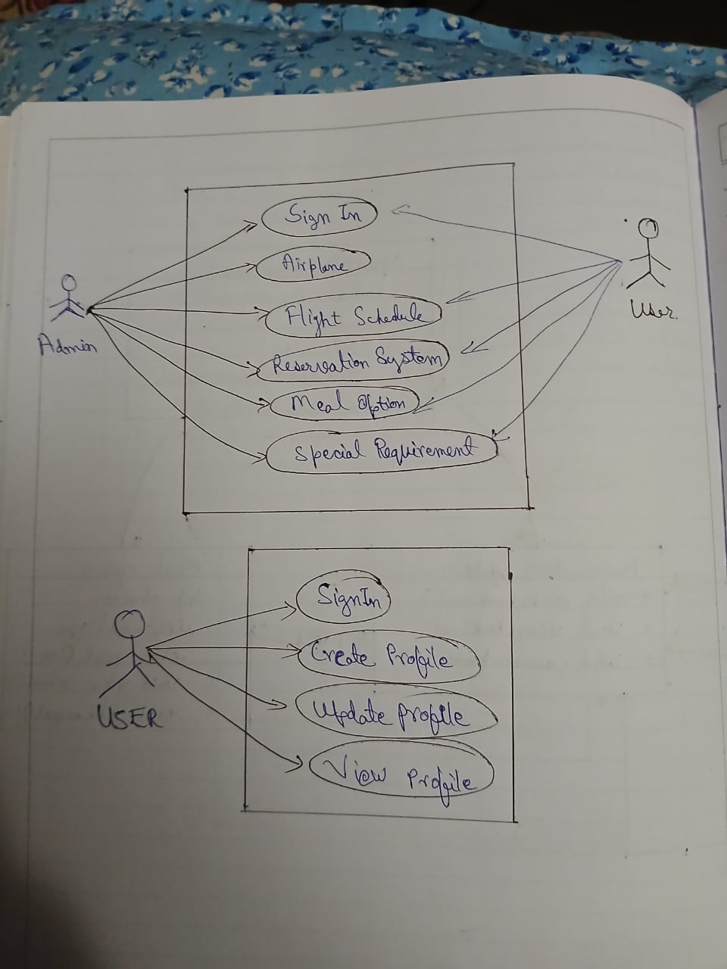
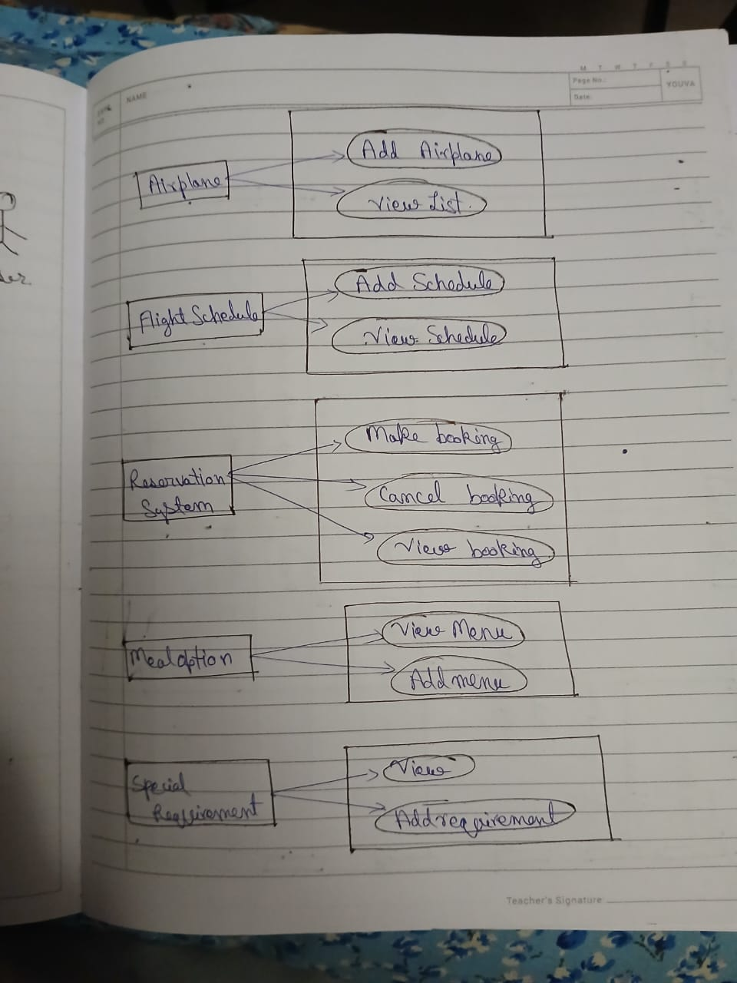
Class Diagram
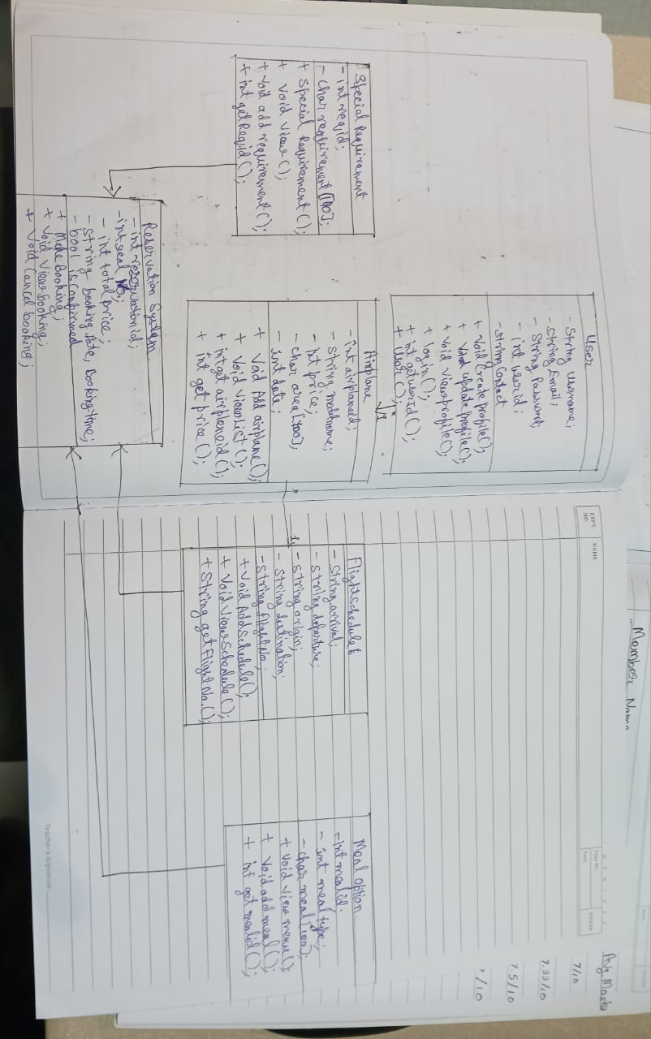
Activity Diagram
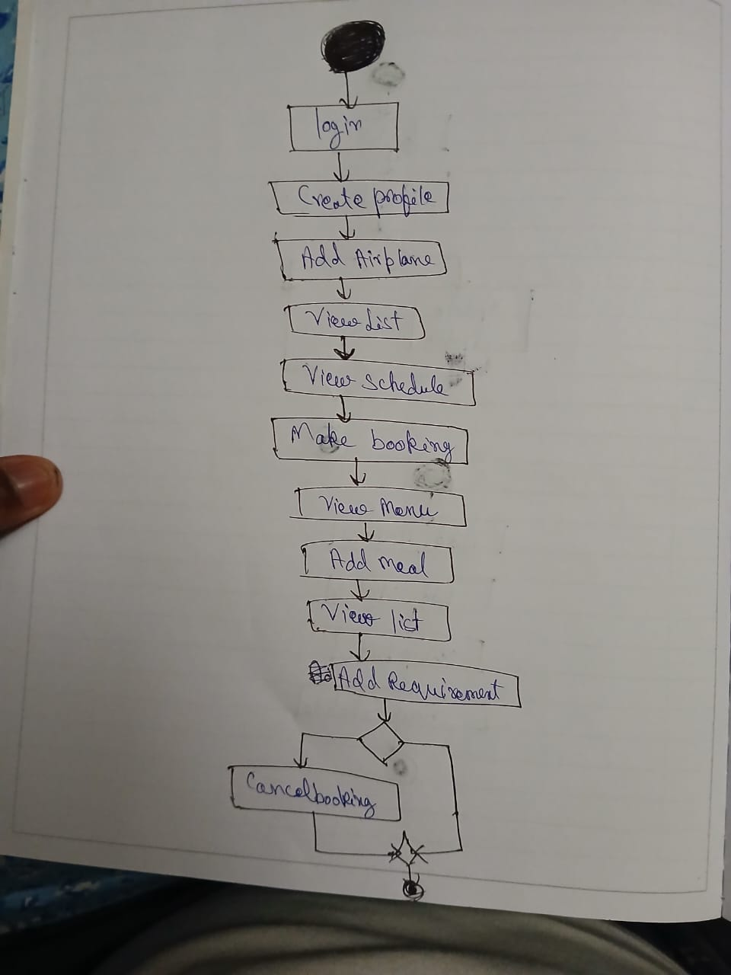
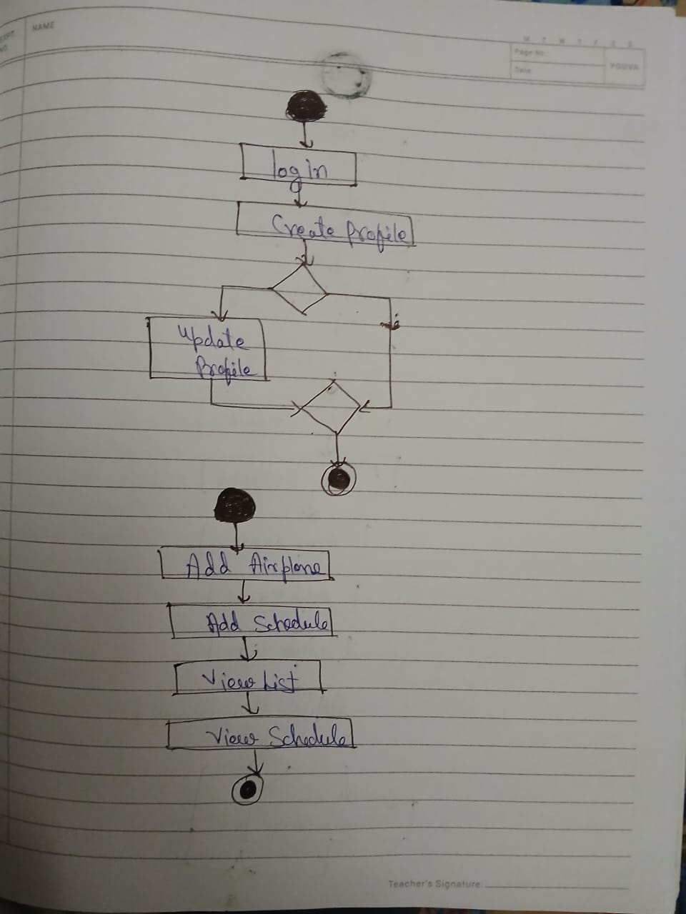
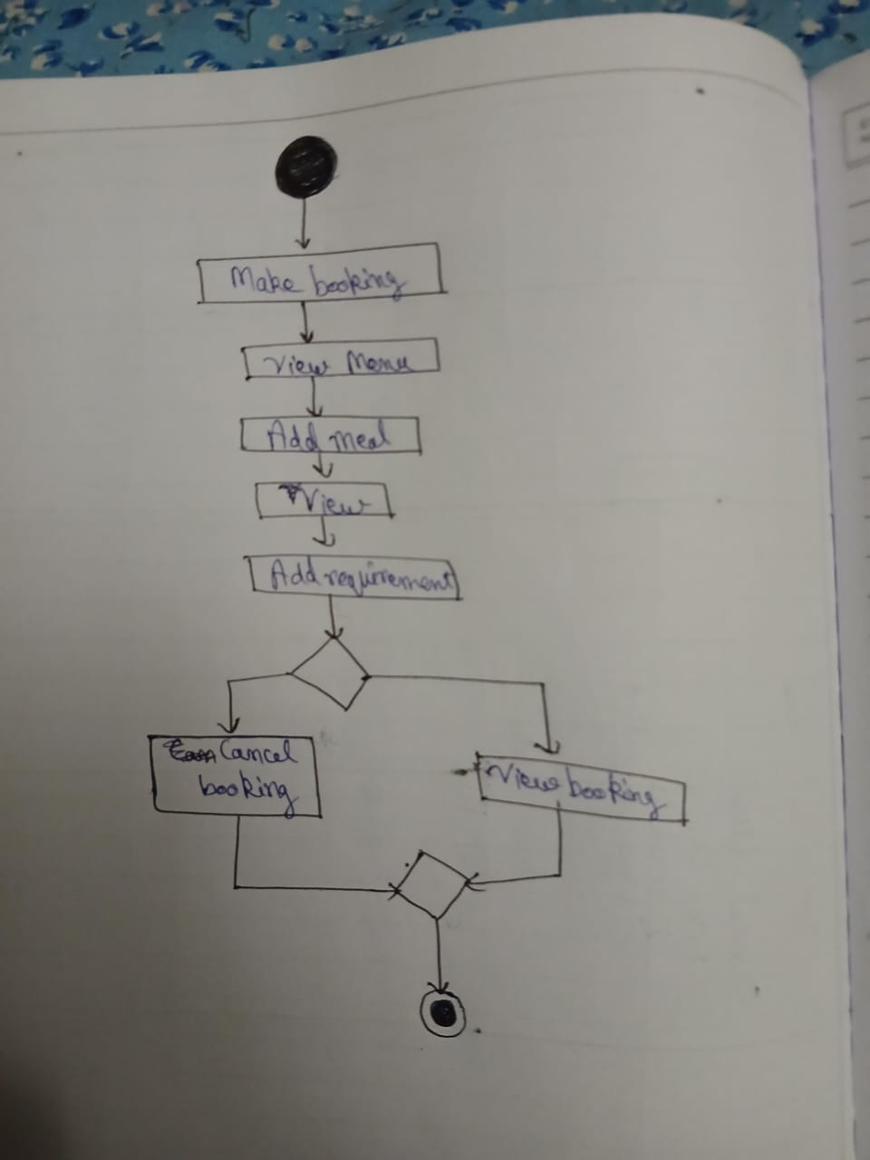
Sequence Diagram
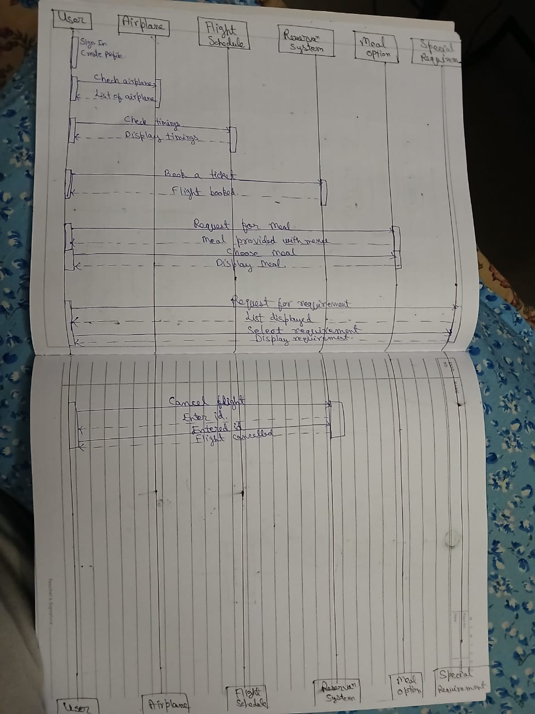
Object Oriented Concepts
In this code we have two types of inheritance;
- Multilevel inheritance
- Multiple inheritance
- Constructor
So with the help of multilevel inheritance we connected our three classes, namely; user, airplane and flight schedule and the with the help of multiple inheritance we connected the meal option, special requirement and flight schedule with reservation system so that the limited access of all classes data members and all the access of member function of the other classes should be given to the reservation class so that it will be easier to make bookings and cancel bookings. And we have used the constructor to generate the id in reservation system, user, special requirement.

- Multilevel inheritance: -
In C++, multilevel inheritance occurs when a class inherits from a derived class, creating a chain of inheritance where a class inherits from a class that itself inherits from another class.
Example code: -
#include <iostream>
class Animal { // Base class
public:
void makeSound() {
std::cout << "Generic animal sound" << std::endl;
}
};
class Dog : public Animal { // Derived class inheriting from Animal
public:
void makeSound() {
std::cout << "Woof!" << std::endl;
}
};
class Puppy : public Dog { // Derived class inheriting from Dog
public:
void play() {
std::cout << "Puppy is playing" << std::endl;
}
};
int main() {
Puppy myPuppy;
myPuppy.makeSound(); // Output: Woof! (from Dog)
myPuppy.play(); // Output: Puppy is playing
return 0;
}

- Multiple inheritance: -
In C++, multiple inheritance allows a class to inherit from multiple base classes, combining their functionalities.
Example code: -
#include <iostream>

// Base class 1
class Animal {
public:
void eat() {
std::cout << "Animal is eating." << std::endl;
}
};

// Base class 2
class Bird {
public:
void fly() {
std::cout << "Bird is flying." << std::endl;
}
};

// Derived class inheriting from both Animal and Bird
class Parrot : public Animal, public Bird {
public:
void speak() {
std::cout << "Parrot is speaking." << std::endl;
}
};

int main() {
Parrot parrot;
parrot.eat(); // From Animal class
parrot.fly(); // From Bird class
parrot.speak(); // Parrot's own function
return 0;
}

Alorithm
step1: start
step 2 : initialize choice =0, Flightcount=2
step 3 : print Welcome to skyhigh reservation system
step 4 : create object booking of reservationSystem class
step 5 : call login function from parent class user
step 6 : print creating a new profile
step 7 : call functions createProfile() and viewProfile() from parent class user
step 8 : print enter fight details
step 9 : call function Addairplane() from parent class Addairplane
step 10 : call function Addschedule(),viewlist() and viewSchedule form parent classs flightSchedule
step 11 : take input of choice from user
step 12 : if choice == 1 call functions addmeal() nd viewmenu() from class MealOption
step 13 : else print no meals selected
step 14 : take input of choice from user for special requirements
step 15 : if choice == 1 call functions view() and addRequirement() from class specialrequirement
step 16 : else print no special requirements selected
step 17 : ask the user if they want to proceed with the booking and inpu choiuce
step 18 : if choice == 1 call functions viewBooking() and makeBooking() from class ReservationSystem
step 19 : ask if the user wants to cancel booking
step 20 : if choice == 1 call functions cancelbooking() from class ReservationSystem
step 21 : print thank you for using sky high reservation system
step 22 : stop

Flowchart
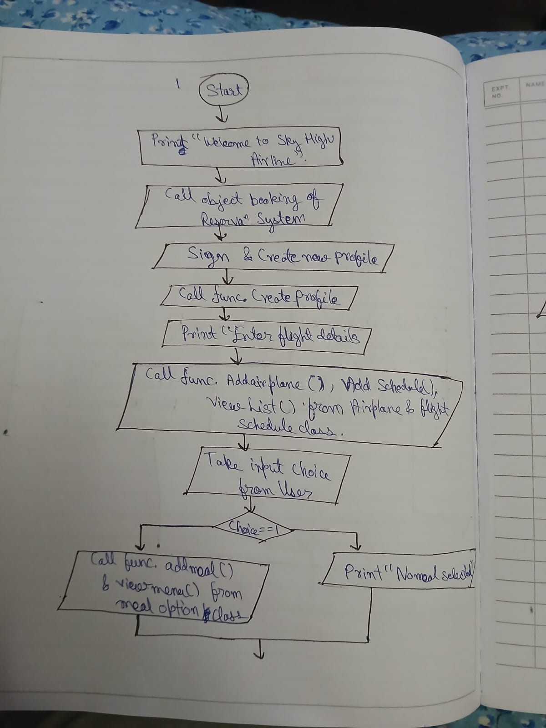
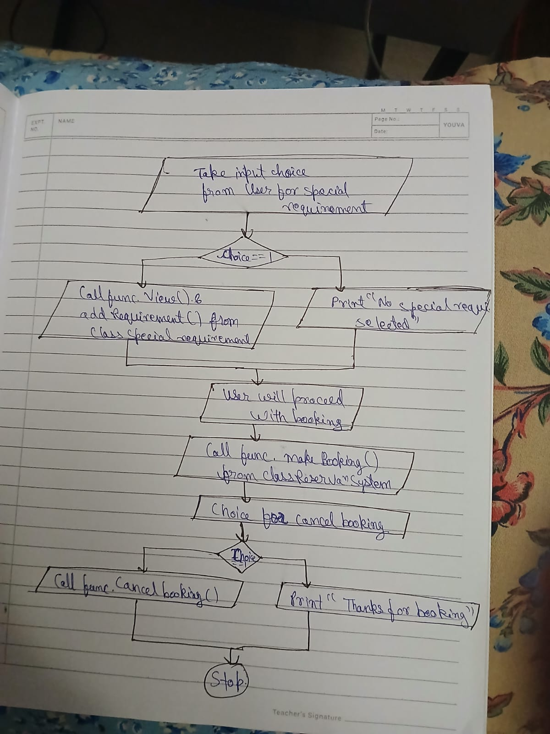
Code

#include <iostream>
#include <string>
#include <cstdlib>
using namespace std;

// Base class for multilevel inheritance
class User {
protected:
int userid;
string username, email, password;
string contact;

public:
User() { userid = rand() % 10000 + 1; }

void createProfile() {
cout << "Enter Username: ";
getline(cin, username);
cout << "Enter Email: ";
getline(cin, email);
cout << "Enter Password: ";
getline(cin, password);
cout << "Enter Contact No: ";
cin >> contact;
cin.ignore();
cout << "Profile created successfully! Your User ID is " << userid << endl;
}

void updateProfile() {
cout << "Enter New Username: ";
getline(cin, username);
cout << "Enter New Email: ";
getline(cin, email);
cout << "Enter New Contact No: ";
cin >> contact;
cin.ignore();
cout << "Profile updated successfully!" << endl;
}

void viewProfile() {
cout << "\nUser ID: " << userid << "\nUsername: " << username << "\nEmail: " << email << "\nContact No.: " << contact << endl;
}

void logIn() {
cout << "\nEnter Email: "; getline(cin, email);
cout << "Enter Password: "; getline(cin, password);
cout << "Signed in successfully!" << endl;
}

int getUserId() {
return userid;
}
};

// Second level in multilevel inheritance
class Airplane : public User {
protected:
int airplaneid;
string modelname;
int price;
char area[100];
int Date;

public:

void AddAirplane() {
cout << "Enter Airplane ID: ";
cin >> airplaneid;
cout << "Enter Model Name: ";
cin >> modelname;
cout << "Enter Price: ";
cin >> price;
cout << "Enter Area Code (single character): ";
cin >> area;
cout << "Enter Date: ";
cin >> Date;
cout << "DONE" << endl;
}

void ViewList(int index) {
cout << "\nFlight " << index + 1 << " Details:";
cout << "\nID: " << airplaneid;
cout << "\nModel: " << modelname;
cout << "\nPrice: $" << price;
cout << "\nArea Code: " << area;
cout << "\nDate:" << Date;
cout << "\n*";
}

int getAirplaneId() {
return airplaneid;
}

int getPrice() {
return price;
}
};

// Third level in multilevel inheritance
class FlightSchedule : public Airplane {
protected:
string arrival;
string departure;
string origin;
string destination;
string flightNo;
// airplaneId is now available through the inheritance hierarchy

public:
void AddSchedule() {
cout << "Enter Flight Number: ";
cin >> flightNo;
cout << "Enter Origin: ";
cin >> origin;
cout << "Enter Destination: ";
cin >> destination;
cout << "Enter Arrival Time: ";
cin >> arrival;
cout << "Enter Departure Time: ";
cin >> departure;
// Using the airplaneid from Airplane class through inheritance
}

void ViewSchedule(int index) {
cout << "\nFlight " << index + 1 << " Schedule:";
cout << "\nFlight Number: " << flightNo;
cout << "\nOrigin: " << origin;
cout << "\nDestination: " << destination;
cout << "\nArrival Time: " << arrival;
cout << "\nDeparture Time: " << departure;
cout << "\nDate: " << Date; // Accessing Date from Airplane through inheritance
cout << "\n*";
}

string getFlightNo() {
return flightNo;
}
};

// Independent class for meal options
class MealOption {
protected:
int mealId;
int mealtype;
char meal[100];

public:
void viewmenu() {
if(mealtype == 1) {
cout << "VEG MENU: -" << endl;
cout << "Veg sandwich" << endl;
cout << "Veg noodles" << endl;
cout << "Veg feast thali" << endl;
cout << "Enter the Meal: ";
cin >> meal;
}
if(mealtype == 2) {
cout << "NON_VEG MENU: -" << endl;
cout << "Non-Veg sandwich" << endl;
cout << "chicken fries" << endl;
cout << "Non-Veg feast thali" << endl;
cout << "Enter the Meal: ";
cin >> meal;
}
}

void addmeal() {
mealId = rand() % 1000 + 1;
cout << "Enter the meal type(1. veg, 2. non-veg): ";
cin >> mealtype;
}

int getMealId() {
return mealId;
}
};

// Independent class for special requirements
class SpecialRequirement {
protected:
int reqId;
char requirement[100];

public:
SpecialRequirement() {
reqId = rand() % 1000 + 1;
}

void view() {
cout << "LIST" << endl;
cout << "Wheel Chair" << endl;
cout << "Doctor/nurse" << endl;
cout << "Staff Support" << endl;
}

void addRequirement() {
cout << "Enter the requirement: ";
cin >> requirement;
}

int getReqId() {
return reqId;
}
};

// Multiple inheritance to connect all classes:
// FlightSchedule (which already includes User and Airplane through multilevel inheritance)
// MealOption and SpecialRequirement
class ReservationSystem : public FlightSchedule, public MealOption, public SpecialRequirement {
private:
int reservationId;
int seatNumber;
int totalPrice;
string bookingDate;
string bookingTime;
bool isConfirmed;

public:
ReservationSystem() {
reservationId = rand() % 10000 + 1;
isConfirmed = false;
}

void makeBooking() {
// Most data is already available through inheritance
cout << "Enter seat number: ";
cin >> seatNumber;

// Calculate total price using price from Airplane (through inheritance)
totalPrice = getPrice();

cout << "Enter booking date (DD/MM/YYYY): ";
cin >> bookingDate;

cout << "Enter booking time (HH:MM): ";
cin >> bookingTime;

isConfirmed = true;
cout << "Booking confirmed! Your reservation ID is " << reservationId << endl;
}

void viewBooking() {
cout << "\n----- FLIGHT BILL -----" << endl;
cout << "Reservation ID: " << reservationId << endl;
cout << "User ID: " << getUserId() << endl; // From User class
cout << "Flight Number: " << getFlightNo() << endl; // From FlightSchedule
cout << "Seat Number: " << seatNumber << endl;
cout << "Meal Option ID: " << getMealId() << endl; // From MealOption
cout << "Special Request ID: " << getReqId() << endl; // From SpecialRequirement
cout << "Total Price: $" << totalPrice << endl;
cout << "Booking Date: " << bookingDate << endl;
cout << "Booking Time: " << bookingTime << endl;
cout << "Status: " << (isConfirmed ? "Confirmed" : "Pending") << endl;
cout << "Thank you for flying with" << endl;
cout << " SKYHIGH AIRLINE" << endl;
}

void cancelBooking() {
isConfirmed = false;
cout << "Booking with reservation ID " << reservationId << " has been cancelled." << endl;
}
};

int main() {
int choice, flightCount = 0;

// Create flights with the complete inheritance chain
ReservationSystem reservations[flightCount];

cout << "Welcome to SKYHIGH AIRLINE Reservation System!" << endl;

// For demonstration, we'll create just one complete booking
ReservationSystem booking;

// Login using User class functionality (inherited)
booking.logIn();

cout << "\nCreating a new profile...\n";
cin.ignore(); // Clear input buffer
booking.createProfile();
booking.viewProfile();

// Add airplane details (from Airplane class)
for(flightCount=0; flightCount<5; flightCount++)
{
cout << "\nEnter flight details:\n";
booking.AddAirplane();

// Add schedule details (from FlightSchedule class)
booking.AddSchedule();
}
for(flightCount=0; flightCount<5; flightCount++)
{
// Display the details
booking.ViewList(0);
booking.ViewSchedule(0);
}
// Add meal options
cout << "\nDo you want meal (1. yes, 2. no): ";
cin >> choice;
if (choice == 1) {
booking.addmeal();
booking.viewmenu();
cout << "Meal Added Successfully" << endl;
} else {
cout << "No meal selected" << endl;
}

// Add special requirements
cout << "\nDo you want special requirement (1. yes, 2. no): ";
cin >> choice;
if (choice == 1) {
booking.view();
booking.addRequirement();
cout << "Requirement Added Successfully" << endl;
} else {
cout << "No special requirement selected" << endl;
}

// Make reservation
cout << "\nProceed with booking? (1. yes, 2. no): ";
cin >> choice;
if (choice == 1) {
booking.makeBooking();
booking.viewBooking();

cout << "\nDo you want to cancel this booking? (1. yes, 2. no): ";
cin >> choice;
if (choice == 1) {
booking.cancelBooking();
}
}

cout << "\nThank you for using SKYHIGH AIRLINE Reservation System!" << endl;
return 0;
}

Output
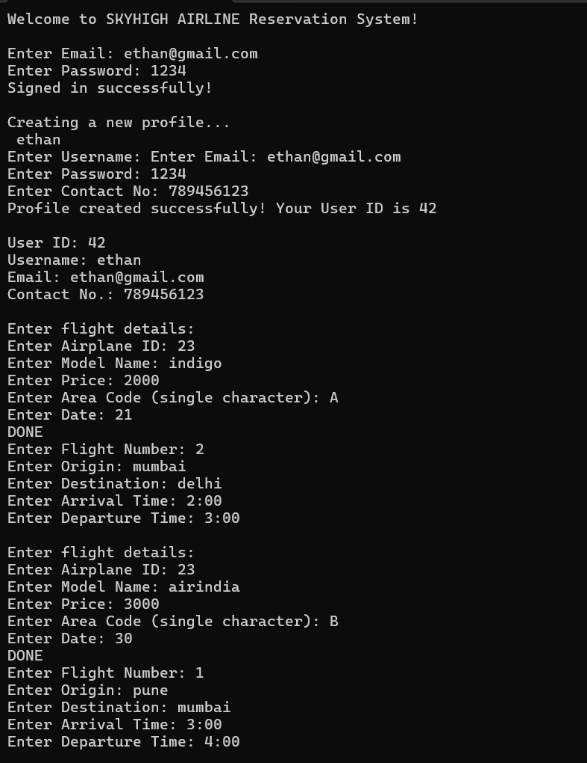
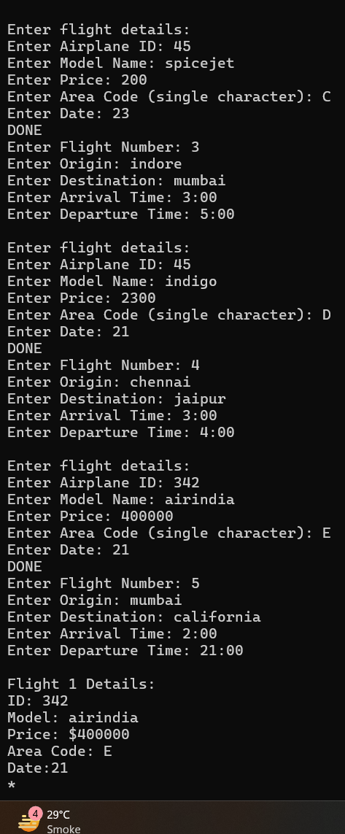
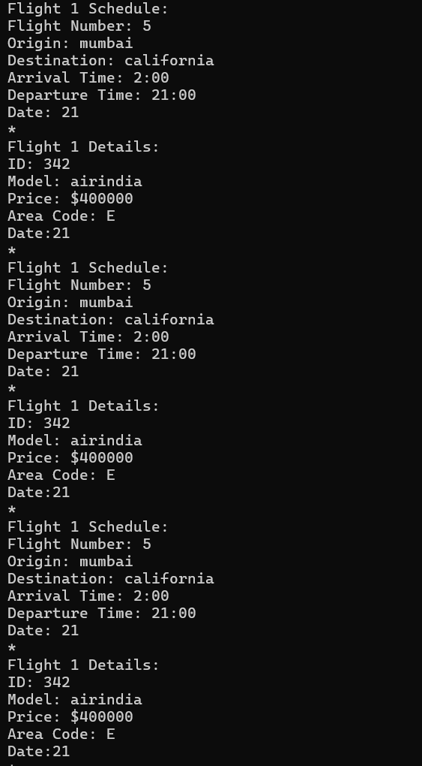
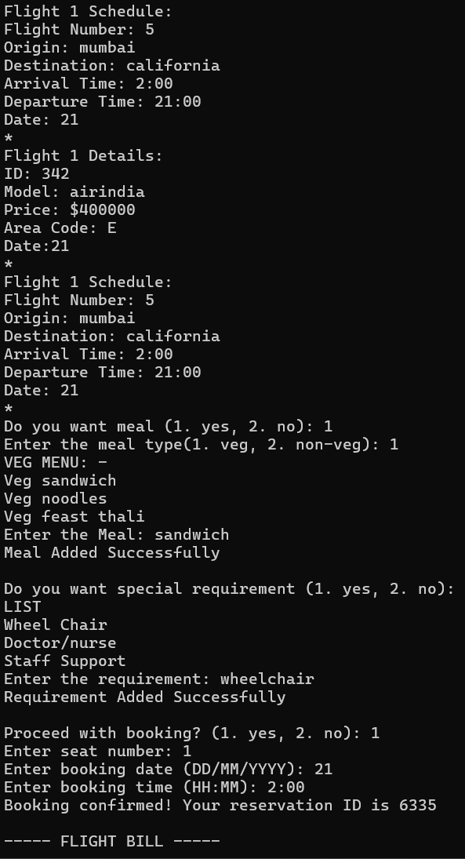
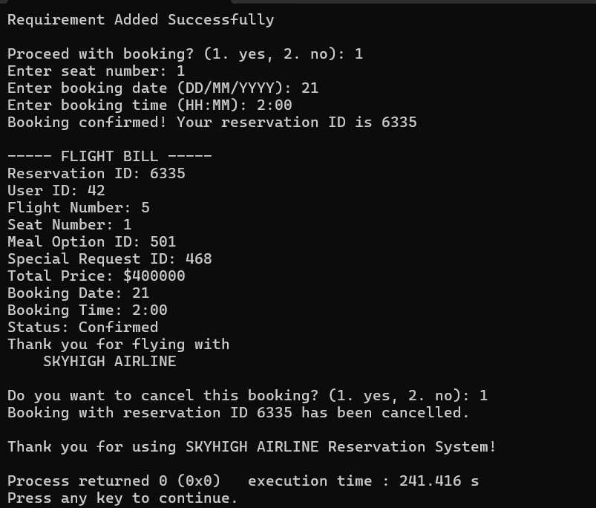

List of errors
- Used cin instead of getline() for username/email
- Used int for string-based values like Date or Area
- Forgot to call cin.ignore() after using cin
- Faced problem while merging the codes, the errors found at that time are, forgot to make the data members protected from public
- confusion while making inheritance
- shows error when we try to merge the mains of different parts of our codes
- Sometimes forgot to put the curly braces correctly in proper sequr=ence because of which the code showed error
- Forgot to put semi-colon sometimes
- Sometimes we forgot that how we have declared the variables, means in upper case of lower case or mix so when we define them and if they are not as per the declared one then it shows error
- Forgot that how we have declared the member function name
- Major problem we have faced was to hard code the flight details. Majorly faced trouble in calling the proper flight details while booking and in generating the list also.
So instead of doing it hard code we took the details also from user.

Scope of Improvement
We have created a simple user friendly booking system. There are lot of improvements available that we can make such as create a proper menu, a step by step booking process in which the flight details are already hard coded, the there is proper login and sign up process without which you cannot proceed futher, a proper flow of the booking process so that whenever a person skips any step so that the system will remind it by showing the error, a proper payment method and proper seat allotment with choice of different classes provided such as busi. Class or economy, etc ; so this are the few improvement that the this code requires to run more smoothly and in a proper way.

References
Balagurusamy, “Inheritance”, in Object Oriented Programming with C++, McGraw-Hill, 8th edition, 2023.
Web(AI) for generating random id for the user.
AI for resolving problems faced during the merging of code.

