Drupal 8: Drupal Behavior/jQuery

1) Create an anchor tag with href attribute using Theme function in jQuery.
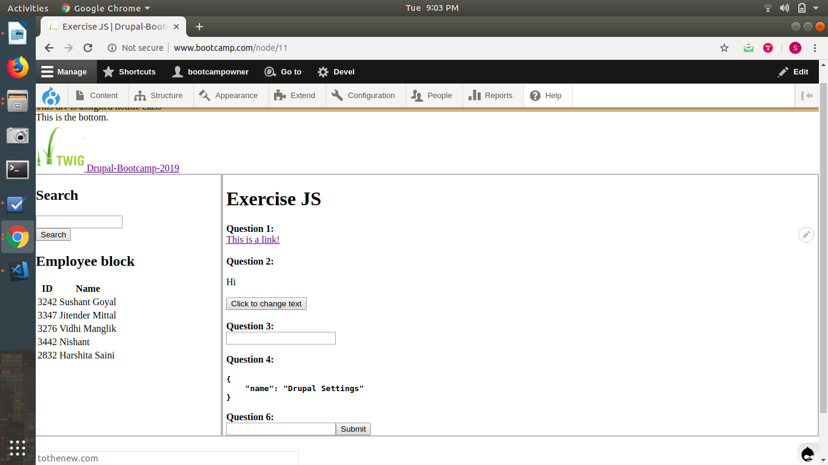
2) Create a simple button and one(or two?) paragraph with text “Hi”. Once the button is clicked, the paragraph text should change to “Hello”. If button is clicked once again, the paragraph text should again change to “Hi”. This process must repeat on subsequent clicks.
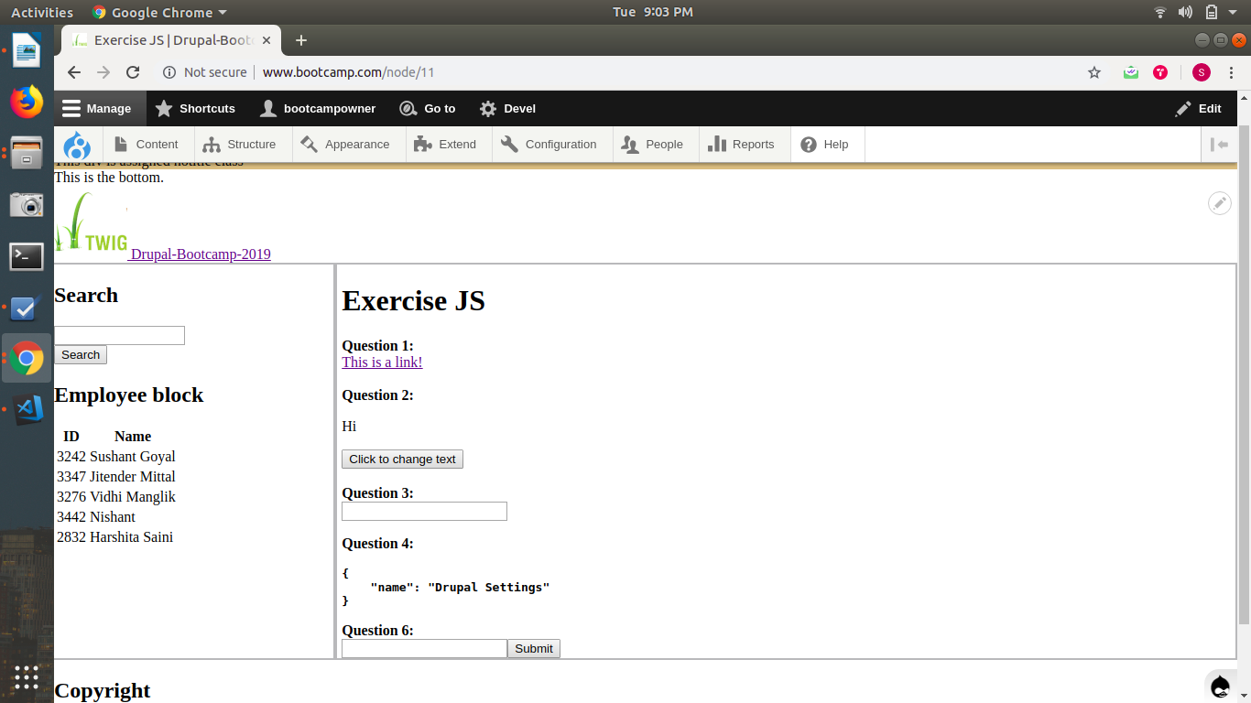
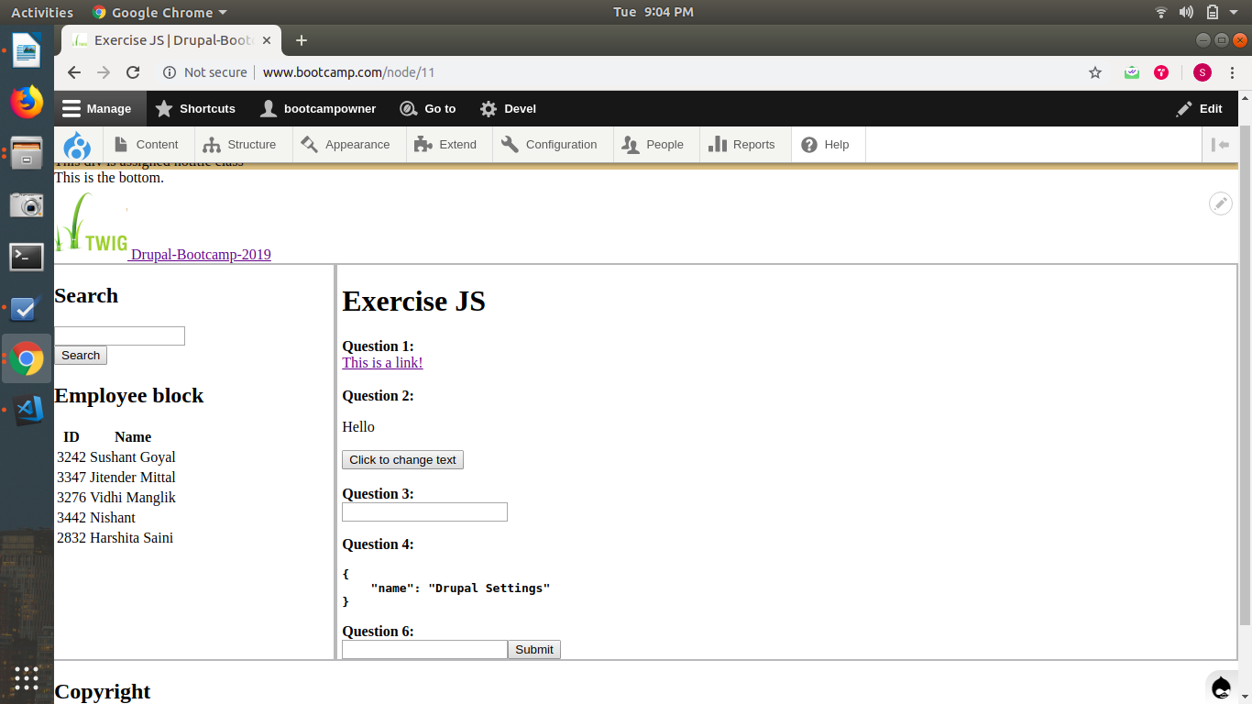
3) Show text value of Textbox in a <p></p> tag when user press Enter key.
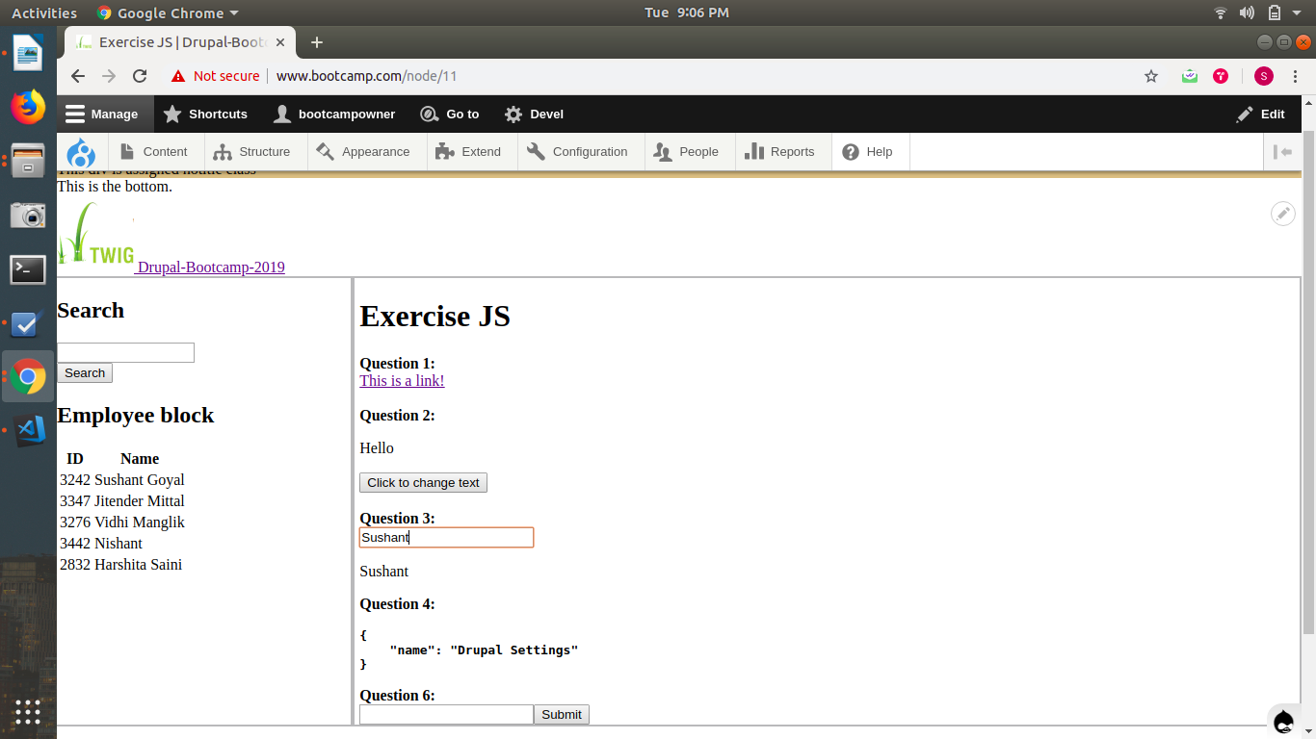

4) Pass a variable & its value in Drupal behaviors settings
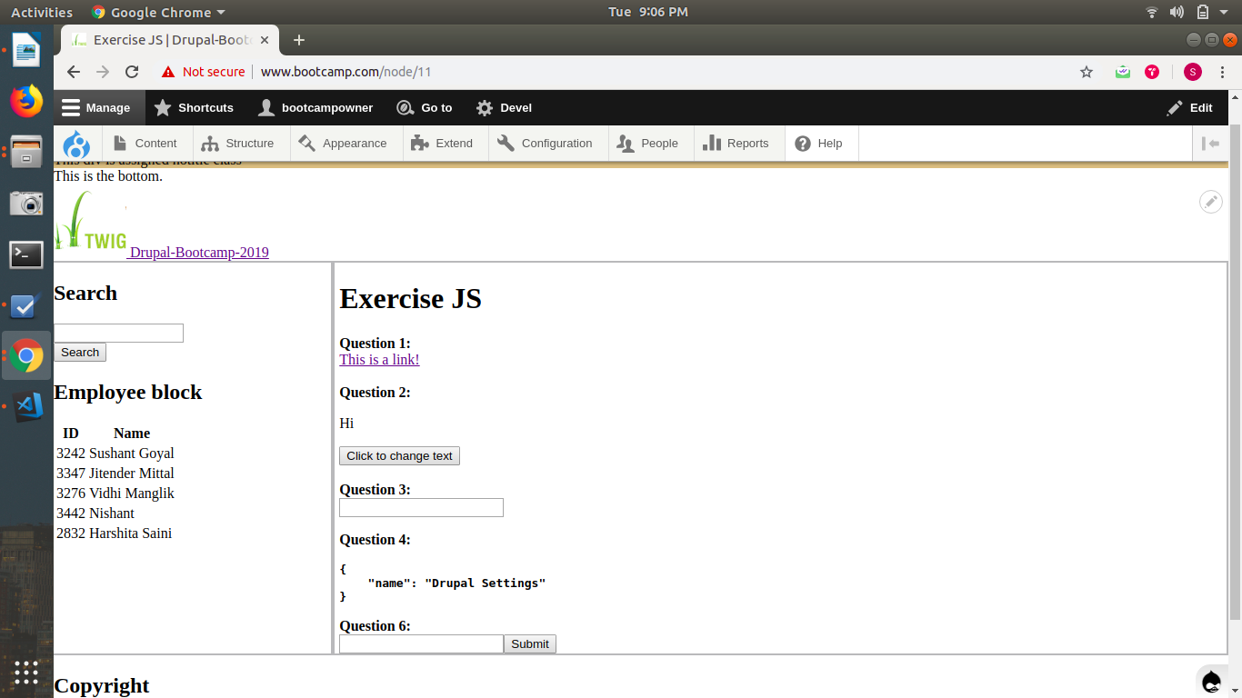
5) Add jquery validate to theme (http://cdn.jsdelivr.net/jquery.validation/1.15.0/jquery.validate.js)
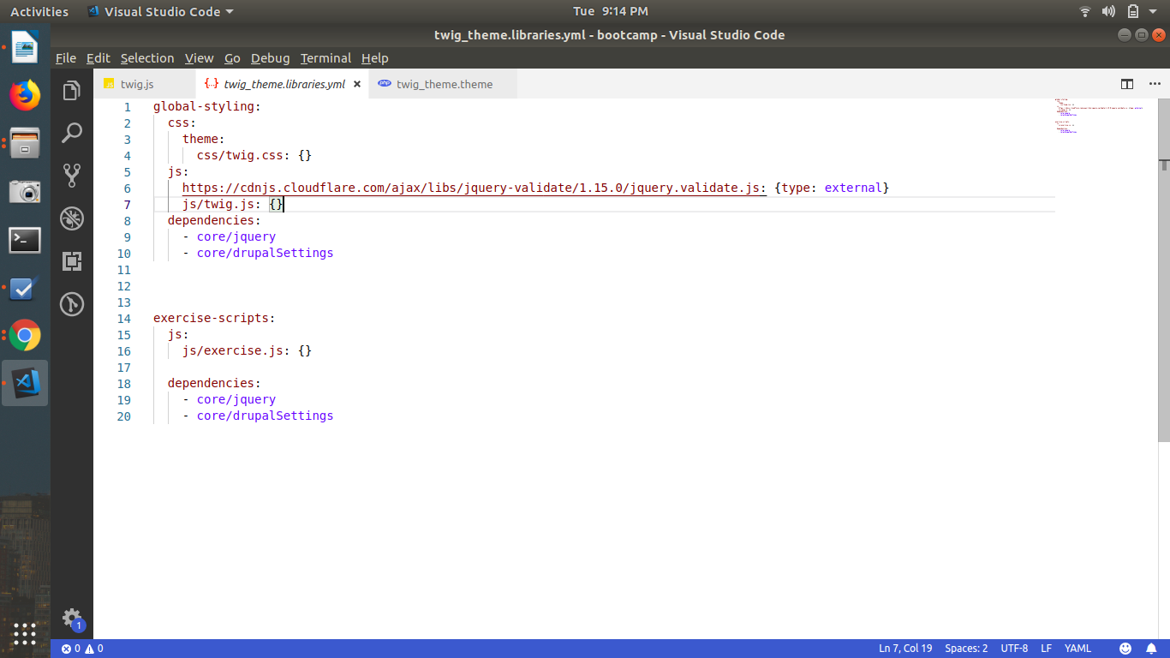

6) Validate textfield for required & minlength using validate jquery.
