Drupal 8: Templating System-TWIG

1. Create html.html.twig in custom theme
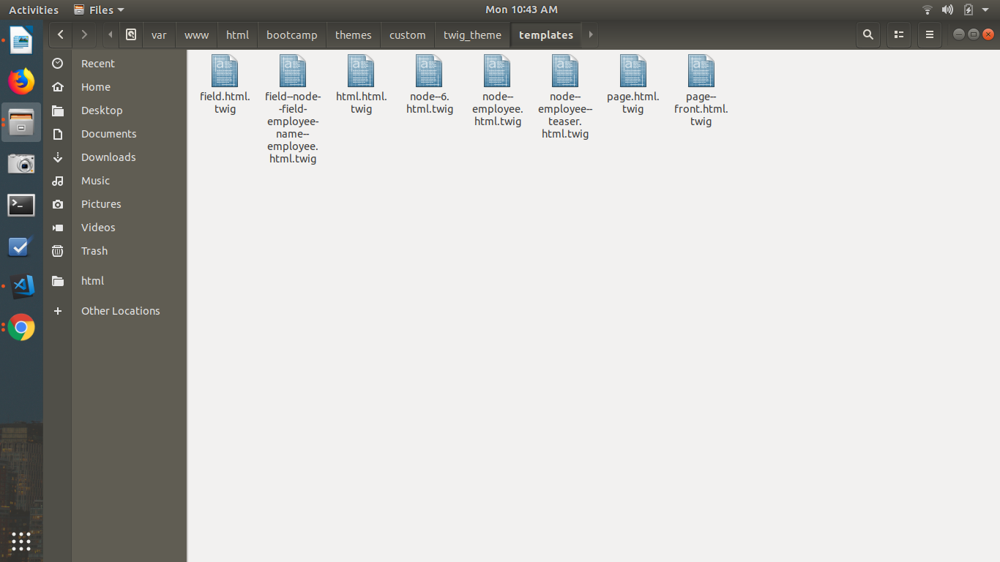
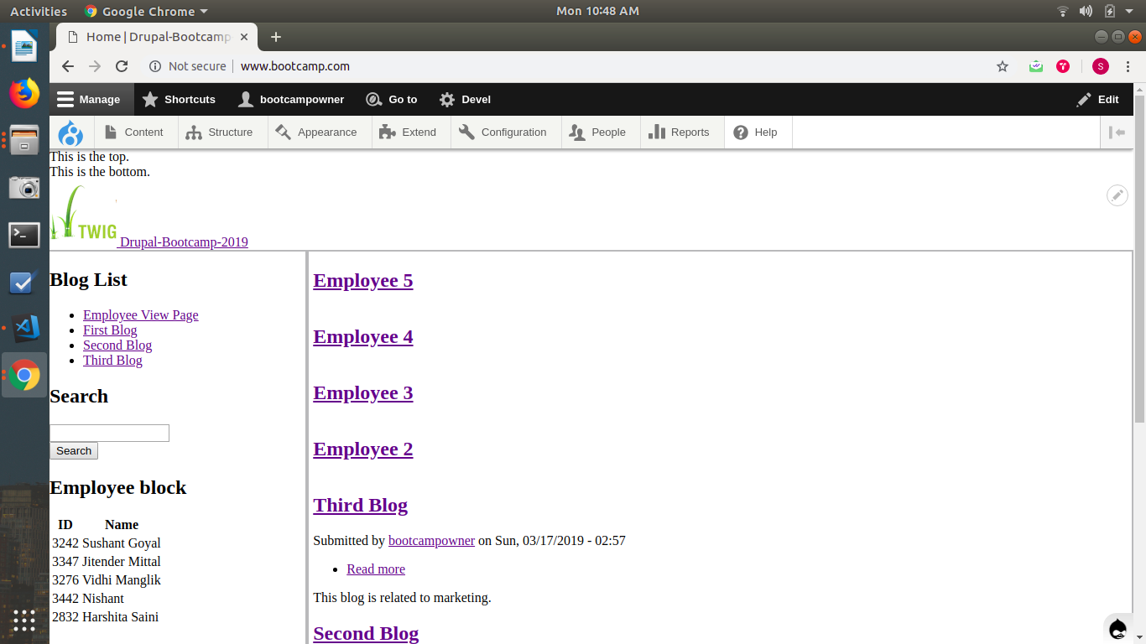

2. Create Page Front HTML Twig in custom theme

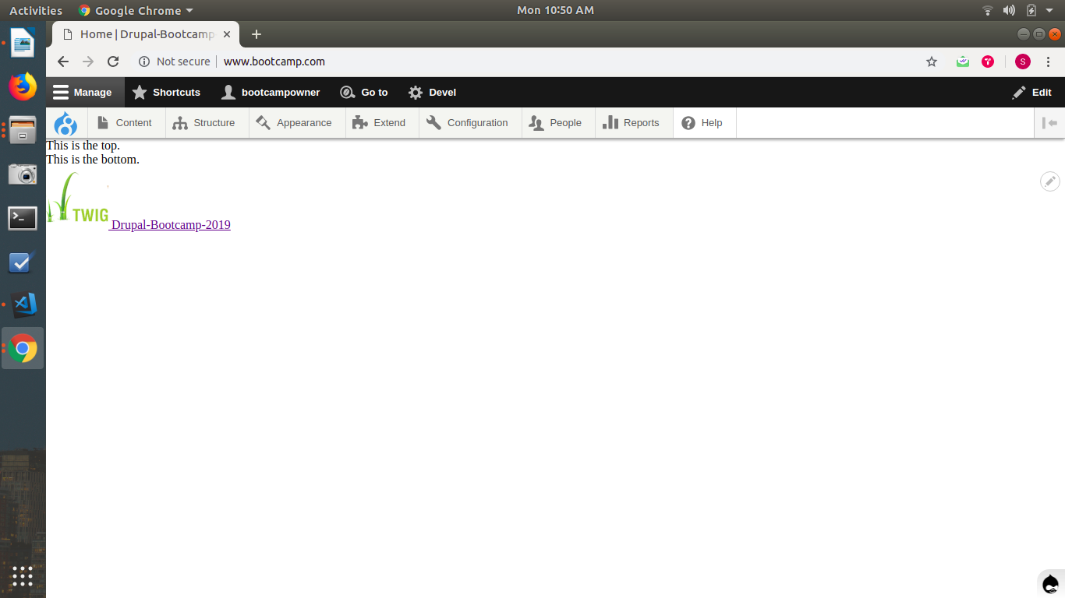
3. Create View Mode Twig in Custom Theme

view-mode : Teaser
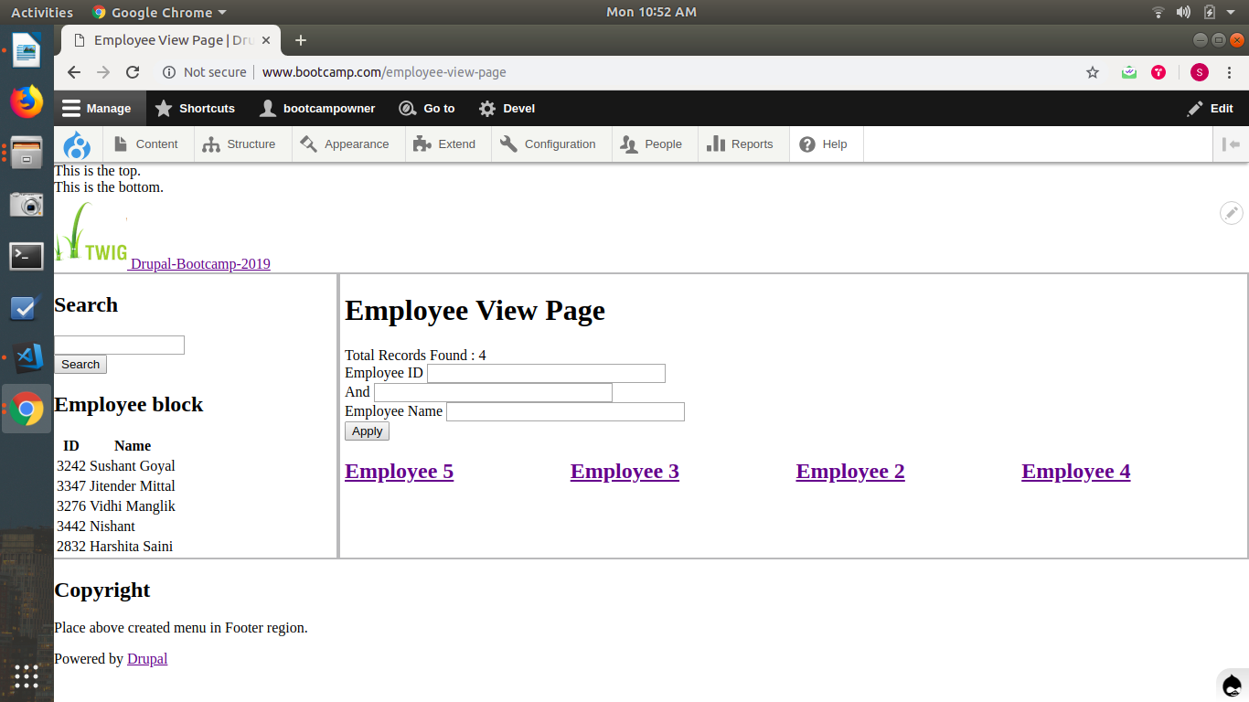

4. Create content type twig
for blog type it displays the submitted by block
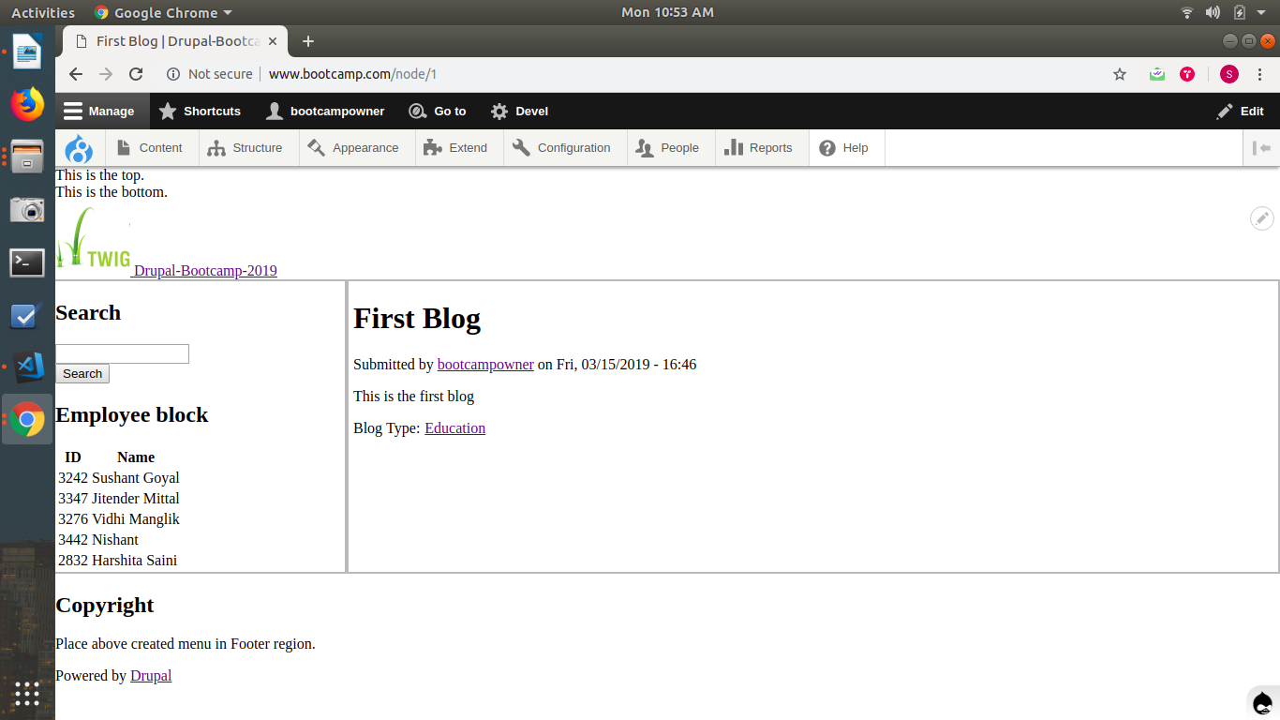
for employee type the block is removed
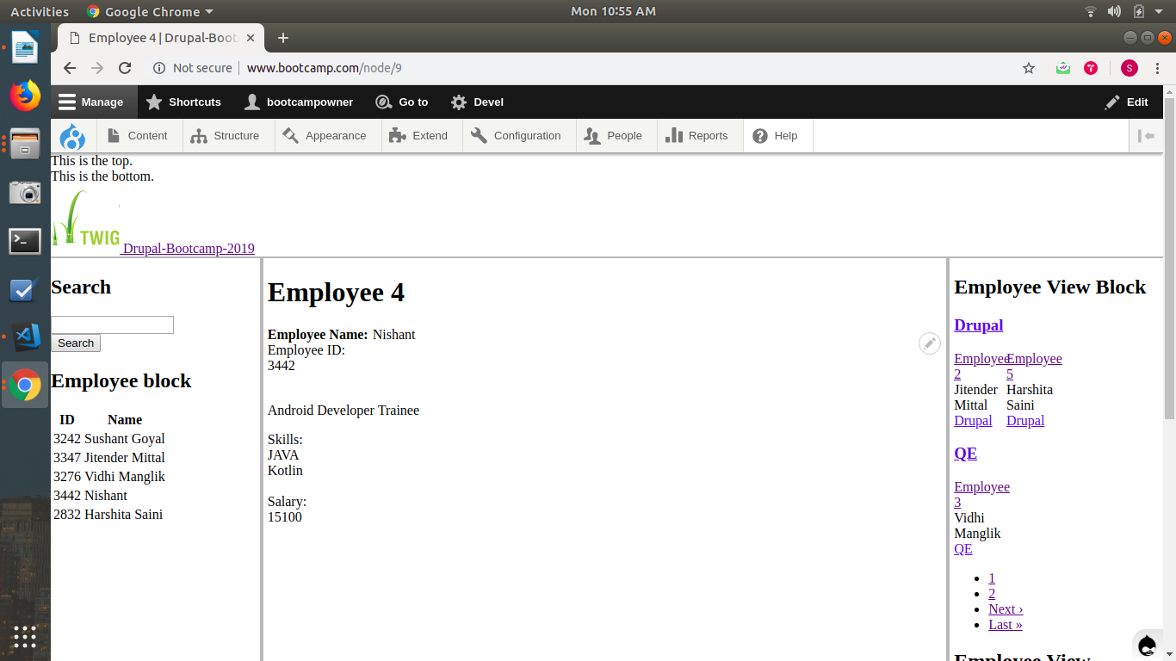

5. Create field twig

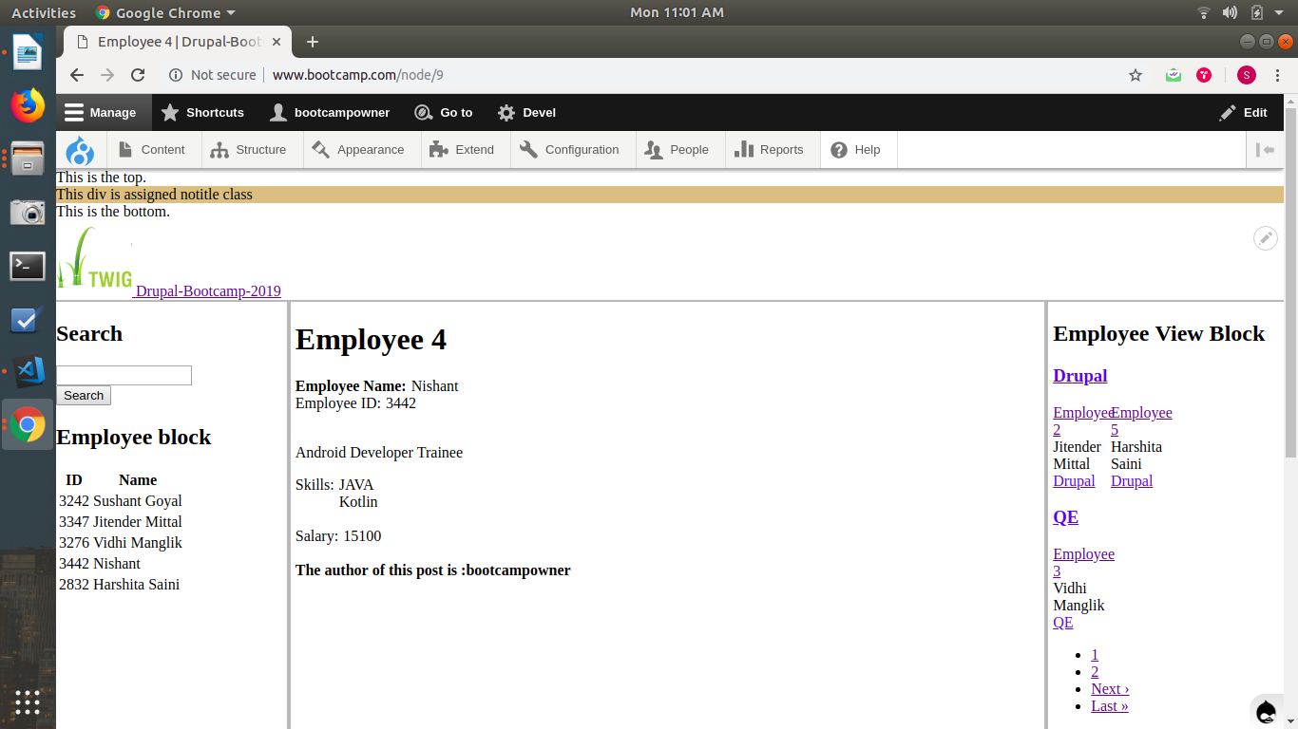
6. Create specific node id twig
for this specific node of employee content type submitted by block is visible
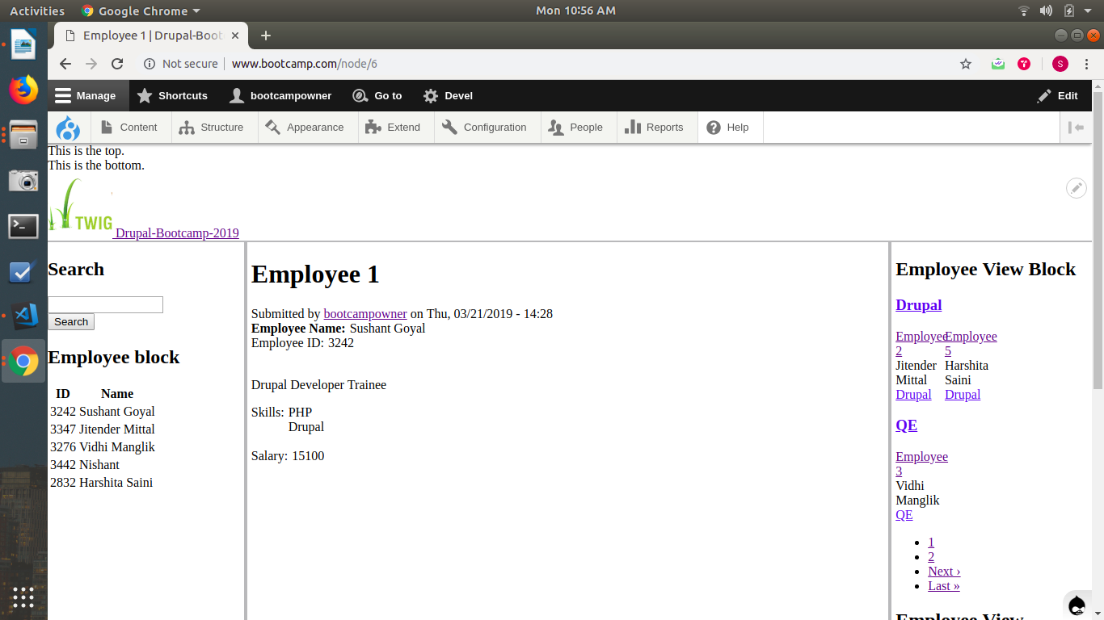

7. Create a custom class "notitle" and place in body

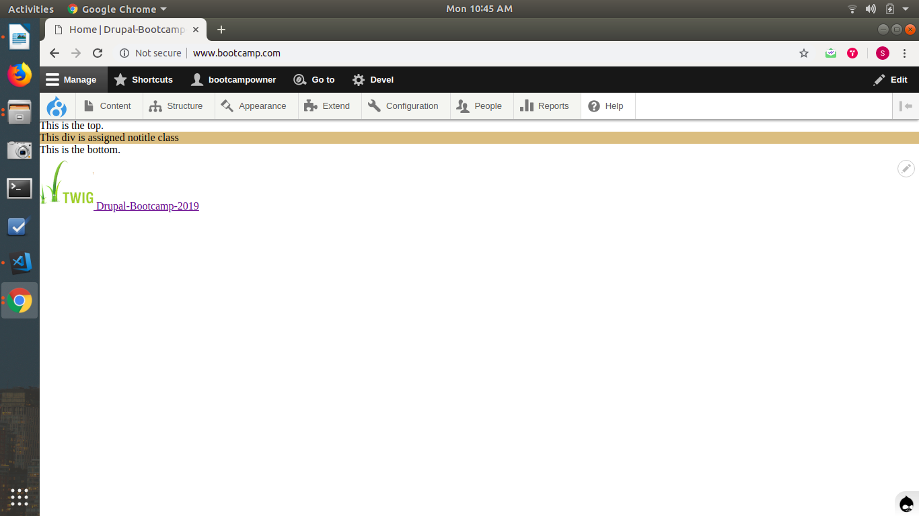
8. Create a variable in node preprocessor to show author full name and use that variable in content type twig

