Drupal 8: Views & Block

Q1:Create a content type named Employee with following fields:
Employee name
Employee Description
Employee ID
Picture
Salary
Skills
Competency(taxonomy term)
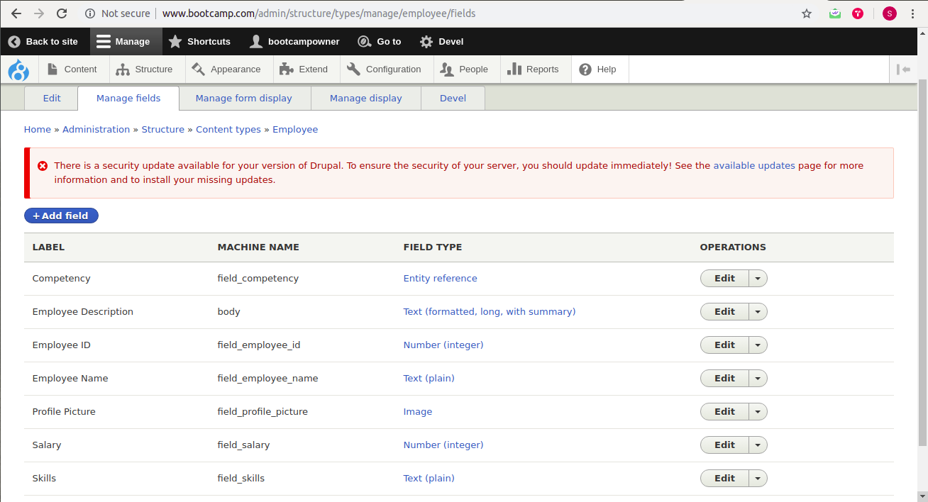
Q2.Create a block programmatically listing all employee name and Employee ID.
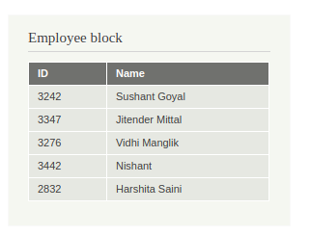

Q3:Create a view block of employee content type showing employee name and competency in grid format with 3 columns and group them on the basis of competency.
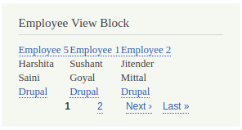

Q4.List the naming conventions for views templates for views created in question 5 and question 6.
For Ques 5 : View Name : employee-view-page
Style: Table
Row style: Fields
Display: Page.
views-view--employee-view-page--page.html.twig
views-view--page.html.twig
views-view--employee-view-page.html.twig
views-view.html.twig
views-view-table--employee-view-page--page.html.twig
views-view-table--page.html.twig
views-view-table--employee-view-page.html.twig
views-view-table.html.twig
views-view-fields--employee-view-page--page.html.twig
views-view-fields--page.html.twig
views-view-fields--employee-view-page.html.twig
Views-view-fields.html.twig
For Ques 6 : View Name : employee-view-block
Style: HTML list
Row style: Fields
Display: Page.
views-view--employee-view-block--page.html.twig
views-view--page.html.twig
views-view--employee-view-block.html.twig
views-view.html.twig
views-view-list--employee-view-block--page.html.twig
views-view-list--page.html.twig
views-view-list--employee-view-block.html.twig
views-view-list.html.twig
views-view-fields--employee-view-block--page.html.twig
views-view-fields--page.html.twig
views-view-fields--employee-view-block.html.twig
Views-view-fields.html.twig
Q5:Create a view page of employee content type in a table format with Employee name,
Employee ID and salary as header
1. Sort it on the basis of Employee ID
2. Trim the Employee Description field to 50 characters.
3. Add header “Total Records found : total”
4. Expose the filter for employee name
5. Expose the filter for employee id (use Between)
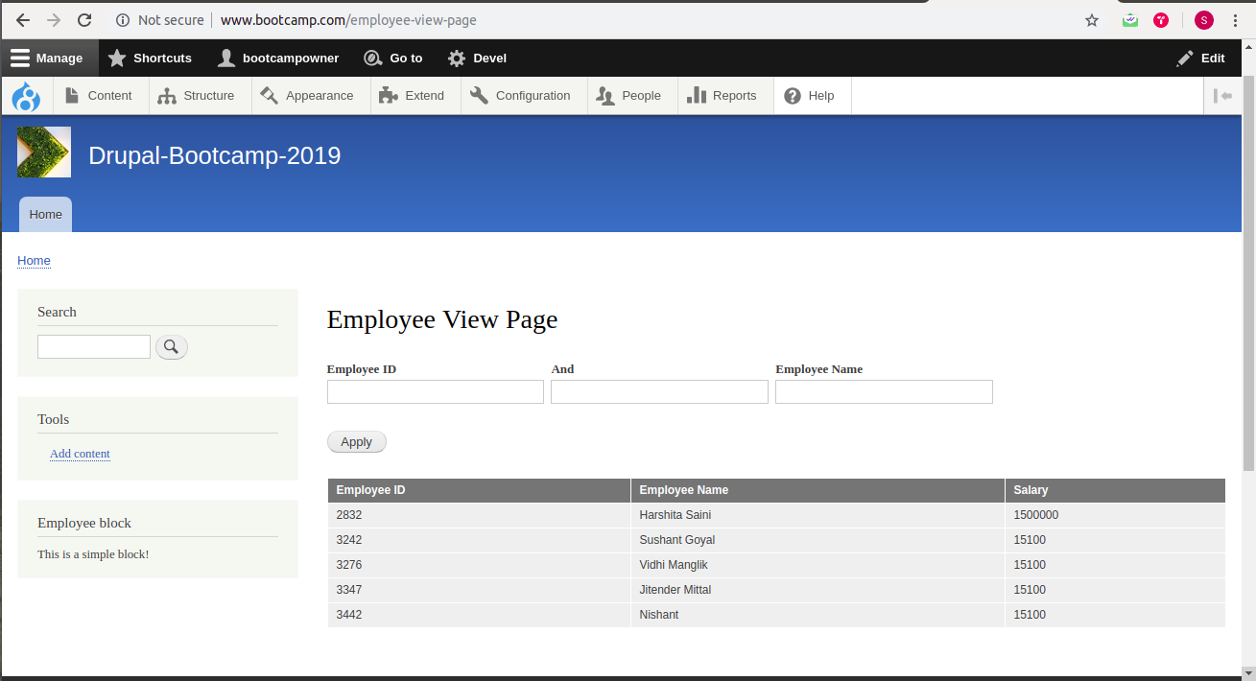

Q6:Create a view to show the Employee details(name,id) in HTML List on the basis of competency(taxonomy term id)
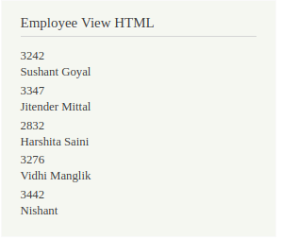

Q7. Create a view listing Employee name based on node id and show it on employee content type.
Note: The title(employee name) should be excluded in which the view is placed.
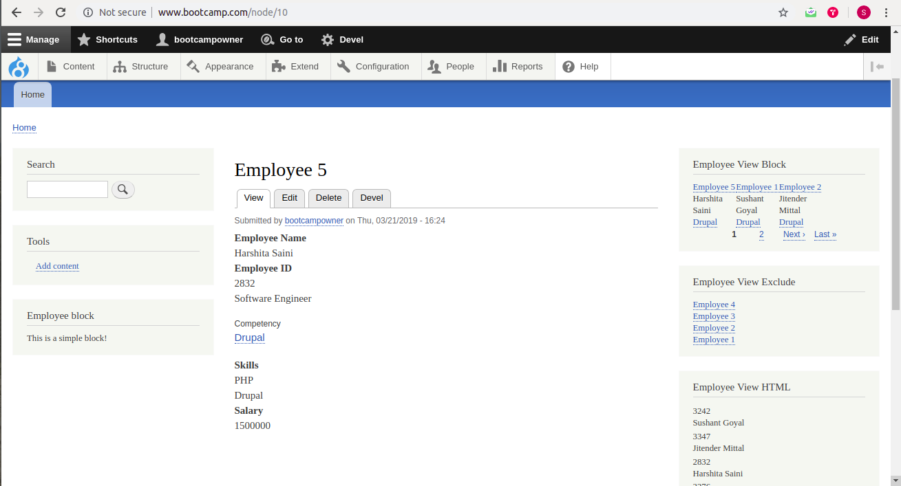

Q8. Create a form with name and mobile fields and on submit show the field values entered inside a block programmatically.
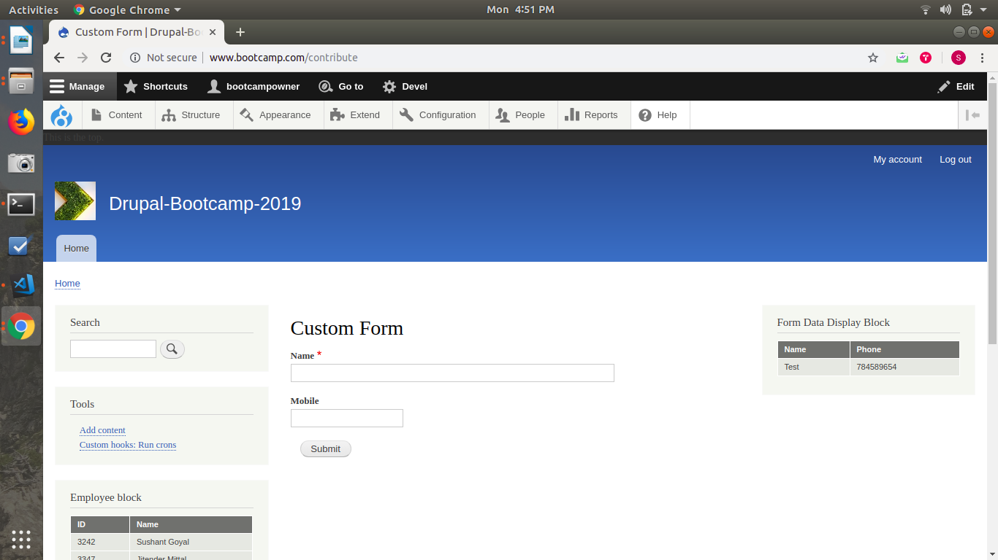
Note: Last four question carry 3 marks and rest are of 2 marks each

