PHP: Apache Configuration

- Create a custom HTML PAGE, Print your name on it?
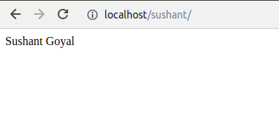

- Install Nginx
sudo apt install nginx
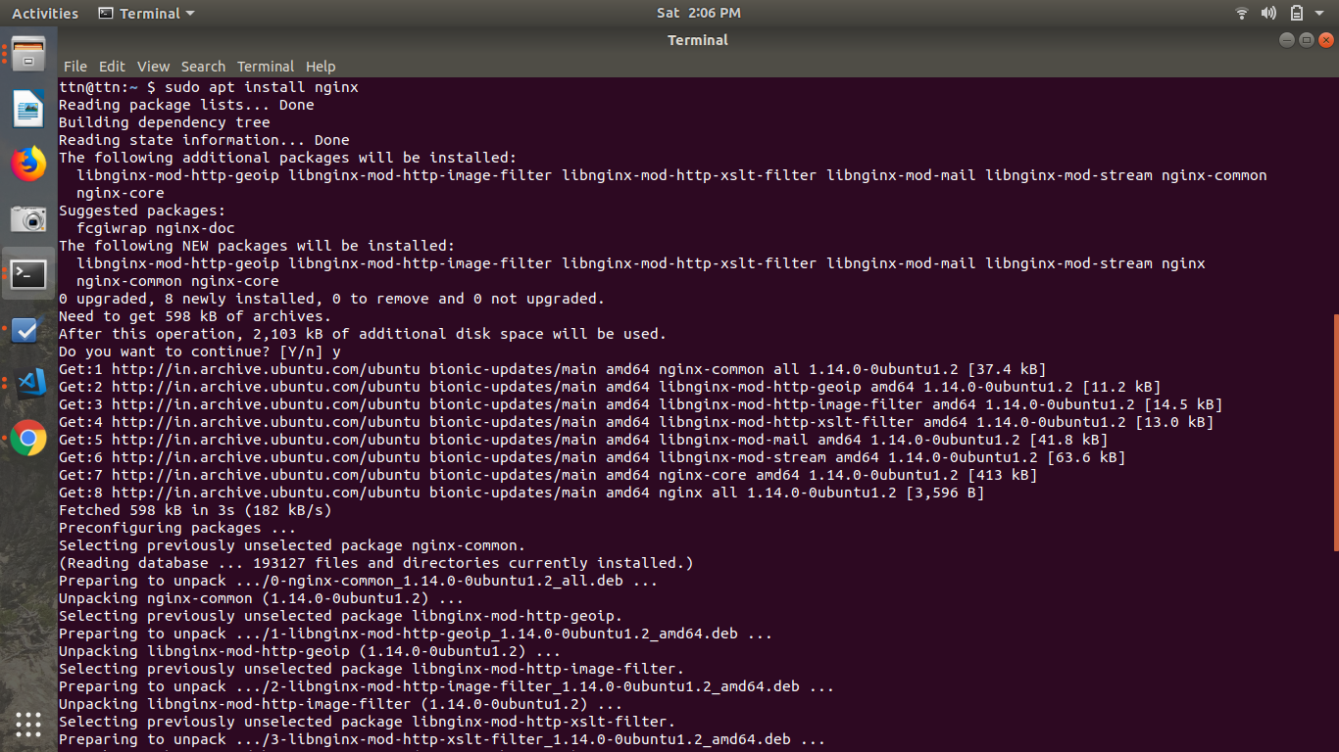
- PUT Vs POST
The difference between POST and PUT is that PUT requests are idempotent. That is, calling the same PUT request multiple times will always produce the same result. In contrast, calling a POST request repeatedly have side effects of creating the same resource multiple times.

- How Does SSL work?
(i) A browser or server attempts to connect to a website secured with SSL. The browser/server requests that the web server identify itself.
(ii) The web server sends the browser/server a copy of its SSL certificate.
(iii) The browser/server checks to see whether or not it trusts the SSL certificate. If so, it sends a message to the web server.
(iv) The web server sends back a digitally signed acknowledgement to start an SSL encrypted session.
(v) Encrypted data is shared between the browser/server and the web server.
- List out five difference in Apache and Nginx
(i) Apache is an open source HTTP server and Nginx is an asynchronous web server which provides high performance and reverse proxy server .
(ii) Apache is open source whereas the nginx is owned by the NGINX.
(iii) Apache has various multiprocessing modules to handle client requests. Nginx can handle multiple reuests and will require minimalistic configuration to do so.
(iv) In Apache a single request is processed on individual thread. But in nginx multiple requests can be handled on a single thread thus resulting in less consumption of resources
(v) Modules in apache can be loaded or unloaded dynamically but in nginx they need to be compiled with the core
- What is Virtual HOST?
A virtual host is used to configure the machine such that it can host various sites. The virtual hosts can be IP based or name based i.e. different IP can be used to host sites or same IP can be used and every site has a different name.
- What is Document ROOT?
Document Root is the root folder where all the files of the website are placed.
- List out five difference in REST and SOAP web service?
REST | SOAP
It is an architecture style | It is a potocol
It can use SOAP as it is a style and requires a protocol to be implemented upon. | SOAP cant use REST as REST is a concept
Requies less resources | Requires more resources
It suuport different type of data formats | It supports XML format only
It inherits the security from the layers that it is working upon. | It has its own integrated security measures.

- Explain all below mentioned HTTP status code in your words with examples?
HTTP STATUS CODE: 200, 300, 301, 302, 304, 307, 400, 401, 403, 404, 500, 503, 550
200 : The request is OK
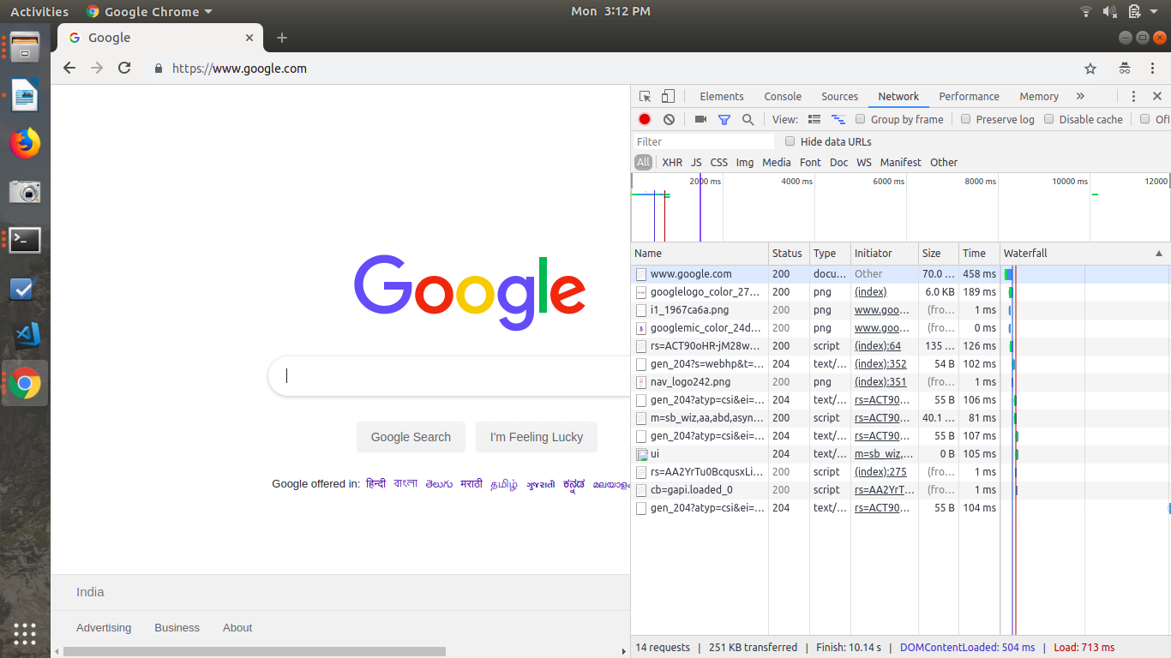
300 : This shows that there are more than one option available for the user to choose from.
301 : It shows that the address has moved some other address permanently.
302 : It shows that the address has moved temporarily. New changes will be reflected on the same domain.
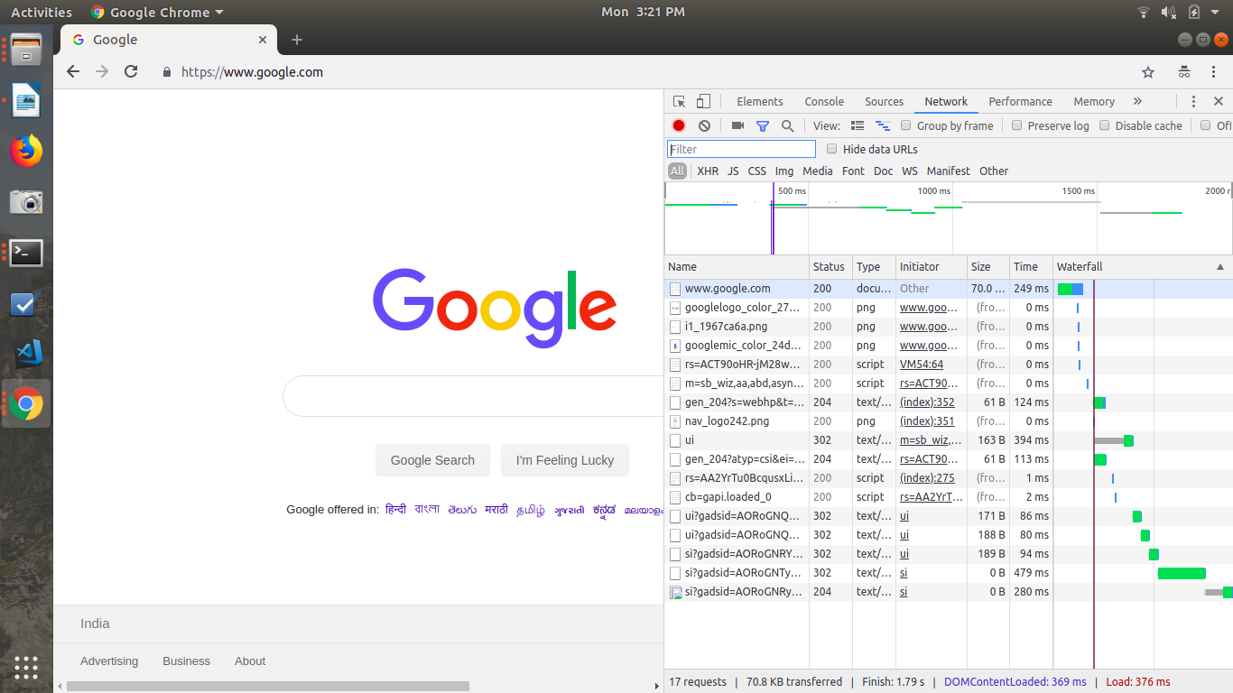
304 : It shows that the data is fetched from the cache. It can be used as it is.
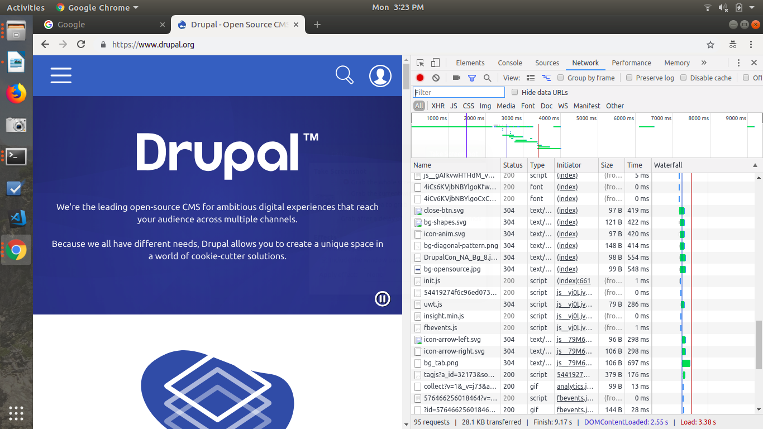
307 : It show that the requested address has moved to some other address temporarily
400 : It displays that the request made is not understood by the server
401 : The requested page requies username and password.
403 : This shows that access is denied
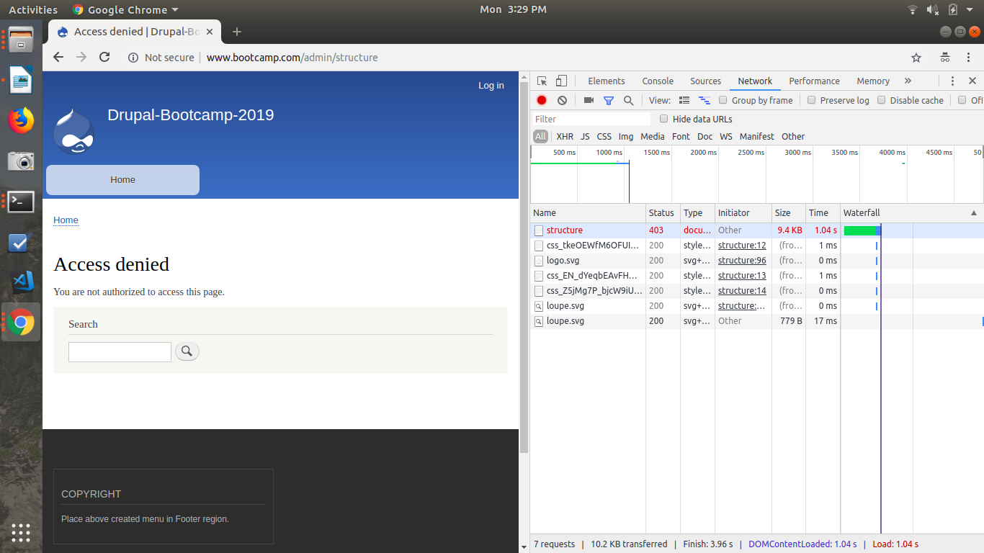

404 : The requested page is not available
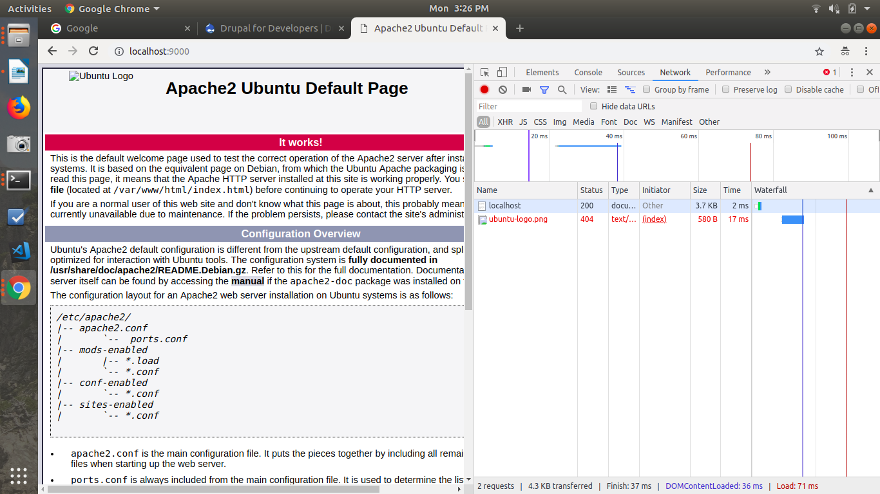
500 : The request was not completed.
503 : The server is temporarily down
550 : This is used to show that there is some issue accessing the file (FTP request can not be completed )
- Yourname_local.com should host custom HTML file.
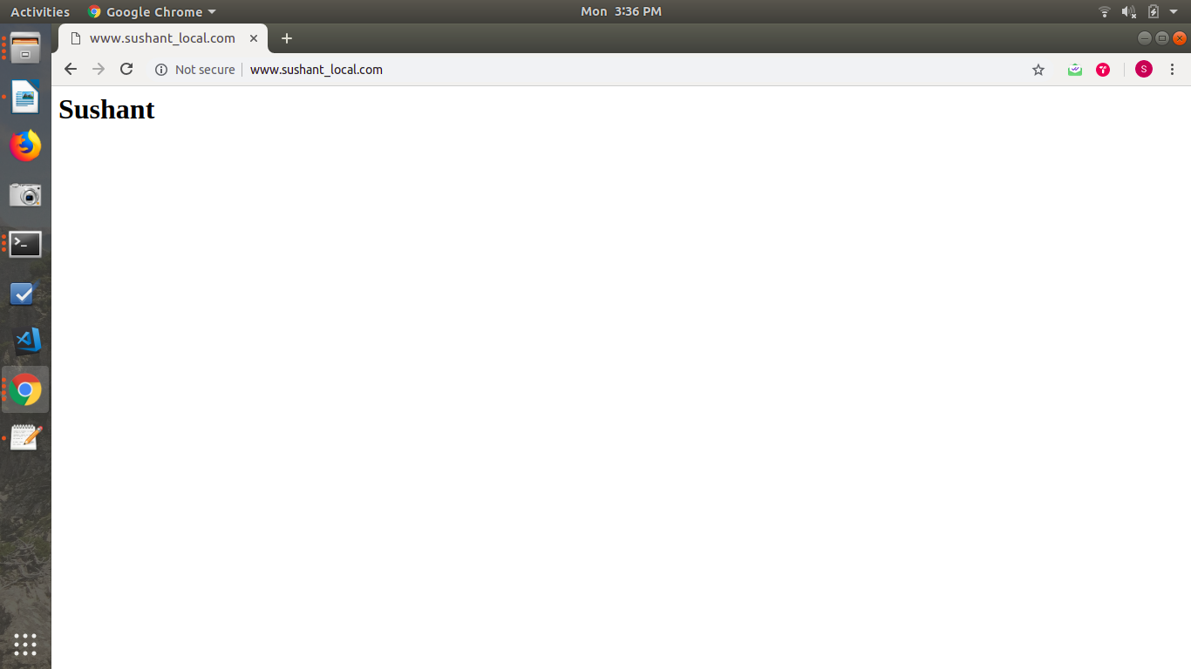

- Host drupal site on your local with your name as domain name.

