PDO LIB

1. Create a form to insert First name, Last name, email id and contact no. Email id must be unique across the table. Validation must on DB and code level.
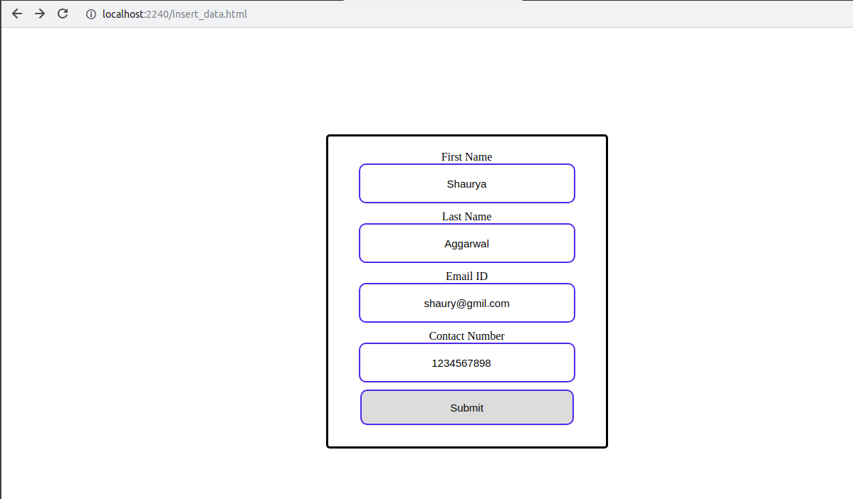

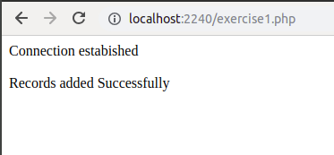

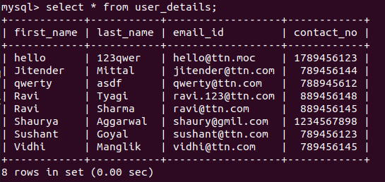

2. Create a form to search records by name, email and contact number. It should show matching results.
