Object Orienteed Programming – 1

1:- Explain OOPS concept with an example.
The three major principles of OOP are;
- Encapsulation – this is concerned with hiding the implementation details and only exposing the methods. The main purpose of encapsulation is to;
  - Reduce software development complexity – by hiding the implementation details and only exposing the operations, using a class becomes easy.
  - Protect the internal state of an object – access to the class variables is via methods such as get and set, this makes the class flexible and easy to maintain.
  - The internal implementation of the class can be changed without worrying about breaking the code that uses the class.
- Inheritance – this is concerned with the relationship between classes. The relationship takes the form of a parent and child. The child uses the methods defined in the parent class. The main purpose of inheritance is;
  - Re-usability– a number of children, can inherit from the same parent. This is very useful when we have to provide common functionality such as adding, updating and deleting data from the database.
- Polymorphism – this is concerned with having a single form but many different implementation ways. The main purpose of polymorphism is;
  - Simplify maintaining applications and making them more extendable.
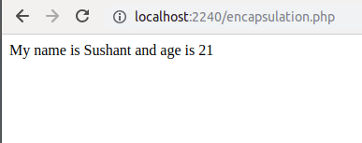

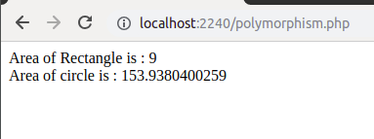

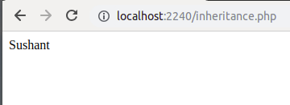

For example : please check encapsulation.php, inheritance.php and polymorphism.php

2:- Explain Classes & Objects with an example.
Class − This is a programmer-defined data type, which includes local functions as well as local data. You can think of a class as a template for making many instances of the same kind (or class) of object.
Object − An individual instance of the data structure defined by a class. You define a class once and then make many objects that belong to it. Objects are also known as instance.
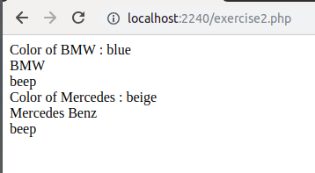

For example : please check exercise2.php

3:- What is a Namespace?
PHP Namespaces are the way of encapsulating items so that same names can be reused without name conflicts.
- It can be seen as an abstract concept . It allows redeclaring the same functions/classes/interfaces/constant functions in the separate namespace without getting the fatal error.
- A namespace is a hierarchically labeled code block holding a regular PHP code.
- A namespace can contain valid PHP code.
- Namespace affects following types of code: classes (including abstracts and traits), interfaces, functions, and constants.
- Namespaces are declared using the namespace keyword.
A namespace must be declared the namespace at the top of the file before any other code – with one exception: the declare keyword.

4:- Explain constructor and destructor with an example.
Constructor is special type of method because its name is similar to class name.Constructor automatically calls when object will be initializing.
The Destructor method will be called as soon as there are no other references to a particular object, or in any order during the shutdown sequence.Destructor automatically call at last.

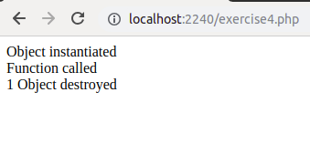

For example : please check exercise4.php

5:- Write a program that initialize class property using constructor.
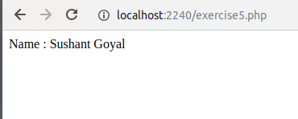

6:- Write a PHP program to return Factorial value of number in a Object oriented way. Factorial logic should be in separate function.
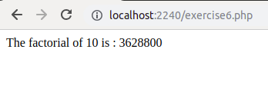

7:- Write a class that extends Abstract class.

Answer : Please check polymorphism.php

8:- Implement Inheritance in PHP program to display the Message when Parent class method is called and when the Child method is called.
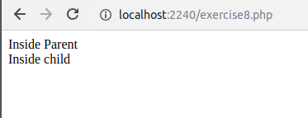

9:- What is method chaining explain with an example.
Answer : When many methods are called in a single instruction, in PHP’s term it is called Method Chaining. Suppose we have a class named User where we have two private property named $name and $age. And there are two methods named setName() and setAge() to set value in $name and $age property. And lastly, to show the value of $name and $age property, there is a getInfo() method. And suppose the name of our object is $user. Now if we do not want to call these three methods differently, instead we want to call the object by just calling it in a single instruction, then we can write like this $user->setName(“Sushant Goyal”)->setAge(21)->getInfo(). This method is called Method Chaining in PHP’s terminology. Each method in class in Method Chaining, that is, the method of the class returns the object of that class. For Method Chaining, instead of writing value return in class, we have to write return $this;.

For Example : Please check encapsulation.php

10:- What is $this keyword.
Answer : The pseudo-variable $this is available when a method is called from within an object context. $this is a reference to the calling object (the object to which the method belongs).

11:- Write program to explain Multi Level Inheritance.
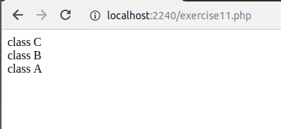

Answer : Please check exercise11.php

12:- What is magic method. Explain these method __call(), __isset(), __unset(), __sleep(), __wakeup() with example.
Answer : Methods that have two underscores (__) prefixed to the original name are called “Magic Methods” and they are used in Object Oriented programming, allowing to respond to specified circumstances when using a specific object. In simple words, these methods specify how to react in those occasions.
__call : __call magic method trigger when you are attempting to call method or function of the class which is either inaccessible or unavailable.
__isset : This magic methods trigger when isset() function is applied on any property of the class which is inaccessible or unavailable.
__unset : __unset is something opposite of isset method. This method triggers when unset() function called on inaccessible or unavailable property of the class.
__sleep : __sleep methods trigger when you are going to serialize your class object.
__wakeup : __wakeup executes when you are un serializing any class object

Please check call.php, isset.php, unset.php, sleep.php, wakeup.php

