OOPS PART - II

1:- Create html form and with one file field and one submit button and print $_
FILES array after submit the form.
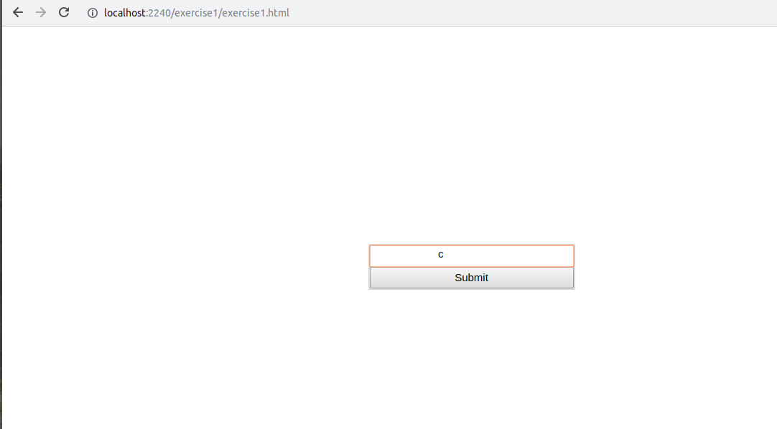
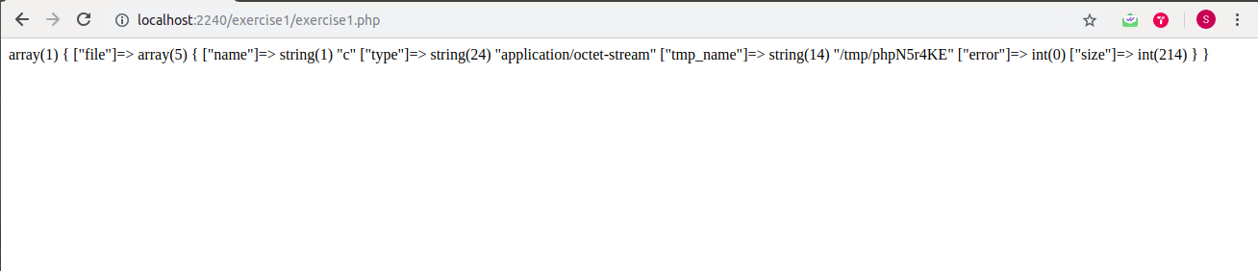

2:- Create php program to set value in cookies and get it by $_COOKIE.
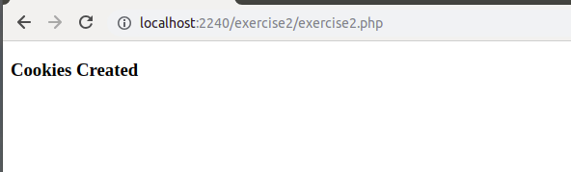

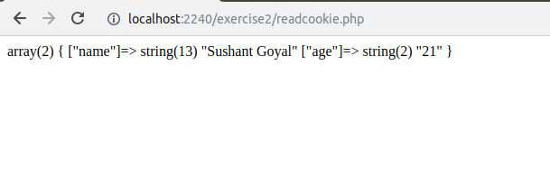
3.- Develop prototype for flight-booking service. Here, we don't own any flights. we are just a service provider mediator.
Define two methods :
a. checkFlightsAvailability() - to check available flights from two vendors like "Air India", "IndiGO".
b. bookFlights() - to book a seat from respective vendor.
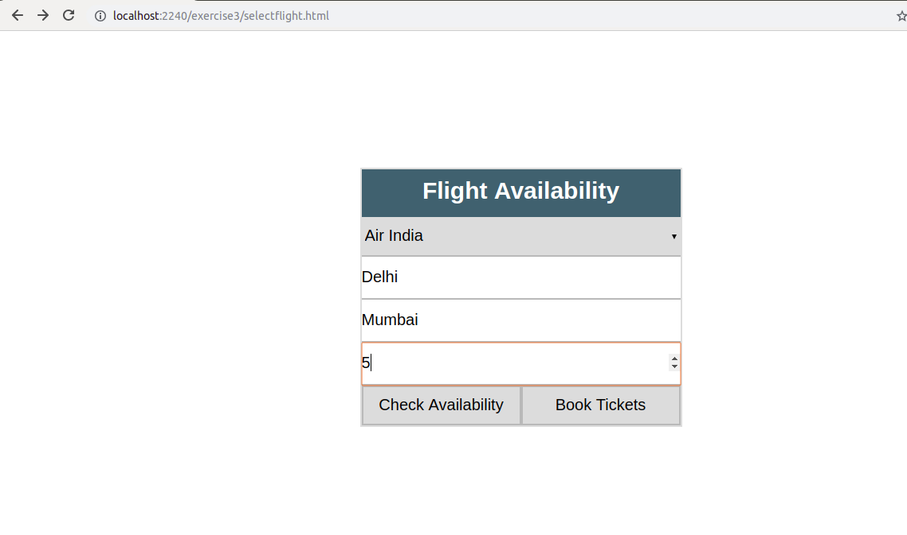
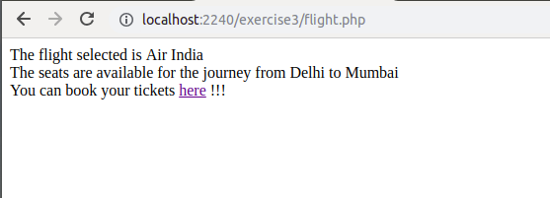

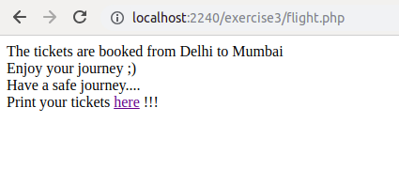

4:- Define three traits and use it in class and override it's function.
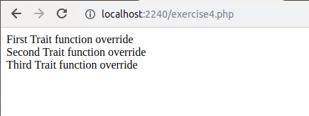

5:- Write a program to check existence of a file and throw exception if file does not exists.
