MYSQL AND MONGO DATABASE

MySQL:
1. Fetch employee's Name, address, Phone, Dob, Department, salary whose salary is greater than the average salary.
SELECT employee_name`,`address`,`contact`,`date_of_birth`,`department`,`base_salary` FROM emp_details WHERE base_salary> (SELECT AVG(base_salary) from emp_details);

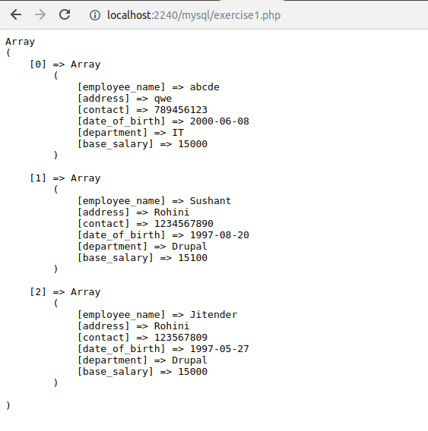
2. Fetch Paid average salary for the current month.
SELECT AVG(salary) FROM salary_details WHERE `month` = '{$month}';

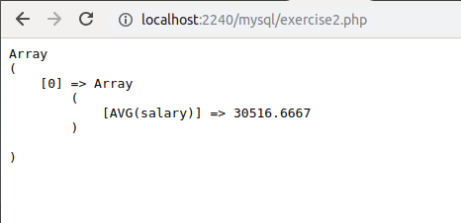

3. Fetch the top 5 Employee's Name, Phone, Salary month, Paid salary for the current month
SELECT emp_details.employee_name,emp_details.contact,salary_details.salary,salary_details.month FROM emp_details,salary_details WHERE salary_details.month = '{$month}' AND emp_details.employee_id = salary_details.employee_id LIMIT 5;

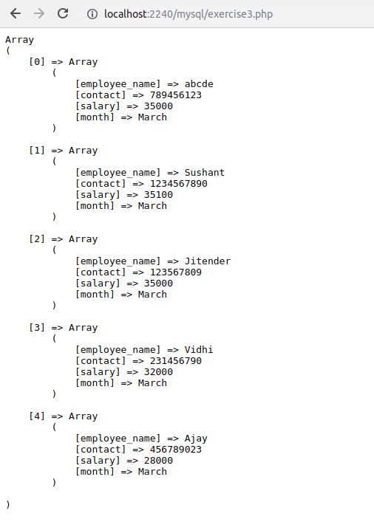
4. Fetch the employee's name, phone, dob, department name, salary who join last month.
SELECT emp_details.employee_name,emp_details.contact,emp_details.date_of_birth,emp_details.department,emp_details.base_salary FROM emp_details WHERE join_month = '{$lastmonth}';

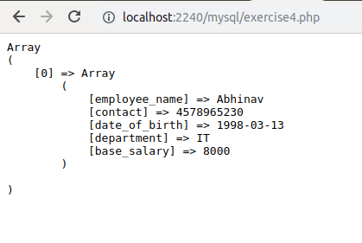

5. Create a Program in PHP that will fetch and show employee details whose DOB is today?
SELECT * FROM emp_details WHERE MONTH(date_of_birth)=MONTH(CURRENT_DATE()) AND DAYOFMONTH(date_of_birth)=DAYOFMONTH(CURRENT_DATE());

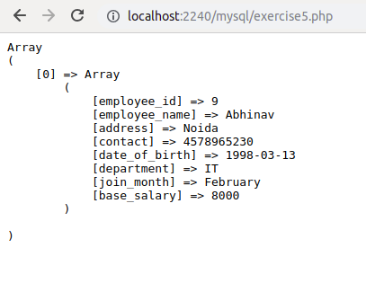

6. What is a composite key?
A composite key is the combinatin of two or more colums so that the data can be identified uniquely. When a single column is considered the uniqueness of the data is not guaranteed.

7. What are the advantage & disadvantage of Index?
Advantages
- Speed up SELECT query
- Helps to make a row unique or without duplicates(primary,unique)
- If index is set to fill-text index, then we can search against large string values. for example to find a word from a sentence etc.
Disadvantages
- Indexes take additional disk space.
- indexes slow down INSERT,UPDATE and DELETE, but will speed up UPDATE if the WHERE condition has an indexed field. INSERT, UPDATE and DELETE becomes slower because on each operation the indexes must also be updated.

8. Create two tables in MYSQL that shows working of INNER, OUTER, LEFT, RIGHT, CROSS JOINS.
Cross Join: SELECT * FROM emp_details CROSS JOIN salary_details

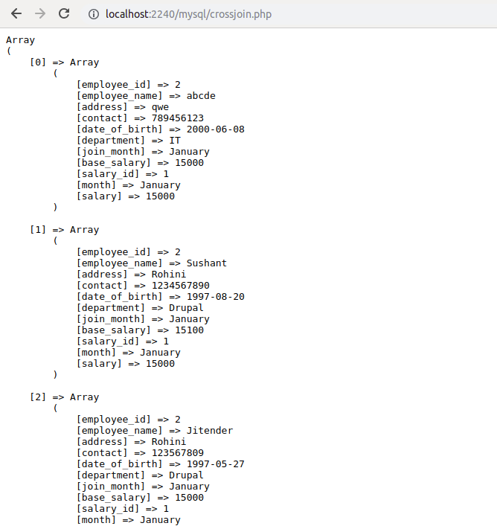

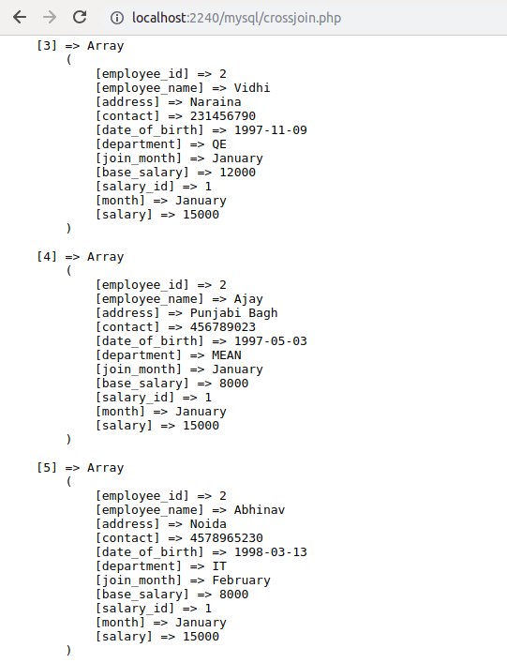

Inner Join : SELECT emp_details.employee_name,emp_details.contact,salary_details.salary,salary_details.month FROM emp_details INNER JOIN salary_details ON emp_details.employee_id = salary_details.employee_id;

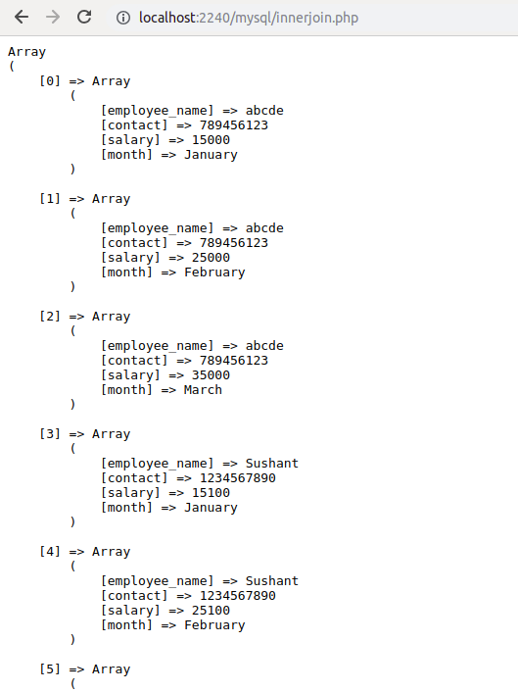
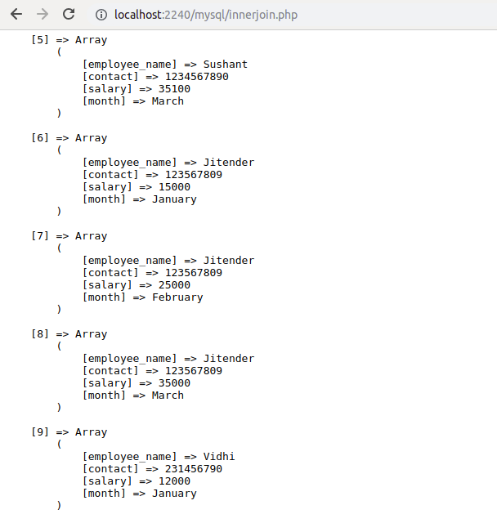

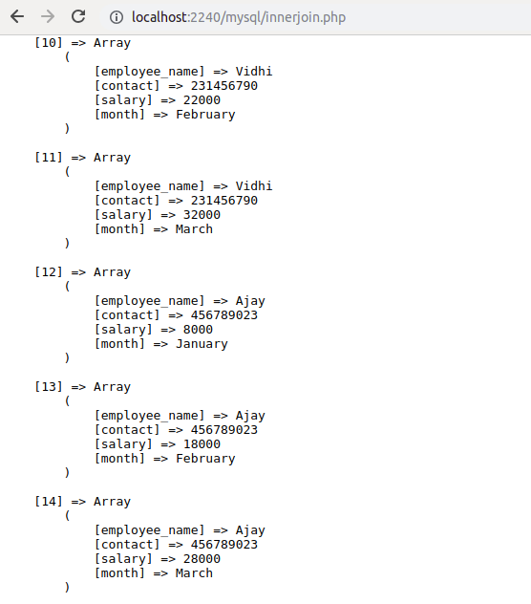

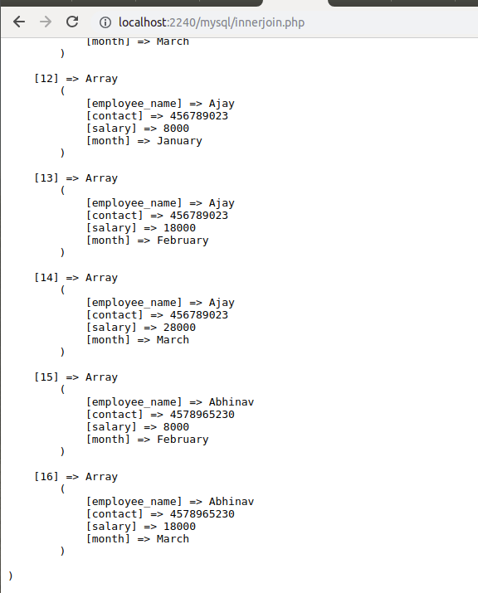

Left Join : SELECT emp_details.employee_name,salary_details.salary,salary_details.month FROM emp_details LEFT JOIN salary_details ON emp_details.employee_id = salary_details.employee_id

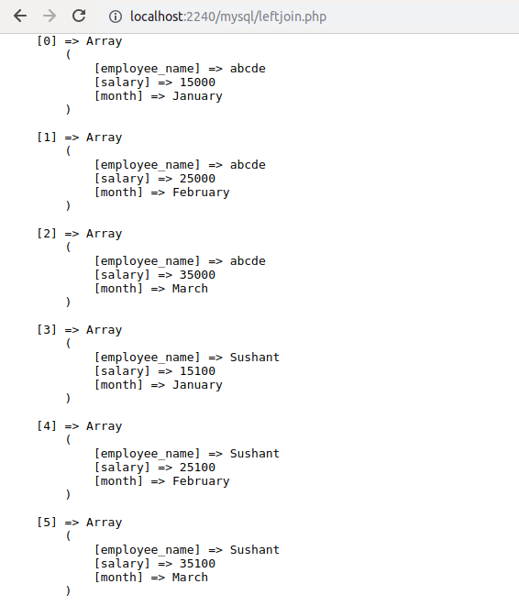

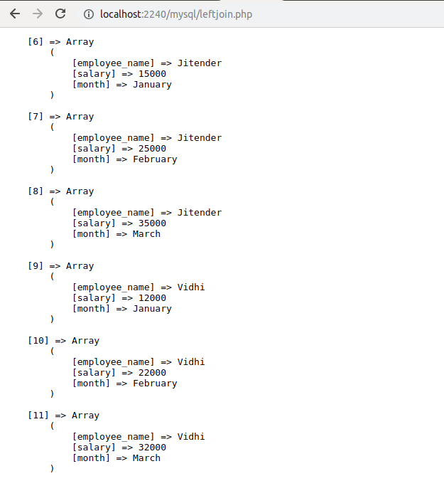
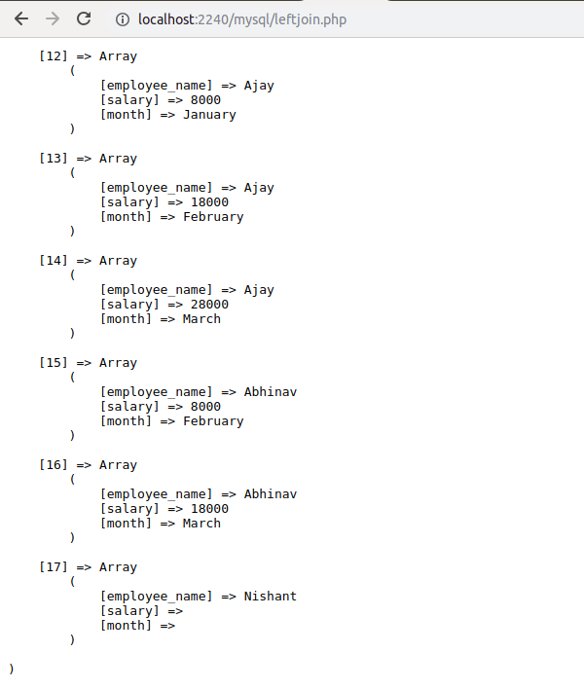

Right Join : SELECT emp_details.employee_name,salary_details.salary,salary_details.month FROM salary_details RIGHT JOIN emp_details ON emp_details.employee_id = salary_details.employee_id

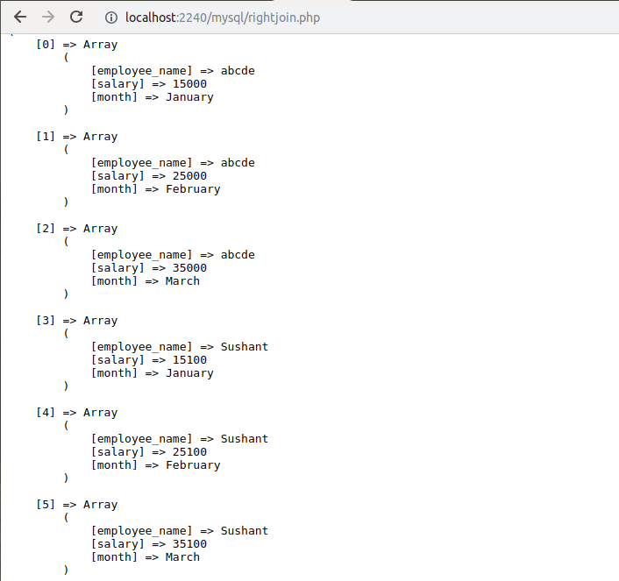
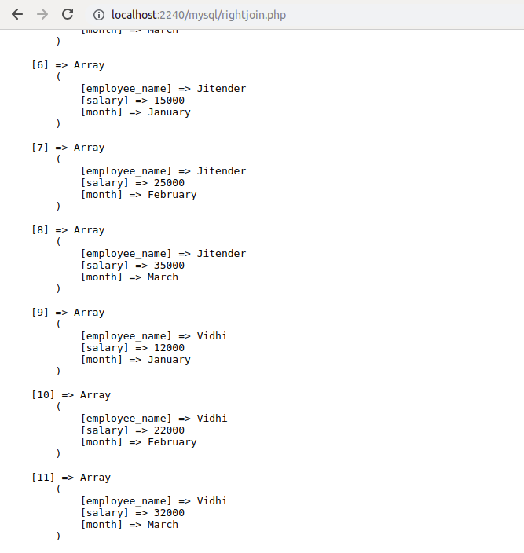

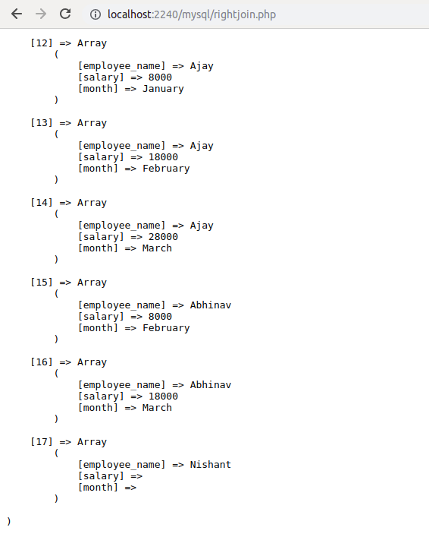
MONGO:
9. Write a program in PHP that will create a database "Bootcamp" with table "mongo".
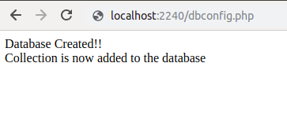

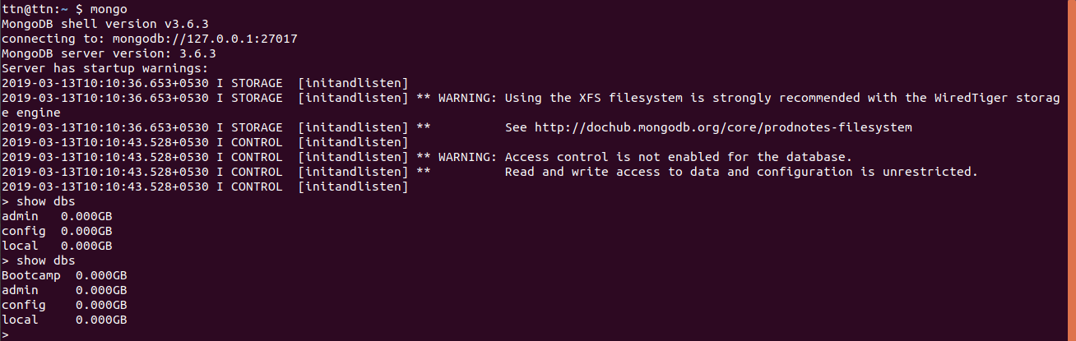
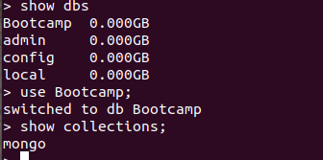

10. Write a PHP program to perform Create, Read, Update and Delete Operations.

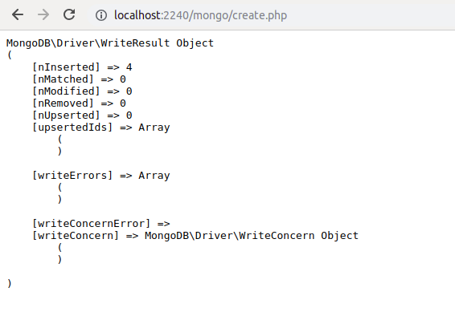
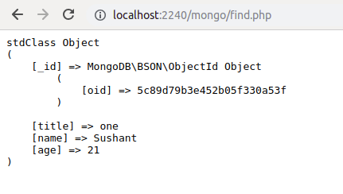

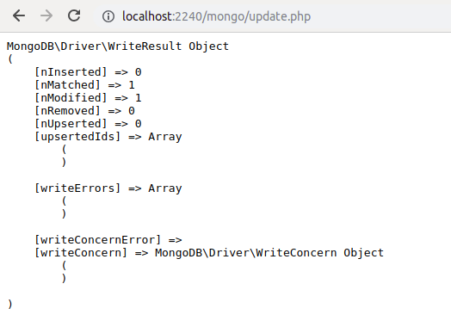
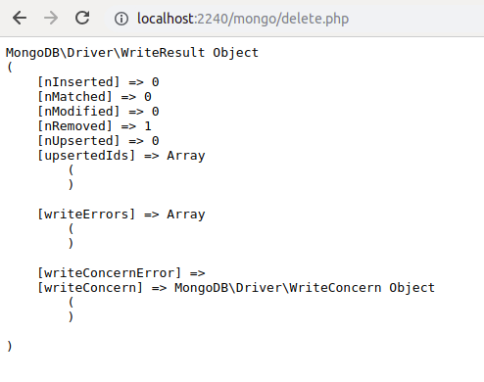

11. Write a PHP program to create a "single field" and "compound" indexes on the MongoDB collection and retrieve data using them.
$singleindex = new \MongoDB\Driver\Command([
'createIndexes' => 'mongo',
'indexes' => [[
'name' => '_id_',
'key' => ['age' => 1]
]]
]);
$compoundindex = new \MongoDB\Driver\Command([
'createIndexes' => 'mongo',
'indexes' => [[
'name' => 'age_1_title_1',
'key' => ['age' => 1,'title'=>1]
]]
]);
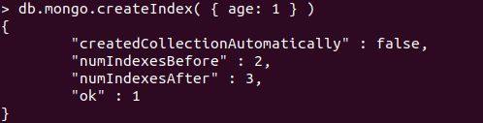
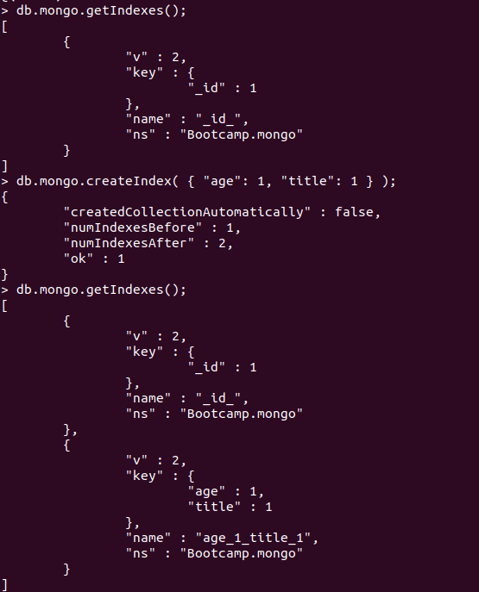

12. Create two users one with "userAdminAnyDatabase" role and another with "readWrite" role and try to access mongo using both of them
> db.createUser( { user: "mongodb", pwd: "mongodb@123", roles: [ { role: "userAdminAnyDatabase", db: "admin" } ] } )
> db.createUser( { user: "mongodb_test", pwd: "test@123", roles: [ { role: "readWrite", db: "test" } ] } )
> db.createUser( { user: "mongodb_boot", pwd: "bootcamp@123", roles: [ { role: "readWrite", db: "Bootcamp" } ] } )

