Exercise 1 Create Databse

Command : create database assignment3;

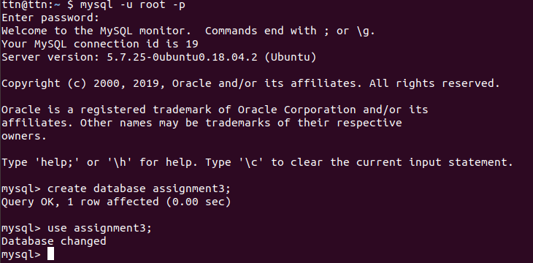
Exercise 2 Design Schema

Tables : Customers
Salespersons
Orders

Table Structure : 1. Customers
customerID (cust_id) Integr,
customerName (cust_name) Varchar
customerEmail (cust_email) Varchar
customerPhoneNumber (cust_phone) Integer
2. Salespersons
salespersonsID (sp_id) Integr,
salespersonsName (sp_name) Varchar
salespersonsEmail (sp_email) Varchar
salespesonsPhoneNumber (sp_phone) Integer
3. Orders
orderID (cust_id) Integr,
customerID (cust_id) Integer
salespersonsID (sp_id) Integer

Exercise 3 Create Tables
Command : create table customers(
-> cust_id int(10) NOT NULL,
-> cust_email varchar(40) NOT NULL,
-> cust_name varchar(50) NOT NULL,
-> cust_phone int(10) UNIQUE,
-> PRIMARY KEY(cust_id)
-> );
create table salespersons(
-> sp_id int(10) NOT NULL,
-> sp_email varchar(40) NOT NULL,
-> sp_name varchar(40) NOT NULL,
-> sp_phone int(10) UNIQUE,
-> PRIMARY KEY(sp_id)
-> );
create table orders(
-> order_id int(10) NOT NULL,
-> cust_id int(10) NOT NULL,
-> sp_id int(10) NOT NULL
-> );
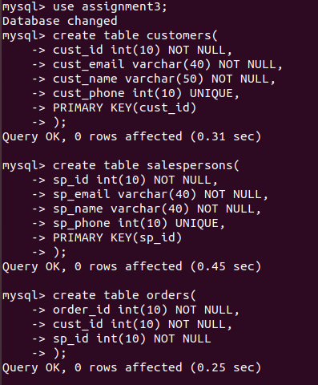

Exercise 4 Insert sample data
Command : insert into customers (cust_id,cust_name,cust_email,cust_phone) values
-> (001, 'Sushant', 'sushant@ttn.com', 1234567890),
-> (002, 'Jitender', 'jitender@ttn.com', 1234567892),
-> (003, 'Vidhi', 'vidhi@ttn.com', 1234567893),
-> (004, 'Aditya', 'aditya@ttn.com', 1234567894);
insert into salespersons (sp_id,sp_name,sp_email,sp_phone) values
-> (201, 'Ajay', 'ajay@gmail.com', 234567891),
-> (202, 'Rohan' , 'rohan@gmail.com', 234567892),
-> (203, 'Chirag' , 'chirag@gmail.com', 234567893),
-> (204, 'Manish' , 'manish@gmail.com', 234567894);
insert into orders (order_id,sp_id,cust_id) values
-> (401,201,002),
-> (402,203,002),
-> (403,201,001),
-> (404,204,001),
-> (405,203,001),
-> (406,201,003),
-> (407,202,004);
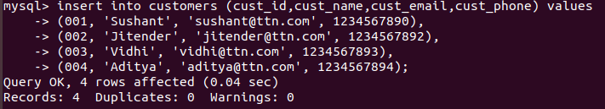
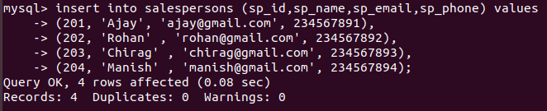

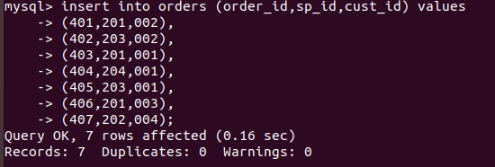

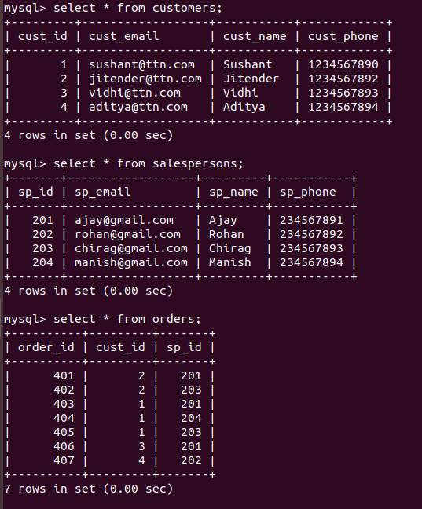

Exercise 5 Find the sales person have multiple orders.
Command : select * from salespersons where sp_id in (select sp_id from orders group by sp_id having COUNT(sp_id)>1);

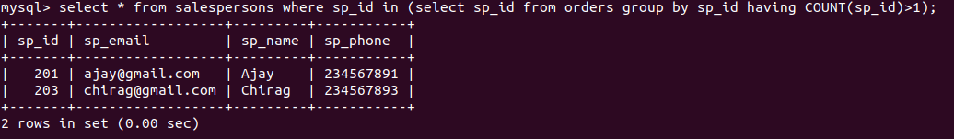
Exercise 6 Find the all sales person details along with order details
Command : select * from salespersons right join orders on salespersons.sp_id=orders.sp_id;

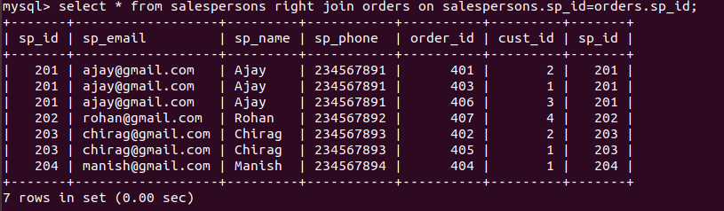
Exercise 7 Create index
Command : create index newIndex on salespersons (sp_id);

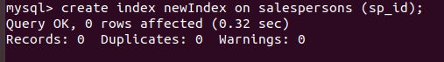
Exercise 8 How to show index on a table
Command : show index from salespersons;

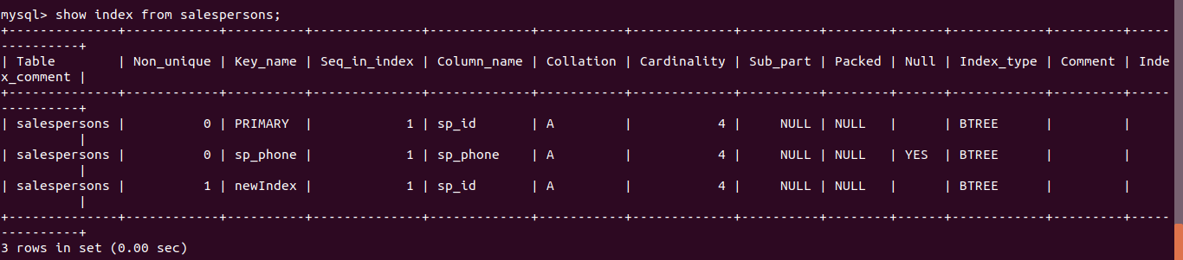

Exercise 9 Find the order number, sale person name, along with the customer to whom that order belongs to
Command : select T.order_id,T.sp_id,salespersons.sp_name,T.cust_id,T.cust_name from (select orders.order_id,orders.sp_id,customers.* from orders left join customers on orders.cust_id = customers.cust_id) as T right join salespersons on salespersons.sp_id= T.sp_id;

