Exercise 1 How are inline and block elements different from each other?

Answer : Inline elements does not cause a line break and they do not acquire full width of the page. They acquire only the space bouded by the opening and the closing tag. The examples of inline elements are anchor tag, span tag which are mostly used.
Block elements are those elements that acquire the full width of the page and causes a line break before and after the element. The example of block elements include div tag, p tag.

Exercise 2 Explain the difference between visibility:hidden and display:none

Answer : visibility:none implies that the tag with this property is hidden on the display but the tag is rendered and occupies its dedicted area on the page.
display:none means that the tag is not displayed on the dispaly. But unlike visibility:none the tag is not rendered and hence does not occupy any space.

Exercise 3 Explain the clear and float properties.

Answer : The float property is used to position the elements in left or right drection of any container.
The clear property tells the other elements if they can float around or not . By using clear the different elements can be placed on both sides too.

Exercise 4 Explain difference between absolute, relative,fixed and static.

Answer : Absolute is used to place the page element where ever we to want it to be. The position of the elements is relative to the immediate parent of the element. If there is no such parent then it will make html as its parent and will place itself relative to the page.
Relative is used to place the element relative to itself. It means that the element place itself relative to the position it was supposed to be at.
Fixed is used to fix the position of an element on the viewport or the window. If we scroll the page the content with fixed position will stay and there and the ret of content will be scrolled.
Static is the default value set for the position of any element. It allows the element to flow onto the page as it normally would. The static is used when the position of any element is given unknowingly. It will forcefully set the position to default and the element can freely flow wherever we want to be placed.

Exercise 5 Write the HTML code to create a table in which there are 4 columns( ID , Employee Name, Designation, Department) and at least 6 rows. Also do some styling to it.
Answer :

Exercise 6 Why do we use meta tags?
Answer : The meta tags are used to provide metadata i.e.data about data. These tags are used to provide additional information regarding the infomation of the author, description of the webpage. This does not contribute to the physical appearance of the page, but helps in SEO.

Exercise 7 Explain box model.
Answer : In CSS every element is treated as a box. The content, padding, border and margin wrap each other.
Content : This is the area where the text is present.
Padding : It is the area between the border and the content outline.
Border : It is the area between the mardin and the outer padding. This is not visible initially. But we can make it visible by givind it some thickness and a color with the style of the border.
Margin : It is the outermost laer of the CSS box. It maintains a distance between the neighbouring elements and the element it contains.
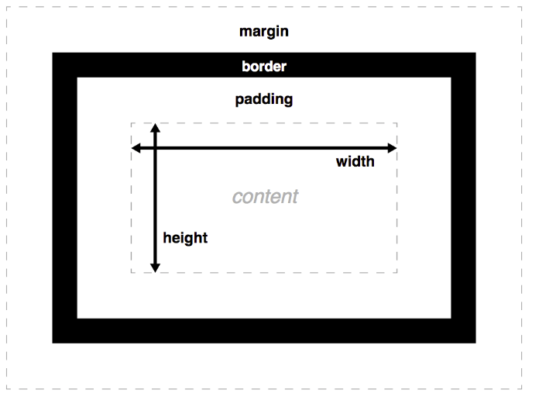

Exercise 8 What are the different types of CSS Selectors?

Answer : The common CSS selector are :
Universal Selector (*): These selectors style all of the elements present on the page at once. They give the same styling to each element.
ID Selector (#): These selectors styel the elements which are identifie by the specific id’s given to them. They have more priority than the class type selectors.
Element Selector (elementname) : These selectors are used to style the elements of same type at once.
Class Selector (.) : These selectors style only those elements which are given the class name by the developer.

Exercise 9 Define Doctype.

Answer : The html document starts with <!DOCTYPE html>. It specifies the version of the html that is being used to create the page. The vaidator check the version of the html and set the browser to ready to accept a html page.

Exercise 10 Explain 5 HTML5 semantic tags.

Answer : <article> : It is used to add big parts of text on the website i.e. it defines the article content of the website.
<aside> : It defines the content that is to be displayed to the side. It is used to generate the sidebar.
<footer> : It is used to define the footnote for the website
<header> : It is used to set the topmost content of the webpage. It is always visible to the viewer.
<nav> : It is used to specify the navigation links onto th webpage.

Exercise 11 Create HTML for web-page.jpg (check resources, highest weightage for answers)

Answer : Please check web-page.html at

Exercise 12 Create HTML for form.png (check resources, highest weightage for answers)

Answer : Please check form.html at

