Getting Started with PHP

1. Steps(with command and screenshots) for installing apache.
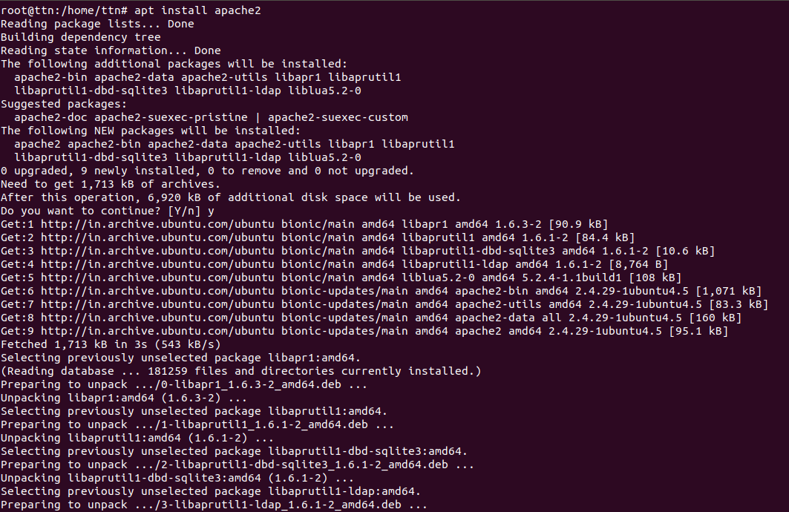
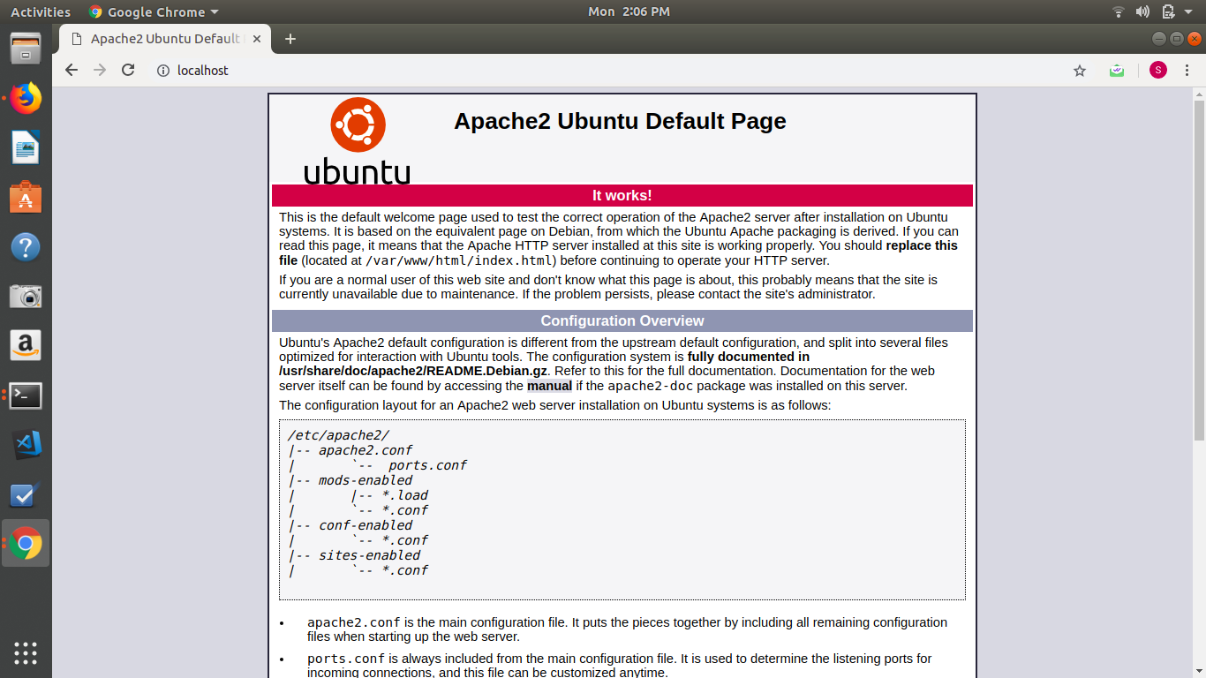
2. Installation steps(with command and screenshots) Php and print current version.
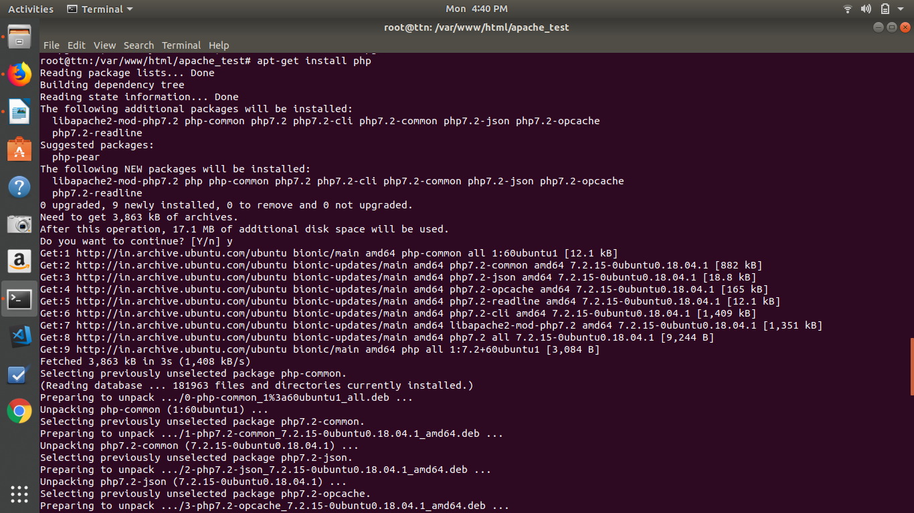
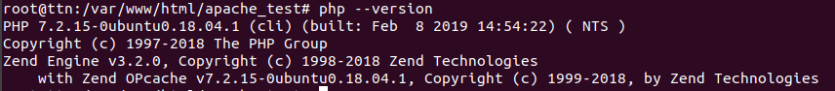
3. Installation steps(with command and screenshots) mysql and print current version?

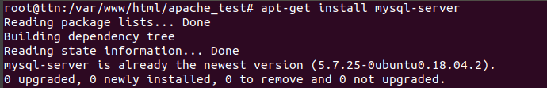
4. What is HTTP?
Answer : HTTP (Hypertext Transfer Protocol) is the set of rules for transferring files (text, graphic images, sound, video, and other multimedia files) on the World Wide Web. As soon as a Web user opens their Web browser, the user is indirectly making use of HTTP. HTTP is an application protocol that runs on top of the TCP/IP suite of protocols (the foundation protocols for the Internet).

5. What is the name of a superuser in Linux?
Answer : The super-user in Linux is root

6. What domain name will have the following address – 127.0.0.1?
Answer : localhost

7. What language should you use for writing a queries for database?
Answer : Structured Query Language(SQL)

8. Which command is used for restart apache
Answer : sudo systemctl reload apache2
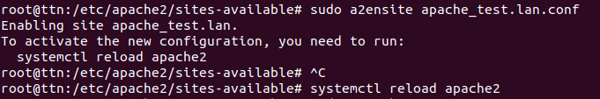
9. Print fibonacci series
<?php
function Fibonacci($number){
if ($number == 0)
return 0;
else if ($number == 1)
return 1;
else
return (Fibonacci($number-1) +
Fibonacci($number-2));
}
$number = 10;
for ($counter = 0; $counter < $number; $counter++){
echo Fibonacci($counter),' ';
}
?>
