Introduction to PHP

- Print 1 & 6 using foreach in array( 1, 2, 3, 4, 5, 6, 7 )

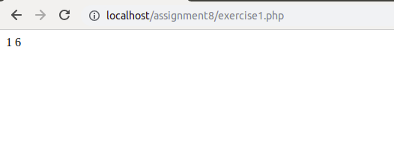
- Print 1 2 3 4 using break and foreach in array( 1, 2, 3, 4, 5, 6, 7 )

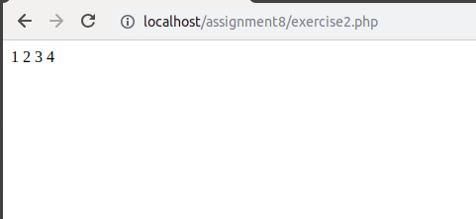

- Using switch case, check if value ($value = 4) is greater than 5 or not. Case should be 1, 2, 3, 4, 5, 6.

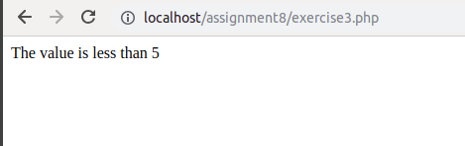

- Create and print an infinite loop.

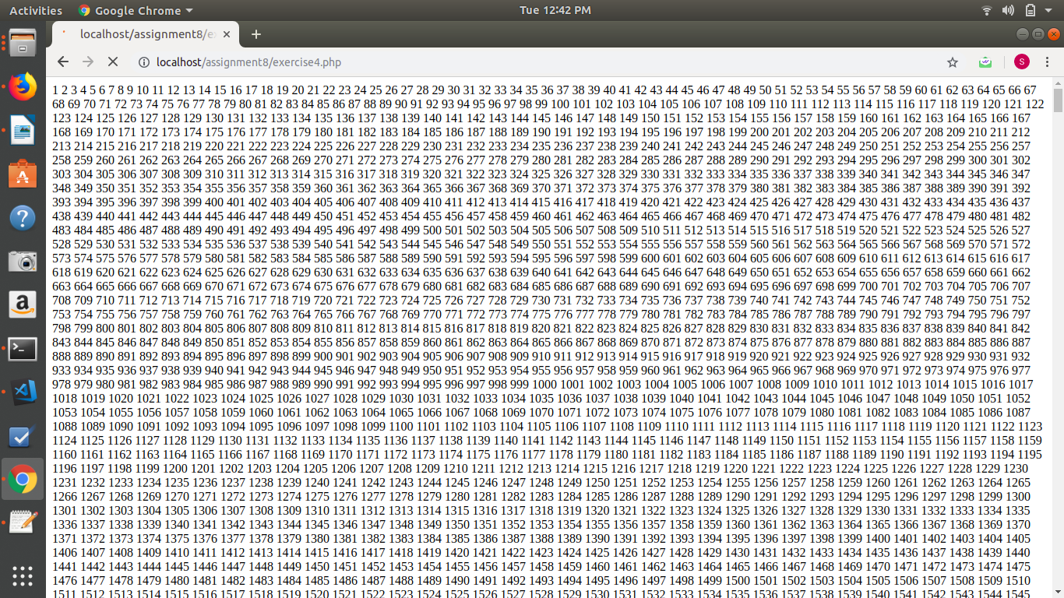
- Create a script that displays 1-2-3-4-5-6-7-8-9-10 on one line. There will be no hyphen(-) at starting and ending position.

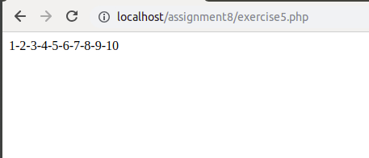

- Using Alternative syntax print values of array( 1, 2, 3, 4, 5, 6, 7 )

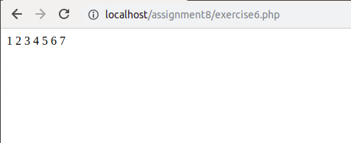

- Print 1,2,3,6,7 from array( 1, 2, 3, 4, 5, 6, 7 )

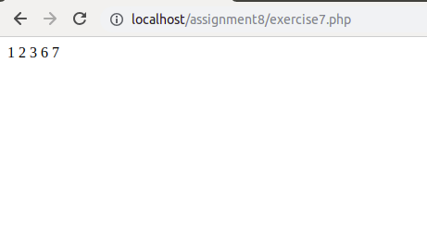

- Create a function to calculate factorial value of a number. Use this function to get factorial of 5.

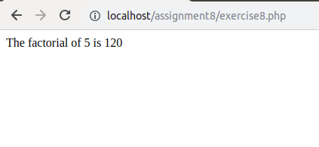

- Include a php file (abc.php) in another file (xyz.php) and use variables from abc.php in xyz.php

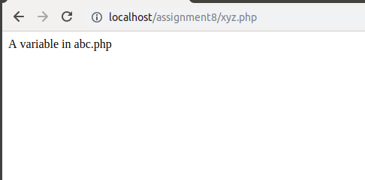

- Using loop find sum of numbers from 1 to 15.

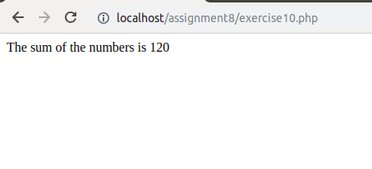


- Give exampe of Print, printf, sprintf.
print : It prints the content just like echo.
printf : it prints the formatted string
sprintf : it returns the formtted string so echo or print is required.
