PHP Built-in Functions

- How to get array first element without knowing the key of Array?
ANS :-
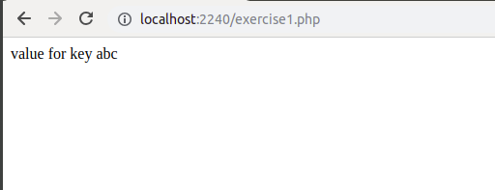
- What is the output of this question?
<?php
$a = array_fill(5, 6, 'banana');
$b = array_fill(-2, 4, 'pear');
print_r($a);
print_r($b);
?>
ANS :-

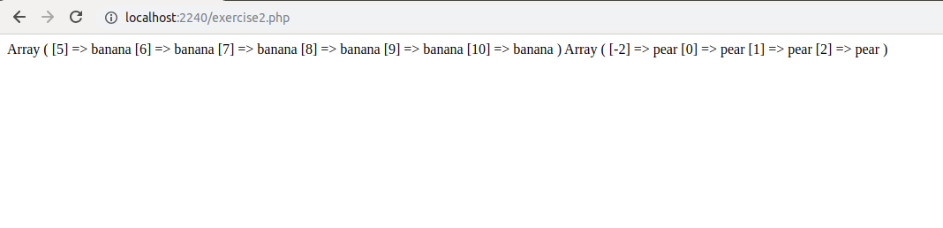

Note :- In case of negative index , first index will be the one which we have selected but next indexes will start from zero.

- What will be the output of this question ?
$a = '1';
$b = &$a;
$b = "2$b";
echo $a.", ".$b;
ANS :-
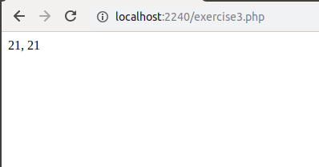

- Where are cookies stored?
ANS :-
A cookie is information stored on your computer by a website you visit.The purpose of the cookie is to help the website keep track of your visits and activity.

The location of cookies depends on the browser. sometimes it may depends on the browser version as well. Like firefox uses seperate files for storing cookies, for each website we visit. On the other hand, chrome uses only one file for storing cookie data for all websites.

All the Firefox cookies are stored in "cookies.txt" at
C:\Documents and Settings\Windows login/user name\Application Data\Mozilla\Firefox\Profiles\profile folder
in IE
C:\Documents and Settings\<User name>\Local Settings
in Chrome
C:\Documents and Settings\<user name>\Local Settings\Application Data\Google\Chrome\User Data\Default\Cookies

- What is the $_SERVER variable?
ANS :- PHP has several predefined variables called "superglobals", which means that they are always accessible, regardless of scope - and you can access them from any function, class or file without having to do anything special.
$_SERVER is a PHP super global variable which holds information about headers, paths, and script locations.

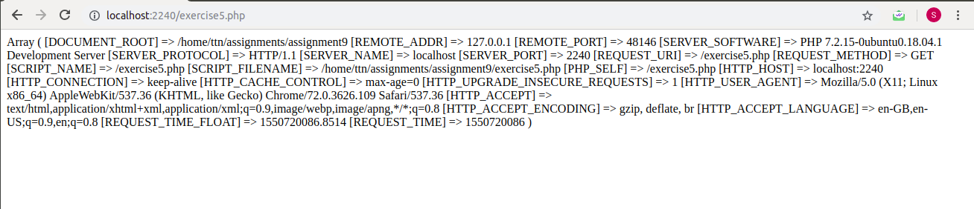

- How can we get second of the current time using date function?
ANS :- for hours – h
minutes – i
seconds - s
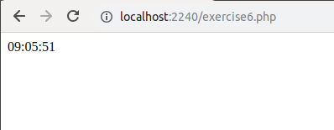

- What is the difference between the functions unlink and unset?
ANS :- In PHP unlink() is a function for file system handling, unlink() is used to delete files. Suppose you have uploaded a file and wants to delete this file through the coding then unlink() function is used to delete the file.
unset() is a function for variable management. It will make a variable undefined. Or we can say that unset() is used to null out the value of a given variable. OR Unset () is used to destroy a variable in PHP. In can be used to remove a single variable, multiple variables, or an element from an array.

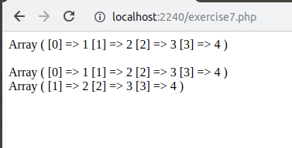

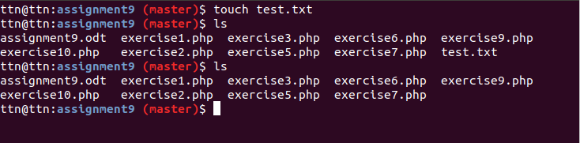
- Why do we use GROUP BY and ORDER BY function in mysql?
ANS :-
GROUP BY is used to group certain records of result set based on the specified column. Suppose, if the specified column has duplicate values , then those values are combined or grouped and according to this grouping other column values are also grouped.

EXAMPLE :-

SELECT COUNT(ID) ,NAME from EMPLOYEES GROUP BY COUNT(ID);

ORDER BY is used to sort result set either in ASCENDING or DESCENDING order based on specified column. By default ORDER BY will sort in ascending order. ASC is used to sort in ascending order and DESC is used to sort in descending order.

EXAMPLE :-

SELECT COUNT(ID) ,NAME from EMPLOYEES GROUP BY COUNT(ID) ORDER BY COUNT(ID) DESC;

- How do we delete a row in a table?
ANS :-
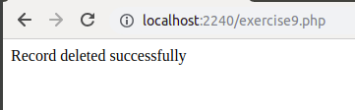

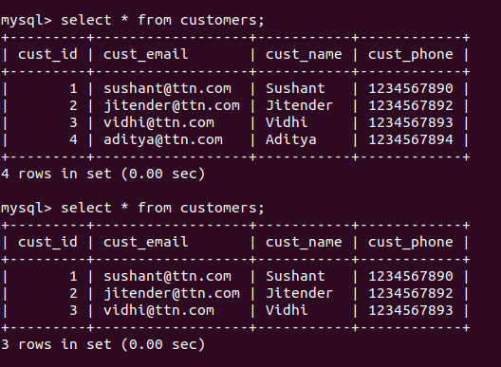

- What is the functionality of the function strstr and stristr?
ANS :- strstr() and stristr both are used to find the first occurence of the string.
stristr( ) is case insensitive and strstr( ) is case sensitive.

