Drupal 8: front-end & Backend

- Install fresh drupal named Drupal-Bootcamp-2019.
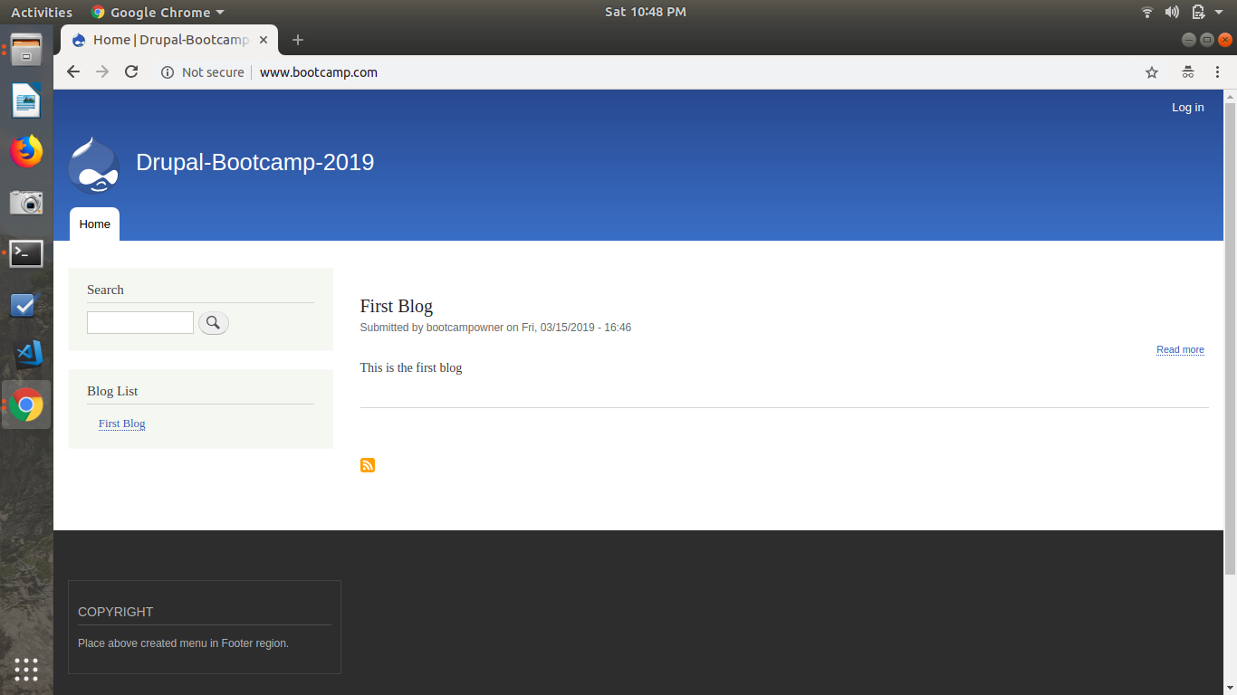
- Upload a new logo for the site.
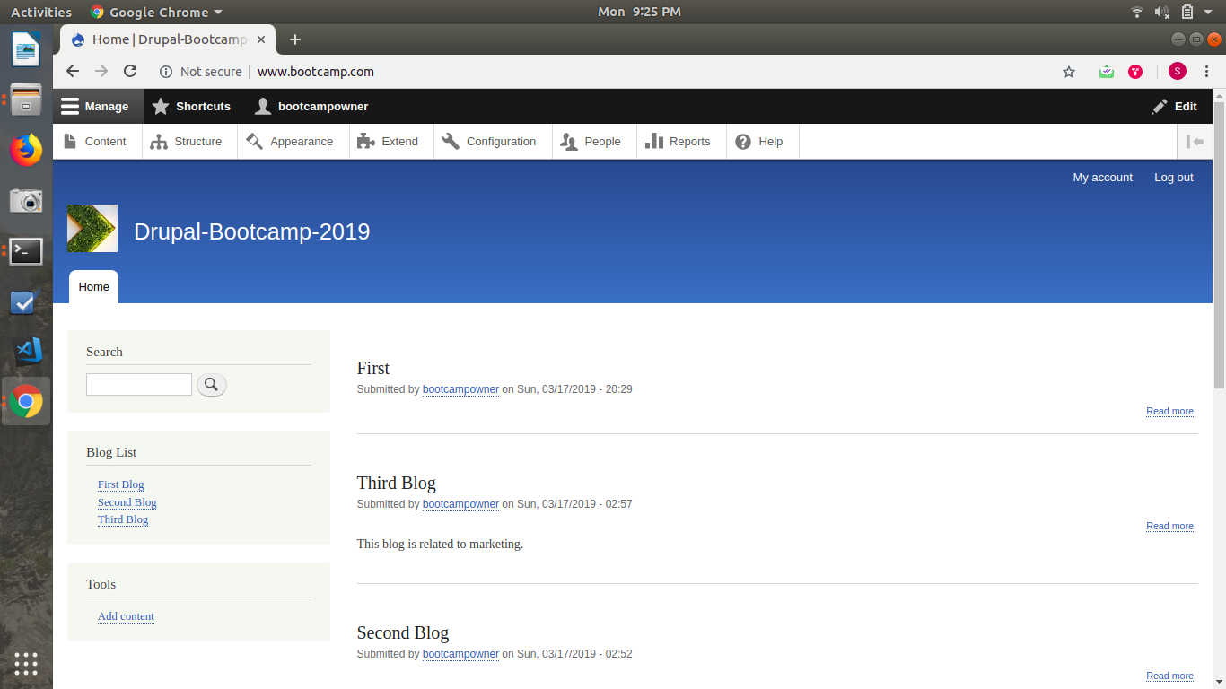

- Create a taxonomy named as "Blog types".

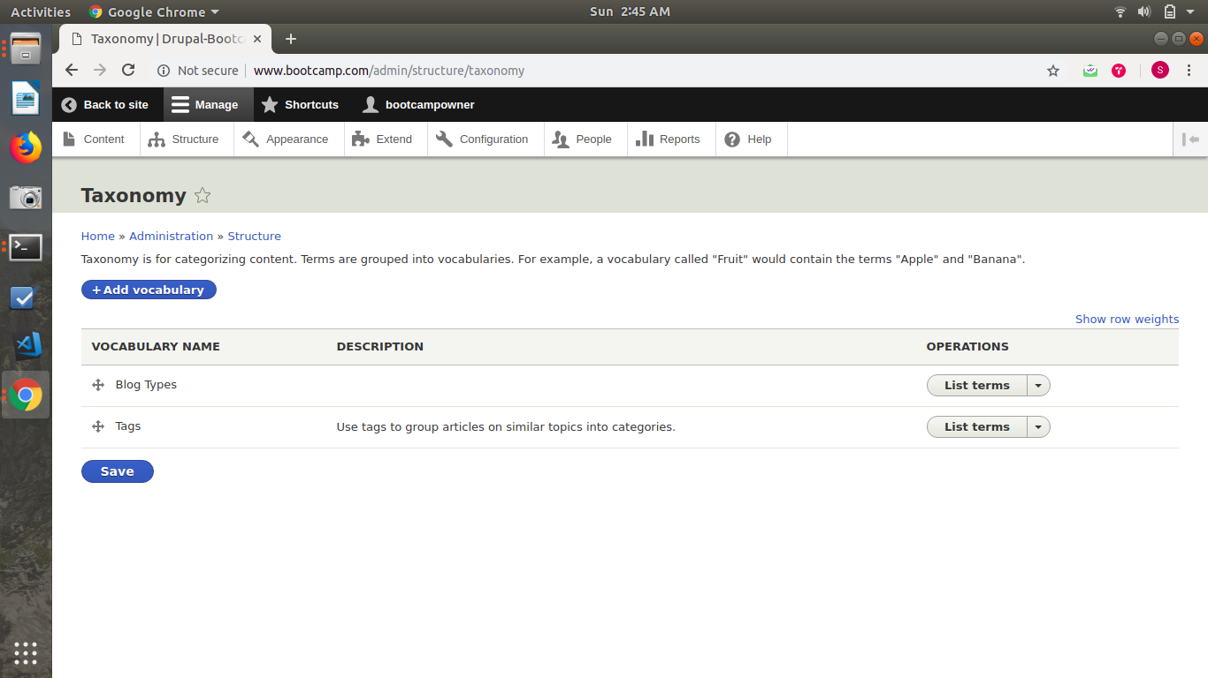
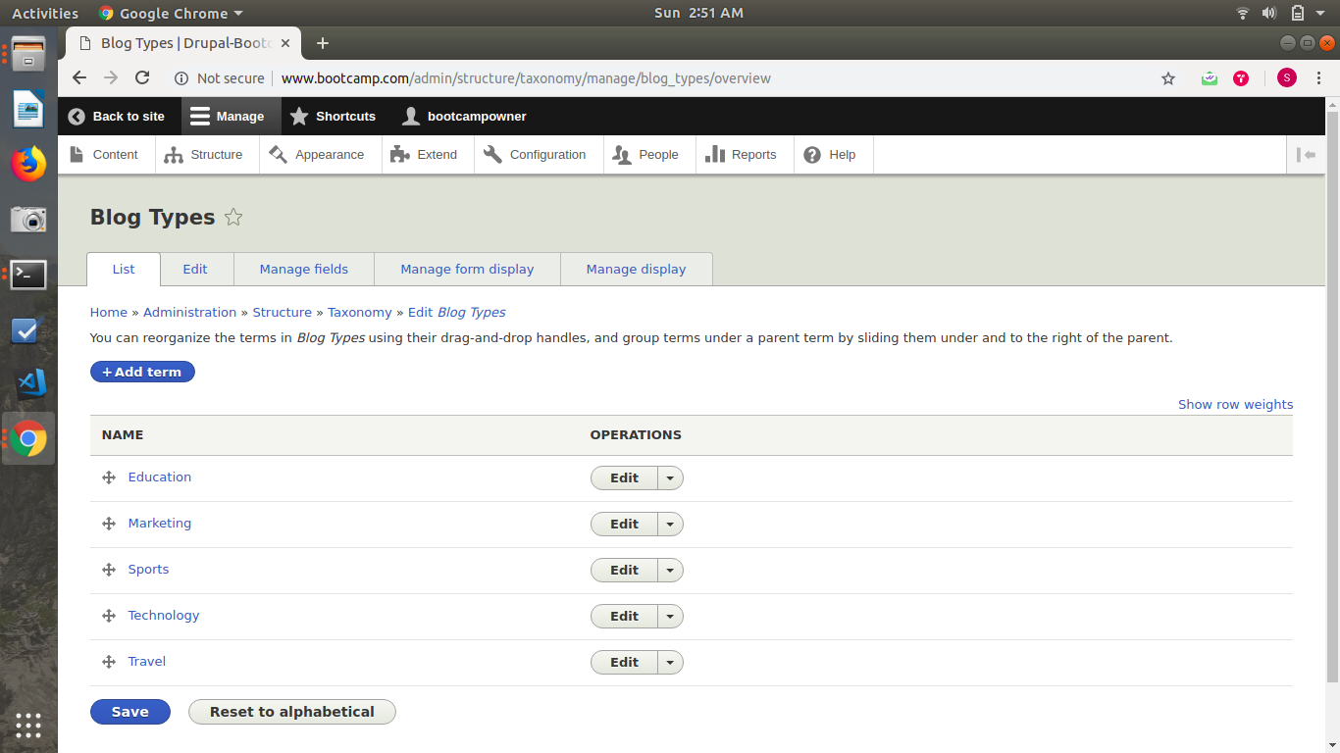
- Create create content type named as "Blog" with following fields:
  - Blog Name
  - Body
  - Image
  - Blog Type ( Use the Blog type taxonomy here)
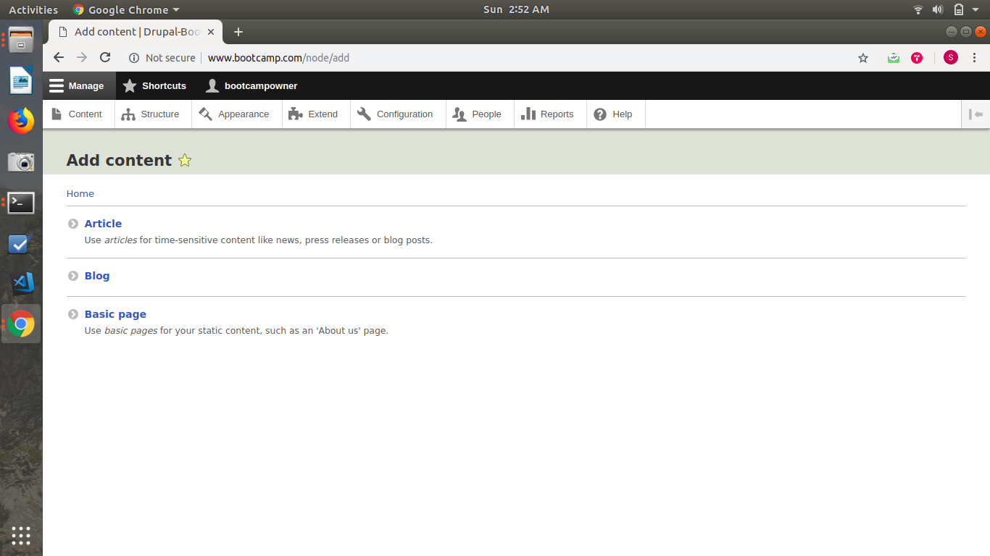

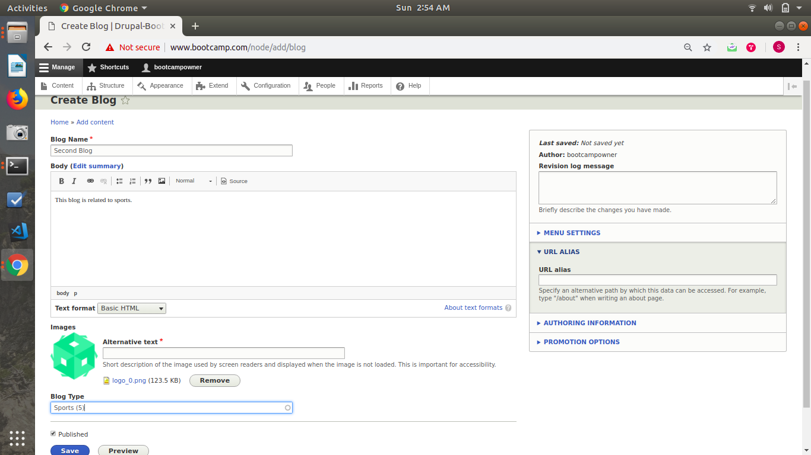

- Create nodes for the above content types and create aliases for them.
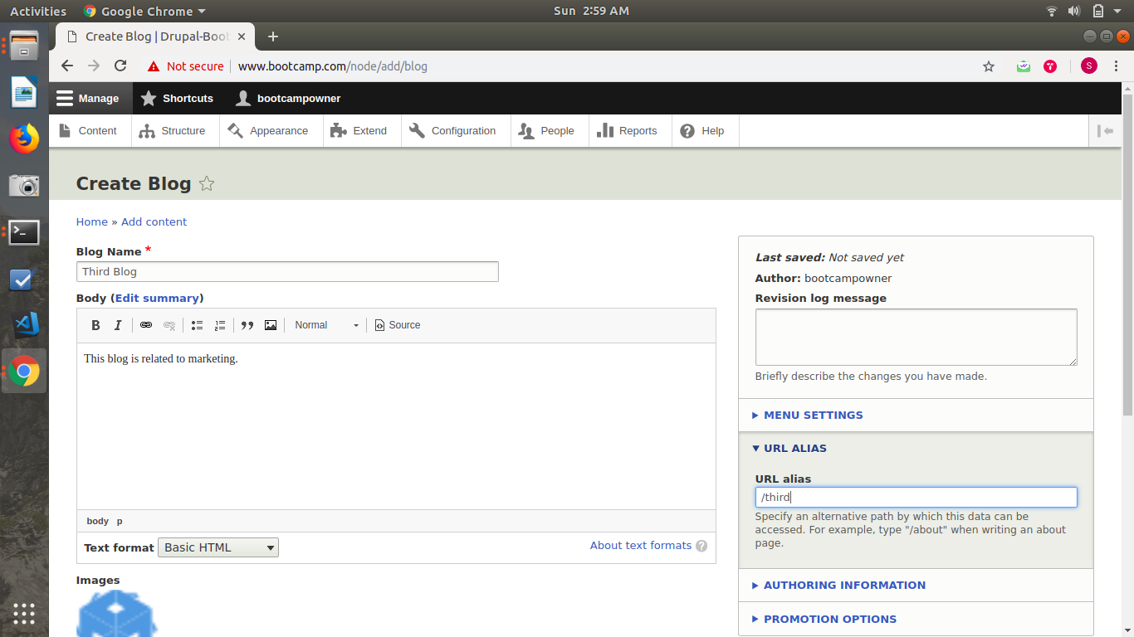
- Create a menu named “Blog List” and add links of the blogs.
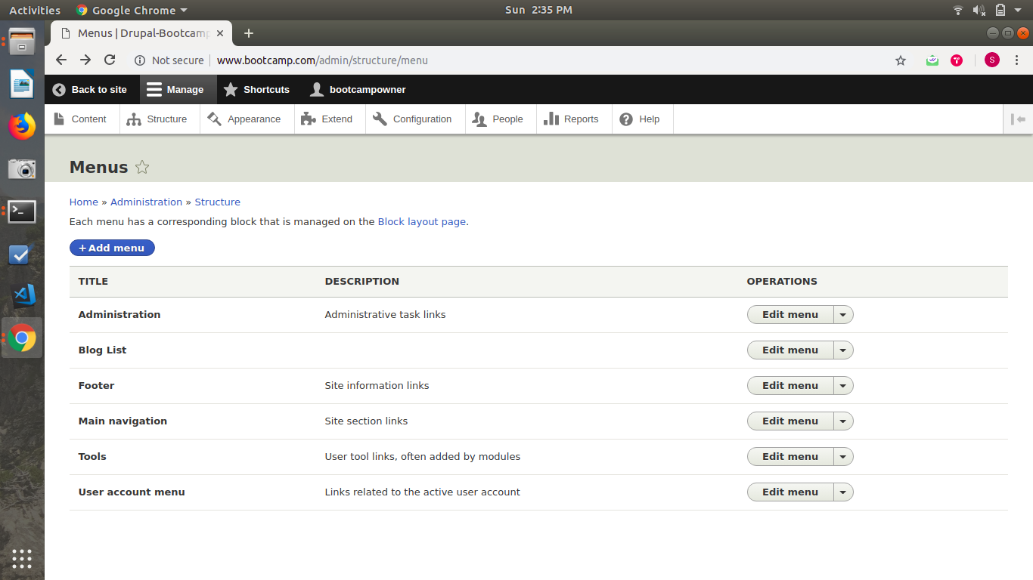
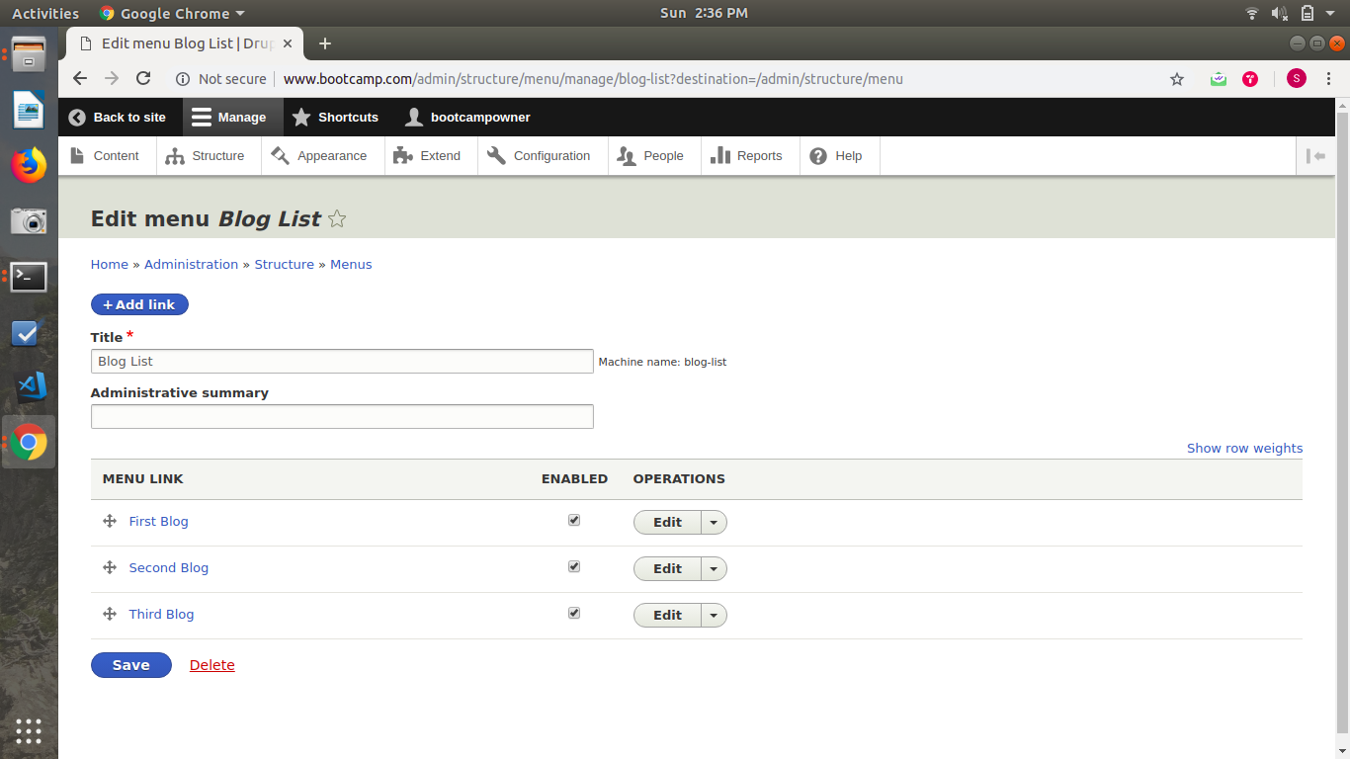

- Place above created menu in Sidebar region.
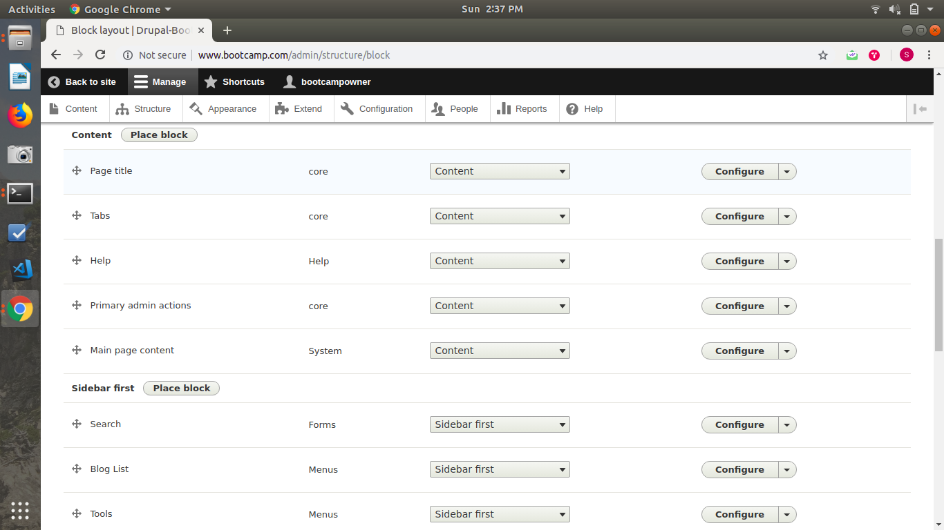
- Create a custom block for copyright and place in footer region.
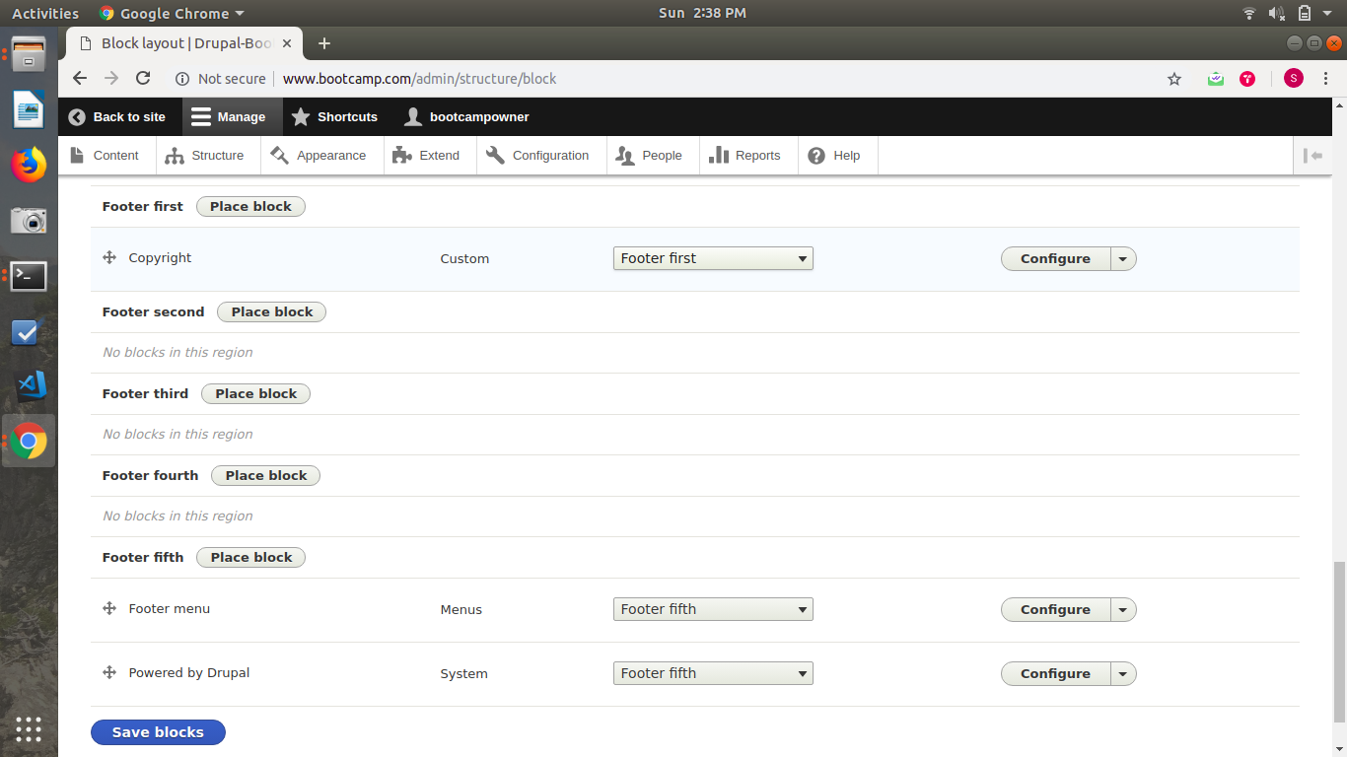

- Create the following roles:
  - Editor
  - Publisher
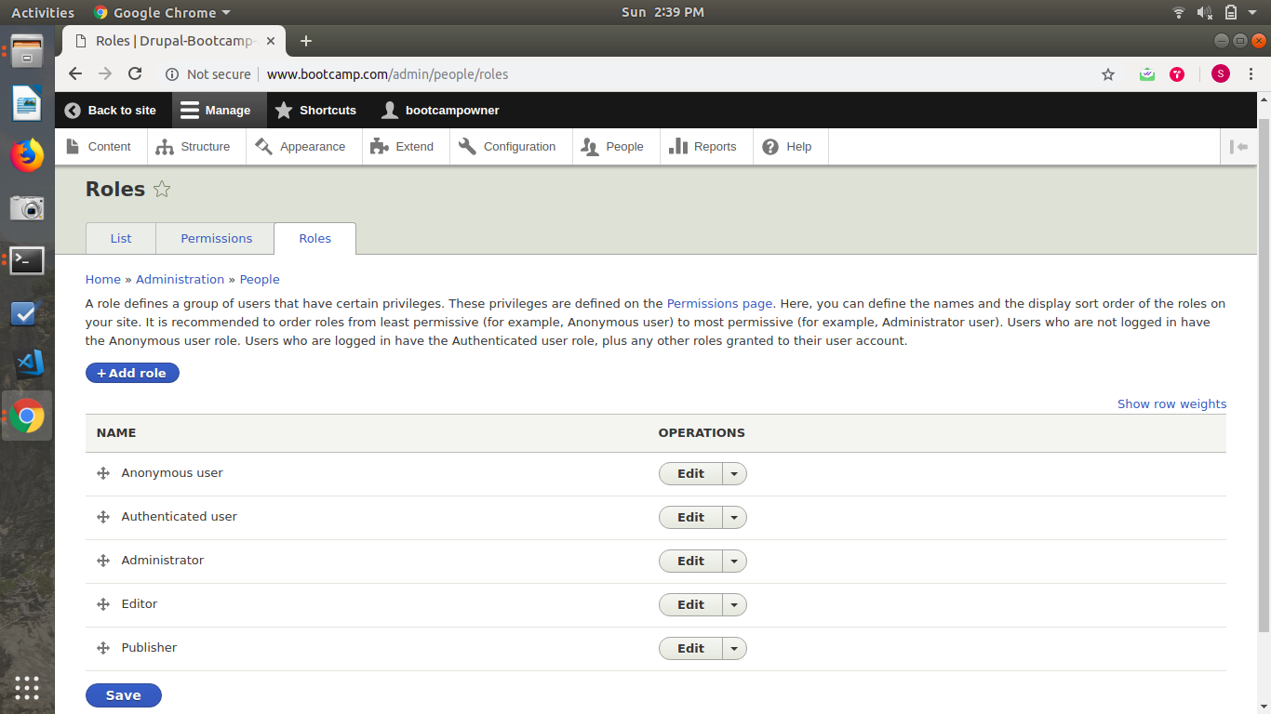
- Create 2 users each for the roles created above.

