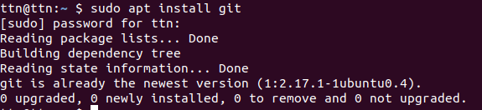
Exercise 1

Git Setup

Exercise 2 Initialise git repository

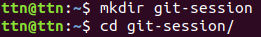

Exercise 3 Add Files to Repository

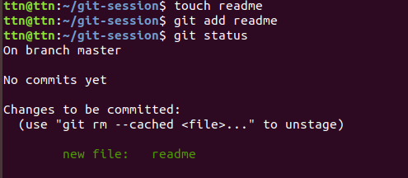

Exercise 4 Unstage a file

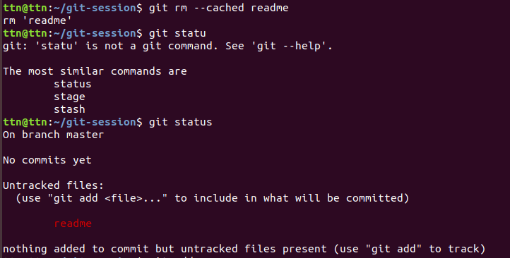
Exercise 5 Commit the file

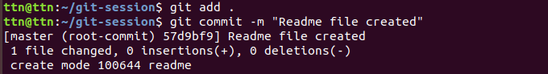
Exercise 6 Add a remote

Exercise 7 Undo changes to a particular file
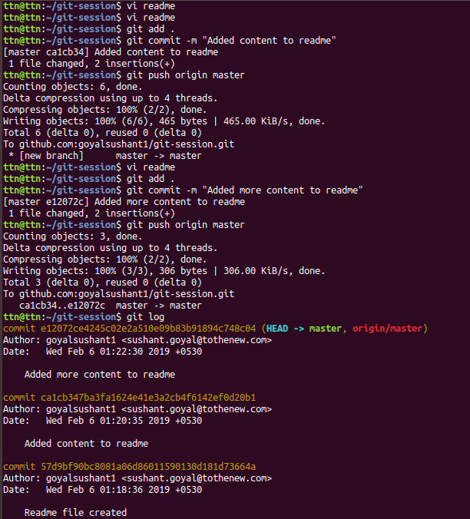

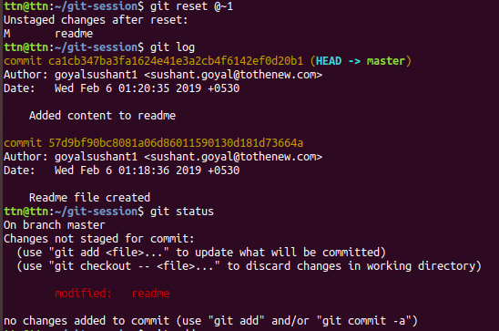

Exercise 8 Push changes to Github

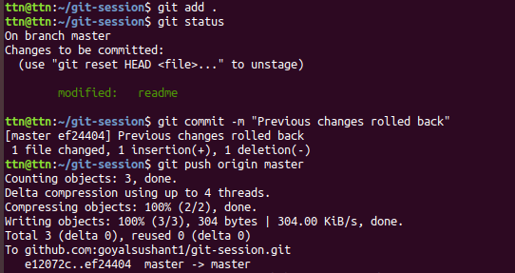

Exercise 9 Clone the repository

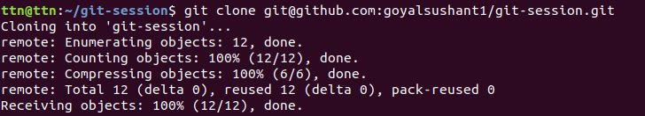
Exercise 10 Add changes to one of the copies and pull changes in the other

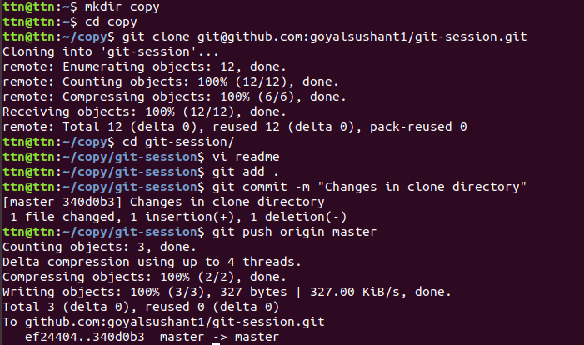
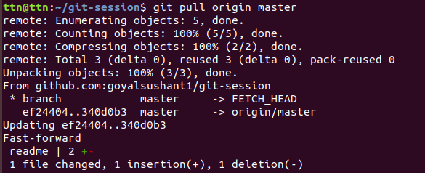
Exercise 11 Check differences between a file and staged file
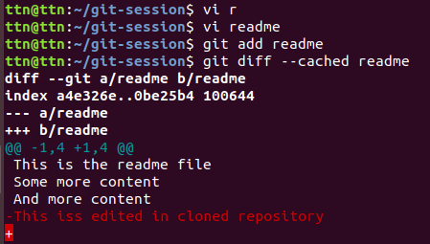

Exercise 12 Ignore a few files to be checked

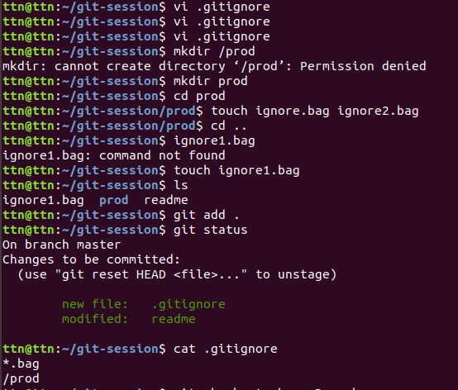
Exercise 13 Create a new branch

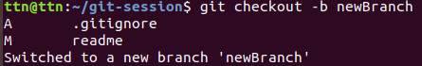

Exercise 14 Diverge them with commits
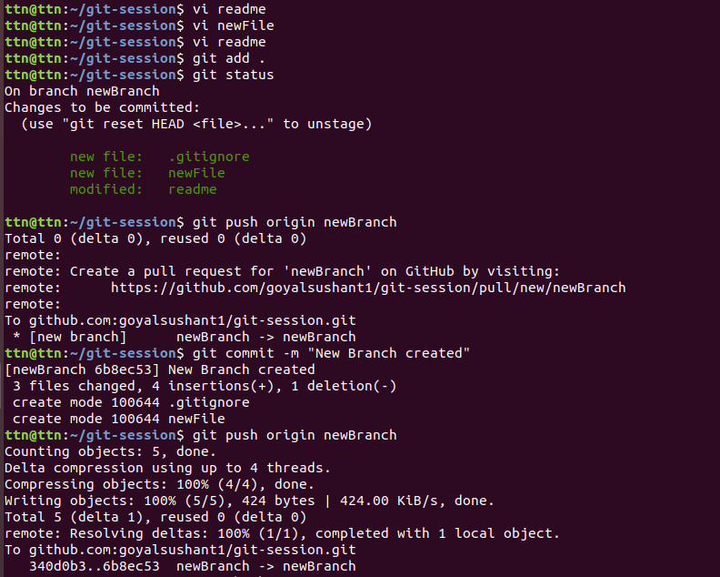
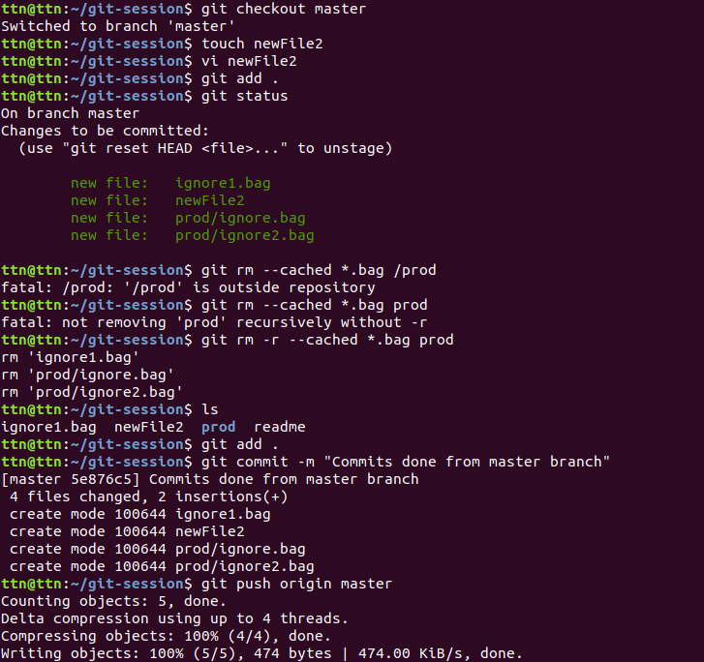
Exercise 15 Edit same file on same line in both branch and commit

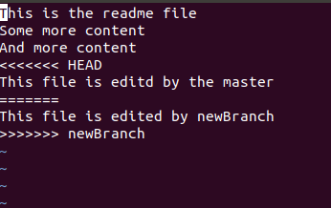

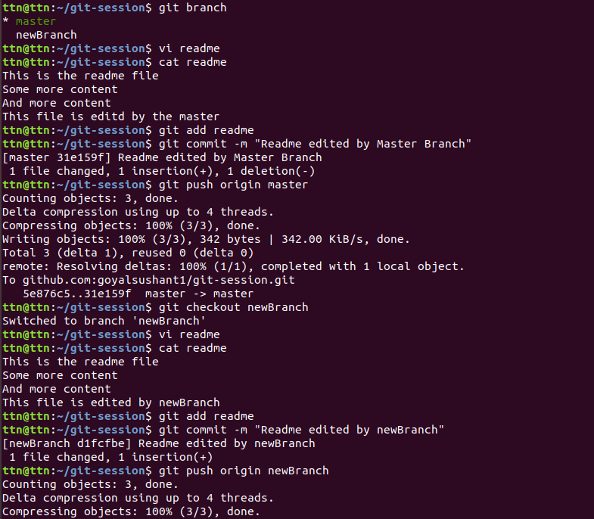

Exercise 16 Try merging and resolve merge conflicts
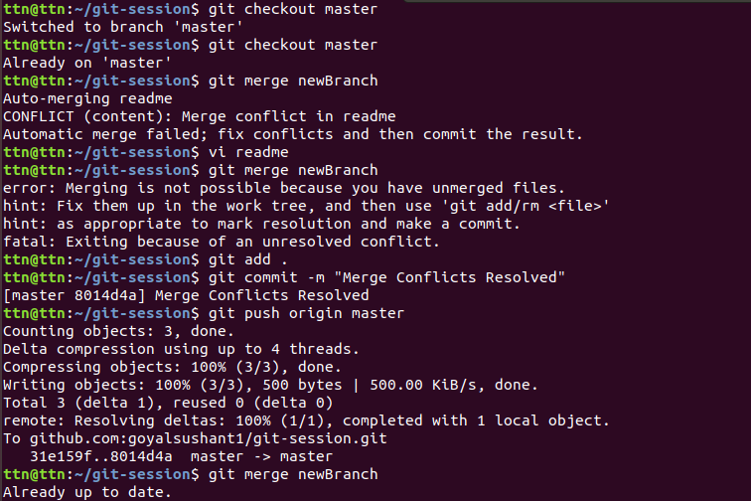
Exercise 17 Stash the changes and pop them

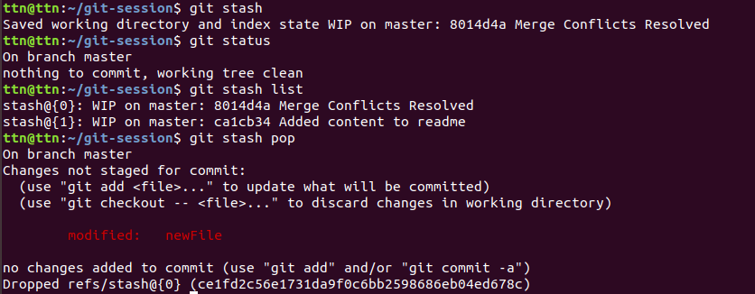
Exercise 18 Add the script to the .bashrc

