Drupal 8: Hooks & Theme

- Write the filename where we use and write hooks.
The hooks are written inside the .module file.
- Write any 10 hooks name and their definition which is used by drupal
=> hook_form_alter : hook_form_alter(&$form, \Drupal\Core\Form\FormStateInterface $form_state, $form_id)
=> hook_page_top : hook_page_top(array &$page_top)
=> hook_page_bottom : hook_page_bottom(array &$page_bottom)
=> hook_user_login : hook_user_login($account)
=> hook_help : hook_help($route_name, \Drupal\Core\Routing\RouteMatchInterface $route_match)
=> hook_install : hook_install()
=> hook_uninstall : hook_uninstall()
=> hook_user_logout : hook_user_logout($account)
=> hook_block-access : hook_block_access(\Drupal\block\Entity\Block $block, $operation, \Drupal\Core\Session\AccountInterface $account)
=> hook_block_view_alter : hook_block_view_alter(array &$build, \Drupal\Core\Block\BlockPluginInterface $block)

- Create a custom module and use any 5 hooks and their implementation.
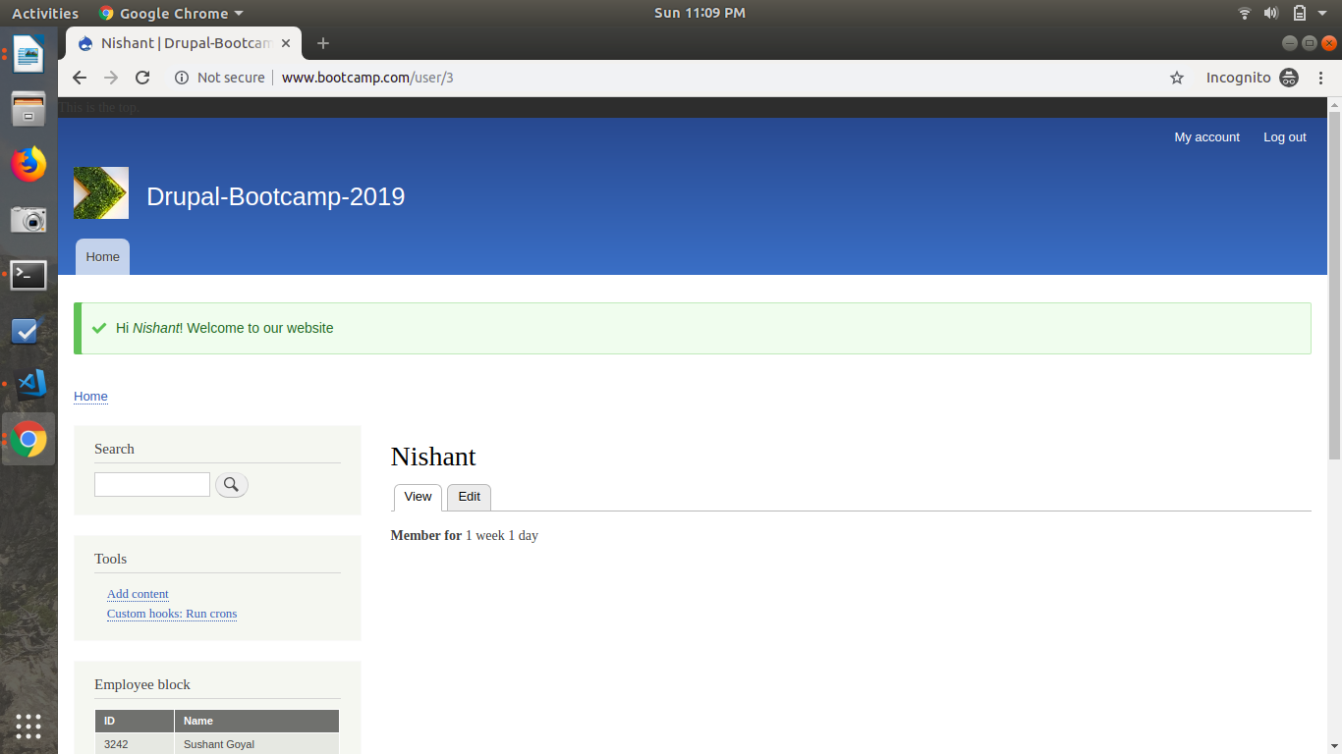

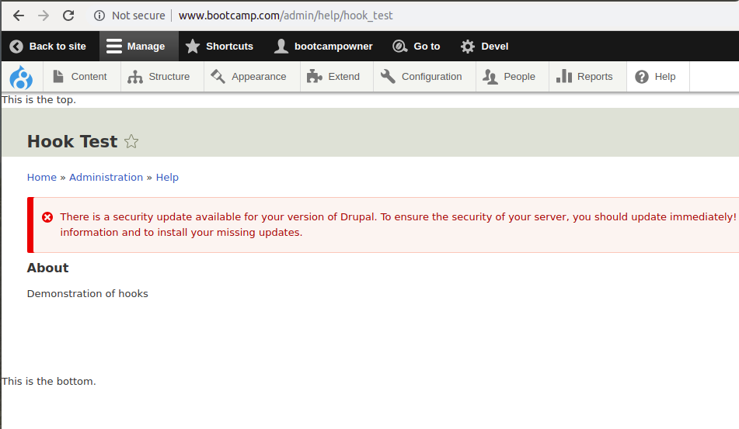
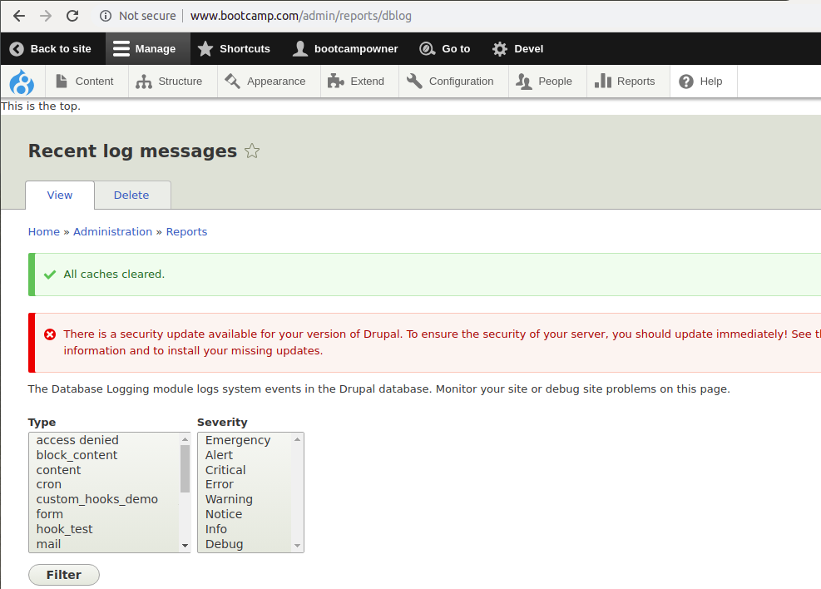

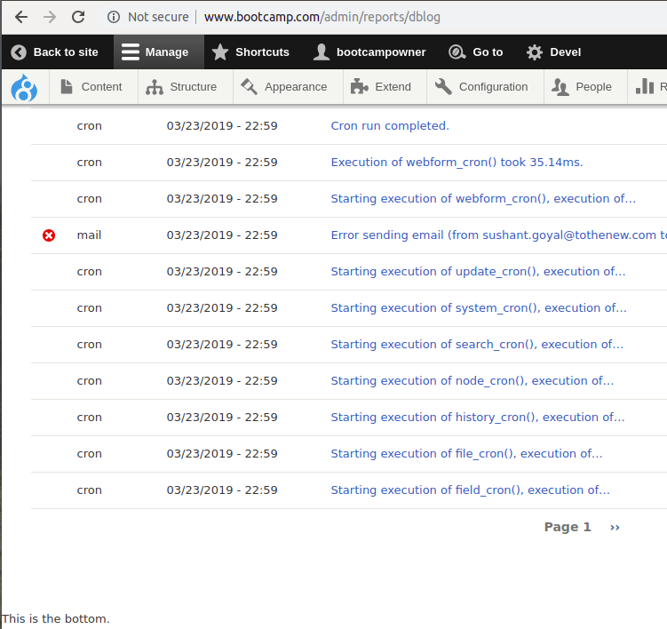

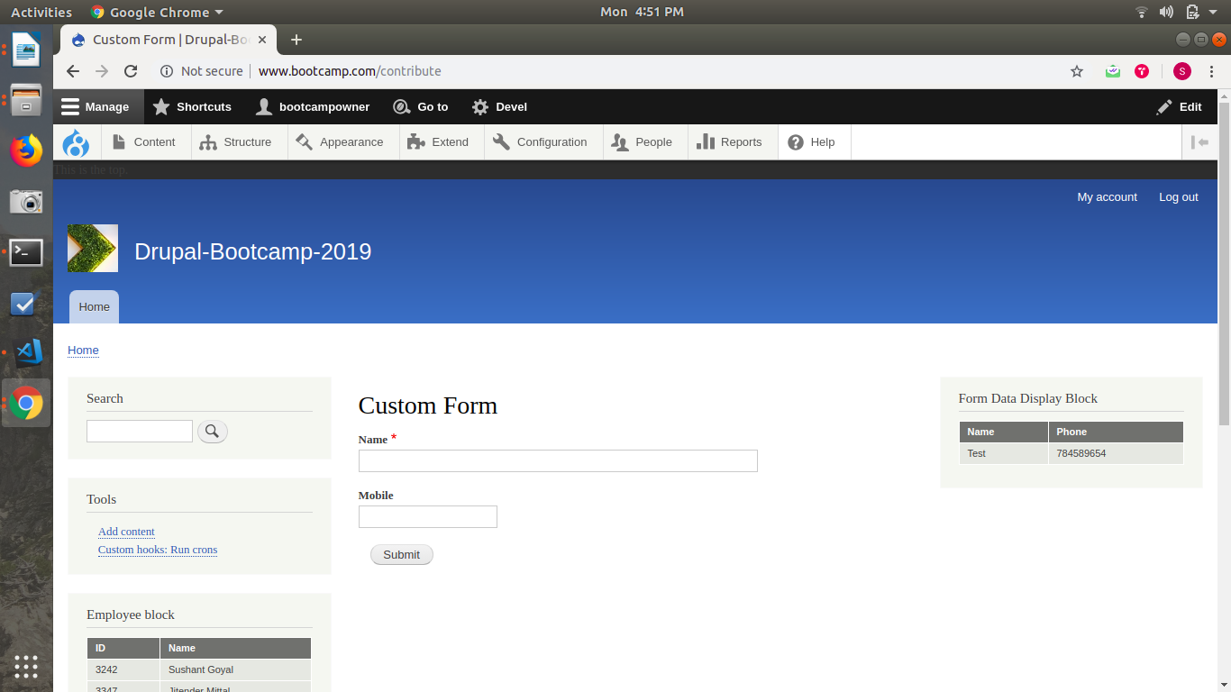

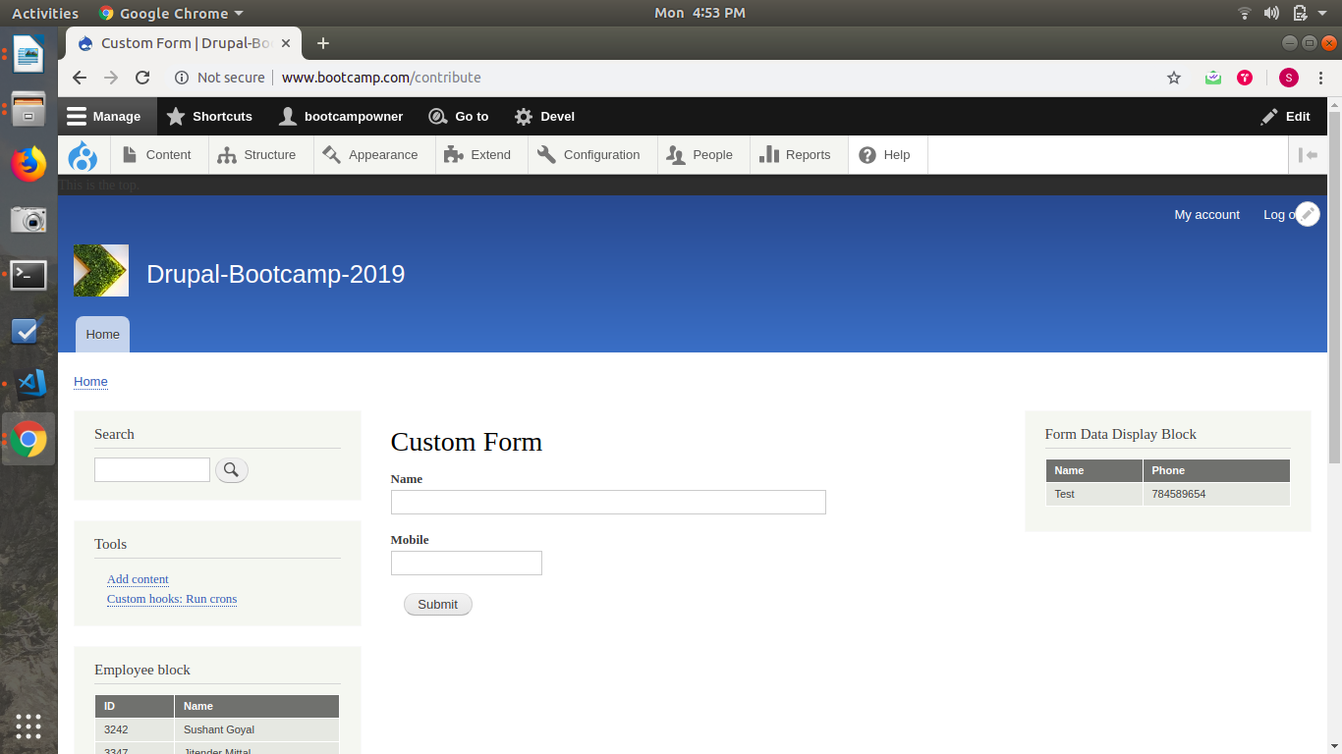
- What is the use of .theme file.
The .theme file is a PHP file that contains all the conditional logic and data (pre)processing of the output. It may also extend basic theme settings.

- What is theme() ?
It generates the themed output. It return an array that is to be rendered according to the template i.e the theme is rendered n the viewport.

- Why we use preprocess functions and how many type of preprocess function in drupal 8?
Preprocess functions are used to manipulate the variables present in the twig files by using the PHP functions to preprocess them and then expose the data to the theme developer.
=> hook_preprocess
=> hook_preprocess_HOOK
=> hook_template_preprocess_default_variables_alter
=> template_preprocess($variables, $hook) : Creates a default set of variables for all theme hooks with template implementations. Provided by Drupal Core.
=>template_preprocess_HOOK($variables) : Should be implemented by the module that registers the theme hook, to set up default variables.
=> MODULE_preprocess($variables, $hook) : hook_preprocess() is invoked on all implementing modules.
=> MODULE_preprocess_HOOK($variables) : hook_preprocess_HOOK() is invoked on all implementing modules, so that modules that didn't define the theme hook can alter the variables.
=> ENGINE_engine_preprocess($variables, $hook) : Allows the theme engine to set necessary variables for all theme hooks with template implementations.
=> ENGINE_engine_preprocess_HOOK($variables) : Allows the theme engine to set necessary variables for the particular theme hook.
=> THEME_preprocess($variables, $hook) : Allows the theme to set necessary variables for all theme hooks with template implementations.
=> THEME_preprocess_HOOK($variables) : Allows the theme to set necessary variables specific to the particular theme hook.
- In which file we write the preprocess functions?
The preprocess functions are written in .theme file.

- What is template engine in drupal 8?
Template engine are used to design the themes. In drupal 8, twig files are used to design temlates and in drupal 7 it was tpl files.

- Add a one text field at the last with your name and save your name (sushil) and add a validation for alphabet.
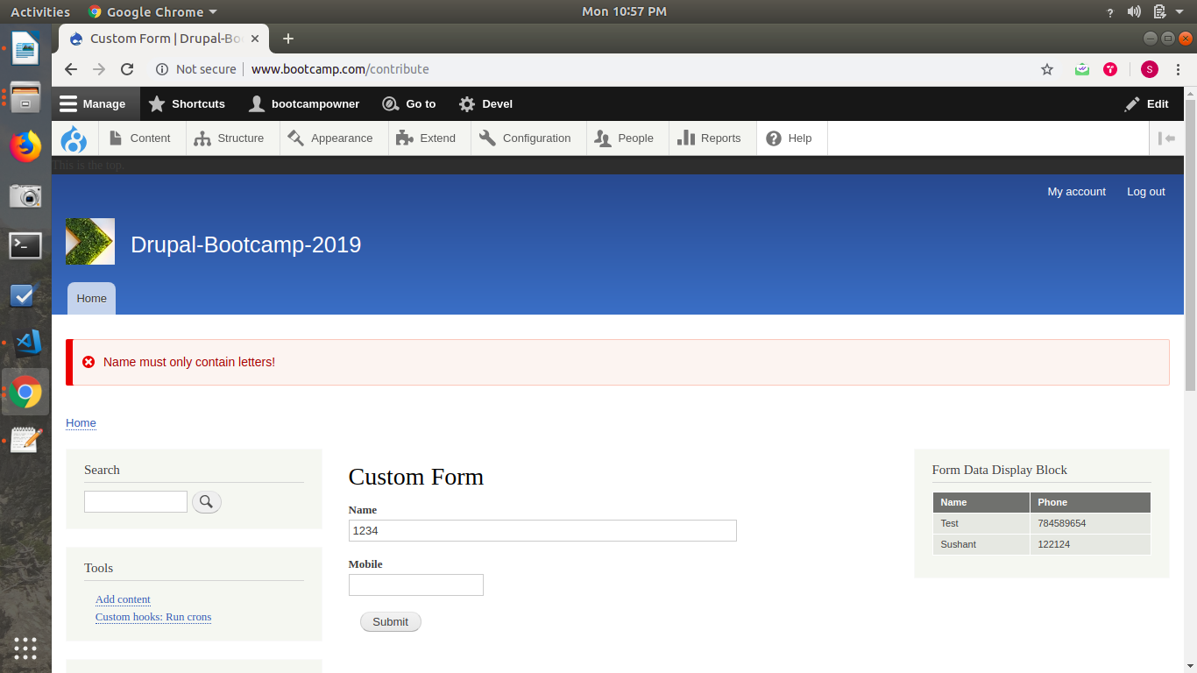
- What is the replacement of hook_init in drupal 8.
Eventsubscriber is used instead of hook_init.

