**Tools required**

**JDK** – Java Development Kit. Every 6 months JDK new version is launched. After 6 months the JDK versions expire and receives no future updates. But there is a JDK LTS version, LTS – Long term support. This version of JDK is basically supported for a period of 3 years and is the most preferable to use.

There a two types ok JDK – 1. Open Source 2. Commercial version. The current owner of JDK is Oracle. Also there are many different versions of JVM.

**SDK- Software Development Kit**

The JDK is effectively a Software Development Kit or SDK. It contains the tool you need to write programs. JDK includes the tools that enables the computer to understand your java code and to execute it. It also has a debugger.

**Hello World Program**

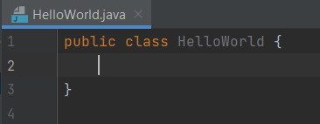

Public and class are two java keywords they have a specific meaning. Keywords are case sensitive i.e. word **public** or **Public** or **PUBLIC** are all different.

The public java keyword is an access modifier. An access modifier allows us to define the scope or how or how other parts of our code can access this code. We are using public access modifier to give full access.

The class keyword is used to define the class with the name **Hello**. The left and right curly braces defines the class block.

**Main Method**

Method is a collection of statements that performs an operation. Main method is the entry point of the java code that java looks for when running a program.

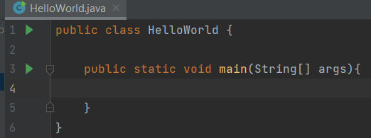

The void keyboard here specifies that the method will not return anything.

**Code Block**

Code block is used to define a block of code. It is mandatory to have in a method declaration and within them the program statements will be added.

**Statement**

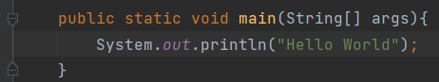

This is a complete command to be executed and can include one or more expressions.