**Kubernetes Security Misconfiguration Etcd, Controller Manager, Scheduler and Kube-API Server**

**Controller Manager:**

Misconfigured Role-Based Access Control (RBAC) permissions can lead to unauthorized access to Kubernetes resources.

For example, if a user is given cluster-admin access, they can manipulate or delete important resources.

To avoid this, role bindings should be properly configured and reviewed regularly.

**Scheduler:**

Misconfigured Pod Security Policies (PSPs) can allow unauthorized access to the Kubernetes cluster.

For example, if a PSP is not properly configured, a malicious user can exploit it to run a container with escalated privileges.

To avoid this, PSPs should be configured and reviewed regularly, and PodSecurityPolicy admission controller should be enabled.

**etcd:**

Misconfigured etcd access controls can allow unauthorized access to the Kubernetes cluster's data.

For example, if etcd is not properly configured, a malicious user can exploit it to read or write data from the cluster.

To avoid this, etcd access controls should be configured, and etcd should be protected by a firewall or other security measures.

**Kube API Server:**

Misconfigured Kube API Server can allow unauthorized access to the Kubernetes cluster.

For example, if the Kube API Server is not properly configured, a malicious user can exploit it to read or write data from the cluster.

To avoid this, Kube API Server should be properly configured, and access should be restricted to authorized users only.

Code examples:

Controller Manager:

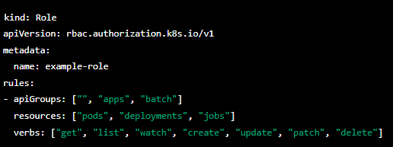

Scheduler:

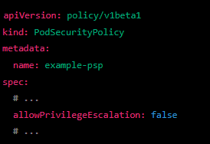

etcd:

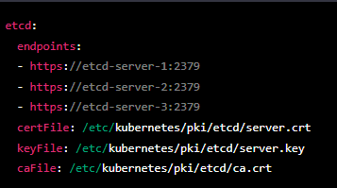

Kube API Server:

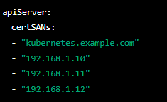

Note: These code examples are for demonstration purposes only and should not be used in a production environment without proper modification and testing.