***GIT COMMANDS AND PUSH FILE ON GITHUB***

**GIT**

GIT is a distributed version control system.

* **To determine GIT name of the user**

git config –global user.name “your name”

For Ex: git config –global user.name vinay

* **To initialize your Folder**

git init

* **To see all hidden Folders**

ls –lart

* **To Know the Status**

git status

* **To create a File in destination Folder**

touch “filename”

For Ex: touch abc.py

* **To Commit all Files**

git add -A

* **To commit all Changes**

git commit –m “Added More Files”

* **To Clear the Terminal**

clear

* **If Someone delete Your Code, To recover it(For One File)**

git checkout “filename”

For Ex: git checkout abc.py

* **If someone delete or change your code(For Multiple File)**

git checkout –f

* **What we have Committed Or To see multiple commits**

git log

* **To see only 5 Commits**

git log -p -5(5 is for last 5 commits …..It can be replaced by Number of Commit that you want to see)

* **To compare working directory with Staging Area**

git diff

* **To Compare Staging Area with last Commit**

git diff –staged

* **To Cancel a Command**

Simply use ^C with Command

For Ex:git diff^C

* **To list all files**

ls

* **To remove a File(also remove from git staging area)**

git rm –cached “filename”

For Ex: git rm –cached waste.py

* **To check the short Status**

git status –s

* **To ignore a file**

touch .gitignore(It will make a separate file and keep those file that we want to ignore)

* **How to push code on github with “git Bash”?**

**Step1: Sign In to your github account and click on “New Repository”**

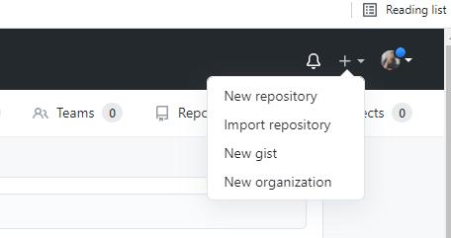

**Step2:Fill the required information.**

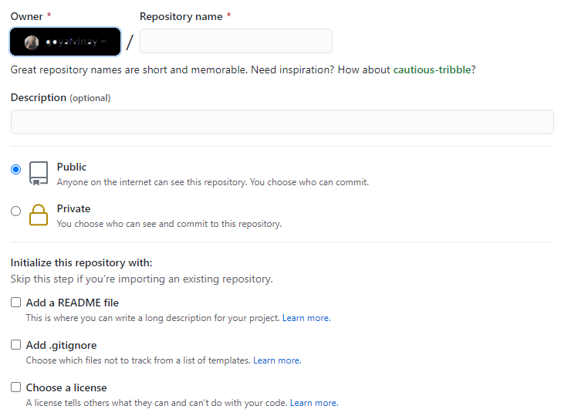

**Then, click on create Repository.**

**Another way,**

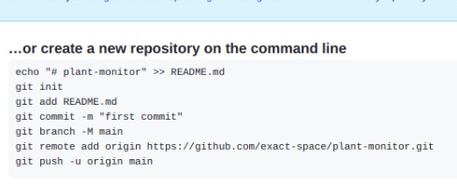

**Step3:Push an existing Repository**

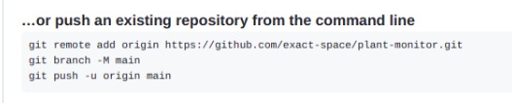

**We need these three commands to push**

**Step4:Now go to your code folder and open git Bash there.**

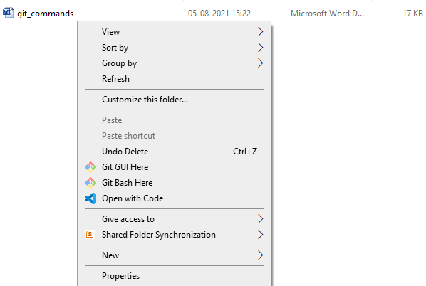

**Step5:i)First of all we will have to initialize git in our folder using**

**git init command**

**ii)Stage files that you want to push/update**

**git add –A**

**iii)Commit**

**git –m “message”**

**Step6:Now our files are ready to push on github repository,and we will now need those 3 lines that we saw in step 3, we just have to type those 3 lines and hit enter one by one.**