**Different Truncate Commands**

1. **Using Shell direction Command**

**$ > filename**

**This command is also used to create a new empty file.**

**2.Using True Command**

**$ true > filename**

**Example:-**

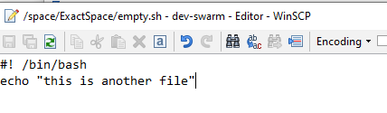

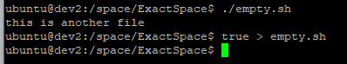

**3.Using Echo Command**

**$ echo –n > filename**

**OR**

**$ echo “ ” > filename**

**OR**

**$ echo > filename**

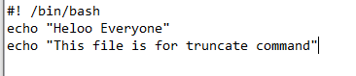

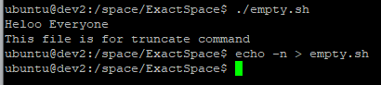

**4.Using cat/cp command**

**$ cat /dev/null > filename**

**Similarly for cp use cp instead of cat**

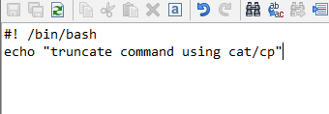

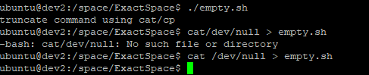

**5.Using dd Command**

**$**  dd if=/dev/null of=filename

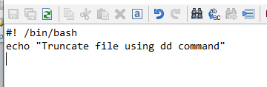

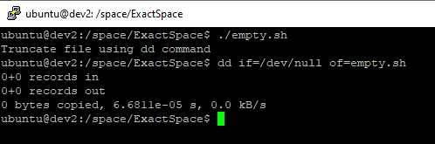

**6. Using sudo command**

**$** sudo sh –c ‘> filename’

OR

$ | sudo tee filename

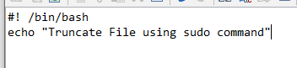

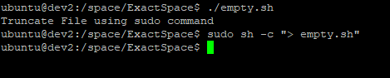

**7.Using truncate Command**

**$** truncate –s 0 filename

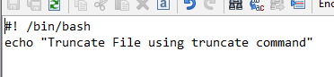

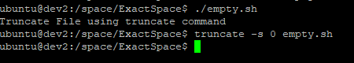

**Note:** remove the contents of all three files by following one quick step, using the “truncate” command followed by the directory location and file extensions.

*$*sudo truncate –s 0 /home/**/*.sh