**ASSIGNMENT DAY - 3**

1. **Find all the information about each products**

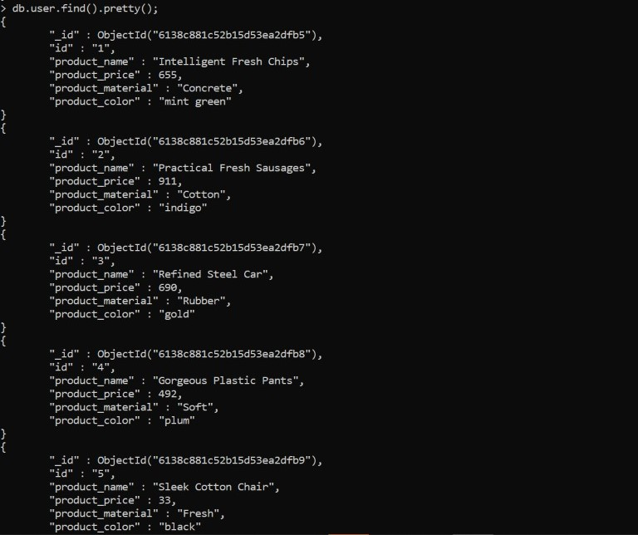

1. **Find the product price which are between 400 to 800**

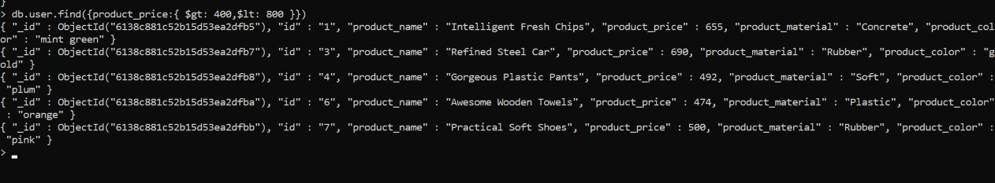

1. **Find the product price which are not between 400 to 600**

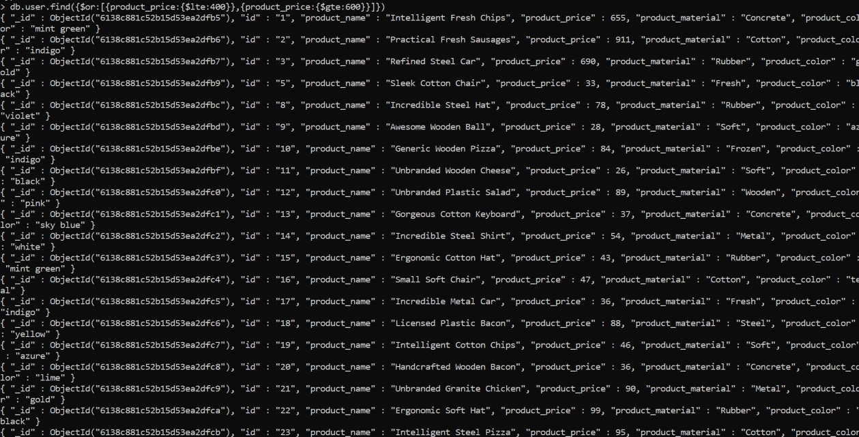

1. **List the four product which are grater than 500 in price**

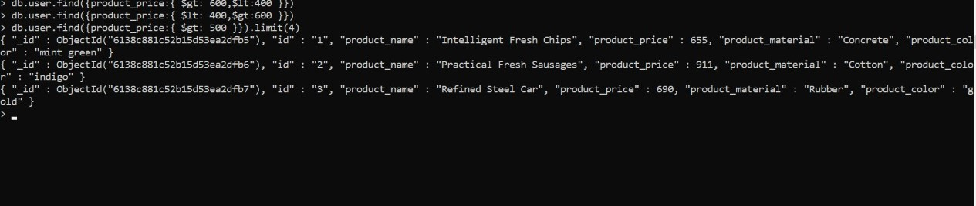

1. **Find the product name and product material of each products**

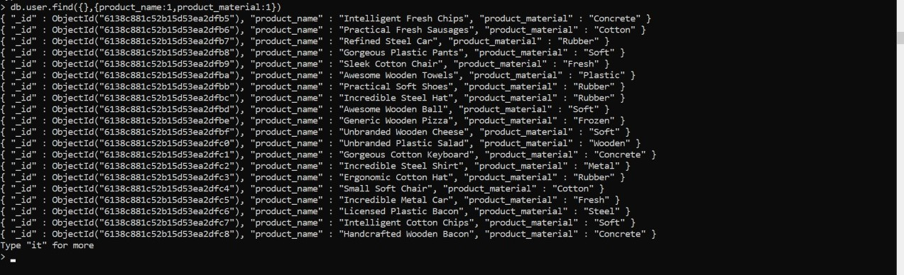

1. **Find the product with a row id of 10**

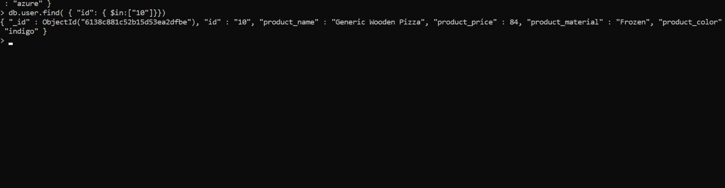

1. **Find only the product name and product material**



1. **Find all products which contain the value of soft in product material**

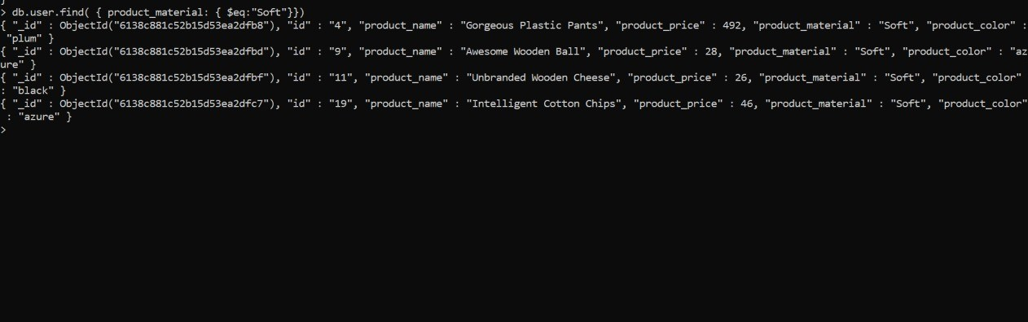

1. **Find products which contain product color indigo and product price 492.00**



No such values exist

VISHRUT GOYAL