Eddie Goynes
Kris Schnieder
ECE 471 LAB 5

1. Screenshots of your completed, error free schematic, symb ol, and layout.
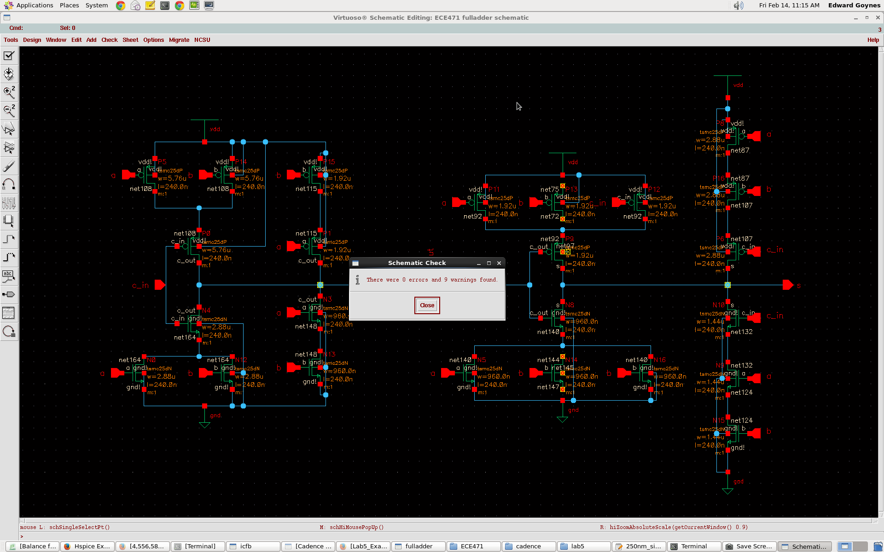
Symbol
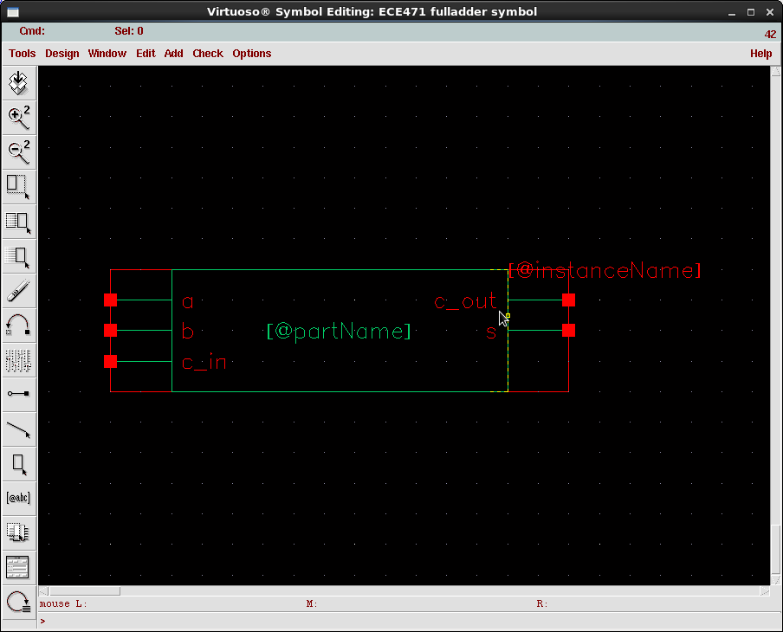

Layout
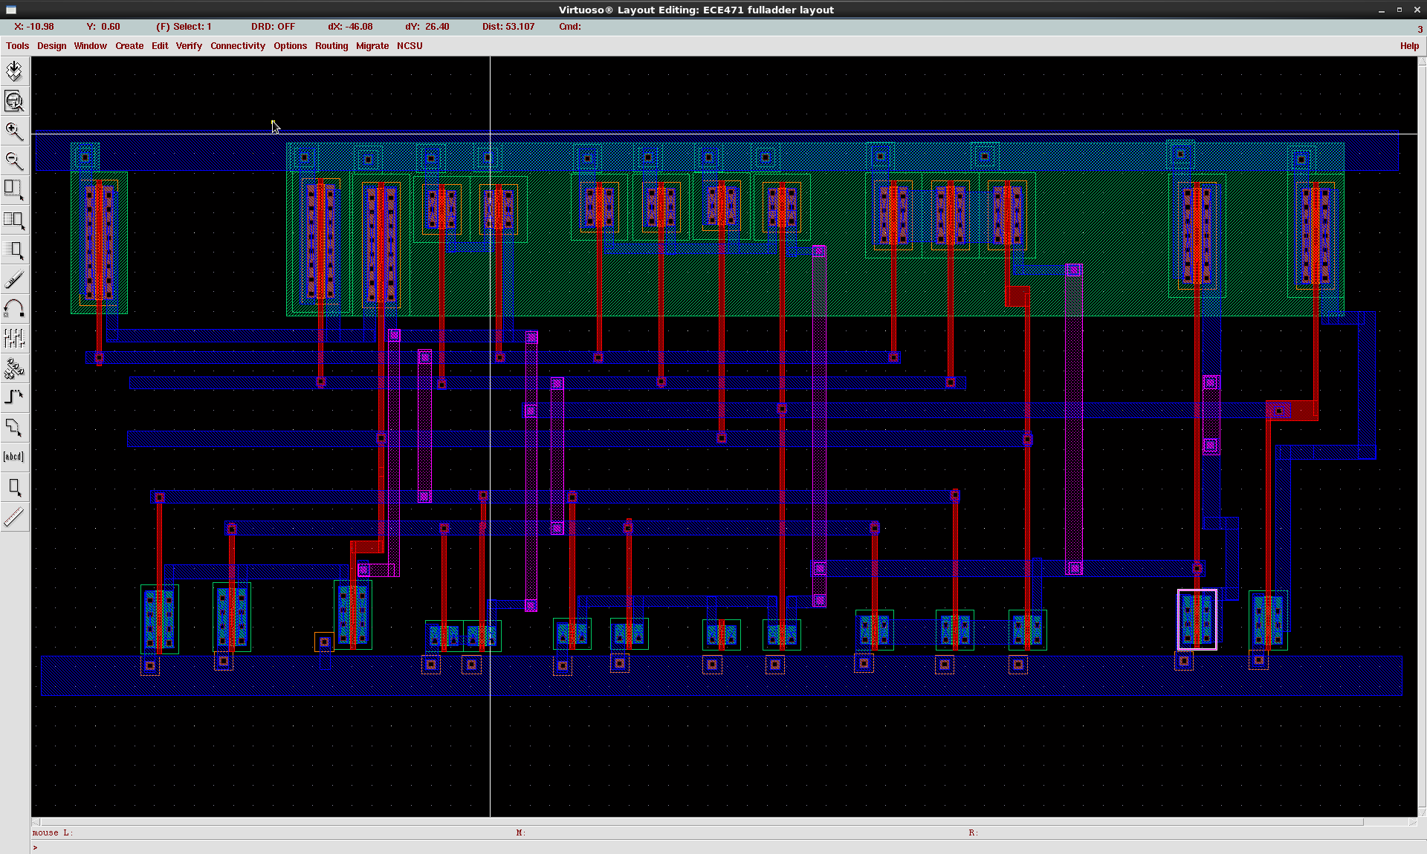
2. Screenshots of your passed DRC and LVS rep orts.

Says Total Errors 0;

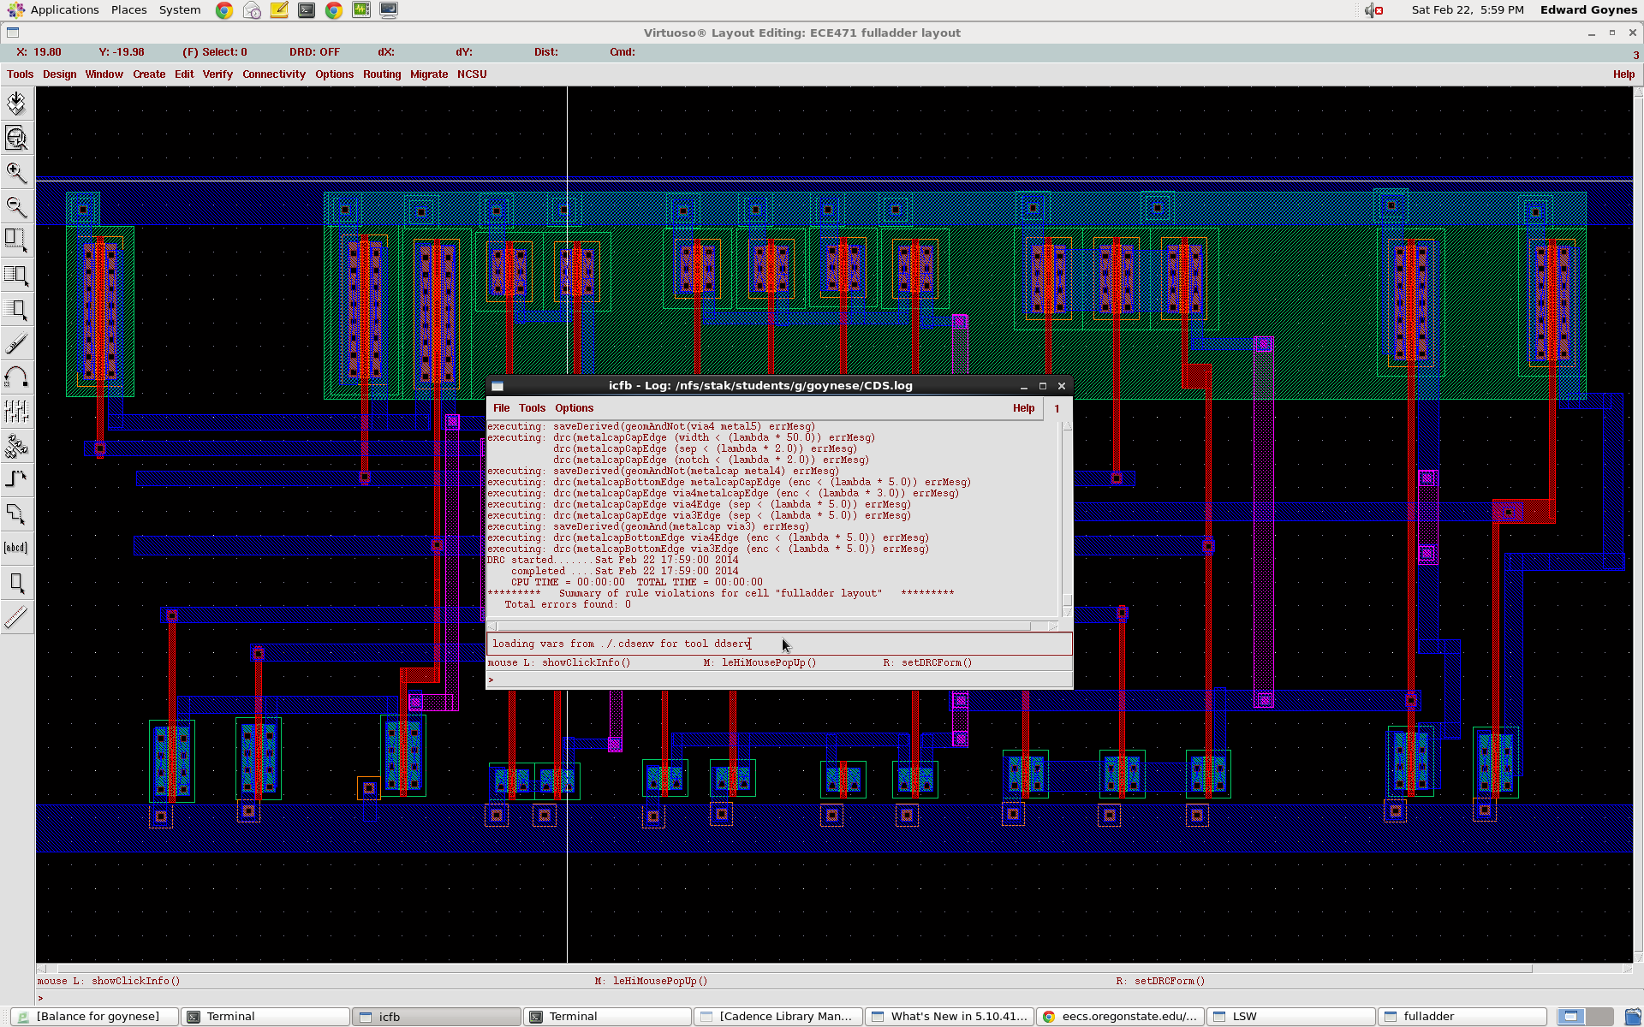

IT Says Succeeded, it's hard to read.

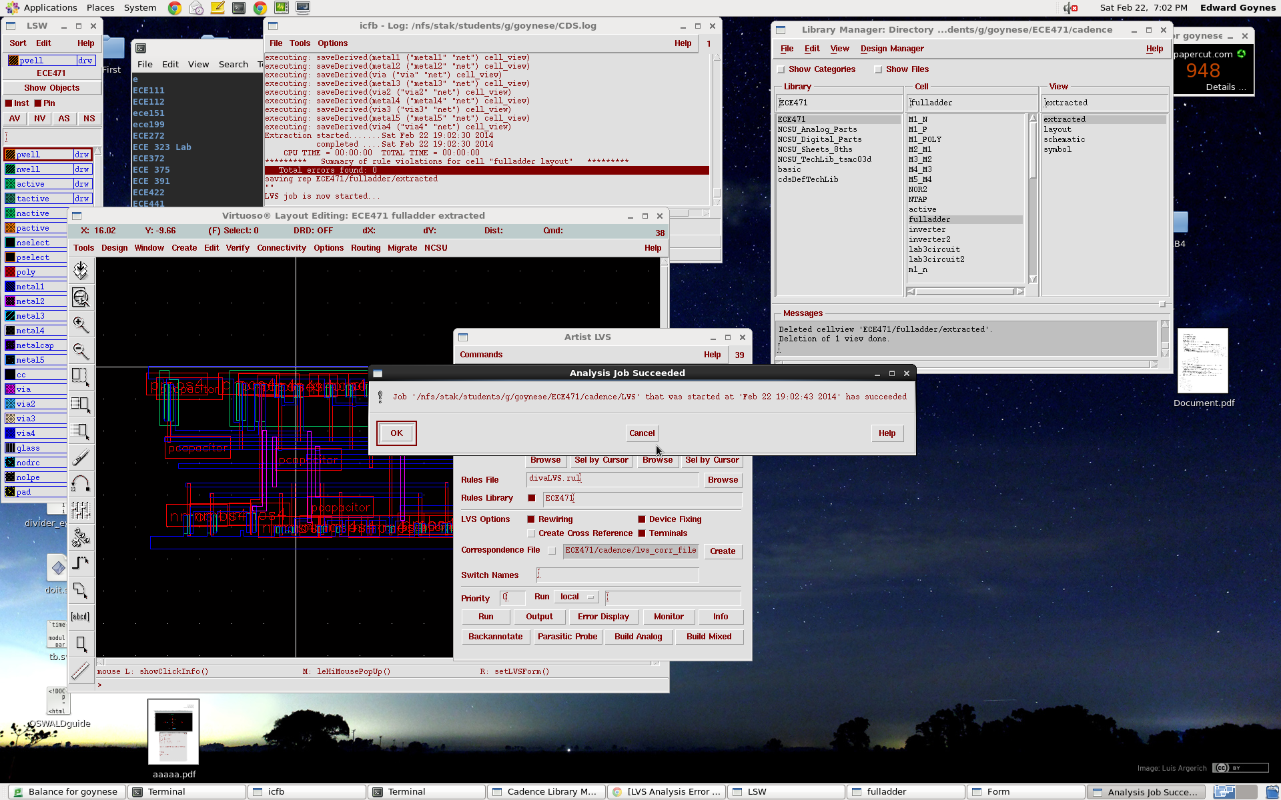
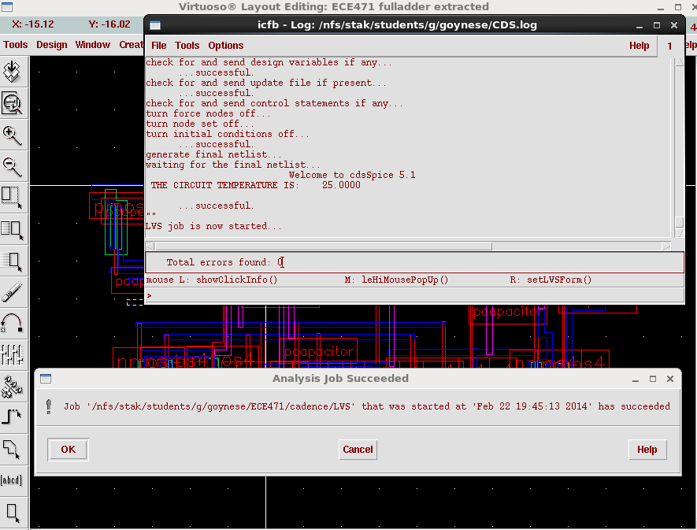

3. Screenshots of your waveforms showing prop er functionality.
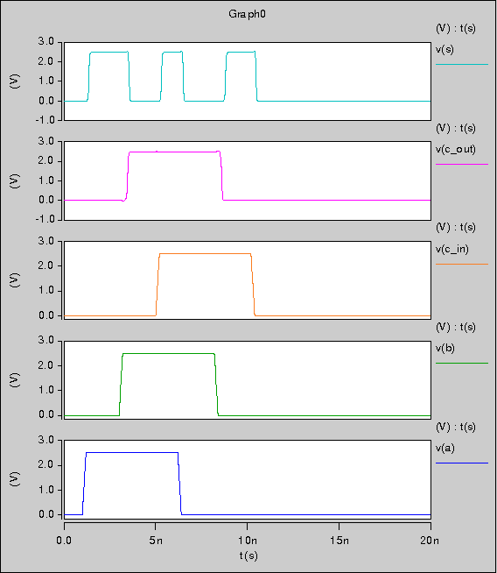

4. Your worst-case tplh value.

Worst case will be when C_In, A, and B are high. Then it transitions into C_in, A, and B going low.

Worst Case is 1.630x10^-10s

5. Your netlists.

Netlist before Layout.

* # FILE NAME: /NFS/STAK/STUDENTS/G/GOYNESE/CADENCE/SIMULATION/FULLADDER/
* HSPICES/SCHEMATIC/NETLIST/FULLADDER.C.RAW
* NETLIST OUTPUT FOR HSPICES.
* GENERATED ON FEB 14 13:14:15 2014

* GLOBAL NET DEFINITIONS
.GLOBAL VDD!
* FILE NAME: ECE471_FULLADDER_SCHEMATIC.S.
* SUBCIRCUIT FOR CELL: FULLADDER.
* GENERATED FOR: HSPICES.
* GENERATED ON FEB 14 13:14:15 2014.

XI8 NET0134 S INVERTER2_G1
XI7 NET0153 C_OUT INVERTER2_G1
MP13 NET72 B VDD! VDD! TSMC25DP L=240E-9 W=1.92E-6 AD=1.152E-12 AS=1.152E-12
+PD=5.04E-6 PS=5.04E-6 M=1
MP14 NET108 B VDD! VDD! TSMC25DP L=240E-9 W=5.76E-6 AD=3.456E-12
+AS=3.456E-12 PD=12.72E-6 PS=12.72E-6 M=1
MP15 NET115 B VDD! VDD! TSMC25DP L=240E-9 W=1.92E-6 AD=1.152E-12
+AS=1.152E-12 PD=5.04E-6 PS=5.04E-6 M=1
MP16 NET107 B NET87 VDD! TSMC25DP L=240E-9 W=2.88E-6 AD=1.728E-12
+AS=1.728E-12 PD=6.96E-6 PS=6.96E-6 M=1
MP12 NET72 C_IN VDD! VDD! TSMC25DP L=240E-9 W=1.92E-6 AD=1.152E-12
+AS=1.152E-12 PD=5.04E-6 PS=5.04E-6 M=1
MP11 NET72 A VDD! VDD! TSMC25DP L=240E-9 W=1.92E-6 AD=1.152E-12 AS=1.152E-12
+PD=5.04E-6 PS=5.04E-6 M=1
MP9 NET0134 NET0153 NET72 VDD! TSMC25DP L=240E-9 W=1.92E-6 AD=1.152E-12
+AS=1.152E-12 PD=5.04E-6 PS=5.04E-6 M=1
MP8 NET87 A VDD! VDD! TSMC25DP L=240E-9 W=2.88E-6 AD=1.728E-12 AS=1.728E-12
+PD=6.96E-6 PS=6.96E-6 M=1
MP6 NET0134 C_IN NET107 VDD! TSMC25DP L=240E-9 W=2.88E-6 AD=1.728E-12
+AS=1.728E-12 PD=6.96E-6 PS=6.96E-6 M=1
MP5 NET108 A VDD! VDD! TSMC25DP L=240E-9 W=5.76E-6 AD=3.456E-12 AS=3.456E-12
+PD=12.72E-6 PS=12.72E-6 M=1
MP1 NET0153 A NET115 VDD! TSMC25DP L=240E-9 W=1.92E-6 AD=1.152E-12
+AS=1.152E-12 PD=5.04E-6 PS=5.04E-6 M=1
MP0 NET0153 C_IN NET108 VDD! TSMC25DP L=240E-9 W=5.76E-6 AD=3.456E-12
+AS=3.456E-12 PD=12.72E-6 PS=12.72E-6 M=1
MN15 NET124 B 0 0 TSMC25DN L=240E-9 W=1.44E-6 AD=864E-15 AS=864E-15
+PD=4.08E-6 PS=4.08E-6 M=1
MN16 NET144 C_IN 0 0 TSMC25DN L=240E-9 W=960E-9 AD=576E-15 AS=576E-15
+PD=3.12E-6 PS=3.12E-6 M=1
MN10 NET0134 C_IN NET132 0 TSMC25DN L=240E-9 W=1.44E-6 AD=864E-15 AS=864E-15
+PD=4.08E-6 PS=4.08E-6 M=1
MN9 NET132 A NET124 0 TSMC25DN L=240E-9 W=1.44E-6 AD=864E-15 AS=864E-15
+PD=4.08E-6 PS=4.08E-6 M=1
MN8 NET0134 NET0153 NET144 0 TSMC25DN L=240E-9 W=960E-9 AD=576E-15
+AS=576E-15 PD=3.12E-6 PS=3.12E-6 M=1
MN5 NET144 A 0 0 TSMC25DN L=240E-9 W=960E-9 AD=576E-15 AS=576E-15 PD=3.12E-6
+PS=3.12E-6 M=1
MN14 NET144 B 0 0 TSMC25DN L=240E-9 W=960E-9 AD=576E-15 AS=576E-15
+PD=3.12E-6 PS=3.12E-6 M=1
MN13 NET148 B 0 0 TSMC25DN L=240E-9 W=960E-9 AD=576E-15 AS=576E-15
+PD=3.12E-6 PS=3.12E-6 M=1
MN12 NET164 B 0 0 TSMC25DN L=240E-9 W=2.88E-6 AD=1.728E-12 AS=1.728E-12
+PD=6.96E-6 PS=6.96E-6 M=1
MN4 NET0153 C_IN NET164 0 TSMC25DN L=240E-9 W=2.88E-6 AD=1.728E-12
+AS=1.728E-12 PD=6.96E-6 PS=6.96E-6 M=1
MN3 NET0153 A NET148 0 TSMC25DN L=240E-9 W=960E-9 AD=576E-15 AS=576E-15
+PD=3.12E-6 PS=3.12E-6 M=1
MN0 NET164 A 0 0 TSMC25DN L=240E-9 W=2.88E-6 AD=1.728E-12 AS=1.728E-12
+PD=6.96E-6 PS=6.96E-6 M=1

Netlist after Layout and Extraction.

* # FILE NAME: /NFS/STAK/STUDENTS/G/GOYNESE/CADENCE/SIMULATION/FULLADDER/
* HSPICES/EXTRACTED/NETLIST/FULLADDER.C.RAW
* NETLIST OUTPUT FOR HSPICES.
* GENERATED ON FEB 22 19:04:03 2014

* FILE NAME: ECE471_FULLADDER_EXTRACTED.S.
* SUBCIRCUIT FOR CELL: FULLADDER.
* GENERATED FOR: HSPICES.
* GENERATED ON FEB 22 19:04:03 2014.

C22 GND C_IN 3.4056096E-15 M=1.0
C23 GND B 5.1077712E-15 M=1.0
C24 GND VDD 5.8515504E-15 M=1.0
C25 GND A 5.505204E-15 M=1.0
C26 C_OUT GND 3.8275104E-15 M=1.0
C27 GND 5 2.87685E-15 M=1.0
C28 C_OUT GND 2.3824152E-15 M=1.0
M29 C_OUT C_IN 16 VDD TSMC25DP L=239.99999143598E-9 W=5.76000002183719E-6
+AD=3.45600002608915E-12 AS=3.45600002608915E-12 PD=6.96000006428221E-6
+PS=6.96000006428221E-6 M=1
M30 16 B VDD VDD TSMC25DP L=239.99999143598E-9 W=5.76000002183719E-6
+AD=3.45600002608915E-12 AS=3.45600002608915E-12 PD=6.96000006428221E-6
+PS=6.96000006428221E-6 M=1
M31 16 A VDD VDD TSMC25DP L=239.99999143598E-9 W=5.76000002183719E-6
+AD=3.45600002608915E-12 AS=3.45600002608915E-12 PD=6.96000006428221E-6
+PS=6.96000006428221E-6 M=1
M32 5 C_OUT 18 VDD TSMC25DP L=239.99999143598E-9 W=1.91999993148784E-6
+AD=1.15200004483645E-12 AS=1.15200004483645E-12 PD=3.11999997393286E-6
+PS=3.11999997393286E-6 M=1
M33 18 C_IN VDD VDD TSMC25DP L=239.99999143598E-9 W=1.91999993148784E-6
+AD=1.15200004483645E-12 AS=1.15200004483645E-12 PD=3.11999997393286E-6
+PS=3.11999997393286E-6 M=1
M34 18 B VDD VDD TSMC25DP L=239.99999143598E-9 W=1.91999993148784E-6
+AD=1.15200004483645E-12 AS=1.15200004483645E-12 PD=3.11999997393286E-6
+PS=3.11999997393286E-6 M=1
M35 18 A VDD VDD TSMC25DP L=239.99999143598E-9 W=1.91999993148784E-6
+AD=1.15200004483645E-12 AS=1.15200004483645E-12 PD=3.11999997393286E-6
+PS=3.11999997393286E-6 M=1
M36 C_OUT A 17 VDD TSMC25DP L=239.99999143598E-9 W=1.91999993148784E-6
+AD=1.15200004483645E-12 AS=1.15200004483645E-12 PD=3.11999997393286E-6
+PS=3.11999997393286E-6 M=1
M37 17 B VDD VDD TSMC25DP L=239.99999143598E-9 W=1.91999993148784E-6
+AD=1.15200004483645E-12 AS=1.15200004483645E-12 PD=3.11999997393286E-6
+PS=3.11999997393286E-6 M=1
M38 5 C_IN 20 VDD TSMC25DP L=239.99999143598E-9 W=2.88000001091859E-6
+AD=1.72800001304457E-12 AS=1.72800001304457E-12 PD=4.08000005336362E-6
+PS=4.08000005336362E-6 M=1
M39 20 B 19 VDD TSMC25DP L=239.99999143598E-9 W=2.88000001091859E-6
+AD=1.72800001304457E-12 AS=1.72800001304457E-12 PD=4.08000005336362E-6
+PS=4.08000005336362E-6 M=1
M40 19 A VDD VDD TSMC25DP L=239.99999143598E-9 W=2.88000001091859E-6
+AD=1.72800001304457E-12 AS=1.72800001304457E-12 PD=4.08000005336362E-6
+PS=4.08000005336362E-6 M=1
M41 15 C_OUT VDD VDD TSMC25DP L=239.99999143598E-9 W=4.80000016978011E-6
+AD=2.88000005788103E-12 AS=2.88000005788103E-12 PD=6.00000021222513E-6
+PS=6.00000021222513E-6 M=1
M42 14 5 VDD VDD TSMC25DP L=239.99999143598E-9 W=4.80000016978011E-6
+AD=2.88000005788103E-12 AS=2.88000005788103E-12 PD=6.00000021222513E-6
+PS=6.00000021222513E-6 M=1
M43 C_OUT C_IN 1 GND TSMC25DN L=239.99999143598E-9 W=2.88000001091859E-6
+AD=1.72800001304457E-12 AS=1.72800001304457E-12 PD=4.08000005336362E-6
+PS=4.08000005336362E-6 M=1
M44 1 B GND GND TSMC25DN L=239.99999143598E-9 W=2.88000001091859E-6
+AD=1.72800001304457E-12 AS=1.72800001304457E-12 PD=4.08000005336362E-6
+PS=4.08000005336362E-6 M=1
M45 1 A GND GND TSMC25DN L=239.99999143598E-9 W=2.88000001091859E-6
+AD=1.72800001304457E-12 AS=1.72800001304457E-12 PD=4.08000005336362E-6
+PS=4.08000005336362E-6 M=1
M46 5 C_OUT 3 GND TSMC25DN L=239.99999143598E-9 W=959.999965743918E-9
+AD=576.000022418227E-15 AS=576.000022418227E-15 PD=2.15999989450211E-6
+PS=2.15999989450211E-6 M=1
M47 4 21 3 GND TSMC25DN L=239.99999143598E-9 W=959.999965743918E-9
+AD=576.000022418227E-15 AS=576.000022418227E-15 PD=2.15999989450211E-6
+PS=2.15999989450211E-6 M=1
M48 3 B GND GND TSMC25DN L=239.99999143598E-9 W=959.999965743918E-9
+AD=576.000022418227E-15 AS=576.000022418227E-15 PD=2.15999989450211E-6
+PS=2.15999989450211E-6 M=1
M49 3 A GND GND TSMC25DN L=239.99999143598E-9 W=959.999965743918E-9
+AD=576.000022418227E-15 AS=576.000022418227E-15 PD=2.15999989450211E-6
+PS=2.15999989450211E-6 M=1
M50 C_OUT A 2 GND TSMC25DN L=239.99999143598E-9 W=959.999965743918E-9
+AD=576.000022418227E-15 AS=576.000022418227E-15 PD=2.15999989450211E-6
+PS=2.15999989450211E-6 M=1
M51 2 B GND GND TSMC25DN L=239.99999143598E-9 W=959.999965743918E-9
+AD=576.000022418227E-15 AS=576.000022418227E-15 PD=2.15999989450211E-6
+PS=2.15999989450211E-6 M=1
M52 5 C_IN 13 GND TSMC25DN L=239.99999143598E-9 W=1.4400000054593E-6
+AD=864.000006522286E-15 AS=864.000006522286E-15 PD=2.64000004790432E-6
+PS=2.64000004790432E-6 M=1
M53 13 A 6 GND TSMC25DN L=239.99999143598E-9 W=1.4400000054593E-6
+AD=864.000006522286E-15 AS=864.000006522286E-15 PD=2.64000004790432E-6
+PS=2.64000004790432E-6 M=1
M54 6 B GND GND TSMC25DN L=239.99999143598E-9 W=1.4400000054593E-6
+AD=864.000006522286E-15 AS=864.000006522286E-15 PD=2.64000004790432E-6
+PS=2.64000004790432E-6 M=1
M55 15 C_OUT GND GND TSMC25DN L=239.99999143598E-9 W=2.40000008489005E-6
+AD=1.44000002894051E-12 AS=1.44000002894051E-12 PD=3.5999998999614E-6
+PS=3.5999998999614E-6 M=1
M56 14 5 GND GND TSMC25DN L=239.99999143598E-9 W=2.40000008489005E-6
+AD=1.44000002894051E-12 AS=1.44000002894051E-12 PD=3.5999998999614E-6
+PS=3.5999998999614E-6 M=1

