ECE471 Lab 6
Edward Goynes
Kris Schneider

OR schematic
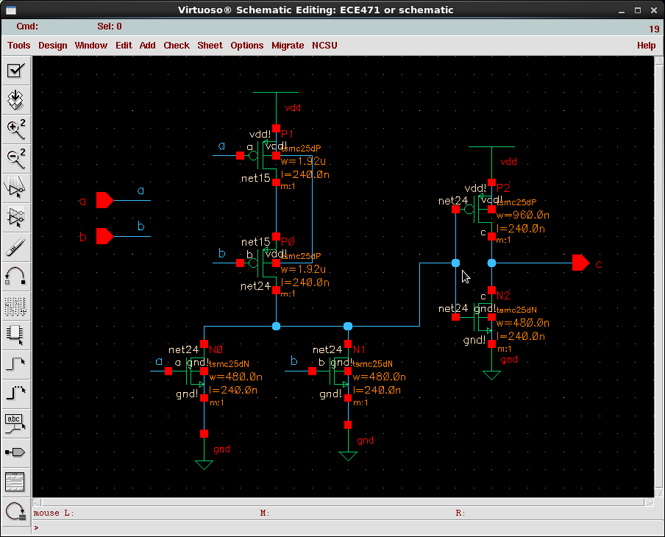

XOR schematic
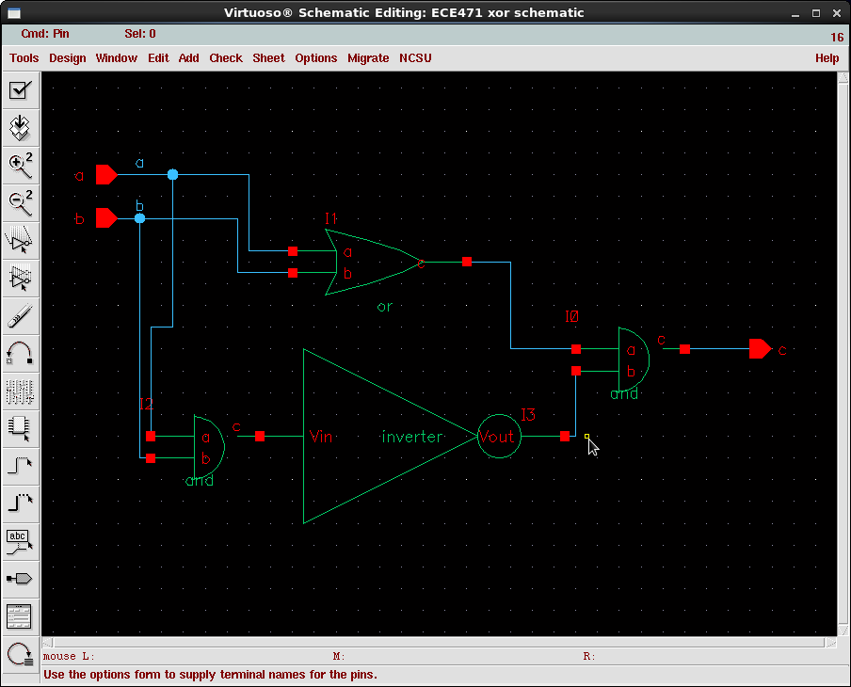

AND schematic
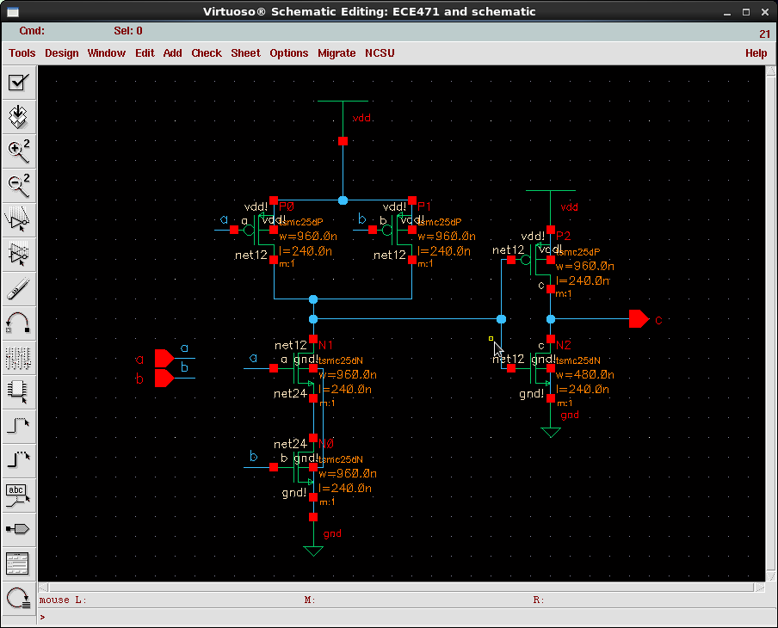

4-bit lookahead
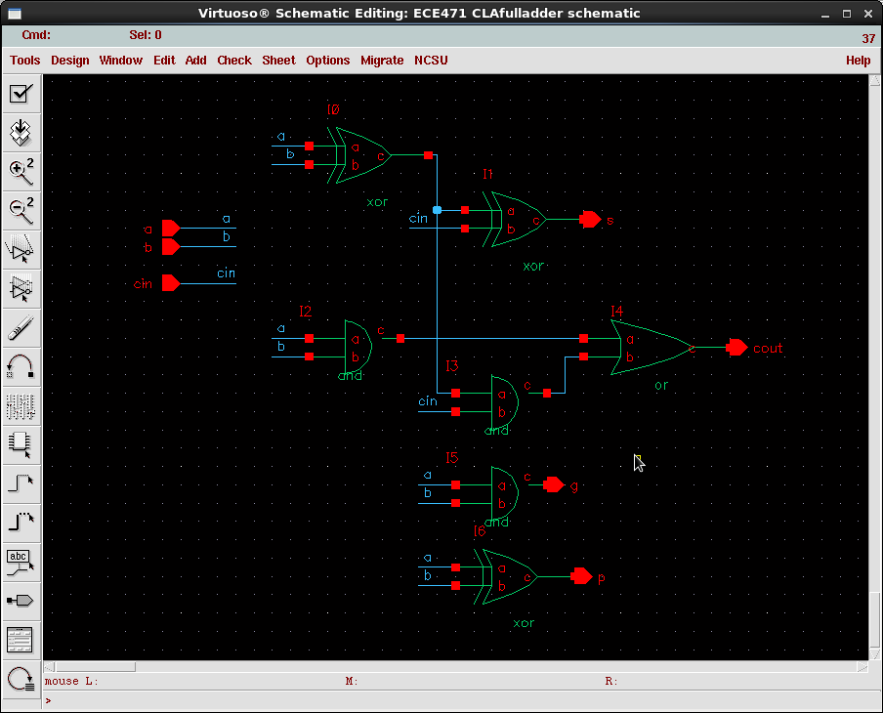
1-bit full adder

Lookahead
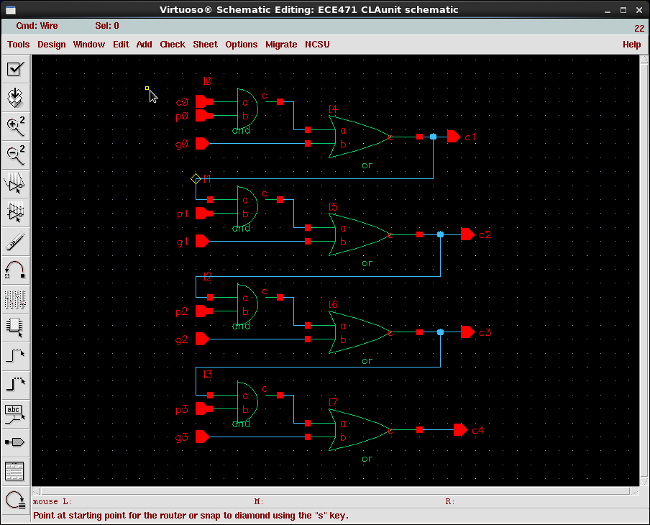

Whole lookahead adder
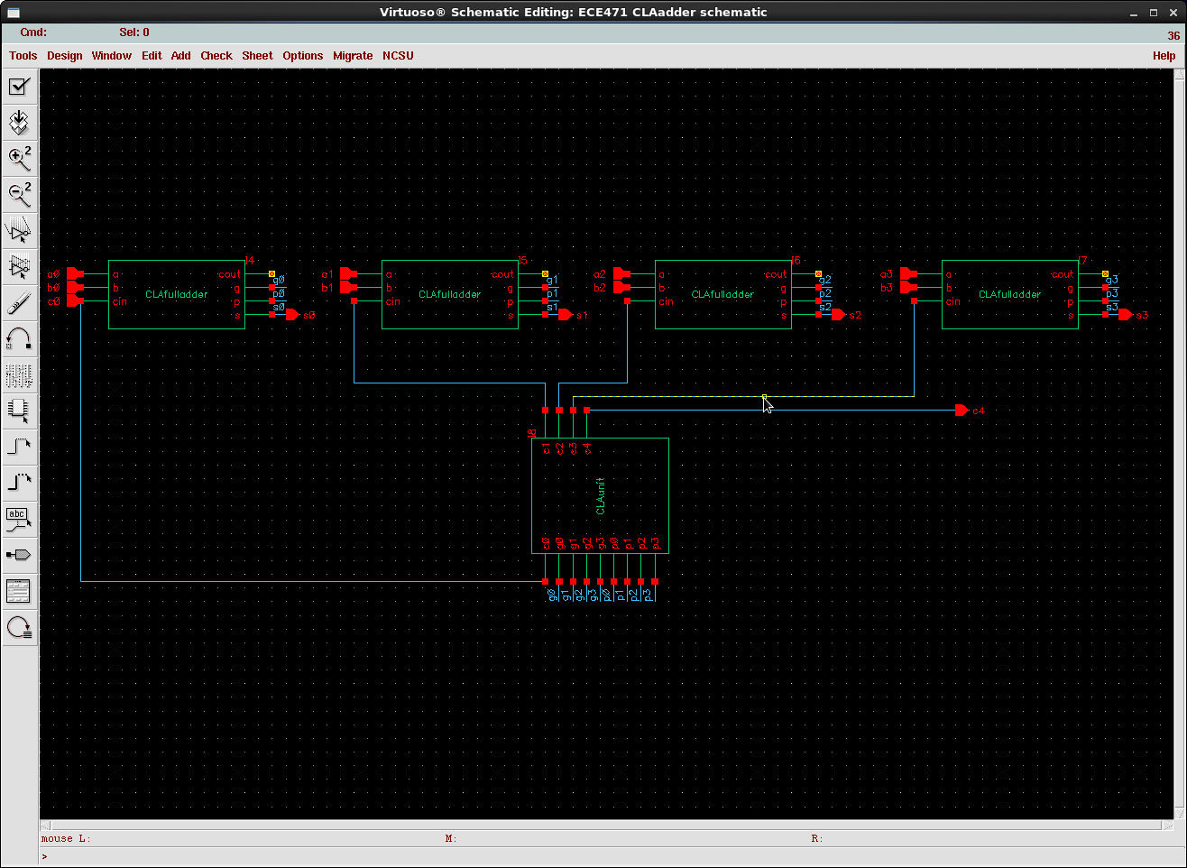
Clock Frequency for each adder
4-bit Adder type | Delay | Freq
Ripple-carry | 1.6nS | 635Mhz
Carry-lookahead | .62nS | 1.613Ghz

Calculated Power for each adder
4-bit Adder type | Static Power | Dyn Power
Ripple-carry
Carry-lookahead

