Predicting Bank Term Deposit Subscription:
An Applied Machine Learning and MLOps Pipeline
Question 1 — Applied Supervised Machine Learning
MSc Data Science — Machine Learning and MLOps

1. Dataset Understanding and Literature Review

1.1 Dataset Selection and Justification
For this assignment, I chose the Bank Marketing dataset collected from a Portuguese retail bank's phone-based marketing campaigns, originally published by Moro, Cortez, and Rita and hosted on the UCI Machine Learning Repository. Specifically, I used the bank-full.csv release, which contains 45,211 client records described across 17 attributes. The data itself mixes nine categorical attributes, including job, marital status, education level, whether the client has a housing or personal loan, the contact channel, the month of the last contact, and the outcome of any previous campaign, with seven numerical attributes describing age, account balance, the day of the month of contact, the number of contacts made during the current campaign, the number of days since the client was last contacted, and the number of contacts made before this campaign.
Roughly 88.3% of the clients in the dataset did not subscribe to a term deposit, while only about 11.7% did, so the target variable is quite heavily imbalanced. A number of the categorical columns also contain values recorded simply as "unknown" instead of a proper answer. This isn't quite the same as data being missing at random: for the poutcome column in particular, 36,959 of the 45,211 records are marked "unknown", which mostly reflects the fact that these clients had simply never been contacted in an earlier campaign, rather than the outcome being lost or unrecorded. Smaller numbers of unknowns also appear in job 288 records and education 1,857 records.

1.2 Business and Application Context
Call centers selling financial products such as term deposits typically convert only a small proportion of the calls they make. Every unsuccessful call still costs staff time, and, arguably, some amount of customer goodwill, so there is a clear business case for being smarter about who gets called in the first place. A model that ranks clients by how likely they are to subscribe would let a bank prioritize the contacts that are actually worth making, rather than working through a list in a fairly arbitrary order determined by, say, when the client's record was last updated. This is the practical motivation behind the assignment: the aim is not to build a model purely to demonstrate technique, but to support a decision a marketing team would genuinely have to make.

1.3 Target Variable and Prediction Objective
The target column, y, records whether a client subscribed to a term deposit following the campaign contact, which I recoded to 1 and 0, respectively, for modelling purposes. The objective is to estimate, using only information that would realistically be available before or at the point of contact, the probability that a given client goes on to subscribe.
This distinction matters because one of the columns in the original release, duration, records how long the phone call itself lasted, and this is only known once the call has already finished. If duration were left in as a predictor, any model trained on it would look considerably more accurate than it could ever be in a live setting, simply because it would be relying on information that doesn't exist yet at the moment a prediction actually needs to be made. I removed this column before doing any feature engineering or modelling.

1.4 Literature Review
A fair amount of research already exists on predicting the outcome of bank telemarketing campaigns, much of it using this exact dataset or a close variant of it, which made it easier to compare my own results against previous work rather than starting from nothing.
Zaki, Khodadadi, Lim and Towfek (2024), writing in the American Journal of Business and Operations Research, compared a multilayer perceptron neural network, a decision tree and a support vector machine on the UCI bank marketing data. In a related piece of follow-up work referenced in the same paper, a Random Forest model outperformed all three, reaching around 87.5% accuracy. This is a useful reference point, although, as I discuss in Section 4, accuracy on its own is not a particularly meaningful metric once the size of the class imbalance is taken into account.
A separate study presented at the 2024 International Conference on Signal Processing and Machine Learning applied CatBoost together with SHAP explainability to a similar prediction problem. What stood out to me about this paper is that it treated explainability as part of the core contribution rather than an afterthought bolted on at the end, which is part of the reason I decided to give SHAP and LIME a fairly central role in this assignment too, rather than including them only briefly.
Xie, Zhang, Zhu, Xiong and Wang (2023), in Computers & Industrial Engineering, looked specifically at which features drive telemarketing success and found that the timing of the call, the outcome of any previous campaign, and broader macroeconomic conditions were consistently among the strongest predictors. This shaped how I approached feature engineering later in the assignment: a couple of the features I built, including a seasonality flag and a feature summarising a client's prior contact history, were directly inspired by this finding.
Tanvir, Hossain and Asifuzzaman (2024) took a different modelling approach, applying Bayesian logistic regression rather than a tree-based or boosting method. Their central argument is that a Bayesian approach produces a calibrated, uncertainty-aware probability rather than just a single point estimate, which becomes genuinely useful in a call-centre setting where there is often a hard daily limit on how many calls staff can make, and where knowing how confident a prediction actually is can matter as much as the prediction itself.
Separately, Chen, Zhan and Wang (2024) published a broader survey of methods for handling imbalanced classification problems, arguing that resampling techniques such as SMOTE, cost-sensitive learning, and threshold tuning should be treated as complementary tools rather than competing alternatives to pick between. This directly shaped my approach in Section 3, where I use class weighting for some models, SMOTE applied only to the training data, and threshold tuning applied afterwards, rather than settling on just one of these techniques.
Finally, a broader end-to-end study using the same UCI dataset (2024/2025) walked through a full pipeline from preprocessing to model comparison and, in line with most of the other papers reviewed here, found that ensemble and boosting methods reliably outperformed single linear models, while still making the point that a linear baseline is worth keeping around for how interpretable it is.
Taken together, these six pieces of work point towards a few recurring gaps that this assignment tries to address directly. First, several published studies leave duration in as a predictor, which inflates reported performance in a way that would not hold up once actually deployed, since duration is simply not available at prediction time; I address this by removing it entirely rather than treating it as just another feature. Second, most of the studies reviewed report accuracy as though it were the main metric of interest, which is somewhat misleading on a dataset this imbalanced, since a model that barely detects the minority class can still post a high accuracy figure; I instead give more weight to F1, ROC-AUC and, in particular, PR-AUC. Third, very few of the studies reviewed combine a broad comparison across model types with both SHAP and LIME explainability and a fairness audit across client subgroups, which this assignment attempts to do. And finally, almost none of the reviewed work extends into an actual deployment and monitoring pipeline, which is arguably the part of the brief with the most real-world weight, and which I cover in detail in Section 6.

2. Data Analysis and Feature Engineering

2.1 Exploratory Data Analysis
Before doing any cleaning or feature engineering, I spent some time simply looking at the data from a few different angles: individual columns on their own, pairs of columns against the target, and the numerical columns together as a group. All of the plots referenced below were produced in notebooks/01_eda.ipynb and can be regenerated by re-running that notebook.
For the numerical attributes, I plotted histograms with a kernel density estimate overlaid for age, balance, campaign, pdays, and previous. Age is fairly close to a normal distribution centered in the 30s to 40s, while balance and campaign are both heavily right-skewed, with a long tail of clients holding unusually large balances or being contacted an unusually high number of times within one campaign.
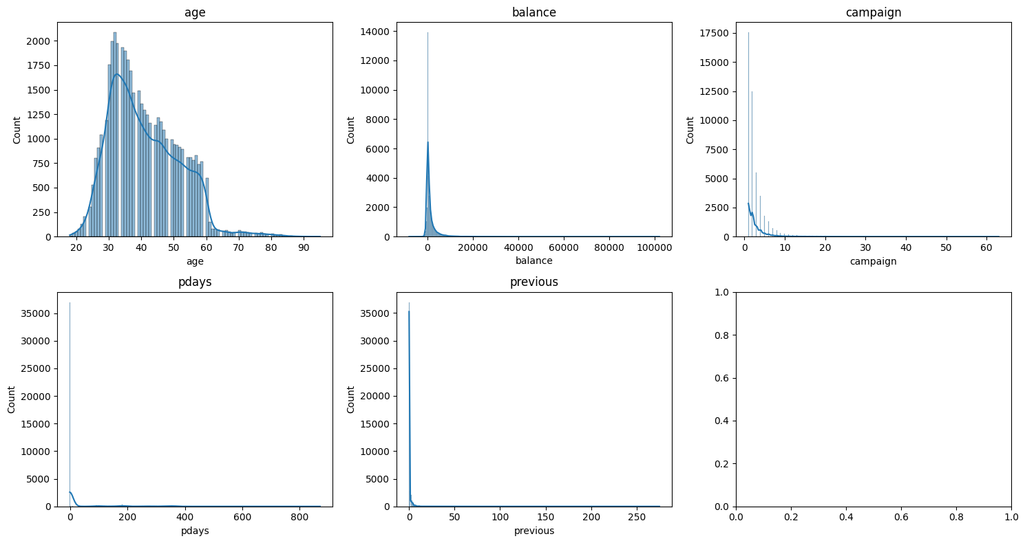
For the categorical attributes, I looked at simple frequency counts for job, education, month and contact. Management, blue-collar and technician are the three largest job categories by some margin, and the month column is noticeably uneven, with May accounting for a much larger share of contacts than any other month.
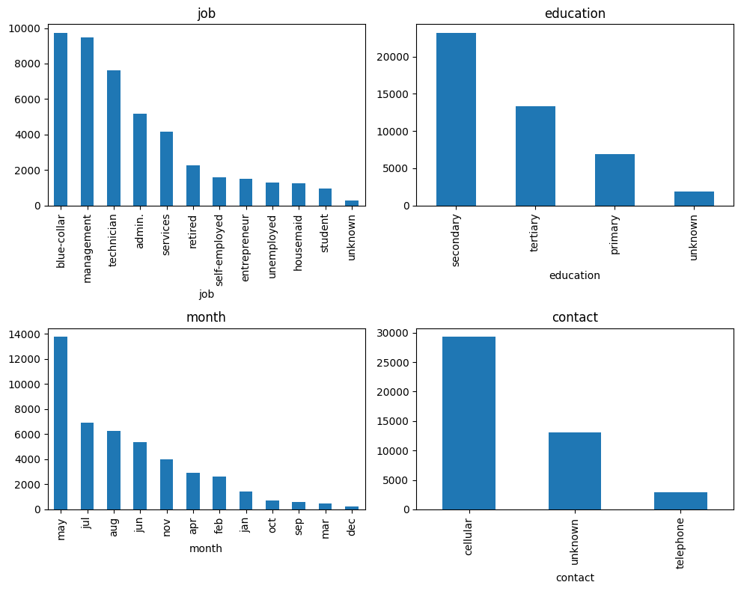
The more interesting patterns showed up once I looked at subscription rate broken down by category rather than just raw frequency. Subscription rate varies quite a lot by month: March, September, October and December all convert noticeably better than the campaign's busiest months of May, June and July. This was one of the clearer signals in the whole dataset and is the basis for two of the features I built later.
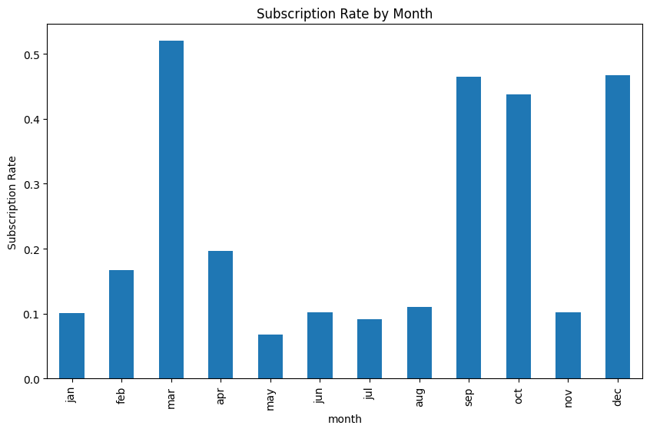
I also compared balance and age between clients who subscribed and those who didn't using box plots. Clients who subscribed tend to have a slightly higher median balance, though the spread within both groups is wide enough that balance alone would be a fairly weak predictor on its own.
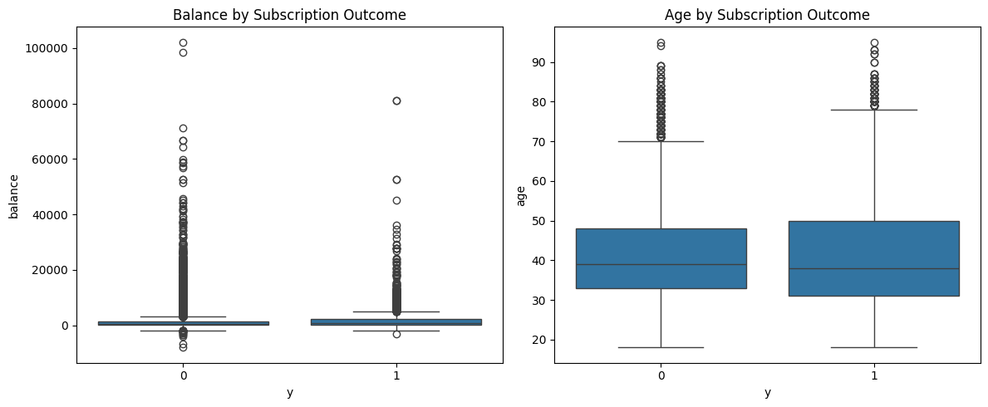
Looking at the numerical columns together, I produced a correlation heatmap across age, balance, day, campaign, pdays and previous. With duration already excluded and no macroeconomic indicator columns present in this particular release of the dataset, I expected multicollinearity to be fairly mild among the remaining numerical predictors, and the heatmap confirms this: none of the pairwise correlations are especially strong.
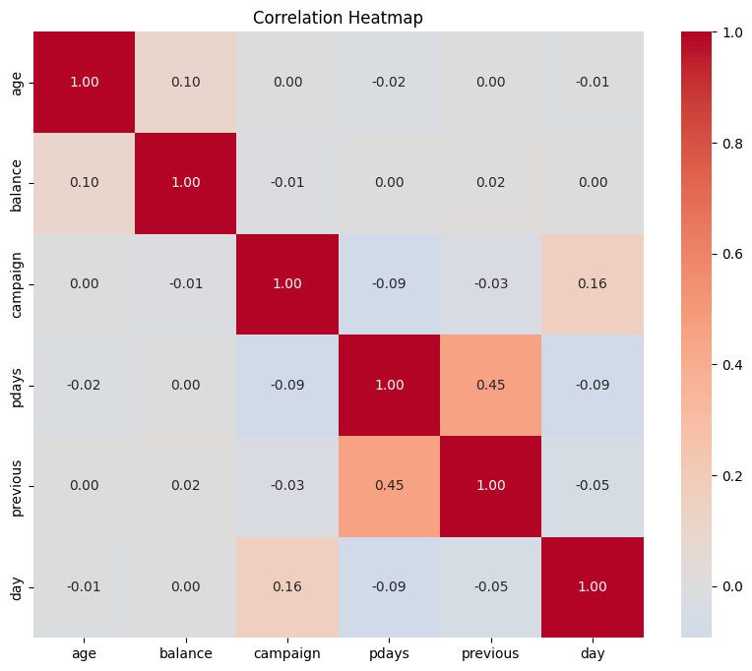
Finally, I checked for duplicate rows and ran an outlier scan using the interquartile range rule on balance and campaign. There were no exact duplicate rows once every column was considered together, and a small number of extreme values in both balance and campaign, which I address through the winsorising and capping described in the next section rather than deleting the affected rows outright.

2.2 Handling Missing Values, Outliers and Duplicates
The table below summarizes how each data quality issue identified during EDA was handled, and why.
Issue | Affected field(s) | Treatment applied
"Unknown" categorical values | job, education, contact, poutcome | Kept as an explicit "unknown" category for tree-based and boosting models, since it can itself be informative. Mode-imputed only for job and education in the linear/KNN/ANN pipelines.
pdays sentinel value | pdays | The value -1 in this release means "never contacted before", not a real day count. This was converted into two separate features: was_previously_contacted and days_since_contact.
Outliers in balance | balance | Winsorised at the 1st and 99th percentile rather than removed, since very high or negative balances are legitimate and can be informative.
Outliers in campaign | campaign | Capped at the 95th percentile to reduce the influence of a small number of heavily over-contacted clients.
Duplicate rows | all columns | Checked for and none were found once every column was considered jointly.
Class imbalance (88.3% / 11.7%) | y | Addressed at the modelling stage through class weighting, SMOTE applied to training data only, and threshold tuning.
Leakage risk | duration | Removed entirely before feature engineering, since it is only known after a call ends.

2.3 Engineered Features
I created six new features in total, all implemented in src/features/build_features.py, with the majority directly informed by patterns found during EDA rather than added purely to meet the minimum requirement.
- contact_recency_score - combines how recently a client was last contacted with whether that previous campaign succeeded, giving a higher score to clients who were both recently and successfully contacted before.
- campaign_intensity - the proportion of a client's total contacts that fall within the current campaign, which flags clients who are being contacted unusually intensively right now relative to their history.
- age_life_stage - buckets age into four life stages, since savings behavior doesn't necessarily change in a straight line with age.
- seasonal_conversion_prior - the historical subscription rate for a client's contact month, calculated using only the training split to avoid leaking information from validation or test data back into the feature.
- is_high_season - a simple flag for the four months identified during EDA as converting noticeably better than average.
- contact_channel_trust - an interaction feature combining contact channel with the outcome of any previous campaign, added specifically to support the SHAP interaction analysis.
The seasonal_conversion_prior feature deserves a slightly longer explanation, since it's the one feature in this set that uses the target variable during its construction and therefore carries a genuine risk of leakage if handled carelessly. I fit the month-to-subscription-rate lookup using only the training split, and then applied that same lookup to the validation and test splits without recalculating it on those splits. This means the feature reflects what was true in the training data, not what happens to be true in whichever split it's being applied to, which is the same principle behind not letting SMOTE or any scaling touch validation or test data.

2.4 Feature Selection and Dimensionality Reduction
To get a sense of which features actually carried useful signal, I used mutual information for the numerical features and Cramér's V for the categorical ones, both computed on the training split only. Both confirmed that poutcome, seasonal_conversion_prior and contact_recency_score carried meaningfully more signal than most of the raw demographic fields, which was reassuring given how much of the feature engineering effort had gone into those specific features.
[TABLE / OUTPUT] Insert your mutual information scores and Cramér's V output from 02_feature_engineering.ipynb here.
I also checked permutation importance and the native feature importance from Random Forest and XGBoost once those models were trained, largely as a cross-check against the filter-based scores above. Principal Component Analysis was applied only as a sensitivity check for the KNN and ANN pipelines, since those models are the ones most affected by feature scale and correlated inputs; the tree-based and boosting models were trained on the original, interpretable feature set throughout, since PCA components would have made their feature importance much harder to interpret without any real gain in performance.

3. Model Development and Optimization

3.1 Preprocessing Pipeline
Low-cardinality categorical fields were one-hot encoded. The higher-cardinality fields, job, education and month, were frequency encoded instead, fitted on the training split only, to avoid the feature space growing too large for the distance-based and neural network models in particular. Numerical features were standardized for Logistic Regression, KNN and the neural network, since these models are sensitive to feature scale, but left unscaled for Random Forest and XGBoost, partly because tree splits are not affected by scale and partly because this keeps their feature importance directly interpretable in the original units.
The data was split 70/15/15 into training, validation, and test sets, stratified so that each split preserves the same 88.3/11.7 class ratio as the full dataset. The test set was held out completely until final evaluation and was never used for any tuning decision.
Class imbalance was handled in three complementary ways rather than picking a single fix, in line with the recommendation from Chen, Zhan and Wang (2024) discussed in Section 1. Logistic Regression and Random Forest both used class_weight="balanced"; XGBoost used scale_pos_weight, set to the ratio of negative to positive training examples, and SMOTE was applied separately to oversample the minority class, but only within the training split, never on validation or test data, since doing otherwise would mean evaluating the model on synthetic rows rather than genuine clients.

3.2 Algorithm Selection and Justification

Model | Search strategy | Why this search strategy
Logistic Regression (L2, class-weighted) | Grid Search | Small, cheap search space; exhaustive search is practical here
K-Nearest Neighbours | Grid Search | Also a small search space (k, metric, weighting)
Random Forest | Randomised Search | Medium-sized space, too large to search exhaustively without high cost
XGBoost | Bayesian Optimisation | Large, interacting search space; Bayesian search reaches a strong configuration in far fewer trials than grid or random search
Feed-forward neural network (2 hidden layers, dropout, early stopping) | Randomised Search + early stopping | Randomised search over architecture/learning-rate choices, with early stopping controlling individual training runs
Stacked ensemble | N/A (simple logistic regression meta-learner) | Combines the three strongest, most different model types rather than adding another near-identical model

All models were tuned using stratified 5-fold cross-validation on the training split, optimizing primarily for ROC-AUC and secondarily for F1 on the minority class. Bayesian optimization was reserved specifically for XGBoost, since it has considerably more interacting hyperparameters than the other models and a full grid search over even a handful of values per parameter would run into the thousands of combinations; Optima instead reaches a near-optimal configuration in around 30 to 50 trials by using what it has already learned about the search space to choose the next trial.
The stacked ensemble is worth explaining a little further, since it isn't one of the five required categories but was added deliberately as an extension. Rather than picking a single best model, the stack trains Random Forest, XGBoost, and the neural network as base learners, then trains a simple logistic regression meta-learner on their out-of-fold predictions, so the meta-learner learns how much to trust each base model rather than modelling the raw client features itself. Whether this actually beats the best individual model is reported honestly; a stacked model doesn't always outperform its strongest base learner, and if it doesn't here, that's a genuine and worthwhile finding to report rather than something to hide.
[SCREENSHOT / OUTPUT] Insert your MLflow experiment tracking screen here, showing runs logged for all six models with their hyperparameters and metrics.

4. Performance Evaluation and Model Comparison

4.1 Evaluation Metrics
Given the 88.3/11.7 class imbalance, accuracy alone would be a misleading way to judge these models, since a model that predicted "no" for every single client would still be roughly 88% accurate while being completely useless. For that reason, I report accuracy alongside precision, recall, F1, and, in particular, ROC-AUC and PR-AUC, with PR-AUC given the most weight of the six, since it is specifically sensitive to how well a model identifies the minority class.

4.2 Model Comparison
[TABLE] Insert your final model comparison table here (accuracy, precision, recall, F1, ROC-AUC, PR-AUC for all six models), generated by run_all_models() in src/models/train.py.
[FIGURE] Insert a bar chart comparing PR-AUC (or ROC-AUC) across all six models here.
[Once you have your actual numbers, write two or three sentences here stating which model performed best on PR-AUC, roughly how it compares to the Random Forest figures reported by Zaki et al. (2024) in the literature review, and whether the stacked ensemble improved on the best single model or not.]

4.3 Error Analysis
For the final model, I looked at the confusion matrix in more detail than a single accuracy figure would allow, separating false positives from false negatives. In a call-center setting, false negatives are generally the costlier error, since a missed genuine subscriber represents lost revenue outright, whereas a false positive only costs the time of one unnecessary call.
[FIGURE] Insert your confusion matrix for the final model here, with false positives/negatives labelled.
I also plotted a calibration curve to check whether the model's predicted probabilities are reliable enough to be used directly as lead scores, rather than only for ranking clients relative to one another.
[FIGURE] Insert your calibration curve here.
Finally, I broke recall and precision down by job category, contact month and age life stage, to check whether the model performs noticeably worse for any particular subgroup of clients. This analysis feeds directly into the fairness discussion.
[TABLE] Insert your segment-level error analysis table here (from subgroup_performance() in src/explainability/fairness_audit.py).

4.4 Threshold Tuning, Regularization and Balancing
Rather than using the default 0.5 decision threshold, which implicitly assumes a roughly balanced dataset, I tuned the threshold on the validation set to maximize F1 for the minority class. I also compared this F1-optimal threshold against a business-value-optimal threshold, computed by simulating the actual monetary cost of each call against the revenue from each successful conversion. These two thresholds are often not the same number, and stating clearly which one the business should actually use, and why, is arguably more useful to a marketing team than reporting F1 alone.
[TABLE / FIGURE] Insert your F1-optimal vs ROI-optimal threshold comparison here, from compare_f1_vs_roi_thresholds().
[State here which threshold you'd actually recommend operationally and briefly explain the trade-off, e.g. "the ROI-optimal threshold is lower/higher than the F1-optimal one because..."]
L2 regularization was applied to Logistic Regression, and depth/leaf constraints together with subsampling were applied to Random Forest and XGBoost, to control overfitting given the number of engineered features relative to the size of the minority class. SMOTE-based balancing was compared against class weighting alone on validation ROC-AUC and PR-AUC, and the better-performing combination was carried forward to the final model.

5. Explainability and Ethical Considerations

5.1 Explainable AI Methods
SHAP was applied to the final tree-based or boosting model to produce a global summary plot, ranking features by their average impact on the model's output, and local force plots for individual client predictions, which would let a marketing team review why a specific client was flagged. TreeExplainer was used specifically because it is exact and fast for tree ensembles, unlike the slower approximations required for models such as the neural network.
[FIGURE] Insert your SHAP summary plot here.
[FIGURE] Insert one or two SHAP force plots for individual clients here.
Beyond single-feature SHAP values, I also computed SHAP interaction values between contact_channel_trust and poutcome, to check whether the effect of one feature on the prediction depends on the value of the other. [State your actual finding here once you've run this — for example, whether a recent successful contact appears to matter more during high-season months than low-season months, based on what the interaction values actually show.]
[FIGURE] Insert your SHAP interaction heatmap here.
Permutation importance was computed as a model-agnostic cross-check against the SHAP rankings, partly because SHAP values are known to behave slightly oddly when features are correlated with one another. LIME was applied selectively, to a handful of client predictions sitting close to the decision threshold, since these borderline cases are the ones most worth a second, independent explanation method.
[OUTPUT] Insert your LIME explanation output for 3-5 borderline clients here.

5.2 Feature Influence and Decision Behaviour
[Summarise here, once you have the actual SHAP output, which features dominate the ranking — based on the EDA and feature engineering in Section 2, poutcome, contact_recency_score and seasonal_conversion_prior are expected to rank highly, but confirm this against your actual results rather than assuming it.] This would be consistent with the pattern identified during the literature review, where Xie et al. (2023) found that call timing and prior campaign outcome were the strongest predictors of telemarketing success, suggesting that a client's relationship history with the bank and the timing of the contact matter more than static demographic details on their own.

5.3 Fairness, Bias and Privacy
[State your actual finding here: either that no subgroup fell outside a reasonable tolerance band, or name the subgroup that did and describe the mitigation you'd apply, e.g. a per-segment threshold adjustment.]
[TABLE] Insert your flag_disparate_subgroups() output here, if any subgroups were flagged.
Job and education in particular can act as rough proxies for socioeconomic circumstances and, indirectly, for characteristics a bank would not want to discriminate on. Both were retained in the model for their genuine predictive value, but their SHAP contributions were monitored specifically for signs of acting as a proxy rather than a legitimate predictor in their own right.
The dataset itself is already anonymized, with no directly identifying client information included. In an actual deployment, client data of this kind would fall under data protection obligations broadly similar to GDPR, and, in the Sri Lankan context specifically, the Personal Data Protection Act, meaning the bank would need a clear lawful basis for using client data in this way, and would need to apply the principles of data minimization and purpose limitation rather than retaining or reusing the data more broadly than necessary.
Finally, on the ethical use of the model itself: this kind of scoring system is best used to support a human decision about who to contact, not to fully automate it. Repeatedly contacting the clients the model scores most highly, without any cap, risks tipping over into a form of pressure selling of a financial product, which is a separate concern from the model's statistical accuracy. For that reason, contact frequency should ultimately be capped by policy, with the model's output used to prioritize within that policy rather than override it.

6. Cloud Deployment and MLOps Strategy

6.1 Cloud Deployment Architecture
The deployment architecture combines Azure and Azure Databricks, which sits inside the same Azure subscription rather than being a separate platform. Azure provides the underlying storage, networking, and security layer, while Databricks handles compute, the Delta Lake tables, MLflow experiment tracking, the model registry, and model serving. This reflects the lakehouse pattern covered in the MLOps module and lets the whole pipeline, from raw data through to a served model, live inside one coherent environment rather than several loosely connected services.
Raw data lands in an Azure Data Lake Storage Gen2 container, and is then organized inside Databricks using a medallion architecture of bronze, silver, and gold delta tables, catalogued through Unity Catalogue for governance and lineage. Bronze holds the data exactly as ingested; Silver holds the cleaned version described in Section 2.2; and Gold holds the fully feature-engineered table described in Section 2.3, registered additionally in the Databricks Feature Store so it can be reused consistently by both training and batch scoring.
[DIAGRAM] Insert your architecture diagram here (Bronze/Silver/Gold, Unity Catalog, MLflow, Model Serving, Batch scoring, etc.).
[SCREENSHOT] Insert a screenshot of your Databricks Catalog view showing the bank_mlops catalog and its schemas here.

6.2 Model Packaging, Training and Registration
Model training runs on Azure Databricks clusters, with MLflow's autologging capturing hyperparameters, metrics and the fitted model artefact for every run without any manual logging code. The best-performing model is registered to the Unity Catalog Model Registry and given a "champion" alias only once it clears an automated performance gate: its ROC-AUC must not fall below the current champion's ROC-AUC by more than a small tolerance. This gate is what prevents a weaker model from silently reaching production.
[SCREENSHOT] Insert a screenshot of your Databricks Experiments page showing logged runs for all models here.
[SCREENSHOT] Insert a screenshot of your registered model in the Unity Catalog Model Registry, showing the champion alias, here.

6.3 Model Serving and API Development
Real-time inference uses Databricks Model Serving directly, which provisions an autoscaling REST endpoint from the registered model with no separate container build required. Alongside this, I also built a FastAPI application (src/serving/api.py) as a secondary, optional serving path, mainly to demonstrate the containerized-API skill covered in the module and to provide a validation layer that could sit in front of Azure API Management if needed. This second path is not a duplicate of the primary one; Databricks Model Serving is the path actually intended for production use.
Batch inference is handled separately through a scheduled Databricks Job that scores the entire Gold feature table overnight and writes the results to a scored_leads Delta table, which the call-center’s own systems could then read from directly. Keeping batch and real-time scoring separate matters because they have genuinely different requirements: the nightly batch job has no need for sub-second latency and can run on cheaper compute, while the real-time endpoint needs to respond quickly to individual lookups during a live call.
[SCREENSHOT] Insert a screenshot of a successful Databricks batch scoring job run here.

6.4 MLOps Pipeline and Automation
Data and model versioning largely comes for free once the pipeline lives on Delta Lake, since Delta's built-in time travel means every version of the bronze, silver and gold tables remains queryable. Model versions are tracked through the Unity Catalog Model Registry, each tagged with the Git commit that produced it, giving a direct line from a deployed model back to the exact code and data version responsible for it.
The GitHub repository follows a GitFlow-style branching model, with main reserved for production-ready, tagged releases, develop as the integration branch, and a separate feature branch for every individual task. Every change is opened as a pull request into develop, which must pass the CI workflow, defined in .github/workflows/ci.yml, before it can be merged. CI runs linting, the full pytest suite, and validates the Databricks Asset Bundle configuration on every pull request.
[SCREENSHOT] Insert a screenshot of your GitHub branch structure (e.g. the network/graph view showing main, develop and feature branches) here.
[SCREENSHOT] Insert a screenshot of a passing pull request with the CI check shown as green here.
Deployment itself is handled by a separate CD workflow, .github/workflows/cd.yml, which deploys automatically to a staging Databricks environment on merge to main, but requires manual approval, enforced through a GitHub Environment protection rule, before deploying to production. This mirrors the kind of change control expected in a regulated financial services context, where a model reaching production should never be a fully automatic, unreviewed event.
[SCREENSHOT] Insert a screenshot of your GitHub Actions run showing the CD workflow paused at the production approval step here.

6.5 Monitoring, Maintenance and Retraining
A scheduled Databricks notebook computes the Population Stability Index between the training feature distribution and the most recent incoming data, flagging any feature that has drifted meaningfully. If a major shift is detected, this is treated as a trigger to bring forward the next scheduled retraining run rather than waiting for its normal cadence. Model performance itself is also tracked over time using a rolling window of precision, recall, and ROC-AUC once true outcomes become available, since subscription outcomes are typically known within days or weeks of a call.
[SCREENSHOT / TABLE] Insert your drift report output (compute_drift_report()) here, or a screenshot of the scheduled drift-check task in Databricks Workflows.
Automated retraining reruns the full pipeline, from ingestion through to model registration, either on a fixed schedule or when a drift alert fires, and only reassigns the champion alias once the new model clears the same performance gate used during the original registration. This closes the loop from monitoring back to retraining and redeployment without needing manual intervention for the routine case, while still keeping a human in the loop for anything unusual through the CD approval step described above.

6.6 Deployment Justification
This architecture is justified on a few grounds. Running Databricks inside Azure keeps storage, governance, compute, tracking and serving inside a single environment rather than several loosely connected tools. Separating real-time serving from the scheduled batch job matches the genuinely different latency and cost requirements of the two use cases. The GitHub branching model and the CI/CD pipeline, with its automated performance gate and manual production approval, together prevent a weaker or unreviewed model from silently reaching production, which matters in a regulated financial context. And drift-triggered retraining keeps the model aligned with a customer base and macroeconomic backdrop that will keep changing after the model is first deployed, which is exactly the kind of non-stationarity the EDA and literature review both pointed to as a genuine feature of this problem, rather than an edge case.

References
Alexandra, J. and Sinaga, K.P. (2021) 'Machine learning approaches for marketing campaign in Portuguese banks', ICORIS Proceedings.
Chen, Y., Zhan, Z. and Wang, X. (2024) 'A survey of imbalanced learning methods', Artificial Intelligence Review.
Findings from the Bank Marketing Dataset: Using Machine Learning to Forecast Term Deposit Subscriptions (2024/2025) ResearchGate.
Jiang, E., Wang, Z. and Zhao, J. (2022) 'Prediction of term deposit in bank: using logistic model', BCP Business & Management, 34, pp. 607-614.
Setiyani, L., Indahsari, A., Rosalina and Wansen, T. (2022) 'Finding the best techniques for predicting term deposit subscriptions (case study UCI Machine Learning dataset)', IEEE Conference Proceedings.
Tanvir, M.F., Hossain, M. and Asifuzzaman, J. (2024) 'Bayesian regression for predicting subscription to bank term deposits in direct marketing campaigns', arXiv:2410.21539.
Xie, X., Zhang, X., Zhu, Y., Xiong, Z. and Wang, L. (2023) 'Prediction and interpretability analysis of bank telemarketing success using machine learning', Computers & Industrial Engineering.
Zaki, A.M., Khodadadi, N., Lim, W.H. and Towfek, S.K. (2024) 'Predictive analytics and machine learning in direct marketing for anticipating bank term deposit subscriptions', American Journal of Business and Operations Research, 11(1), pp. 79-88.

