INTERNET OF THINGS (IOT) NETWORKING PROTOCOLS AND SCALABILITY ISSUES
IoT has completely transformed the concept of internet from the one machine of highest performance to the network of billions of the tiny sensors and the actuators (Ali et al., 2015). The classical TCP/IP cannot be directly used because of the hardware limitations like low power consumption, small size, limited memory, and low processing power; so, IoT-specific protocols such as 6LoWPAN, MQTT, and CoAP are developed (Görmüş et al., 2018). Actually, these protocols mostly aim at making data transmission more efficient, especially in IIoT environments, however, they still face the problem of scalability which is actually a crucial success factor for any system (Mirani et al., 2022). What was found is that as you keep adding the nodes to the network, the issues of both the data traffic and the network management become larger and larger. Hence, the usage of the hierarchical structures and the standardization of the connections will be unavoidable, if millions of the devices are put into the system without the loss of the performance (Ali et al., 2015). One of the strongest methods that can address such serious issues of scalability is a mixture of the new edge computing architectures and dynamic routing algorithms. Currently, engineering work is dedicated to finding a compromise between energy saving, production of higher security levels, and scaling without any failures
Internet of Things (IoT) describes a system of physical devices connected to the internet to collect/store data or retrieve data at any time. The principles of system engineering that provide the foundation for the architecture of IoT networks are Internet Protocol (IP) addressing systems and Transmission Control Protocol (TCP)/IP model layered architecture (Tanenbaum & Wetherall, 2011).
Machine to machine (M2M) communication, which allows devices to communicate by data exchange in a focused and centralized, was the first technology to spark development in the IoT network. The evolution of wireless technology and the rise of cloud computing has enabled the development of decentralized and scalable cloud computing architectures. In contrast to traditional networks that emphasize high bandwidth and total connectivity, IoT networks are built to enable connectivity to a limited number of nodes that operate with minimal processing capabilities, short battery life and sporadic data (Atzori et al., 2010).In most case scenarios, the overall architecture of the Internet of Things encompasses three general layers. Any applications dealing with the collection of sensory data from the real world, such as sensors and actuators, are considered to reside at the lowest level or Perception Layer, which serves the same function as the physical layer and data link layers of the OSI model. Then, at the Network Layer, the data sets collected from the Perception Layer are transmitted using mechanisms based on IP addresses, routing, and packet forwarding. Finally, the data is analyzed at the Application Layer, where there are user services such as automation of smart home applications and health monitoring services. The layered model of IoT architecture facilitates the structuring of systems and processes (Tanenbaum & Wetherall, 2011).
An alternate way of classifying protocols pertaining to IoT networks describes the range of communication each protocol covers. For short-range communication typically involving Local Area Networks (LAN), there are Bluetooth, Wi-Fi, and Zigbee. Long-range communication, on the other hand, covers more extensive areas with lower power consumption, and protocols for such Long Area Networks (WANs) use LoRaWAN and NB-IoT. This classification provides the basis for selecting technologies for various IoT applications (Atzori et al., 2010).
Protocols like Zigbee and Wi-Fi were developed so devices could communicate over short ranges within a LAN. Protocols such as LoRaWAN and NB-IoT are designed for WANs (Wide Area Networks). Protocols such as these allow for communication over large distances while still consuming minimal power. (Atzori et al., 2010).
Finally, IoT networking protocols must meet several key requirements, including low energy consumption, scalability, reliability, security, and interoperability between heterogeneous devices. Core networking concepts such as IP addressing, subnetting, and routing play a critical role in ensuring efficient communication within IoT systems. Therefore, a strong foundation in traditional networking is essential for understanding and designing IoT infrastructures (Course Notes, 2026).
IOT protocols have been widely used in many fields for different purposes and have been the subject of articles and articles. In this section, IOT protocols will be discussed in more detail in articles.IOT protocols are divided into classes according to their intended use and layers. (OASIS, 2014; Shelby et al., 2014).
- Network / Communication Layer Protocols: These protocols enable the establishment of physical connections between devices. They are divided into two as Short Distance and Long Distance.
- Short Distance protocols: Wi-Fi, Bluetooth / BLE, Zigbee, Z-Wave can be given as examples. (IEEE, 2020)
- Long Distance protocols: LoRaWAN, NB-IoT, LTE-M can be given as examples. (LoRa Alliance, 2021)
- Network Layer Protocols: These protocols ensure the regulation of network traffic by routing data within the network. IPv4 / IPv6, 6LoWPAN, RPL (Routing Protocol for Low-Power and Lossy Networks) can be given as examples of Network Layer Protocols.
- Transport Layer Protocols: These protocols are responsible for data security and transmission. There are two types: TCP (Transmission Control Protocol) and UDP (User Datagram Protocol).
Protocol | Bandwidth | Energy Consumption | Latency | Data Transmission Model
MQTT | Low | Low | Low | Publish / Subscribe
CoAP | Very low | Very low | Very low | Request / Response
HTTP | High | High | Medium-High | Request / Response
AMQP | Medium | High | Medium | Queue (Message Broker)
DDS | Medium | Medium | Very low | Publish / Subscribe
- Application Layer Protocols: It is the most important layer among IOT protocols. It ensures the regulation of data flow and exchange. It is examined in two parts.
- Messaging / Data Transfer: MQTT (Message Queuing Telemetry Transport), CoAP (Constrained Application Protocol), AMQP (Advanced Message Queuing Protocol) and HTTP / HTTPS can be given as examples. (OASIS, 2014; Shelby et al., 2014)
- Real-Time / Data Flow: WebSocket and DDS (Data Distribution Service) can be given as examples. (Object Management Group, 2015)
- Security Protocols: These protocols ensure security between data. Examples include TLS/SSL, DTLS, and IPSec. (Rescorla, 2018)
It is technically possible to compare IOT protocols in the same layer. In Table.1, IOT protocols are compared according to bandwidth, energy consumption, latency and data transmission model information.
Table.1
Looking at the data in Table.1, CoAP should be preferred if a fast and low-energy layer is desired, MQTT should be preferred if a balanced layer is desired, HTTP / AMQP should be preferred if a heavy protocol is desired, and DDS should be preferred if a real-time system is desired.
IOT protocols have a scalable structure. This structure expresses the performance change of the system and is determined according to certain parameters. The most common scalability matrices are throughput, latency, and packet loss ratio. (Shelby et al., 2014; OASIS, 2014)
- Throughput (Throughput / Transfer Capacity): It refers to how much data is transmitted per unit time. It is determined as Low/High and is expressed as Low if the amount of data transmitted is low, and High if the amount of data transmitted is high. In IOT, this term refers to the speed of data transmission between protocols. Data transfer is low in protocols with low bandwidth and examples are MQTT and CoAP in Table.1. In places with high bandwidth, data transfer in protocols is high and an example is HTTP in Table.1.
- Latency: It is used to express the time sent between data in ms. In IOT, this term refers to the time elapsed in the data flow. When we look at Table.1, it is seen that the time taken for data flow in MQTT, CoAP and DDS protocols is low, that is, these protocols are fast protocols. When we look at HTTP and AMQP protocols, it is seen that the latency rate is higher, that is, these protocols are slower.
- Packet Loss Ratio: This ratio gives the Lost package / sent package ratio and is important for reliability. If the PLR ratio is high, it means that there is data loss in the protocol, if it is low, the transmission in the protocol is reliable. MQTT (QoS 1/2) and HTTP (TCP) are examples of protocols with low PLR ratio. CoAP (UDP) is an example of a protocol with a high PLR ratio.
Network topologies are important for data flow and transmission. It shows how devices connect to each other and how they manage the flow. Throughput, latency and packet loss ratio are effective in choosing the right network topology in IOT. (IEEE, 2020)
- Star Topology
All devices are connected to a common device (gateway/router), and the data flow is carried out through this device. The installation structure is simple, easy to manage, and widely preferred. Wi-Fi in IOT, MQTT systems can be given as examples of this topology.
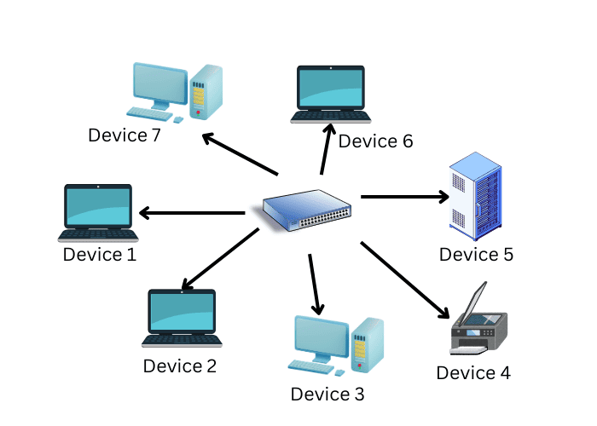
Picture.1 Star Topology
- Mesh Topology
All devices are connected to each other, and the data flow takes place directly among themselves without being connected to a device (gateway/router). It has high reliability, can self-heal, but consumes more energy than star topology. Zigbee and Thread systems in IOT can be given as examples of this topology.

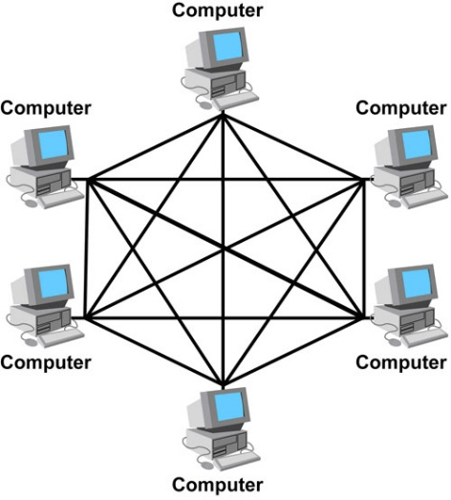
Picture.2 Mesh Topology
In large-scale networks, Star and Mesh topology differ in many criteria, especially throughput, latency and packet loss ratio.
Criteria | Star Topology | Mesh Topology
Architecture | Central (hub/gateway) | Distributed (multi-link)
Scalability | Limited (gateway bottleneck) | Very high
Throughput | A bottleneck occurs in the center | Traffic is distributed
Latency | Low at first, increases in load | More stable, but sometimes higher
Packet Loss | Very high in center failure | Low (there are alternative ways)
Reliability | Low (single point of failure) | Very high (self-healing)
Energy Consumption | Low | High (routing cost)
Management | Simple | Complex
Table.2
Looking at the data in Table.2, as the number of devices increases in the Star topology, the throughput (bottleneck) latency increases, and the risk of packet loss increases. In the mesh topology, as the number of devices increases, the network becomes more resilient, traffic is distributed, and packet loss decreases. It can be preferred in both topologies according to usage needs. (IEEE, 2020).
In this part of the article, IOT protocols are classified according to their layer and intended use. MQTT, CoAP, HTTP, AMQP and DDS protocols were compared in terms of energy efficiency, latency and scalability to show which protocol is suitable for which purposes. In addition, information about Star and Mesh topologies was given and their features were shown by comparison.
With rapid growth in IoT technology, there have been several security concerns arising mainly due to issues related to scalability. Because the number of interconnected devices reaches billions, traditional security methods become insufficient and creating various attack surfaces.
4.1. Security Vulnerabilities Arising from Scalability
When IoT networks reach a large-scale, key management becomes a bottleneck for the entire system. Also, distributing, updating and cancelling unique cryptographic keys among varied devices is costly in terms of calculation and logistically complex. In addition, authentication is often not scalable. Connection requests from many devices at the same time causes overload of the central authentication servers and service become unavailable (Chuang & Lee, 2014).
4.2. Network Congestion and Performance Risks
Scalability directly effects network performance and causes more vulnerable security breaches. As more devices come together in a network, the probability of protocol collisions increases. These collisions lead to data loss and increased retransmission rates. This issue makes the network vulnerable to Distributed Denial of Service (DDoS) attacks. Attackers, can turn numerous insecure devices into botnets using weakened protocols and can make IoT system services unusable by bombarding the network with traffic (Lin et al., 2017).
4.3. Energy Consumption and Protocol Overhead
Most of IoT devices have limited resources and a limited battery power. By adding strong security layers in these devices, we increase the protocol overhead because of extra packet size needed for encryption headers and handshake messages. In a large-scale deployment, this extra overhead causes significant battery depletion. This situation causes "Sleep Deprivation Attacks" where attackers keep the devices awake and using their energy until they run out, causing permanent node and network connection failure (Lin et al., 2017).
4.4. Single Point of Failure (SPoF)
Centralized or broker-based systems poses an important risk, such as standard MQTT architectures (Chuang & Lee, 2014). Because many devices depend on a single broker for message routing creates a critical vulnerability, turning central point into a target for attackers. Any successful breach or a technical crash at this central point can cause a cascading failure, leading to the complete collapse of a large-scale system like a smart city infrastructure (Lin et al., 2017).
In conclusion making an IoT network bigger is always a balance between growing the network and keeping it safe. As IoT networks get bigger, they have risks from centralized management using too much energy and network problems. To deal with these risks Internet of Things networks need to use security that is not controlled by one main computer and protocols that are not too heavy, for the devices so they can keep growing without making the system weak (Al-Fuqaha et al. 2015).
As more and more devices are added to the Internet of Things, the old centralized networks can no longer keep up. Manufacturers are constantly adding new devices to the market and all of them want to go online. To manage such an increase, it is not a single centralized system, but rather a distributed system. (Al-Fuqaha et al., 2015)
The two important issues here are edge and fog computing, instead of sending all the data in the environment to the remote for me cloud drive, it is at the edge, that is, next to the devices where it creates the information. As a result, the devices can react instantly. It provides improvements in different examples such as driverless cars, robotics or smart hospital systems. When we process data locally, there is an advantage that we save bandwidth as it sends less data to the cloud, and we prevent possible network congestion oluyoruz.art It is more reliable because it is not tied to a single point. (Chiang & Zhang, 2016)
Another topic I will mention is Software Defined Networking (SDN). The task of sdn is that it allows you to program itself. In fact,maybe you are doing this, you are separating the brain from the installation, companies or organizations can see how data is moving in real time, if we think about machine learning, you can manage or detect traffic flow. The ever-growing accumulation of devices can be quite challenging for us (Kreutz et al., 2015)
To be honest, Iot is not a very powerful device because it does not have much processing power or more than one battery from my perspective. Since it has such features, its normal encryption is unrealistic. Lightweight encryption guess is important because with more useful algorithms we can provide security without draining batteries and slowing down devices. (Raza et al., 2013).
Sometimes it can make adjustments accordingly. For example, it might change the communication method when the network is congested. Or it might rearrange devices to save power when power consumption is high. Or it might optimize frequencies and channels to reduce interference. Thanks to these capabilities, everything works more efficiently and smoothly. (Zhang et al., 2020)
Conclusion
In this research report, it is stated that IoT communication standards are not just methods of superficial data transfer, but the very basics of ensuring sustainable operation and very large expansion of the system. Extremely small resource nodes are mainly linked to global Internet standards based on IPv6 such as 6LoWPAN and 6TiSCH for communication. This makes the platform very immune to accommodation of different network topologies. However, upgrading the protocol all at once has always been the main problem of the research; besides that, local data processing through edge and fog computing is gradually becoming the differentiating feature (Mirani et al., 2022). In the end, continuing the search for the best security, lowest power consumption, and highest scalability will be the research area to make the smart environments of the future (Ali et al., 2015).

REFERENCES
- Ali, Z. H., Ali, H. A., & Badawy, M. M. (2015). Internet of Things (IoT): Definitions, challenges and recent research directions. International Journal of Computer Applications, 128(1), 37–47.
- Görmüş, S., Aydın, H., & Ulutaş, G. (2018). Security for the internet of things: A survey of existing mechanisms, protocols and open research issues. Journal of the Faculty of Engineering and Architecture of Gazi University, 33(4), 1247–1272.
- Mirani, A. A., Velasco-Hernandez, G., Awasthi, A., & Walsh, J. (2022). Key challenges and emerging technologies in industrial IoT architectures: A review. Sensors, 22(15), 5836.
- Atzori, L., Iera, A., & Morabito, G. (2010). The Internet of Things: A survey.
- Tanenbaum, A. S., & Wetherall, D. J. (2011). Computer Networks. Course Notes (2026).
- OASIS. (2014). MQTT Version 3.1.1 specification.
- Shelby, Z., Hartke, K., & Bormann, C. (2014). The Constrained Application Protocol (CoAP) (RFC 7252). IETF.
- IEEE. (2020). IEEE 802.11 wireless LAN standard. IEEE Standards Association.
- LoRa Alliance. (2021). LoRaWAN specification.
- Rescorla, E. (2018). TLS 1.3 (RFC 8446). IETF.
- Object Management Group. (2015). Data Distribution Service (DDS) specification
- Chuang, M. C., & Lee, J. F. (2014). TEAM: Trust-extended authentication mechanism for vehicular ad hoc networks. IEEE Systems Journal, 8(3), 749-758.
- Lin, J., Yu, W., Zhang, N., Yang, X., Zhang, H., & Zhao, W. (2017). A survey on Internet of Things: Architecture, enabling technologies, security and privacy, and applications. IEEE Internet of Things Journal.
- Al-Fuqaha, A., Guizani, M., Mohammadi, M., Aledhari, M., & Ayyash, M. (2015). Internet of Things: A survey on enabling technologies, protocols, and applications. IEEE Communications Surveys & Tutorials

