Intra block copy
Abc_dae Intra Ibs Ibs

IBC merge/AMVP list construction
The IBC merge/AMVP list construction compared to VVC is modified as follows: Ibs Ibs
- The reference area is extended to the whole reconstructed area. Ibs Ibs
- Only if an IBC merge/AMVP candidate is valid, it can be inserted into the IBC merge/AMVP candidate list.
- Above-right, bottom-left, and above-left spatial candidates (belonging to the adjacent spatial candidate category) and one pairwise average candidate can be added into the IBC merge/AMVP candidate list.
- Template based adaptive reordering (ARMC-TM) is applied to IBC merge list with template cost calculated using SATD.
- Candidates from non-adjacent spatial neighboring blocks (a.k.a., non-adjacent candidates) can be added to the candidate lists of IBC merge modes and IBC AMVP. These non-adjacent candidates are inserted right after the adjacent spatial candidates. In addition, temporal BV candidates are derived from collocated positions and shifted collocated positions in the collocated pictures. The temporal BV candidates are added to the list between the non-adjacent BV candidates and the HBVP candidates for both IBC merge and IBC AMVP. The same reference area of non-adjacent merge in regular inter mode is reuse`d for the IBC.
- Auto-relocated block vector prediction (AR-BVP) candidates are added to the IBC merge and AMVP candidate list right after the HBVP candidates. As shown in Figure 62, a guiding block vector BV_{0,1} (i.e., an existing BVP already in the candidate list) associated with the current block B₀ points to a reference block B₁. If B₁ has a BV denoted as BV_{1,2} pointing to a reference block B₂, then BV_{0,2}, given by BV_{0,2} = BV_{0,1} +BV_{1,2}, is defined as the AR-BVP, guided by BV_{0,1}. When deriving BV_{n,n+1} guided by BV_{0,n,} all five positions including top-left (e.g., LT in Figure 63. The five positions in B_{n} (n is set to 1).), top-right (e.g., RT in Figure 63. The five positions in B_{n} (n is set to 1).), center (e.g., Ctr in Figure 63), bottom-left (e.g., LB in Figure 63), and bottom-right (e.g., RB in Figure 63) positions of B_{n} are checked to find BV_{n,n+1}.
- Restriction that adjacent spatial candidates cannot be used for IBC merge of a 4x4 CU is removed.
The HMVP table size for IBC is increased to 25. After up to 20 IBC merge candidates are derived with full pruning, they are reordered together. After reordering, the first 6 candidates with the lowest template matching costs are selected as the final candidates in the IBC merge list.
The zero vectors’ candidates to pad the IBC Merge/AMVP list are replaced with a set of BVP candidates located in the IBC reference region. A zero vector is invalid as a block vector in IBC merge mode, and consequently, it is discarded as BVP in the IBC candidate list.
Three candidates are located on the nearest corners of the reference region, and three additional candidates are determined in the middle of the three sub-regions (A, B, and C), whose coordinates are determined by the width, and height of the current block and the ΔX and ΔY parameters, as is depicted in Figure 64.
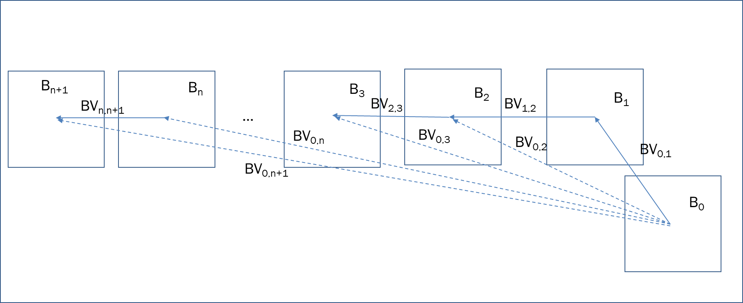
Figure 62. An example of how to derive AR-BVP.
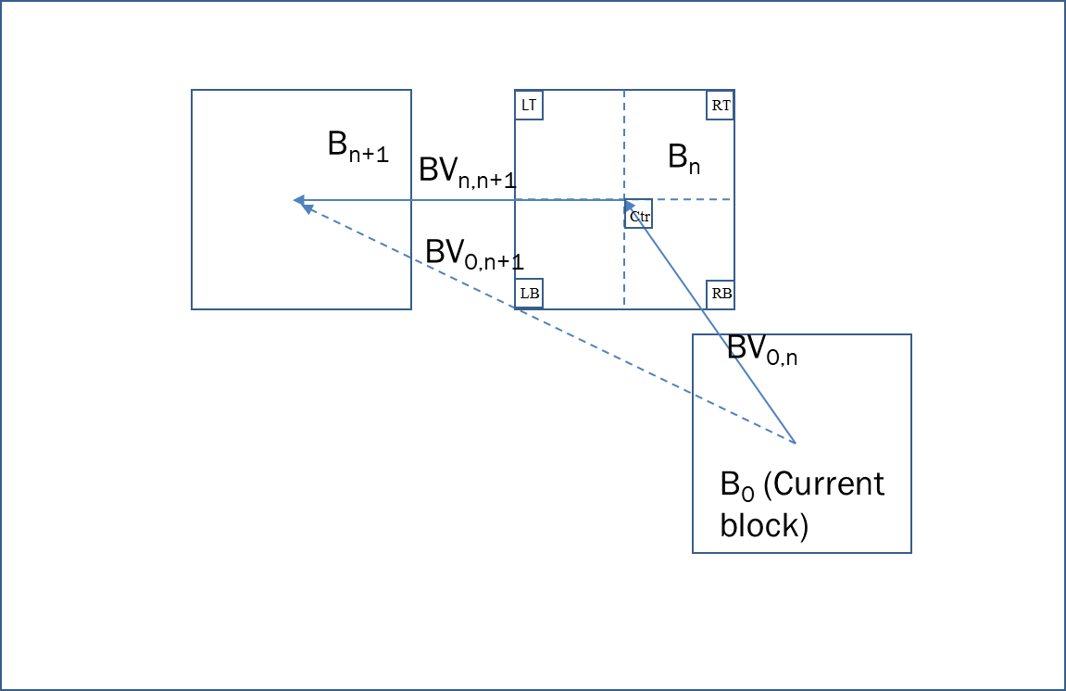
Figure 63. The five positions in B_{n} (n is set to 1).
During the IBC AMVP list construction, a clustering of the BVP candidates may be applied when both BV candidate components are non-zero. The clustering as shown in Figure 65 with L2 distance is applied if there are more than 2 valid BV candidates and up to 6 candidates are clustered, the clustering radius is defined as
$$Radius=\log_{2}{((cbWidth∙cbHeight)≫MIN_PU_SIZE)}$$
The clustering method is applied in the candidate list order, and the candidates assigned to a group are removed from the list for the subsequent clusters. In each group, the BVP with a lowest TM cost is selected as the representative candidate of that group. Finally, the representative candidates of the two first groups are chosen as the candidates for the IBC AMVP list.
Furthermore, if one of BV candidate components is zero or block is coded in RRIBC, a flag is signalled to indicate this case with a directional flag indicating horizontal or vertical component is non-zero. Instead of usual IBC AMVP list, two new BVP candidates are derived, and the sign of the non-zero BV component is derived at decoder side. The AMVP BVP0 is set to the nearest valid location to the current block (-cbWidth or -cbHeight), so the non-zero BVD is always negative, pointing to the left for a BV with a zero vertical component or to the above for a BV with a zero horizontal component. Likewise, the AMVP BVP1 is set to the farthest position from the current block in the valid reference region, that is the left boundary or the top boundary of the IBC search region. Consequently, if the BVP1 is selected, the BVD is always positive, pointing to the right for BV with a zero vertical component or to the bottom for BV with a zero-horizontal component.
Figure 64. Padding candidates for the replacement of the zero-vector in the IBC list.
$$Radius=\log_{2}{((cbWidth∙cbHeight)≫MIN_PU_SIZE)}$$
Figure 65. IBC candidate clustering based on the L2 distance and the TM cost.
The optimal IBC AMVP index is signalled, which allows deriving the sign of the non-zero BVD component at the decoder side. The absolute magnitude of non-zero BVD component is further signalled. In RRIBC, the direction of the flipping mode is derived from the signalled directional flag.

IBC with Template Matching
Template Matching is used in IBC for both IBC merge mode and IBC AMVP mode.
The IBC-TM merge list is modified compared to the one used by regular IBC merge mode such that the candidates are selected according to a pruning method with a motion distance between the candidates as in the regular TM merge mode. The ending zero motion fulfillment is replaced by motion vectors to the left (-W, 0), top (0, -H) and top-left (-W, -H), where W is the width and H the height of the current CU.
In the IBC-TM merge mode, the selected candidates are refined with the Template Matching method prior to the RDO or decoding process. The IBC-TM merge mode has been put in competition with the regular IBC merge mode and a TM-merge flag is signaled.
In the IBC-TM AMVP mode, up to 3 candidates are selected from the IBC-TM merge list. Each of those 3 selected candidates are refined using the Template Matching method and sorted according to their resulting Template Matching cost. Only the 2 first ones are then considered in the motion estimation process as usual.
The Template Matching refinement for both IBC-TM merge and AMVP modes is quite simple since IBC motion vectors are constrained (i) to be integer and (ii) within a reference region as shown in Figure 66. So, in IBC-TM merge mode, all refinements are performed at integer precision, and in IBC-TM AMVP mode, they are performed either at integer or 4-pel precision depending on the AMVR value. Such a refinement accesses only to samples without interpolation. In both cases, the refined motion vectors and the used template in each refinement step must respect the constraint of the reference region.

X
Curr
X
X
Curr
X
X
X
X
Curr
X

X
Curr
X
Figure 66: IBC reference region depending on current CU position.

Ibc reference area
The reference area for Ibs is extended to two CTU rows above. Figure 67 illustrates the reference area for coding CTU (m, n). Specifically, for CTU (m, n) to be coded, the reference area includes CTUs with index (m–2, n–2)…(W, n–2),(0, n–1)…(W, n–1),(0, n)…(m, n), where W denotes the maximum horizontal index within the current tile, slice or picture. When CTU size is 256, the reference area is limited to one CTU row above. This setting ensures that for CTU size being 128 or 256, IBC does not require extra memory in the current ETM platform. The per-sample block vector search (or called local search) range is limited to [–(C << 1), C >> 2] horizontally and [–C, C >> 2] vertically to adapt to the reference area extension, where C denotes the CTU size. Ibs Ibs
Figure 67. Reference area for IBC when CTU (m, n) is coded. The blue block denotes the current CTU; green blocks denote the reference area; and the white blocks denote invalid reference area.

Fractional pel IBC
The option of block vector resolutions is extended to include quarter-pel resolution in additional to full-pel and 4-pel. Like inter AMVR syntax, the first bin is signalled to indicate whether BV is in quarter-pel resolution, and the second bin is signalled to switch between full-pel and 4-pel resolutions. The interpolation filters applied to the luma (8-tap) and chroma (6-tap existed inter interpolation) components of an IBC block. For template-based IBC tools, a 2-tap bilinear interpolation filter is applied to generate template prediction blocks. Reference sample padding is performed when some of them are located outside IBC reference area. When needed, it performs in horizontal direction first and then vertical direction.

Filtered IBC prediction
Additional filtered IBC mode is introduced, where a filter is applied to IBC predictor, which is derived by minimizing MSE between current and reference template.
Output of the filter is calculated as follows: xCb, nCbSX, xTbCmp, cIdx log2TrafoSize

TEST:
abc_def / abc_def_ghi / a0_def_ghi /
log2CbSizeC / log2TrafoSize / xCb, nCbSX, xTbCmp, cIdx /
xY, qP, bS,
x0, y1
d,
CbSaX
ABC_MODE
If / if / When / when / coding unit
Cb is greater than 10 / Cb is less than 10 / A is equal to log2TrafoSize[ 0 ][ 1 ] / Cb are not equal to log
Cbs are set equal to ABC_MODE / Cbs are set equal to abc_def
ue(v), se(v), or ae(v) ae(v), Max( 0, QState − 1 )
수학식: $f_{D}\left(k,l\right)=f\left(l,k\right),$ $c_{D}\left(k,l\right)=c\left(l,k\right)$ / 대응텍스트: ,𝑓-𝐷.,𝑘,𝑙.=𝑓,𝑙,𝑘., ,𝑐-𝐷.,𝑘,𝑙.=𝑐,𝑙,𝑘.
$$K\left(x,y\right)=min⁡(y,\max\left(-y,x\right))$$

predLumaVal = c0C + c1N + c2S + c3E + c4W + c5P + c6B
The nonlinear term P is represented as power of two of the center sample C and scaled to the sample value range of the content:
P = ( C*C + midVal ) >> bitDepth
The bias term B represents a scalar offset between the input and output and is set to middle luma value (512 for 10-bit content).
This filtered mode is used as an additional mode for non-merge IBC blocks, and it is not used together with IBC-LIC, IBC-CIIP or RR-IBC. For IBC merge modes, this filtering mode is inherited when merge mode list is constructed. The mode flag is signalled before the IBC-LIC flag.

BVD prediction
Similar to MVD prediction, possible BVD sign combinations of IBC mode are sorted according to the template matching cost. Moreover, the first 4 most signification suffix bins of exponential Golomb code used to represent BVD magnitudes is also sorted according to the TM cost. An example is shown in Figure 68. Template matching operation is used to determine a BVD candidate with the best cost and indicate in the bitstream whether the best candidate is predicted correctly or not.
Figure 68. Prediction of BVD.

Reconstruction-Reordered IBC (RR-IBC)
A Reconstruction-Reordered IBC (RR-IBC) mode is allowed for IBC coded blocks. When RR-IBC is applied, the samples in a reconstruction block are flipped according to a flip type of the current block. At the encoder side, the original block is flipped before motion search and residual calculation, while the prediction block is derived without flipping. At the decoder side, the reconstruction block is flipped back to restore the original block.
Two flip methods, horizontal flip and vertical flip, are supported for RR-IBC coded blocks. A syntax flag is firstly signalled for an IBC AMVP coded block, indicating whether the reconstruction is flipped, and if it is flipped, another flag is further signaled specifying the flip type. For IBC merge and BV candidates in SGPM mode, the flip type is inherited from neighbouring blocks, without syntax signalling. Considering the horizontal or vertical symmetry, the current block and the reference block are normally aligned horizontally or vertically. Therefore, when a horizontal flip is applied, the vertical component of the BV is not signaled and inferred to be equal to 0. Similarly, the horizontal component of the BV is not signaled and inferred to be equal to 0 when a vertical flip is applied.
To better utilize the symmetry property, a flip-aware BV adjustment approach is applied to refine the block vector candidate. For example, as shown in Figure 69, (x_{nbr}, y_{nbr}) and (x_{cur}, y_{cur}) represent the coordinates of the center sample of the neighbouring block and the current block, respectively, BV^{nbr} and BV^{cur} denotes the BV of the neighbouring block and the current block, respectively. Instead of directly inheriting the BV from a neighbouring block, the horizontal component of BV^{cur} is calculated by adding a motion shift to the horizontal component of BV^{nbr} (denoted as BV^{nbr}_{h}) in case that the neighbouring block is coded with a horizontal flip, i.e., BV^{cur}_{h} =2(x_{nbr} -x_{cur}) + BV^{nbr}_{h} . Similarly, the vertical component of BV^{cur} is calculated by adding a motion shift to the vertical component of BV^{nbr} (denoted as BV^{nbr}_{v}) in case that the neighbouring block is coded with a vertical flip, i.e., BV^{cur}_{v} =2(y_{nbr} -y_{cur}) + BV^{nbr}_{v} .
Figure 69. Illustration of BV adjustment for (a) horizontal flip, and (b) vertical flip, respectively.
(a)
(b)

