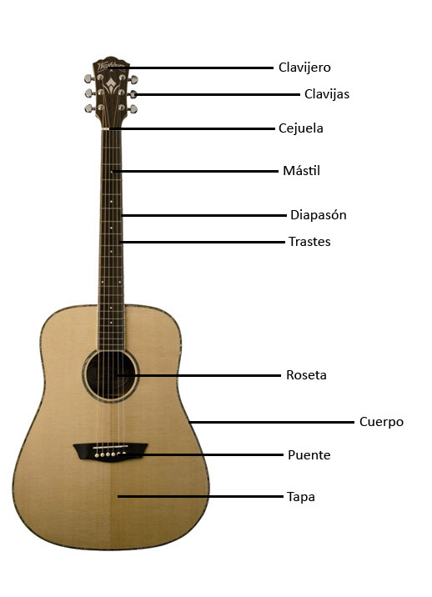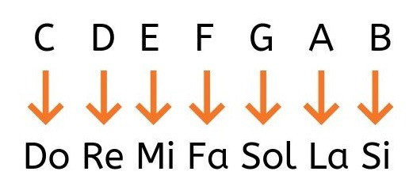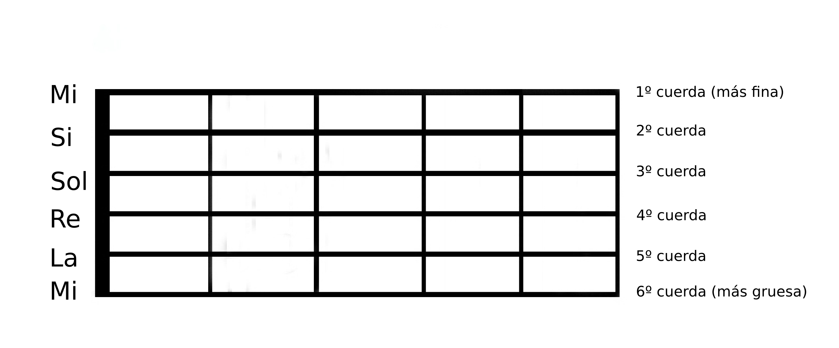

**FAMILIAS DE LAS NOTAS MAYORES**

Fíjate en que, para los acordes, normalmente utilizamos números romanos: mayúsculas para los acordes mayores y minúsculas para los acordes menores. De esta manera, podemos ver que los acordes mayores están en las posiciones I, IV y V. Los acordes menores estarán en las posiciones ii, iii, y vi

|  |  |  |  |  |  |  |
| --- | --- | --- | --- | --- | --- | --- |
| **Clave mayor** | **I** | **ii** | **iii** | **IV** | **V** | **vi** |
| A ([song examples](https://www.guitarplayerbox.com/es/select/chords/find/songs/?type=a&chSel=A%2cBm%2cCsharpm%2cD%2cE%2cFsharpm&maxcapo=0&element=deepButton)) | [A](javascript:TINY.box.show(%7bimage:'/images/Chords/diagram/A.jpg',boxid:'frameless',animate:true%7d)) | [Bm](javascript:TINY.box.show(%7bimage:'/images/Chords/diagram/Bm.jpg',boxid:'frameless',animate:true%7d)) | [C#m](javascript:TINY.box.show(%7bimage:'/images/Chords/diagram/Csharpm.jpg',boxid:'frameless',animate:true%7d)) | [D](javascript:TINY.box.show(%7bimage:'/images/Chords/diagram/D.jpg',boxid:'frameless',animate:true%7d)) | [E](javascript:TINY.box.show(%7bimage:'/images/Chords/diagram/E.jpg',boxid:'frameless',animate:true%7d)) | [F#m](javascript:TINY.box.show(%7bimage:'/images/Chords/diagram/Fsharpm.jpg',boxid:'frameless',animate:true%7d)) |
| B | [B](javascript:TINY.box.show(%7bimage:'/images/Chords/diagram/B.jpg',boxid:'frameless',animate:true%7d)) | [C#m](javascript:TINY.box.show(%7bimage:'/images/Chords/diagram/Csharpm.jpg',boxid:'frameless',animate:true%7d)) | [D#m](javascript:TINY.box.show(%7bimage:'/images/Chords/diagram/Dsharpm.jpg',boxid:'frameless',animate:true%7d)) | [E](javascript:TINY.box.show(%7bimage:'/images/Chords/diagram/E.jpg',boxid:'frameless',animate:true%7d)) | [F#](javascript:TINY.box.show(%7bimage:'/images/Chords/diagram/Fsharp.jpg',boxid:'frameless',animate:true%7d)) | [G#m](javascript:TINY.box.show(%7bimage:'/images/Chords/diagram/Gsharpm.jpg',boxid:'frameless',animate:true%7d)) |
| C ([song examples](https://www.guitarplayerbox.com/es/select/chords/find/songs/?type=a&chSel=Am&chSel=C&chSel=Dm&chSel=Em&chSel=F&chSel=G&maxcapo=0&element=deepButton)) | [C](javascript:TINY.box.show(%7bimage:'/images/Chords/diagram/C.jpg',boxid:'frameless',animate:true%7d)) | [Dm](javascript:TINY.box.show(%7bimage:'/images/Chords/diagram/Dm.jpg',boxid:'frameless',animate:true%7d)) | [Em](javascript:TINY.box.show(%7bimage:'/images/Chords/diagram/Em.jpg',boxid:'frameless',animate:true%7d)) | [F](javascript:TINY.box.show(%7bimage:'/images/Chords/diagram/F.jpg',boxid:'frameless',animate:true%7d)) | [G](javascript:TINY.box.show(%7bimage:'/images/Chords/diagram/G.jpg',boxid:'frameless',animate:true%7d)) | [Am](javascript:TINY.box.show(%7bimage:'/images/Chords/diagram/Am.jpg',boxid:'frameless',animate:true%7d)) |
| D ([song examples](https://www.guitarplayerbox.com/es/select/chords/find/songs/?type=a&chSel=A&chSel=Bm&chSel=D&chSel=Em&chSel=Fsharpm&chSel=G&maxcapo=0&element=deepButton)) | [D](javascript:TINY.box.show(%7bimage:'/images/Chords/diagram/D.jpg',boxid:'frameless',animate:true%7d)) | [Em](javascript:TINY.box.show(%7bimage:'/images/Chords/diagram/Em.jpg',boxid:'frameless',animate:true%7d)) | [F#m](javascript:TINY.box.show(%7bimage:'/images/Chords/diagram/Fsharpm.jpg',boxid:'frameless',animate:true%7d)) | [G](javascript:TINY.box.show(%7bimage:'/images/Chords/diagram/G.jpg',boxid:'frameless',animate:true%7d)) | [A](javascript:TINY.box.show(%7bimage:'/images/Chords/diagram/A.jpg',boxid:'frameless',animate:true%7d)) | [Bm](javascript:TINY.box.show(%7bimage:'/images/Chords/diagram/Bm.jpg',boxid:'frameless',animate:true%7d)) |
| E ([song examples](https://www.guitarplayerbox.com/es/select/chords/find/songs/?type=a&chSel=A&chSel=B&chSel=Csharpm&chSel=E&chSel=Fsharpm&maxcapo=0&element=deepButton)) | [E](javascript:TINY.box.show(%7bimage:'/images/Chords/diagram/E.jpg',boxid:'frameless',animate:true%7d)) | [F#m](javascript:TINY.box.show(%7bimage:'/images/Chords/diagram/Fsharpm.jpg',boxid:'frameless',animate:true%7d)) | [G#m](javascript:TINY.box.show(%7bimage:'/images/Chords/diagram/Gsharpm.jpg',boxid:'frameless',animate:true%7d)) | [A](javascript:TINY.box.show(%7bimage:'/images/Chords/diagram/A.jpg',boxid:'frameless',animate:true%7d)) | [B](javascript:TINY.box.show(%7bimage:'/images/Chords/diagram/B.jpg',boxid:'frameless',animate:true%7d)) | [C#m](javascript:TINY.box.show(%7bimage:'/images/Chords/diagram/Csharpm.jpg',boxid:'frameless',animate:true%7d)) |
| F ([song examples](https://www.guitarplayerbox.com/es/select/chords/find/songs/?type=a&chSel=Am&chSel=Asharp&chSel=C&chSel=Dm&chSel=F&chSel=Gm&maxcapo=0&element=deepButton)) | [F](javascript:TINY.box.show(%7bimage:'/images/Chords/diagram/F.jpg',boxid:'frameless',animate:true%7d)) | [Gm](javascript:TINY.box.show(%7bimage:'/images/Chords/diagram/Gm.jpg',boxid:'frameless',animate:true%7d)) | [Am](javascript:TINY.box.show(%7bimage:'/images/Chords/diagram/Am.jpg',boxid:'frameless',animate:true%7d)) | [A#](javascript:TINY.box.show(%7bimage:'/images/Chords/diagram/Asharp.jpg',boxid:'frameless',animate:true%7d)) | [C](javascript:TINY.box.show(%7bimage:'/images/Chords/diagram/C.jpg',boxid:'frameless',animate:true%7d)) | [Dm](javascript:TINY.box.show(%7bimage:'/images/Chords/diagram/Dm.jpg',boxid:'frameless',animate:true%7d)) |
| G ([song examples](https://www.guitarplayerbox.com/es/select/chords/find/songs/?type=a&chSel=Am&chSel=Bm&chSel=C&chSel=D&chSel=Em&chSel=G&maxcapo=0&element=deepButton)) | [G](javascript:TINY.box.show(%7bimage:'/images/Chords/diagram/G.jpg',boxid:'frameless',animate:true%7d)) | [Am](javascript:TINY.box.show(%7bimage:'/images/Chords/diagram/Am.jpg',boxid:'frameless',animate:true%7d)) | [Bm](javascript:TINY.box.show(%7bimage:'/images/Chords/diagram/Bm.jpg',boxid:'frameless',animate:true%7d)) | [C](javascript:TINY.box.show(%7bimage:'/images/Chords/diagram/C.jpg',boxid:'frameless',animate:true%7d)) | [D](javascript:TINY.box.show(%7bimage:'/images/Chords/diagram/D.jpg',boxid:'frameless',animate:true%7d)) | [Em](javascript:TINY.box.show(%7bimage:'/images/Chords/diagram/Em.jpg',boxid:'frameless',animate:true%7d)) |

**FAMILIAS DE NOTAS MENORES**

El siguiente gráfico de tonalidades de acordes muestra las claves menores. En este caso los acordes mayores están en las posiciones III, VI y VII. Los acordes menores están en las posiciones i, iv y v.

|  |  |  |  |  |  |  |
| --- | --- | --- | --- | --- | --- | --- |
| **Clave menor** | **i** | **III** | **iv** | **v** | **VI** | **VII** |
| Am ([song examples](https://www.guitarplayerbox.com/es/select/chords/find/songs/?type=a&chSel=Am&chSel=C&chSel=Dm&chSel=Em&chSel=F&chSel=G&maxcapo=0&element=deepButton)) | [Am](javascript:TINY.box.show(%7bimage:'/images/Chords/diagram/Am.jpg',boxid:'frameless',animate:true%7d)) | [C](javascript:TINY.box.show(%7bimage:'/images/Chords/diagram/C.jpg',boxid:'frameless',animate:true%7d)) | [Dm](javascript:TINY.box.show(%7bimage:'/images/Chords/diagram/Dm.jpg',boxid:'frameless',animate:true%7d)) | [Em](javascript:TINY.box.show(%7bimage:'/images/Chords/diagram/Em.jpg',boxid:'frameless',animate:true%7d)) | [F](javascript:TINY.box.show(%7bimage:'/images/Chords/diagram/F.jpg',boxid:'frameless',animate:true%7d)) | [G](javascript:TINY.box.show(%7bimage:'/images/Chords/diagram/G.jpg',boxid:'frameless',animate:true%7d)) |
| Bm | [Bm](javascript:TINY.box.show(%7bimage:'/images/Chords/diagram/Bm.jpg',boxid:'frameless',animate:true%7d)) | [D](javascript:TINY.box.show(%7bimage:'/images/Chords/diagram/D.jpg',boxid:'frameless',animate:true%7d)) | [Em](javascript:TINY.box.show(%7bimage:'/images/Chords/diagram/Em.jpg',boxid:'frameless',animate:true%7d)) | [F#m](javascript:TINY.box.show(%7bimage:'/images/Chords/diagram/Fsharpm.jpg',boxid:'frameless',animate:true%7d)) | [G](javascript:TINY.box.show(%7bimage:'/images/Chords/diagram/G.jpg',boxid:'frameless',animate:true%7d)) | [A](javascript:TINY.box.show(%7bimage:'/images/Chords/diagram/A.jpg',boxid:'frameless',animate:true%7d)) |
| Cm | [Cm](javascript:TINY.box.show(%7bimage:'/images/Chords/diagram/Cm.jpg',boxid:'frameless',animate:true%7d)) | [D#](javascript:TINY.box.show(%7bimage:'/images/Chords/diagram/Dsharp.jpg',boxid:'frameless',animate:true%7d)) | [Fm](javascript:TINY.box.show(%7bimage:'/images/Chords/diagram/Fm.jpg',boxid:'frameless',animate:true%7d)) | [Gm](javascript:TINY.box.show(%7bimage:'/images/Chords/diagram/Gm.jpg',boxid:'frameless',animate:true%7d)) | [G#](javascript:TINY.box.show(%7bimage:'/images/Chords/diagram/Gsharp.jpg',boxid:'frameless',animate:true%7d)) | [A#](javascript:TINY.box.show(%7bimage:'/images/Chords/diagram/Asharp.jpg',boxid:'frameless',animate:true%7d)) |
| Dm ([song examples](https://www.guitarplayerbox.com/es/select/chords/find/songs/?type=a&chSel=Am&chSel=Asharp&chSel=C&chSel=Dm&chSel=F&chSel=Gm&maxcapo=0&element=deepButton)) | [Dm](javascript:TINY.box.show(%7bimage:'/images/Chords/diagram/Dm.jpg',boxid:'frameless',animate:true%7d)) | [F](javascript:TINY.box.show(%7bimage:'/images/Chords/diagram/F.jpg',boxid:'frameless',animate:true%7d)) | [Gm](javascript:TINY.box.show(%7bimage:'/images/Chords/diagram/Gm.jpg',boxid:'frameless',animate:true%7d)) | [Am](javascript:TINY.box.show(%7bimage:'/images/Chords/diagram/Am.jpg',boxid:'frameless',animate:true%7d)) | [A#](javascript:TINY.box.show(%7bimage:'/images/Chords/diagram/Asharp.jpg',boxid:'frameless',animate:true%7d)) | [C](javascript:TINY.box.show(%7bimage:'/images/Chords/diagram/C.jpg',boxid:'frameless',animate:true%7d)) |
| Em ([song examples](https://www.guitarplayerbox.com/es/select/chords/find/songs/?type=a&chSel=Am&chSel=Bm&chSel=C&chSel=D&chSel=Em&chSel=G&maxcapo=0&element=deepButton)) | [Em](javascript:TINY.box.show(%7bimage:'/images/Chords/diagram/Em.jpg',boxid:'frameless',animate:true%7d)) | [G](javascript:TINY.box.show(%7bimage:'/images/Chords/diagram/G.jpg',boxid:'frameless',animate:true%7d)) | [Am](javascript:TINY.box.show(%7bimage:'/images/Chords/diagram/Am.jpg',boxid:'frameless',animate:true%7d)) | [Bm](javascript:TINY.box.show(%7bimage:'/images/Chords/diagram/Bm.jpg',boxid:'frameless',animate:true%7d)) | [C](javascript:TINY.box.show(%7bimage:'/images/Chords/diagram/C.jpg',boxid:'frameless',animate:true%7d)) | [D](javascript:TINY.box.show(%7bimage:'/images/Chords/diagram/D.jpg',boxid:'frameless',animate:true%7d)) |
| Fm | [Fm](javascript:TINY.box.show(%7bimage:'/images/Chords/diagram/Fm.jpg',boxid:'frameless',animate:true%7d)) | [G#](javascript:TINY.box.show(%7bimage:'/images/Chords/diagram/Gsharp.jpg',boxid:'frameless',animate:true%7d)) | [A#m](javascript:TINY.box.show(%7bimage:'/images/Chords/diagram/Asharpm.jpg',boxid:'frameless',animate:true%7d)) | [Cm](javascript:TINY.box.show(%7bimage:'/images/Chords/diagram/Cm.jpg',boxid:'frameless',animate:true%7d)) | [C#](javascript:TINY.box.show(%7bimage:'/images/Chords/diagram/Csharp.jpg',boxid:'frameless',animate:true%7d)) | [D#](javascript:TINY.box.show(%7bimage:'/images/Chords/diagram/Dsharp.jpg',boxid:'frameless',animate:true%7d)) |
| Gm | [Gm](javascript:TINY.box.show(%7bimage:'/images/Chords/diagram/Gm.jpg',boxid:'frameless',animate:true%7d)) | [A#](javascript:TINY.box.show(%7bimage:'/images/Chords/diagram/Asharp.jpg',boxid:'frameless',animate:true%7d)) | [Cm](javascript:TINY.box.show(%7bimage:'/images/Chords/diagram/Cm.jpg',boxid:'frameless',animate:true%7d)) | [Dm](javascript:TINY.box.show(%7bimage:'/images/Chords/diagram/Dm.jpg',boxid:'frameless',animate:true%7d)) | [D#](javascript:TINY.box.show(%7bimage:'/images/Chords/diagram/Dsharp.jpg',boxid:'frameless',animate:true%7d)) | [F](javascript:TINY.box.show(%7bimage:'/images/Chords/diagram/F.jpg',boxid:'frameless',animate:true%7d)) |