Motors

|  |  |  |
| --- | --- | --- |
| AKM 33H |  | Used in Park et al., 2020  Not suitable for wearble applications because of need high voltage supply – 480 V |
| Power 300 servo |  | Weight: 670g  Torque: 300Kg*cm  Range: 270° |
| ASMC | ASMC-04A |  |
|  | ASMC-04B |  |
| ASME | ASME-02 series  (ASME-02A and ASME-02B) | <https://content.instructables.com/ORIG/FCA/QIQI/IQA4XCJY/FCAQIQIIQA4XCJY.pdf> 12V~24V  550g  220kg.cm and 340kg.cm max  No 360° |
|  | ASME-03 series | **Not found** |
|  | ASME-04 series | **\* ASME-04A Starting torque 260kg.cm max; Holding torque 220kg.cm max; Rated speed (24V power supply): 0.12s/60°**  <https://www.ebay.com/itm/124563092741?hash=item1d0089f505:g:WPYAAOSwZWJgH6T8>  * ASME-04B Starting torque 380kg.cm max; Holding torque 340kg.cm max; Rated speed (24V power supply): 0.5s/60° |
|  | ASME-MR series | 360-degree controllable range.  * ASME-MRA  Starting torque 260kg.cm max; Holding torque 220kg.cm max; Rated speed (24V power supply): 0.12s/60°  <https://www.ebay.com/itm/284127802544?_trkparms=aid%3D1110018%26algo%3DHOMESPLICE.COMPLISTINGS%26ao%3D1%26asc%3D232171%26meid%3D66ae7bfa6ec1431e96ebf5b95f4dd70b%26pid%3D101196%26rk%3D3%26rkt%3D12%26mehot%3Dpf%26sd%3D133709339784%26itm%3D284127802544%26pmt%3D1%26noa%3D0%26pg%3D2047675%26algv%3DItemStripV101HighAdFeeWithCompV3Ranker%26brand%3DUnbranded&_trksid=p2047675.c101196.m2219>  * ASME-MRB  Starting torque 380kg.cm max; Holding torque 340kg.cm max; Rated speed (24V power supply): 0.5s/60° |
|  | ASME-MX series | Steel Gear  *ASME-MXB  High Torque Servo DC 12V~24V 380kg.cm Steel Gear 3600 Degree for Large Robot  <https://www.ebay.com/itm/124644475179?hash=item1d0563c12b:g:BDkAAOSwAyxgVZ8I>  *ASME-MXA  <https://www.ebay.com/itm/284221598925?hash=item422ced6ccd:g:T-kAAOSwV4FgUIIj>  * 0.12s/60° (0.12s is required to turn 60 degrees), at 24V;  * 0.24s/60° (It takes 0.24s to turn 60 degrees), at 12V |

* Servo Horn
* Nyloncoated stainless-steel cable
* cable spool
* Waist belt and a pulley system
* Battery 12-24 V
* 2 Arduino boards with Bluetooth
* Load cell

|  |  |  |
| --- | --- | --- |
| MLP-25 | Used in the paper Park et al. 2020 | Small, compact and expensive |
|  |  |  |

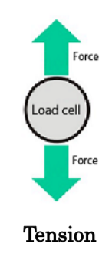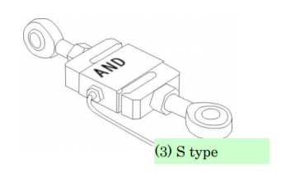

* In order to control the timing when the pelvic resistance force was delivered, the ankle position signals were measured using **two custom designed 3-dimensional position sensors**.

The controller used the ankle position signals to trigger the resistance force at targeted phase of gait.