Part A.
A1. Your genders.
Male | Female

A2. How old are you?
60-70 | 70-80 | ＞80

A3. What is your weight and High? (single choice for each)
＜40KG | 40-50kg | 50-60kg | 60-70kg | ＞70kg
＜150CM | 150-160CM | 160-170CM | 170-180CM | ＞180CM

A4. What are the main activities you have done in the last 20 minutes? (single choice for each)
Reclining | Seat, quiet | Standing/Talking/Housework/Playing cards
Walking | Dancing, exercise

A5. What is your location? (single choice for each)
East-west street | North-south street
Green land | Open space

A6. What are you wearing at the moment? Overall:
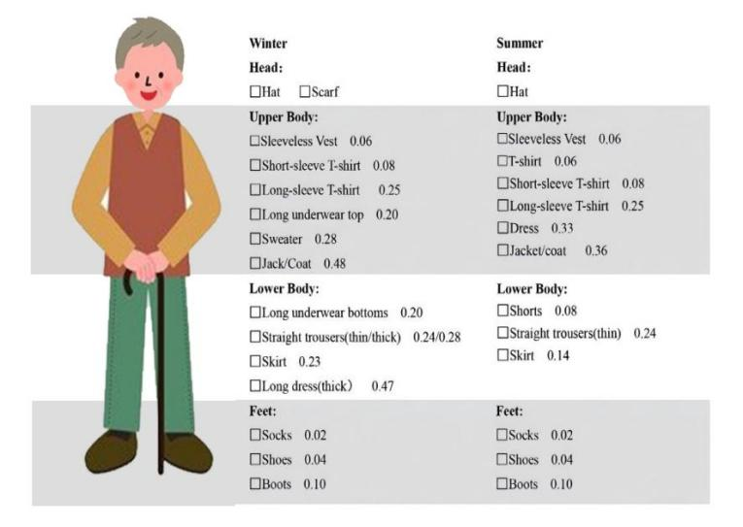
Part B
B1. How warm or cold you feel? (single choice for each)
Cold | Cool | Slightly Cool | Neutral | Slightly Warm | Warm | Hot
(-3) | (-2) | (-1) | (0) | (+1) | (+2) | (+3)

B2. Please describe your thermal comfort level now? (single choice for each)
Very Discomfort | Discomfort | Neutral | Comfort | Very Comfort
(-2) | (-1) | (0) | (+1) | (+2)

B3. You will be more comfortable if the air temperature？(single choice for each)
Lower | No change | Higher
(-1) | (0) | (+1)

B4. You will be more comfortable if the relative humidity？ (single choice for each)
Lower | No change | Higher
(-1) | (0) | (+1)

B5. You will be more comfortable if the wind speed？ (single choice for each)
Lower | No change | Higher
(-1) | (0) | (+1)

B6. You will be more comfortable if the solar radiation？ (single choice for each)
Lower | No change | Higher
(-1) | (0) | (+1)

B7. Can you acceptable this place? (single choice for each)
Unacceptable | Acceptable
(0) | (+1)

Part C
C1.What time of day are you outside? (multiple choice possible)
6:00-8:00 | 8:00-10:00 | 10:00-12:00 | 12:00-14:00
14:00-16:00 | 16:00-18:00 | 18:00-20:00 | 20:00-22:00

C2. How long on average do you spend outside each day? (single choice for each)
0-30min | 30-60min | 60-120min | ＞120min

C3. What do you usually go out for? (multiple choice possible)
Walking | Chatting | Participate in activities
looking after children | Basking in the sun or shade | Breathing fresh air
Exercise

C4. Where do you often have activities? (multiple choice possible)
Close to home | Many friends | Nice view
feel Cooling | Kids love it | Large venue
labor

Tree arrangements preference
C5. What is your preferred tree height? (multiple choices allowed)
Short trees ( ≤ 5 m) | Medium height trees ( 5-15 m)
Tall trees ( ≥ 15 m) | Mix of short, medium and tall trees

C6. What is your preferred tree planting density for outdoor activities? (multiple choices allowed)
Dense, creating large areas of shade
Medium density, providing both shade and sunlight
Sparse, mainly for decoration and landscaping

C7. What is your preferred way of arranging trees? (multiple choices allowed)
Neatly arranged, formal layout
Natural growth, random distribution
Concentrated small groups of trees to form landscape spots

C8. What is your preference for seasonal changes in trees? (multiple choices allowed)
Prefer seasonal changes to add variety to the landscape
Prefer evergreen trees and consistency in the landscape
No particular preference

C9. What function would you most like trees to provide? (multiple choices allowed)
Provides space to move around
Provides more beautiful views
Provides more shade

C10. How would you like thermal comfort in daily activities? (multiple choices allowed)
Provide full shade to increase comfort, with thermal comfort a priority
Provide partial shade, allowing daylight to penetrate, balancing activity and thermal comfort
Prefer open areas with no visible shade, ease of movement preferred

C11. What is your preferred wind environment ? (multiple choices allowed)
Windless environment
Breezy flow
More gusty wind

