

LabTech Testing Limited

STANDARD TEST PROCEDURE
ASTM D6760
Integrity Testing of Concrete Deep Foundation by
Crosshole Sonic Logging Test

(Document Code: STP03-FDT-D6760)

Revision No.: 3

(Holder: Intranet)
UNCONTROLLED COPY

IMPLEMENTATION DATE |  | 02 May 2026
PREPARED BY | :
 |  | (Senior Engineer, Chu Lap Man Raymond)
APPROVED BY | :
 |  | (Laboratory Manager, Lam Hoi Fan James)

Controlled copy is stamped with ‘CONTROLLED DOCUMENT”. This document is the property of LabTech Testing Limited. It shall not be reproduced in whole or in part without the approval of the Laboratory Director. UNCONTROLLED copy is not subject to update. Only CONTROLLED copy shall be used as working document.

Table of Content

1. Introduction 3
2. Definitions 3
3. Principle 4
4. Limitations 5
5. Equipment 5
6. Testing Procedures 6
7. Calculation 9
8. Record 11
9. Report 11
10. Specific Calibration / Verification Requirements 12
11. Measurement Uncertainty 13

Figure & Tables
Figure 1 – Typical Ultrasonic Profile
Figure 2 – Test Arrangement
Figure 3 – Ultrasonic Profile with Defect Interpretations

REVISION LEDGER

Rev. No. | Section No. | Page(s) | Revision Outline
1 | NA | NA | First Issue
2 | cover  5.1.3  6.5 | cover  5  7 | Change test name to “Crosshole Sonic Logging Test”  Use of thermometer and operating temperature  Measure the distance between access tubes
3 | 2.1  5.14  6.11  6.15  6.17  6.20 | 3  5  7  8  8  9 | Typo revised  Equipment added  Internal temperature of the access tube revised  Testing procedure revised  Testing procedure revised  Testing procedure revised

- Introduction
  - This test method covers procedures for checking the homogeneity and integrity of concrete in deep foundation such as bored piles, drilled shafts, concrete piles or augercast piles. This method can also be extended to diaphragm walls, barrettes, dams etc. In this test method, all the above will be designated “deep foundation elements.”
  - The test shall be carried out only by approved personnel of a HOKLAS accredited laboratory.

- Definitions
  - Access Ducts: preformed steel tubes, placed in the concrete to allow probe entry in pairs to measure pulse transmission in the concrete between the probes.
  - Anomaly: irregularity or series of irregularities observed in an ultrasonic profile indicating a possible flaw.
  - Depth interval: the maximum incremental spacing along the pile shaft between ultrasonic pulses.
  - Flaw: any deviation from the planned shape or material (or both) of the element.
  - Integrity evaluation: the qualitative or quantitative evaluation of the concrete continuity and consistency between the access ducts or boreholes.
  - Specifier: the party requesting that the tests are carried out, for example, the engineer or client.
  - Ultrasonic profile: a combined graphical output of a series of measured or processed ultrasonic pulses with depth.
  - Ultrasonic pulse: data for one specific depth of a short duration generated by a transmitter probe and sensed by the receiver probe.
  - Defects in sonic logging refer to structural flaws or discontinuities within the concrete that can affect the integrity or quality of the material，including:
    - Voids: Empty spaces within the concrete that can weaken the structure.
    - Cracks: Fractures in the concrete that can compromise its strength.
    - Delamination: Separation of layers within the concrete.
    - Honeycombing: Gaps or air pockets in the concrete mix.
  - Anomaly: in sonic logging tests refer to unexpected variations or deviations in the measured sound wave velocities that may indicate irregularities in the concrete structure. Anomalies can signal the presence of defects or changes in material properties such as:
    - Changes in material composition: Variations in aggregate distribution or concrete mix.
    - Moisture content: Variances in moisture levels affecting the concrete properties.
    - Deterioration: Degradation of the concrete over time due to environmental factors.
    - Variation in density: Inhomogeneities leading to fluctuations in sound wave velocities.

- Principle
  - Ensure that the testing procedures comply with environmental regulations and safety standards. Proper disposal of borehole fluids and waste materials is essential to minimize environmental impact.
  - Two ultrasonic probes, one a transmitter and the other a receiver, are lowered and lifted usually in unison in their respective water-filled access duct(s) to test the full shaft length from top to bottom.
  - The transmitter probe generates ultrasonic pulses at frequent and regular intervals during the probes’-controlled travel rate. The probe depth and receiver probe’s output (timed relative to the transmitter probe’s ultrasonic pulse generation) are recorded for each pulse.
  - The receiver’s output signals are sampled and saved as amplitude versus time for each sampled depth. These signals can be then nested to produce a “waterfall” diagram".

  - The data are further processed and presented to show the first arrival of the ultrasonic pulse and the relative energy of the signal to aid interpretation. The processed data are plotted versus depth as a graphical representation of the ultrasonic profile of the tested structure.

- Limitations
  - Proper installation of the access ducts is essential for effective testing and interpretation. The method does not give the exact type of defect (for example, inclusion, honeycombing, lack of cement particles, etc.) but rather only that a defect exists.
  - The method is limited primarily to testing the concrete between the access ducts and thus gives little information about the concrete outside the reinforcement cage to which the access ducts are attached when the tubes are attached to the inside of the reinforcement cage.

- Equipment
  - Apparatus for Determining Physical Test Parameters
    - Weighted Measuring Tape: A plumb bob connected to a measuring tape shall be used as a dummy probe to check free passage through and determine the unobstructed length of each access duct to the nearest 100 mm. The plumb bob shall have a diameter similar to the diameter of the probes.
    - Magnetic Compass: magnetic compass accurate to within 10° shall be used to document the access duct designations compared with the site layout plan.
    - Thermometer: temperature shall be recorded by using thermometer (Operating Temperature: 0°C to 40°C)
    - Stopwatch: A stopwatch capable of measuring time to the nearest second shall be used to monitor the duration of probe pulling to ensure the speed complies with the specified limits.

  - Apparatus for Obtaining Measurements
    - Probes: probes shall allow a generated or detected pulse within 125 mm of the bottom of the access duct. The weight of each probe shall in all cases be sufficient to allow it to sink under its own weight in the access ducts. The probe housing shall be waterproof to at least 1.5 times the maximum depth of testing.
    - Transmitter Probe: the transmitter probe shall generate an ultrasonic pulse with a frequency of between 30,000Hz and 60,000 Hz.
    - Receiver Probe: the receiver probe shall be of a similar size and compatible design to the transmitter probe and used to detect the arrival of the ultrasonic pulse generated by the transmitter probe.
    - Probe Centralizer: If the receiver or transmitter probes, or both, are less than half the access duct diameter, each probe shall be fitted with centralizers with effective diameter equivalent to at least 50 % of the access duct diameter. It shall be designed to minimize any possible snagging on irregularities in the inner access duct wall.
    - Signal Transmission Cables: the signal cables used to deploy the probes and transmit data from the probes shall be sufficiently robust to support the probes’ weight.
    - Probe Depth-Measuring Device: the depth-measuring device shall be accurate to within 1 % of the access duct length, or 0.25 m, whichever is larger.
  - Apparatus for Recording, Processing and Displaying Data
    - The CHAMP-Q instrument: The signals from the transmitter and receiver probes and the depth-measuring device shall be transmitted to a field rugged, computerized apparatus for recording, processing and displaying the data in the form of an ultrasonic profile.
    - Assesses concrete quality and consistency of drilled shafts and other cast-in-place concrete structures.
    - Performs real-time analysis on site, as well as data transfer with CHA-W reporting software for additional analysis.

- Testing Procedures
  - The access tubes shall be supplied and installed during construction by or in cooperation with the contractor of the deep foundation element to be tested.
  - Tubing work must be performed before concreting.
  - The access tubes shall be steel pipe typically with internal diameter 38mm to 150mm is preferable.
  - Measure the center-to-center distance between all access tubes at the top of the shaft using a measuring tape.
  - Use a magnetic compass to define and document the access tube orientation (Northing) compared with the site layout plan.
  - Use a weighted measuring tape to verify the unobstructed length of each access tube to the nearest 100 mm before inserting the probes.
  - Each tube shall be protected at both ends with screw-on caps.
  - After concreting, all the tubes must be checked that they are free of blockage or damage.
  - The tests shall be performed at least 7days after casting depending on concrete strength and shaft diameter (larger diameter shafts).
  - The access tube shall be filled to the top with clean water and need to cooling down the internal temperature of the access tube to be within 0°C to 30°C before the testing.
  - The functionality of the equipment should be checked according to the manufacturer’s operation instructions before the testing.
  - Interconnections of the CHAMP-Q instrument and set up for the CHA-W for data analysis.
  - Input all the test pile information into the panel including the following information provided by the customer:
    - Type of pile
    - Cast date for the concreting
    - Nominal size and length of the test pile
    - Existing ground level
    - Pile top level
    - Pile cut-off level
    - Pile toe level
    - Diameter and length of access tubes
  - Place the transmitter and receiver probes at the same level, carefully lower the probes down to the bottom of the access ducts, until both probes reach the bottom of the duct or encounter an obstruction. Adjust the level to ensure that both probes are aligned at the same level before lifting.
  - Lift the pair of probes by pulling the cables simultaneously at a steady rate. To ensure the pulling speed does not exceed the maximum limit of 0.5 m/s, the operator shall calculate the minimum pulling time required for each tube (e.g., Minimum Time [s] = Tube Length [m] / 0.5 [m/s]). A stopwatch should be used to monitor the process, ensuring the actual pulling time is not less than the calculated minimum time.
  - View and check the tested profile. Compare the length of the measured ultrasonic profile with the measured access tube length. The difference between the corrected measurement shall not exceed 1% of the measured length or 0.25m, whichever is larger. If the difference exceeds the allowable tolerance, the discrepancy shall be recorded on the worksheet, including the measured values and calculated difference and the Client shall be informed.
  - Repeat from clause 6.12 for the remaining pairs of access tubes.
  - A hard copy and soft copy of the ultrasonic profiles shall be clearly presented and annotated. The ultrasonic profiles shall be collated separately for each test deep foundation element. As a minimum, the profile shall include the calculated relative energy and the arrival time or apparent wave speed derived from the arrival time and tube spacing. The left edge of the traditional “waterfall” diagram also corresponds to the first arrival time.
  - A single pair of probes (one transmitter and one receiver) is used for each test profile to ensure clear signal transmission without interference.

  - For large-diameter piles, due to the long distance between pipes, the pulling speed should be reduced as much as possible, generally lower than 0.5m/s.
  - In the event that the same tube pair (e.g. 1–4, 2–5) is tested more than once across different test cycles, the PDI system automatically appends a suffix (e.g. -1, -2) to the profile file name (e.g. EPC 1-4.CHX, EPC 1-4-1.CHX) to differentiate between repeated soundings.
  - This suffix serves as a unique identifier, allowing the laboratory to trace, review, and compare each dataset independently. Profiles with suffixes are evaluated based on waveform clarity, FAT curve stability, and consistency before selecting the representative profile for reporting.
  - Selection Criteria:
Among the repeated profiles, the representative one is selected based on:
Waveform clarity (clear V-shaped arrivals, low noise);
Smooth and continuous FAT curve without abnormal jumps or early arrivals;
Delay% and Kv% distribution consistent with adjacent profiles;
Compliance with engineering standards (ASTM D6760, HKCI_TM3).

- Calculation
The velocity of sound (𝑉) in concrete during a sonic logging test is calculated as:
$V=\frac{D}{T}$
Where:
𝑉 = Velocity of sound in the concrete (m/s or ft/s).
𝐷 = Horizontal distance between the transmitter and receiver probes (m or ft).
𝑇 = Travel time of the ultrasonic wave between the transmitter and receiver probes (seconds).

Explanation of the Parameters
1. Distance (𝐷)
This is the fixed distance between the access tubes embedded in the concrete.
The access tubes are installed parallel to each other within the foundation before pouring the concrete.
The distance is measured center-to-center between the tubes and should be recorded during installation.
2. Travel Time (𝑇)
This is the time it takes for the ultrasonic wave to travel from the transmitter probe to the receiver probe.
The travel time is measured directly during the test using a CSL testing device.
The first arrival of the sonic wave (the first arrival time) is used to calculate the wave velocity.
3. Velocity (𝑉)
The calculated velocity indicates the quality and integrity of the concrete:
Higher velocities typically indicate sound, well-compacted concrete.
Lower velocities suggest defects such as voids, cracks, or poorly consolidated areas.
Detailed Calculation Process
- Input Parameters:
  - Measure the distance (D) between the access tubes.
  - Record the travel time (T) for the ultrasonic wave between the transmitter and receiver probes at each test depth.
- Apply the Formula:
  - Use the equation $V=\frac{D}{T}$ to calculate the wave velocity at each test depth.

- Interpret Results:
  - Compare the calculated velocity to typical values for concrete:
    - Good-quality concrete: Velocities above 3,500 m/s (or 11,500 ft/s).
    - Poor-quality concrete: Velocities significantly below this range (e.g., < 3,000 m/s, or 9,800 ft/s)

- Record
  - Worksheet: FST03-FDT-D6760
  - Test Report template: FDT-D6760-RT
  - Daily Record: FQS09-FDT-D6760

- Report
  - General
    - Project and client identification
    - Date of test
    - Description of the testing apparatus unit and probes
    - Identification of test staff and of person responsible for the validity of the test report.
  - Test Deep Foundation Element
    - Identification and location of test deep foundation element
    - As-built geometry of test deep foundation element including nominal or actual (or both) diameter and length
    - Arrangement and identification of access ducts, relative separation of ducts, and identifying designation documentation
    - Any failure of the probes to penetrate the full depth of the access ducts shall be reported
    - Cut-off and ground elevation of the deep foundation element, elevation of each access duct top, or length of access duct above top of concrete at time of test
    - Any other specific observation or given information relevant to each deep foundation element tested that relate to the deep foundation element tested.
    - The test report shall contain comments on the integrity of the deep foundation element tested, including locations of suspected anomalies and, when appropriate, the influence of construction techniques on the results.

- Specific Calibration / Verification Requirements
  - The calibration requirements are based on HOKALS Supplementary Criteria No. 2 and 16.
  - Calibration of sonic logger signal recording apparatus
    - Check time base over the measuring range, e.g. 20 µs to 600 µs for sonic logger.
    - Either by a ‘competent calibration body，as defined in Clause 2.1 of HOKLAS SC-02; or
    - Calibrate using reference oscilloscope, CRT, frequency analyzer or any reference measuring device.
    - Maximum period between successive calibrations or verification is 2 years.
  - Calibration of depth measuring device of sonic logger
    - Calibrate using a reference rule; or
    - Check against plumb-weighed measuring device before test on site
    - Maximum period between successive calibrations or verification is 1 year.

  - Verification of sonic logger to known anomalies
    - Verify by means of known defects in a concrete panel. The sonic path distance between two access tubes shall be practicably comparable to the maximum distance used for site testing.
    - Maximum period between successive calibrations or verification is 3 months or every ten series of site testing, whichever is more stringent.

- Measurement Uncertainty
  - Based on the ISO/IEC Guide 98-3, commonly known as the GUM (Guide to the Expression of Uncertainty in Measurement) applied in ultrasonic logging test.
  - Define the Measurement Task: Clearly outline the objectives of the ultrasonic logging test, including the parameters being measured (e.g., thickness, flaw detection).
  - Step1: Calculate Individual Uncertainties: Use appropriate methods to quantify both Type A and Type B uncertainties.
  - Step2: Combine Uncertainties: Apply the formula for combined standard uncertainty.
  - Equation: ${u_{c}= \sqrt{(u_{A}^{2}+ u_{B }^{2}+….. +u_{n}^{2} )}}_{}$
  - Step3: Determine Coverage Factor: Select an appropriate coverage factor (commonly 𝑘=2 for a 95% confidence level) to calculate expanded uncertainty: U = k . $u_{c}$
Where:
Type A Uncertainty: From repeated measurements, you take 5 readings and calculate the mean and standard deviation.
Type B Uncertainty 𝑢𝐵=0.1
Format the Results: Present the measurement results along with the associated uncertainty. For example, a result might be reported as: Thickness = 10.0 ± 0.5 mm.
Figure 1
Typical Ultrasonic Profile

Figure 2
Test Arrangement

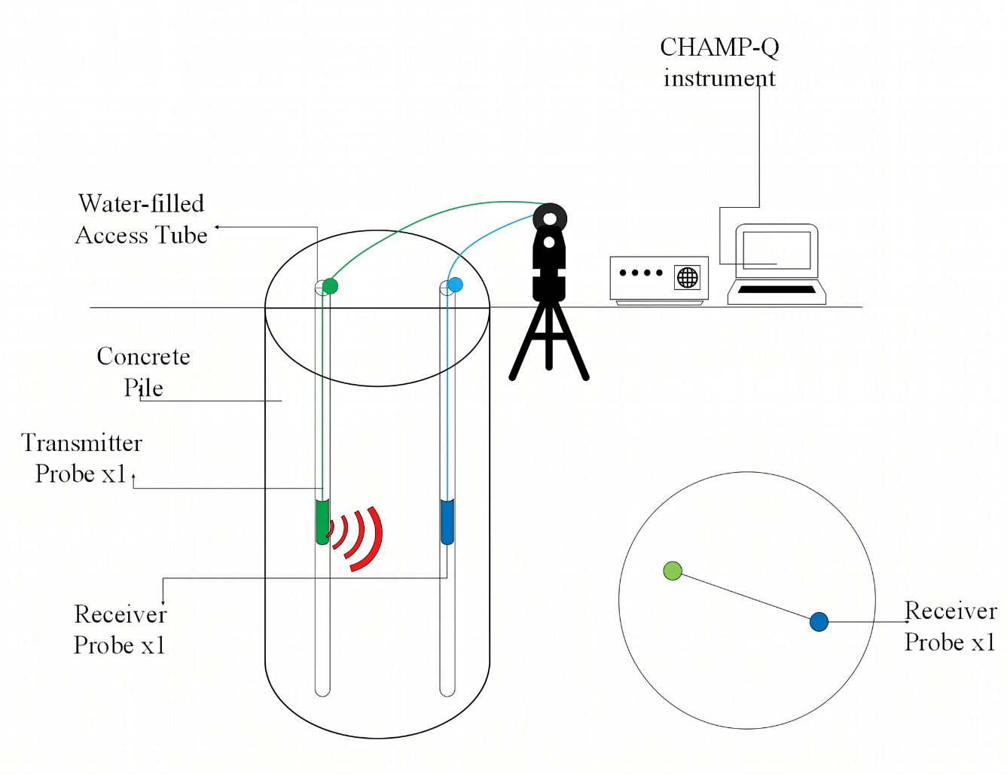
`

Transmitter
Probe x 1
Water-filled
Access Tube
`

`

`

`

Figure 3
Ultrasonic Profile with Defect Interpretations
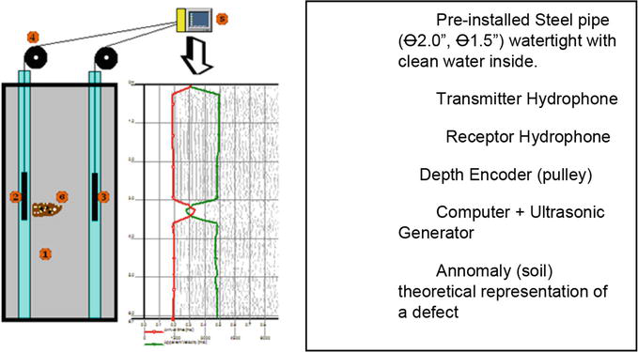

End of Procedure

