DESCRIPTIVES VARIABLES=SUBNR ADJEXT ADJINT IAMEXT IAMINT EXTRA RESER LIVEL SHY TALKA INTRO OUTGO
QUIET
/STATISTICS=MEAN STDDEV MIN MAX.

Descriptives

Notes
Output Created |  | 30-JAN-2019 16:36:47
Comments
Input | Data | \\files.brown.edu\Home\gpagnier\Documents\GitHub\MultivariateStats\HW1\HW1DataTable.sav
Input | Active Dataset | DataSet1
Input | Filter | <none>
Input | Weight | <none>
Input | Split File | <none>
Input | N of Rows in Working Data File | 159
Missing Value Handling | Definition of Missing | User defined missing values are treated as missing.
Missing Value Handling | Cases Used | All non-missing data are used.
Syntax |  | DESCRIPTIVES VARIABLES=SUBNR ADJEXT ADJINT IAMEXT IAMINT EXTRA RESER LIVEL SHY TALKA INTRO OUTGO  QUIET  /STATISTICS=MEAN STDDEV MIN MAX.
Resources | Processor Time | 00:00:00.00
Resources | Elapsed Time | 00:00:00.01

Descriptive Statistics
 | N | Minimum | Maximum | Mean | Std. Deviation
SUBNR | 159 | 101 | 1253 | 271.39 | 223.097
ADJEXT | 99 | 0 | 4 | .90 | 1.093
ADJINT | 99 | 0 | 6 | .99 | 1.216
IAMEXT | 100 | 0 | 2 | .28 | .533
IAMINT | 99 | 0 | 2 | .23 | .470
EXTRA | 112 | 1 | 9 | 5.41 | 1.794
RESER | 112 | 1 | 9 | 5.29 | 1.843
LIVEL | 112 | 1 | 9 | 5.92 | 1.628
SHY | 112 | 1 | 11 | 5.02 | 1.982
TALKA | 112 | 1 | 9 | 5.62 | 2.037
INTRO | 112 | 1 | 9 | 4.72 | 2.037
OUTGO | 112 | 2 | 9 | 5.94 | 1.646
QUIET | 112 | 1 | 9 | 4.84 | 1.887
Valid N (listwise) | 53

FREQUENCIES VARIABLES=ADJEXT
/HISTOGRAM
/ORDER=ANALYSIS.

Frequencies

Notes
Output Created |  | 30-JAN-2019 16:38:08
Comments
Input | Data | \\files.brown.edu\Home\gpagnier\Documents\GitHub\MultivariateStats\HW1\HW1DataTable.sav
Input | Active Dataset | DataSet1
Input | Filter | <none>
Input | Weight | <none>
Input | Split File | <none>
Input | N of Rows in Working Data File | 159
Missing Value Handling | Definition of Missing | User-defined missing values are treated as missing.
Missing Value Handling | Cases Used | Statistics are based on all cases with valid data.
Syntax |  | FREQUENCIES VARIABLES=ADJEXT  /HISTOGRAM  /ORDER=ANALYSIS.
Resources | Processor Time | 00:00:03.52
Resources | Elapsed Time | 00:00:02.08

Statistics
ADJEXT
N | Valid | 99
N | Missing | 60

ADJEXT
 |  | Frequency | Percent | Valid Percent | Cumulative Percent
Valid | 0 | 50 | 31.4 | 50.5 | 50.5
Valid | 1 | 21 | 13.2 | 21.2 | 71.7
Valid | 2 | 18 | 11.3 | 18.2 | 89.9
Valid | 3 | 8 | 5.0 | 8.1 | 98.0
Valid | 4 | 2 | 1.3 | 2.0 | 100.0
Valid | Total | 99 | 62.3 | 100.0
Missing | System | 60 | 37.7
Total |  | 159 | 100.0

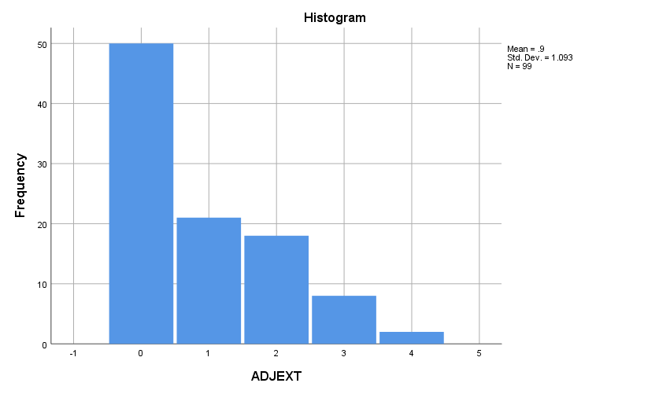

FREQUENCIES VARIABLES=ADJEXT
/PIECHART FREQ
/ORDER=ANALYSIS.

Frequencies

Notes
Output Created |  | 30-JAN-2019 16:38:37
Comments
Input | Data | \\files.brown.edu\Home\gpagnier\Documents\GitHub\MultivariateStats\HW1\HW1DataTable.sav
Input | Active Dataset | DataSet1
Input | Filter | <none>
Input | Weight | <none>
Input | Split File | <none>
Input | N of Rows in Working Data File | 159
Missing Value Handling | Definition of Missing | User-defined missing values are treated as missing.
Missing Value Handling | Cases Used | Statistics are based on all cases with valid data.
Syntax |  | FREQUENCIES VARIABLES=ADJEXT  /PIECHART FREQ  /ORDER=ANALYSIS.
Resources | Processor Time | 00:00:01.02
Resources | Elapsed Time | 00:00:00.33

Statistics
ADJEXT
N | Valid | 99
N | Missing | 60

ADJEXT
 |  | Frequency | Percent | Valid Percent | Cumulative Percent
Valid | 0 | 50 | 31.4 | 50.5 | 50.5
Valid | 1 | 21 | 13.2 | 21.2 | 71.7
Valid | 2 | 18 | 11.3 | 18.2 | 89.9
Valid | 3 | 8 | 5.0 | 8.1 | 98.0
Valid | 4 | 2 | 1.3 | 2.0 | 100.0
Valid | Total | 99 | 62.3 | 100.0
Missing | System | 60 | 37.7
Total |  | 159 | 100.0

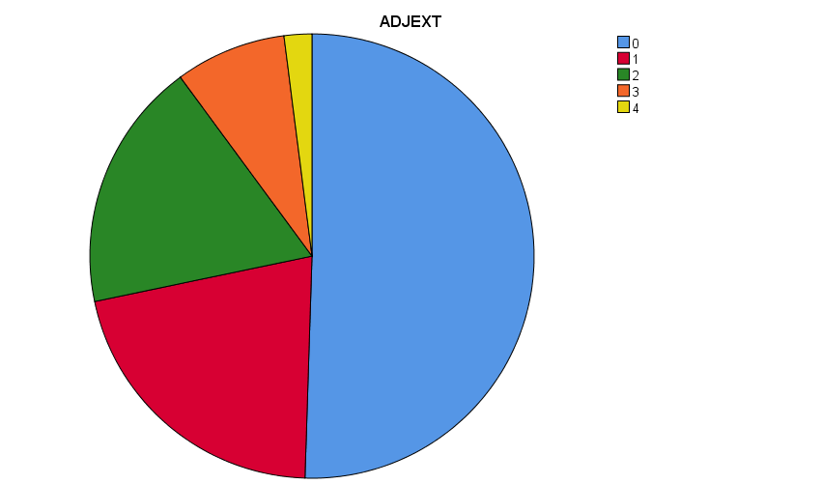

FREQUENCIES VARIABLES=ADJEXT ADJINT IAMEXT IAMINT EXTRA RESER LIVEL SHY TALKA INTRO OUTGO QUIET
/ORDER=ANALYSIS.

EXAMINE
VARIABLES=EXTRA RESER LIVEL SHY TALKA INTRO OUTGO QUIET
/PLOT=NPPLOT.

Explore

Notes
Output Created |  | 30-JAN-2019 16:59:20
Comments
Input | Data | \\files.brown.edu\Home\gpagnier\Documents\GitHub\MultivariateStats\HW1\HW1DataTable.sav
Input | Active Dataset | DataSet1
Input | Filter | <none>
Input | Weight | <none>
Input | Split File | <none>
Input | N of Rows in Working Data File | 159
Missing Value Handling | Definition of Missing | User-defined missing values for dependent variables are treated as missing.
Missing Value Handling | Cases Used | Statistics are based on cases with no missing values for any dependent variable or factor used.
Syntax |  | EXAMINE  VARIABLES=EXTRA RESER LIVEL SHY TALKA INTRO OUTGO QUIET  /PLOT=NPPLOT.
Resources | Processor Time | 00:00:04.27
Resources | Elapsed Time | 00:00:03.26

Total Sample

Case Processing Summary
 | Cases
 | Valid |  | Missing |  | Total
 | N | Percent | N | Percent | N | Percent
EXTRA | 112 | 70.4% | 47 | 29.6% | 159 | 100.0%
RESER | 112 | 70.4% | 47 | 29.6% | 159 | 100.0%
LIVEL | 112 | 70.4% | 47 | 29.6% | 159 | 100.0%
SHY | 112 | 70.4% | 47 | 29.6% | 159 | 100.0%
TALKA | 112 | 70.4% | 47 | 29.6% | 159 | 100.0%
INTRO | 112 | 70.4% | 47 | 29.6% | 159 | 100.0%
OUTGO | 112 | 70.4% | 47 | 29.6% | 159 | 100.0%
QUIET | 112 | 70.4% | 47 | 29.6% | 159 | 100.0%

Descriptives
 |  |  | Statistic | Std. Error
EXTRA | Mean |  | 5.41 | .169
EXTRA | 95% Confidence Interval for Mean | Lower Bound | 5.07
EXTRA | 95% Confidence Interval for Mean | Upper Bound | 5.75
EXTRA | 5% Trimmed Mean |  | 5.39
EXTRA | Median |  | 5.00
EXTRA | Variance |  | 3.217
EXTRA | Std. Deviation |  | 1.794
EXTRA | Minimum |  | 1
EXTRA | Maximum |  | 9
EXTRA | Range |  | 8
EXTRA | Interquartile Range |  | 3
EXTRA | Skewness |  | .019 | .228
EXTRA | Kurtosis |  | -.809 | .453
RESER | Mean |  | 5.29 | .174
RESER | 95% Confidence Interval for Mean | Lower Bound | 4.94
RESER | 95% Confidence Interval for Mean | Upper Bound | 5.63
RESER | 5% Trimmed Mean |  | 5.31
RESER | Median |  | 5.00
RESER | Variance |  | 3.395
RESER | Std. Deviation |  | 1.843
RESER | Minimum |  | 1
RESER | Maximum |  | 9
RESER | Range |  | 8
RESER | Interquartile Range |  | 3
RESER | Skewness |  | -.123 | .228
RESER | Kurtosis |  | -.710 | .453
LIVEL | Mean |  | 5.92 | .154
LIVEL | 95% Confidence Interval for Mean | Lower Bound | 5.61
LIVEL | 95% Confidence Interval for Mean | Upper Bound | 6.22
LIVEL | 5% Trimmed Mean |  | 5.92
LIVEL | Median |  | 6.00
LIVEL | Variance |  | 2.651
LIVEL | Std. Deviation |  | 1.628
LIVEL | Minimum |  | 1
LIVEL | Maximum |  | 9
LIVEL | Range |  | 8
LIVEL | Interquartile Range |  | 2
LIVEL | Skewness |  | -.098 | .228
LIVEL | Kurtosis |  | -.381 | .453
SHY | Mean |  | 5.00 | .183
SHY | 95% Confidence Interval for Mean | Lower Bound | 4.64
SHY | 95% Confidence Interval for Mean | Upper Bound | 5.36
SHY | 5% Trimmed Mean |  | 4.99
SHY | Median |  | 5.00
SHY | Variance |  | 3.748
SHY | Std. Deviation |  | 1.936
SHY | Minimum |  | 1
SHY | Maximum |  | 9
SHY | Range |  | 8
SHY | Interquartile Range |  | 2
SHY | Skewness |  | -.023 | .228
SHY | Kurtosis |  | -.551 | .453
TALKA | Mean |  | 5.62 | .192
TALKA | 95% Confidence Interval for Mean | Lower Bound | 5.23
TALKA | 95% Confidence Interval for Mean | Upper Bound | 6.00
TALKA | 5% Trimmed Mean |  | 5.64
TALKA | Median |  | 6.00
TALKA | Variance |  | 4.149
TALKA | Std. Deviation |  | 2.037
TALKA | Minimum |  | 1
TALKA | Maximum |  | 9
TALKA | Range |  | 8
TALKA | Interquartile Range |  | 3
TALKA | Skewness |  | -.057 | .228
TALKA | Kurtosis |  | -.856 | .453
INTRO | Mean |  | 4.72 | .192
INTRO | 95% Confidence Interval for Mean | Lower Bound | 4.34
INTRO | 95% Confidence Interval for Mean | Upper Bound | 5.10
INTRO | 5% Trimmed Mean |  | 4.74
INTRO | Median |  | 5.00
INTRO | Variance |  | 4.148
INTRO | Std. Deviation |  | 2.037
INTRO | Minimum |  | 1
INTRO | Maximum |  | 9
INTRO | Range |  | 8
INTRO | Interquartile Range |  | 3
INTRO | Skewness |  | -.170 | .228
INTRO | Kurtosis |  | -1.080 | .453
OUTGO | Mean |  | 5.94 | .155
OUTGO | 95% Confidence Interval for Mean | Lower Bound | 5.63
OUTGO | 95% Confidence Interval for Mean | Upper Bound | 6.25
OUTGO | 5% Trimmed Mean |  | 5.95
OUTGO | Median |  | 6.00
OUTGO | Variance |  | 2.708
OUTGO | Std. Deviation |  | 1.646
OUTGO | Minimum |  | 2
OUTGO | Maximum |  | 9
OUTGO | Range |  | 7
OUTGO | Interquartile Range |  | 2
OUTGO | Skewness |  | -.096 | .228
OUTGO | Kurtosis |  | -.569 | .453
QUIET | Mean |  | 4.84 | .178
QUIET | 95% Confidence Interval for Mean | Lower Bound | 4.49
QUIET | 95% Confidence Interval for Mean | Upper Bound | 5.19
QUIET | 5% Trimmed Mean |  | 4.82
QUIET | Median |  | 5.00
QUIET | Variance |  | 3.560
QUIET | Std. Deviation |  | 1.887
QUIET | Minimum |  | 1
QUIET | Maximum |  | 9
QUIET | Range |  | 8
QUIET | Interquartile Range |  | 3
QUIET | Skewness |  | .122 | .228
QUIET | Kurtosis |  | -.788 | .453

Tests of Normality
 | Kolmogorov-Smirnovª |  |  | Shapiro-Wilk
 | Statistic | df | Sig. | Statistic | df | Sig.
EXTRA | .134 | 112 | .000 | .951 | 112 | .000
RESER | .142 | 112 | .000 | .960 | 112 | .002
LIVEL | .130 | 112 | .000 | .954 | 112 | .001
SHY | .117 | 112 | .001 | .965 | 112 | .005
TALKA | .117 | 112 | .001 | .956 | 112 | .001
INTRO | .172 | 112 | .000 | .939 | 112 | .000
OUTGO | .134 | 112 | .000 | .955 | 112 | .001
QUIET | .121 | 112 | .000 | .961 | 112 | .002

a. Lilliefors Significance Correction

SHY

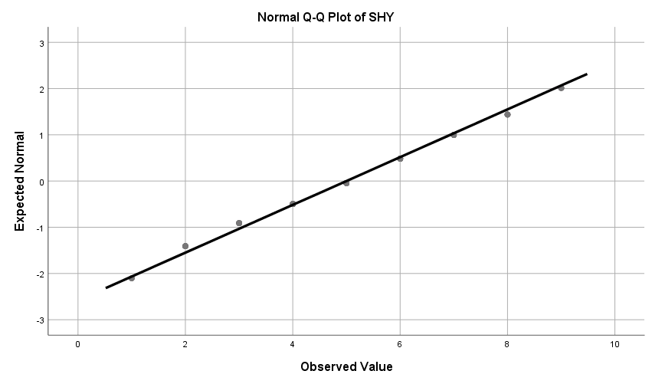

EXAMINE
VARIABLES=EXTRA RESER LIVEL SHY TALKA INTRO OUTGO QUIET
/PLOT=BOXPLOT.

Explore

Notes
Output Created |  | 30-JAN-2019 17:17:26
Comments
Input | Data | \\files.brown.edu\Home\gpagnier\Documents\GitHub\MultivariateStats\HW1\HW1DataTable.sav
Input | Active Dataset | DataSet1
Input | Filter | <none>
Input | Weight | <none>
Input | Split File | <none>
Input | N of Rows in Working Data File | 159
Missing Value Handling | Definition of Missing | User-defined missing values for dependent variables are treated as missing.
Missing Value Handling | Cases Used | Statistics are based on cases with no missing values for any dependent variable or factor used.
Syntax |  | EXAMINE  VARIABLES=EXTRA RESER LIVEL SHY TALKA INTRO OUTGO QUIET  /PLOT=BOXPLOT.
Resources | Processor Time | 00:00:02.84
Resources | Elapsed Time | 00:00:01.68

Total Sample

Descriptives
 |  |  | Statistic | Std. Error
EXTRA | Mean |  | 5.41 | .169
EXTRA | 95% Confidence Interval for Mean | Lower Bound | 5.07
EXTRA | 95% Confidence Interval for Mean | Upper Bound | 5.75
EXTRA | 5% Trimmed Mean |  | 5.39
EXTRA | Median |  | 5.00
EXTRA | Variance |  | 3.217
EXTRA | Std. Deviation |  | 1.794
EXTRA | Minimum |  | 1
EXTRA | Maximum |  | 9
EXTRA | Range |  | 8
EXTRA | Interquartile Range |  | 3
EXTRA | Skewness |  | .019 | .228
EXTRA | Kurtosis |  | -.809 | .453
RESER | Mean |  | 5.29 | .174
RESER | 95% Confidence Interval for Mean | Lower Bound | 4.94
RESER | 95% Confidence Interval for Mean | Upper Bound | 5.63
RESER | 5% Trimmed Mean |  | 5.31
RESER | Median |  | 5.00
RESER | Variance |  | 3.395
RESER | Std. Deviation |  | 1.843
RESER | Minimum |  | 1
RESER | Maximum |  | 9
RESER | Range |  | 8
RESER | Interquartile Range |  | 3
RESER | Skewness |  | -.123 | .228
RESER | Kurtosis |  | -.710 | .453
LIVEL | Mean |  | 5.92 | .154
LIVEL | 95% Confidence Interval for Mean | Lower Bound | 5.61
LIVEL | 95% Confidence Interval for Mean | Upper Bound | 6.22
LIVEL | 5% Trimmed Mean |  | 5.92
LIVEL | Median |  | 6.00
LIVEL | Variance |  | 2.651
LIVEL | Std. Deviation |  | 1.628
LIVEL | Minimum |  | 1
LIVEL | Maximum |  | 9
LIVEL | Range |  | 8
LIVEL | Interquartile Range |  | 2
LIVEL | Skewness |  | -.098 | .228
LIVEL | Kurtosis |  | -.381 | .453
SHY | Mean |  | 5.00 | .183
SHY | 95% Confidence Interval for Mean | Lower Bound | 4.64
SHY | 95% Confidence Interval for Mean | Upper Bound | 5.36
SHY | 5% Trimmed Mean |  | 4.99
SHY | Median |  | 5.00
SHY | Variance |  | 3.748
SHY | Std. Deviation |  | 1.936
SHY | Minimum |  | 1
SHY | Maximum |  | 9
SHY | Range |  | 8
SHY | Interquartile Range |  | 2
SHY | Skewness |  | -.023 | .228
SHY | Kurtosis |  | -.551 | .453
TALKA | Mean |  | 5.62 | .192
TALKA | 95% Confidence Interval for Mean | Lower Bound | 5.23
TALKA | 95% Confidence Interval for Mean | Upper Bound | 6.00
TALKA | 5% Trimmed Mean |  | 5.64
TALKA | Median |  | 6.00
TALKA | Variance |  | 4.149
TALKA | Std. Deviation |  | 2.037
TALKA | Minimum |  | 1
TALKA | Maximum |  | 9
TALKA | Range |  | 8
TALKA | Interquartile Range |  | 3
TALKA | Skewness |  | -.057 | .228
TALKA | Kurtosis |  | -.856 | .453
INTRO | Mean |  | 4.72 | .192
INTRO | 95% Confidence Interval for Mean | Lower Bound | 4.34
INTRO | 95% Confidence Interval for Mean | Upper Bound | 5.10
INTRO | 5% Trimmed Mean |  | 4.74
INTRO | Median |  | 5.00
INTRO | Variance |  | 4.148
INTRO | Std. Deviation |  | 2.037
INTRO | Minimum |  | 1
INTRO | Maximum |  | 9
INTRO | Range |  | 8
INTRO | Interquartile Range |  | 3
INTRO | Skewness |  | -.170 | .228
INTRO | Kurtosis |  | -1.080 | .453
OUTGO | Mean |  | 5.94 | .155
OUTGO | 95% Confidence Interval for Mean | Lower Bound | 5.63
OUTGO | 95% Confidence Interval for Mean | Upper Bound | 6.25
OUTGO | 5% Trimmed Mean |  | 5.95
OUTGO | Median |  | 6.00
OUTGO | Variance |  | 2.708
OUTGO | Std. Deviation |  | 1.646
OUTGO | Minimum |  | 2
OUTGO | Maximum |  | 9
OUTGO | Range |  | 7
OUTGO | Interquartile Range |  | 2
OUTGO | Skewness |  | -.096 | .228
OUTGO | Kurtosis |  | -.569 | .453
QUIET | Mean |  | 4.84 | .178
QUIET | 95% Confidence Interval for Mean | Lower Bound | 4.49
QUIET | 95% Confidence Interval for Mean | Upper Bound | 5.19
QUIET | 5% Trimmed Mean |  | 4.82
QUIET | Median |  | 5.00
QUIET | Variance |  | 3.560
QUIET | Std. Deviation |  | 1.887
QUIET | Minimum |  | 1
QUIET | Maximum |  | 9
QUIET | Range |  | 8
QUIET | Interquartile Range |  | 3
QUIET | Skewness |  | .122 | .228
QUIET | Kurtosis |  | -.788 | .453

LIVEL

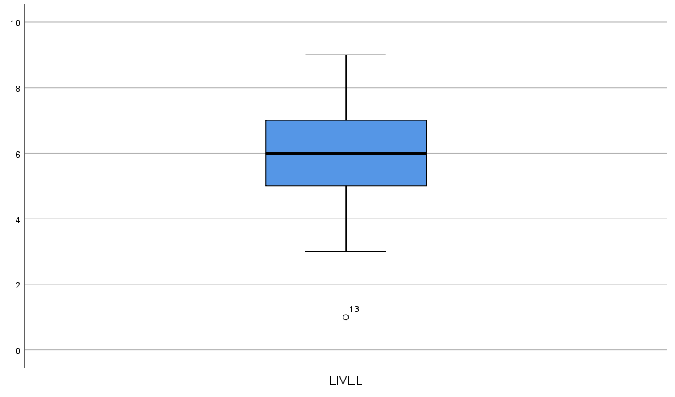

EXAMINE
VARIABLES=EXTRA RESER LIVEL SHY TALKA INTRO OUTGO QUIET
/PLOT=SCATTERPLOTS.

GRAPH
VARIABLES=EXTRA RESER LIVEL SHY TALKA INTRO OUTGO QUIET
/PLOT=SCATTERPLOTS.

GRAPH
/SCATTERPLOT(BIVAR)=ADJEXT WITH EXTRA
/MISSING=LISTWISE.

GRAPH
/SCATTERPLOT(BIVAR)=ADJEXT WITH EXTRA
/MISSING=LISTWISE.

Graph

Notes
Output Created |  | 30-JAN-2019 17:29:49
Comments
Input | Data | \\files.brown.edu\Home\gpagnier\Documents\GitHub\MultivariateStats\HW1\HW1DataTable.sav
Input | Active Dataset | DataSet1
Input | Filter | <none>
Input | Weight | <none>
Input | Split File | <none>
Input | N of Rows in Working Data File | 159
Syntax |  | GRAPH  /SCATTERPLOT(BIVAR)=ADJEXT WITH EXTRA  /MISSING=LISTWISE.
Resources | Processor Time | 00:00:00.27
Resources | Elapsed Time | 00:00:00.29

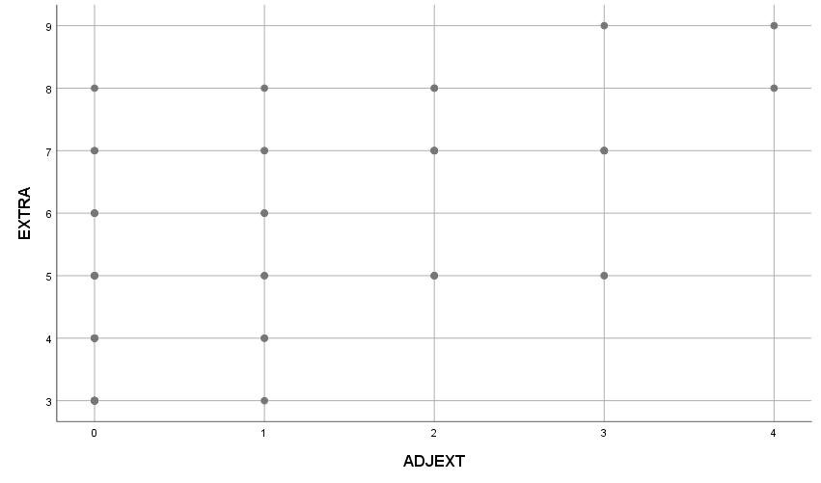

CROSSTABS
/TABLES=ADJEXT BY EXTRA
/FORMAT=AVALUE TABLES
/CELLS=COUNT
/COUNT ROUND CELL.

Crosstabs

Notes
Output Created |  | 30-JAN-2019 17:49:14
Comments
Input | Data | \\files.brown.edu\Home\gpagnier\Documents\GitHub\MultivariateStats\HW1\HW1DataTable.sav
Input | Active Dataset | DataSet1
Input | Filter | <none>
Input | Weight | <none>
Input | Split File | <none>
Input | N of Rows in Working Data File | 159
Missing Value Handling | Definition of Missing | User-defined missing values are treated as missing.
Missing Value Handling | Cases Used | Statistics for each table are based on all the cases with valid data in the specified range(s) for all variables in each table.
Syntax |  | CROSSTABS  /TABLES=ADJEXT BY EXTRA  /FORMAT=AVALUE TABLES  /CELLS=COUNT  /COUNT ROUND CELL.
Resources | Processor Time | 00:00:00.03
Resources | Elapsed Time | 00:00:00.04
Resources | Dimensions Requested | 2
Resources | Cells Available | 524245

Case Processing Summary
 | Cases
 | Valid |  | Missing |  | Total
 | N | Percent | N | Percent | N | Percent
ADJEXT * EXTRA | 53 | 33.3% | 106 | 66.7% | 159 | 100.0%

ADJEXT * EXTRA Crosstabulation
Count
 |  | EXTRA
 |  | 3 | 4 | 5 | 6 | 7 | 8 | 9
ADJEXT | 0 | 7 | 5 | 5 | 3 | 2 | 1 | 0
ADJEXT | 1 | 1 | 2 | 2 | 2 | 2 | 1 | 0
ADJEXT | 2 | 0 | 0 | 3 | 0 | 5 | 2 | 0
ADJEXT | 3 | 0 | 0 | 2 | 0 | 5 | 0 | 1
ADJEXT | 4 | 0 | 0 | 0 | 0 | 0 | 1 | 1
Total |  | 8 | 7 | 12 | 5 | 14 | 5 | 2

ADJEXT * EXTRA Crosstabulation
Count
 |  | Total
ADJEXT | 0 | 23
ADJEXT | 1 | 10
ADJEXT | 2 | 10
ADJEXT | 3 | 8
ADJEXT | 4 | 2
Total |  | 53

GRAPH
/SCATTERPLOT(BIVAR)=SHY WITH EXTRA
/MISSING=LISTWISE.

Graph

Notes
Output Created |  | 30-JAN-2019 17:53:13
Comments
Input | Data | \\files.brown.edu\Home\gpagnier\Documents\GitHub\MultivariateStats\HW1\HW1DataTable.sav
Input | Active Dataset | DataSet1
Input | Filter | <none>
Input | Weight | <none>
Input | Split File | <none>
Input | N of Rows in Working Data File | 159
Syntax |  | GRAPH  /SCATTERPLOT(BIVAR)=SHY WITH EXTRA  /MISSING=LISTWISE.
Resources | Processor Time | 00:00:00.30
Resources | Elapsed Time | 00:00:00.30

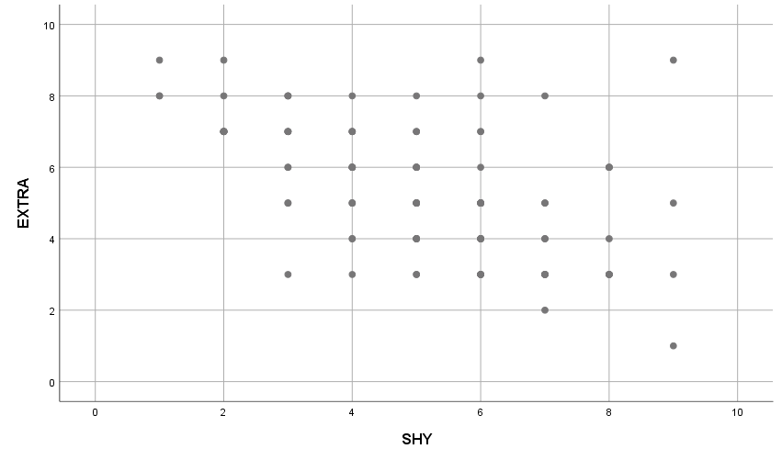

CROSSTABS
/TABLES=SHY BY EXTRA
/FORMAT=AVALUE TABLES
/CELLS=COUNT
/COUNT ROUND CELL.

Crosstabs

Notes
Output Created |  | 30-JAN-2019 17:55:05
Comments
Input | Data | \\files.brown.edu\Home\gpagnier\Documents\GitHub\MultivariateStats\HW1\HW1DataTable.sav
Input | Active Dataset | DataSet1
Input | Filter | <none>
Input | Weight | <none>
Input | Split File | <none>
Input | N of Rows in Working Data File | 159
Missing Value Handling | Definition of Missing | User-defined missing values are treated as missing.
Missing Value Handling | Cases Used | Statistics for each table are based on all the cases with valid data in the specified range(s) for all variables in each table.
Syntax |  | CROSSTABS  /TABLES=SHY BY EXTRA  /FORMAT=AVALUE TABLES  /CELLS=COUNT  /COUNT ROUND CELL.
Resources | Processor Time | 00:00:00.03
Resources | Elapsed Time | 00:00:00.03
Resources | Dimensions Requested | 2
Resources | Cells Available | 524245

Case Processing Summary
 | Cases
 | Valid |  | Missing |  | Total
 | N | Percent | N | Percent | N | Percent
SHY * EXTRA | 112 | 70.4% | 47 | 29.6% | 159 | 100.0%

SHY * EXTRA Crosstabulation
Count
 |  | EXTRA
 |  | 1 | 2 | 3 | 4 | 5 | 6 | 7
SHY | 1 | 0 | 0 | 0 | 0 | 0 | 0 | 0
SHY | 2 | 0 | 0 | 0 | 0 | 0 | 0 | 9
SHY | 3 | 0 | 0 | 1 | 0 | 2 | 2 | 4
SHY | 4 | 0 | 0 | 1 | 2 | 3 | 6 | 4
SHY | 5 | 0 | 0 | 2 | 5 | 6 | 5 | 3
SHY | 6 | 0 | 0 | 5 | 6 | 8 | 1 | 2
SHY | 7 | 0 | 1 | 5 | 2 | 2 | 0 | 0
SHY | 8 | 0 | 0 | 4 | 1 | 0 | 3 | 0
SHY | 9 | 1 | 0 | 1 | 0 | 1 | 0 | 0
Total |  | 1 | 1 | 19 | 16 | 22 | 17 | 22

SHY * EXTRA Crosstabulation
Count
 |  | EXTRA
 |  | 8 | 9
SHY | 1 | 2 | 1 | 3
SHY | 2 | 1 | 1 | 11
SHY | 3 | 3 | 0 | 12
SHY | 4 | 1 | 0 | 17
SHY | 5 | 1 | 0 | 22
SHY | 6 | 1 | 1 | 24
SHY | 7 | 1 | 0 | 11
SHY | 8 | 0 | 0 | 8
SHY | 9 | 0 | 1 | 4
Total |  | 10 | 4 | 112

COMPUTE NEWLIVELY=SQRT(LIVELY).

Error # 4285 in column 24. Text: LIVELY
Incorrect variable name: either the name is more than 64 characters, or it is
not defined by a previous command.
Execution of this command stops.
COMPUTE NEWLIVELY=SQRT(LIVEL).
EXECUTE.
COMPUTE LIVELSQRT=SQRT(LIVEL).
EXECUTE.
COMPUTE LIVELLOG=LG10(LIVEL).
EXECUTE.
COMPUTE EXTRASQRT=SQRT(EXTRA).
EXECUTE.
COMPUTE EXTRALOG=LG10(EXTRA).
EXECUTE.
EXAMINE
VARIABLES=EXTRASQRT EXTRALOG LIVELSQRT LIVELLOG
/PLOT=NPPLOT.

Explore

Notes
Output Created |  | 30-JAN-2019 18:14:58
Comments
Input | Data | \\files.brown.edu\Home\gpagnier\Documents\GitHub\MultivariateStats\HW1\HW1DataTable.sav
Input | Active Dataset | DataSet1
Input | Filter | <none>
Input | Weight | <none>
Input | Split File | <none>
Input | N of Rows in Working Data File | 159
Missing Value Handling | Definition of Missing | User-defined missing values for dependent variables are treated as missing.
Missing Value Handling | Cases Used | Statistics are based on cases with no missing values for any dependent variable or factor used.
Syntax |  | EXAMINE  VARIABLES=EXTRASQRT EXTRALOG LIVELSQRT LIVELLOG  /PLOT=NPPLOT.
Resources | Processor Time | 00:00:01.73
Resources | Elapsed Time | 00:00:01.55

Total Sample

Case Processing Summary
 | Cases
 | Valid |  | Missing |  | Total
 | N | Percent | N | Percent | N | Percent
EXTRASQRT | 112 | 70.4% | 47 | 29.6% | 159 | 100.0%
EXTRALOG | 112 | 70.4% | 47 | 29.6% | 159 | 100.0%
LIVELSQRT | 112 | 70.4% | 47 | 29.6% | 159 | 100.0%
LIVELLOG | 112 | 70.4% | 47 | 29.6% | 159 | 100.0%

Descriptives
 |  |  | Statistic | Std. Error
EXTRASQRT | Mean |  | 2.2915 | .03793
EXTRASQRT | 95% Confidence Interval for Mean | Lower Bound | 2.2163
EXTRASQRT | 95% Confidence Interval for Mean | Upper Bound | 2.3667
EXTRASQRT | 5% Trimmed Mean |  | 2.2964
EXTRASQRT | Median |  | 2.2361
EXTRASQRT | Variance |  | .161
EXTRASQRT | Std. Deviation |  | .40143
EXTRASQRT | Minimum |  | 1.00
EXTRASQRT | Maximum |  | 3.00
EXTRASQRT | Range |  | 2.00
EXTRASQRT | Interquartile Range |  | .65
EXTRASQRT | Skewness |  | -.360 | .228
EXTRASQRT | Kurtosis |  | -.319 | .453
EXTRALOG | Mean |  | .7058 | .01548
EXTRALOG | 95% Confidence Interval for Mean | Lower Bound | .6751
EXTRALOG | 95% Confidence Interval for Mean | Upper Bound | .7364
EXTRALOG | 5% Trimmed Mean |  | .7120
EXTRALOG | Median |  | .6990
EXTRALOG | Variance |  | .027
EXTRALOG | Std. Deviation |  | .16387
EXTRALOG | Minimum |  | .00
EXTRALOG | Maximum |  | .95
EXTRALOG | Range |  | .95
EXTRALOG | Interquartile Range |  | .24
EXTRALOG | Skewness |  | -.956 | .228
EXTRALOG | Kurtosis |  | 1.768 | .453
LIVELSQRT | Mean |  | 2.4078 | .03317
LIVELSQRT | 95% Confidence Interval for Mean | Lower Bound | 2.3421
LIVELSQRT | 95% Confidence Interval for Mean | Upper Bound | 2.4735
LIVELSQRT | 5% Trimmed Mean |  | 2.4181
LIVELSQRT | Median |  | 2.4495
LIVELSQRT | Variance |  | .123
LIVELSQRT | Std. Deviation |  | .35102
LIVELSQRT | Minimum |  | 1.00
LIVELSQRT | Maximum |  | 3.00
LIVELSQRT | Range |  | 2.00
LIVELSQRT | Interquartile Range |  | .41
LIVELSQRT | Skewness |  | -.612 | .228
LIVELSQRT | Kurtosis |  | 1.041 | .453
LIVELLOG | Mean |  | .7530 | .01317
LIVELLOG | 95% Confidence Interval for Mean | Lower Bound | .7269
LIVELLOG | 95% Confidence Interval for Mean | Upper Bound | .7791
LIVELLOG | 5% Trimmed Mean |  | .7611
LIVELLOG | Median |  | .7782
LIVELLOG | Variance |  | .019
LIVELLOG | Std. Deviation |  | .13938
LIVELLOG | Minimum |  | .00
LIVELLOG | Maximum |  | .95
LIVELLOG | Range |  | .95
LIVELLOG | Interquartile Range |  | .15
LIVELLOG | Skewness |  | -1.586 | .228
LIVELLOG | Kurtosis |  | 6.335 | .453

Tests of Normality
 | Kolmogorov-Smirnovª |  |  | Shapiro-Wilk
 | Statistic | df | Sig. | Statistic | df | Sig.
EXTRASQRT | .133 | 112 | .000 | .944 | 112 | .000
EXTRALOG | .153 | 112 | .000 | .908 | 112 | .000
LIVELSQRT | .137 | 112 | .000 | .937 | 112 | .000
LIVELLOG | .161 | 112 | .000 | .872 | 112 | .000

a. Lilliefors Significance Correction

EXTRASQRT

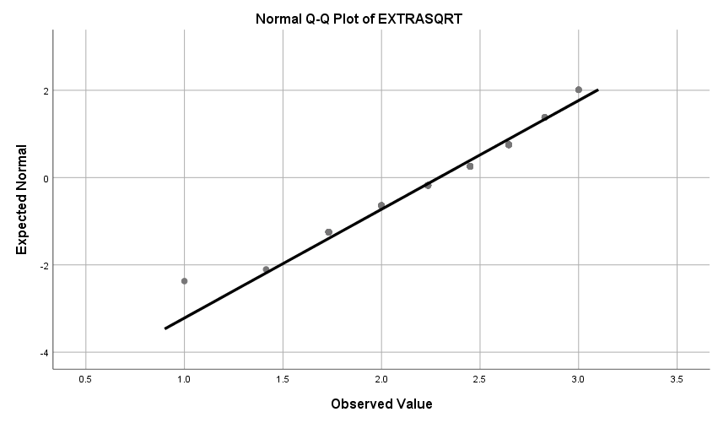

EXTRALOG

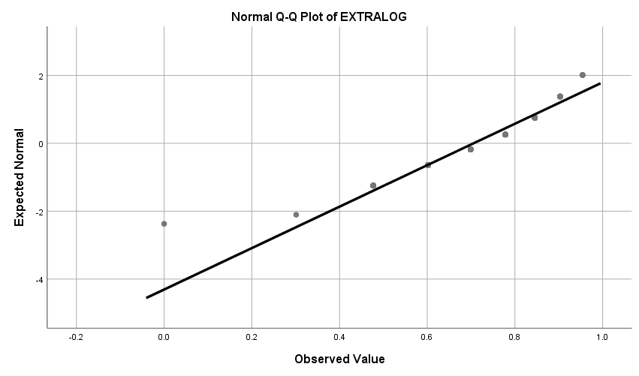

LIVELSQRT

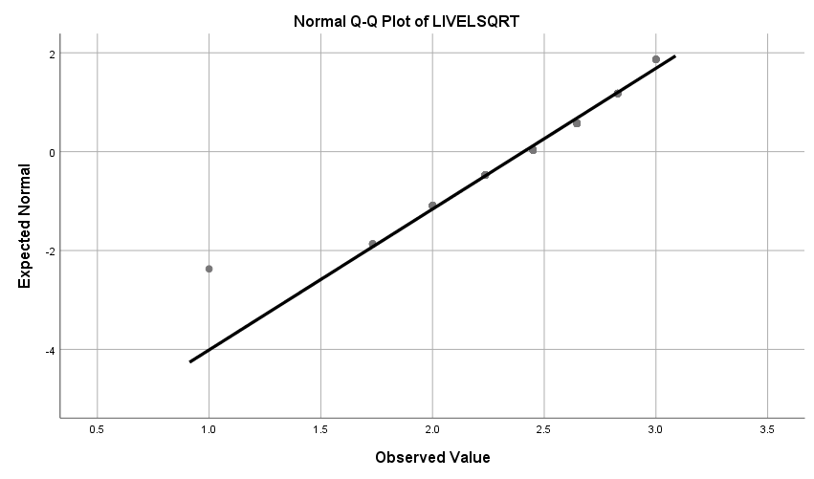

LIVELLOG

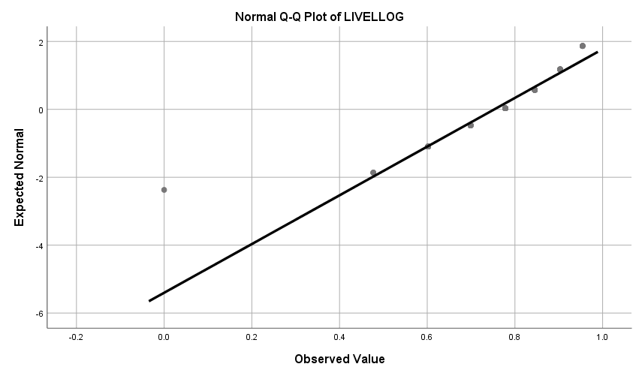

COMPUTE EXTRAVERT=OUTGO + EXTRA.
EXECUTE.
COMPUTE INTROVERT=QUIET + INTRO.
EXECUTE.
DESCRIPTIVES VARIABLES=EXTRAVERT INTROVERT
/STATISTICS=MEAN STDDEV MIN MAX KURTOSIS SKEWNESS.

Descriptives

Notes
Output Created |  | 30-JAN-2019 18:31:09
Comments
Input | Data | \\files.brown.edu\Home\gpagnier\Documents\GitHub\MultivariateStats\HW1\HW1DataTable.sav
Input | Active Dataset | DataSet1
Input | Filter | <none>
Input | Weight | <none>
Input | Split File | <none>
Input | N of Rows in Working Data File | 159
Missing Value Handling | Definition of Missing | User defined missing values are treated as missing.
Missing Value Handling | Cases Used | All non-missing data are used.
Syntax |  | DESCRIPTIVES VARIABLES=EXTRAVERT INTROVERT  /STATISTICS=MEAN STDDEV MIN MAX KURTOSIS SKEWNESS.
Resources | Processor Time | 00:00:00.02
Resources | Elapsed Time | 00:00:00.01

Descriptive Statistics
 | N | Minimum | Maximum | Mean | Std. Deviation | Skewness
 | Statistic | Statistic | Statistic | Statistic | Statistic | Statistic | Std. Error
EXTRAVERT | 112 | 3.00 | 18.00 | 11.3482 | 3.25136 | .057 | .228
INTROVERT | 112 | 2.00 | 18.00 | 9.5625 | 3.54833 | -.093 | .228
Valid N (listwise) | 112

Descriptive Statistics
 | Kurtosis
 | Statistic | Std. Error
EXTRAVERT | -.666 | .453
INTROVERT | -.700 | .453
Valid N (listwise)

PPLOT
/VARIABLES=EXTRAVERT INTROVERT
/NOLOG
/NOSTANDARDIZE
/TYPE=Q-Q
/FRACTION=BLOM
/TIES=MEAN
/DIST=NORMAL.

EXAMINE
VARIABLES=EXTRAVERT INTROVERT
/PLOT=NPPLOT.

Explore

Notes
Output Created |  | 30-JAN-2019 18:35:44
Comments
Input | Data | \\files.brown.edu\Home\gpagnier\Documents\GitHub\MultivariateStats\HW1\HW1DataTable.sav
Input | Active Dataset | DataSet1
Input | Filter | <none>
Input | Weight | <none>
Input | Split File | <none>
Input | N of Rows in Working Data File | 159
Missing Value Handling | Definition of Missing | User-defined missing values for dependent variables are treated as missing.
Missing Value Handling | Cases Used | Statistics are based on cases with no missing values for any dependent variable or factor used.
Syntax |  | EXAMINE  VARIABLES=EXTRAVERT INTROVERT  /PLOT=NPPLOT.
Resources | Processor Time | 00:00:01.00
Resources | Elapsed Time | 00:00:00.97

Total Sample

Case Processing Summary
 | Cases
 | Valid |  | Missing |  | Total
 | N | Percent | N | Percent | N | Percent
EXTRAVERT | 112 | 70.4% | 47 | 29.6% | 159 | 100.0%
INTROVERT | 112 | 70.4% | 47 | 29.6% | 159 | 100.0%

Descriptives
 |  |  | Statistic | Std. Error
EXTRAVERT | Mean |  | 11.3482 | .30722
EXTRAVERT | 95% Confidence Interval for Mean | Lower Bound | 10.7394
EXTRAVERT | 95% Confidence Interval for Mean | Upper Bound | 11.9570
EXTRAVERT | 5% Trimmed Mean |  | 11.3452
EXTRAVERT | Median |  | 11.0000
EXTRAVERT | Variance |  | 10.571
EXTRAVERT | Std. Deviation |  | 3.25136
EXTRAVERT | Minimum |  | 3.00
EXTRAVERT | Maximum |  | 18.00
EXTRAVERT | Range |  | 15.00
EXTRAVERT | Interquartile Range |  | 5.00
EXTRAVERT | Skewness |  | .057 | .228
EXTRAVERT | Kurtosis |  | -.666 | .453
INTROVERT | Mean |  | 9.5625 | .33529
INTROVERT | 95% Confidence Interval for Mean | Lower Bound | 8.8981
INTROVERT | 95% Confidence Interval for Mean | Upper Bound | 10.2269
INTROVERT | 5% Trimmed Mean |  | 9.5595
INTROVERT | Median |  | 10.0000
INTROVERT | Variance |  | 12.591
INTROVERT | Std. Deviation |  | 3.54833
INTROVERT | Minimum |  | 2.00
INTROVERT | Maximum |  | 18.00
INTROVERT | Range |  | 16.00
INTROVERT | Interquartile Range |  | 5.00
INTROVERT | Skewness |  | -.093 | .228
INTROVERT | Kurtosis |  | -.700 | .453

Tests of Normality
 | Kolmogorov-Smirnovª |  |  | Shapiro-Wilk
 | Statistic | df | Sig. | Statistic | df | Sig.
EXTRAVERT | .098 | 112 | .010 | .976 | 112 | .040
INTROVERT | .120 | 112 | .000 | .976 | 112 | .040

a. Lilliefors Significance Correction

EXTRAVERT

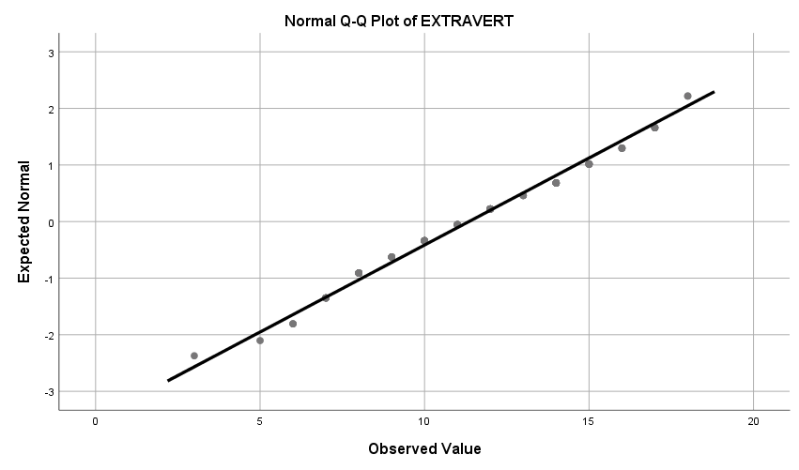

EXAMINE
VARIABLES=EXTRA OUTGO
/PLOT=NPPLOT.

Explore

Notes
Output Created |  | 30-JAN-2019 18:53:06
Comments
Input | Data | \\files.brown.edu\Home\gpagnier\Documents\GitHub\MultivariateStats\HW1\HW1DataTable.sav
Input | Active Dataset | DataSet1
Input | Filter | <none>
Input | Weight | <none>
Input | Split File | <none>
Input | N of Rows in Working Data File | 159
Missing Value Handling | Definition of Missing | User-defined missing values for dependent variables are treated as missing.
Missing Value Handling | Cases Used | Statistics are based on cases with no missing values for any dependent variable or factor used.
Syntax |  | EXAMINE  VARIABLES=EXTRA OUTGO  /PLOT=NPPLOT.
Resources | Processor Time | 00:00:00.94
Resources | Elapsed Time | 00:00:01.01

Total Sample

Case Processing Summary
 | Cases
 | Valid |  | Missing |  | Total
 | N | Percent | N | Percent | N | Percent
EXTRA | 112 | 70.4% | 47 | 29.6% | 159 | 100.0%
OUTGO | 112 | 70.4% | 47 | 29.6% | 159 | 100.0%

Descriptives
 |  |  | Statistic | Std. Error
EXTRA | Mean |  | 5.41 | .169
EXTRA | 95% Confidence Interval for Mean | Lower Bound | 5.07
EXTRA | 95% Confidence Interval for Mean | Upper Bound | 5.75
EXTRA | 5% Trimmed Mean |  | 5.39
EXTRA | Median |  | 5.00
EXTRA | Variance |  | 3.217
EXTRA | Std. Deviation |  | 1.794
EXTRA | Minimum |  | 1
EXTRA | Maximum |  | 9
EXTRA | Range |  | 8
EXTRA | Interquartile Range |  | 3
EXTRA | Skewness |  | .019 | .228
EXTRA | Kurtosis |  | -.809 | .453
OUTGO | Mean |  | 5.94 | .155
OUTGO | 95% Confidence Interval for Mean | Lower Bound | 5.63
OUTGO | 95% Confidence Interval for Mean | Upper Bound | 6.25
OUTGO | 5% Trimmed Mean |  | 5.95
OUTGO | Median |  | 6.00
OUTGO | Variance |  | 2.708
OUTGO | Std. Deviation |  | 1.646
OUTGO | Minimum |  | 2
OUTGO | Maximum |  | 9
OUTGO | Range |  | 7
OUTGO | Interquartile Range |  | 2
OUTGO | Skewness |  | -.096 | .228
OUTGO | Kurtosis |  | -.569 | .453

Tests of Normality
 | Kolmogorov-Smirnovª |  |  | Shapiro-Wilk
 | Statistic | df | Sig. | Statistic | df | Sig.
EXTRA | .134 | 112 | .000 | .951 | 112 | .000
OUTGO | .134 | 112 | .000 | .955 | 112 | .001

a. Lilliefors Significance Correction

EXTRA

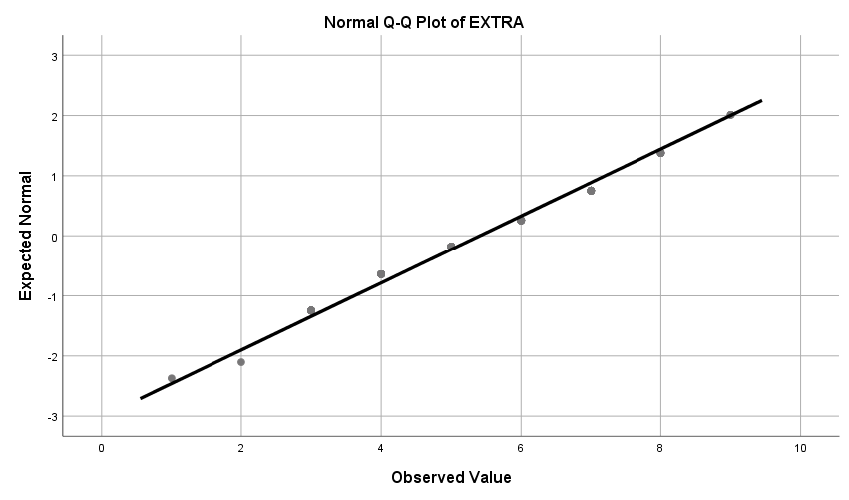

OUTGO

