



*DEPARTMENT OF COMPUTER SCIENCE*

*SOFTWARE ENGINEERING*

***INTEGRATOR PROJECT PROFILE I***



***Members:***

*Gabriel Aguirre*

*Josué Alemán*

*Jhoel Chicaiza*

*Kevin Chuquimarca*

*Alisson Clavijo*

***Tutor:***

*Ing. Edison Lascano*

*Sangolquí, June* *20, 2020*



CINEMA BOX OFFICE(ONLINE)

**1.** **Title** 3

**2.** **Introduction** 3

**3.** **Defining and justifying the problem** 3

**4.** **Bjectivesbjetivos** System **- Purpose** 3

**4.1.** **Overall goal** 3

**4.2.** **Specific goals** 3

**5.** **Overview** 4

**6.** **Reach** 4

**7.** **Definition, Acronyms and Abbreviation** 4

**8.** **Theoretical framework** 5

8.1 Product Functionality 5

8.2 User Features 5

8.3 Development IDE (NetBeans) 6

8.4 Scrum methodology 6

**9.** **Restrictions** 6

**10.** **Ideas to defend** 7

**11.** **Requirements** 7

**12.** **Personnel involved** 8

**13.** **Diagrams Case of Use** 9

**14.** **Diagram of classesis** 9

**15.** **Expected results** 10

**16.** **Viability** 10

**16.1.** **Technical** 10

**16.2.** **Human** 12

**16.2.1.** **Business Tutor** 12

**16.2.2.** **Students** 12

**17.** **Bibliography** 12

# **Title**

"CinemaBox Office (Online)".

# **Introduction**

A system will be developed which will allow you to register, book and buy tickets forcinema; and you will have an administrator who will be in charge of the administration of the ticket of movies and promotions.

# **Defining and justifying the problem**

We need a system that recognizes the type of user that is treating the system, those who may be admins or clients; this system must be attractive and easily accessible to the clients. The system must show necessary and accurate information, this way the client will be able to choose what to purchase. It will also have to save the client data once they have made a purchase, and constantly compare that information to avoid problems such as available schedules, seats availability and age restrictions.

# **Bjectivesbjetivos** System **- Purpose**

## **Overall goal**

Develop and implement a system, by testing in a coding program (in Java) to be able to register, book and buy tickets for cinema.

## **Specific goals**

* Implement a functionality that allows you to look at and enter new user information, you will do so by encoding the information to files.
* Perform tests or testing by reviewing the coding which must be well structured and thus be able to find the errors and proceed to fix them, so we will use the ide which also helps us to identify errors in the source code. }
* Implement a feature that allows us to search for movies and show us the information on the screen.

# **Overview**

The program must have a menu with the option of administrator and cliente, in the administrator system you can enter the list of movies and promotions that will be displayed in the menu of the client and thus the latter can choose the movie, seat, room and format; then the payment method will be indicated and once canceled generate an invoice.

# **Reach**

The priority scope we have in this project would be to be able to make two basic options:

* Observe movie information on the movie billboard.
* Book or buy movie tickets.

All this accompanied by simple interfaces that allow the use of any type of person,

# **Definition, Acronyms and Abbreviation**

|  |  |
| --- | --- |
| Exception | The class Exception and its subclasses are a form of Throwable that indicates conditions that a reasonable application might want to catch |

# **Theoretical framework**

# Product Functionality

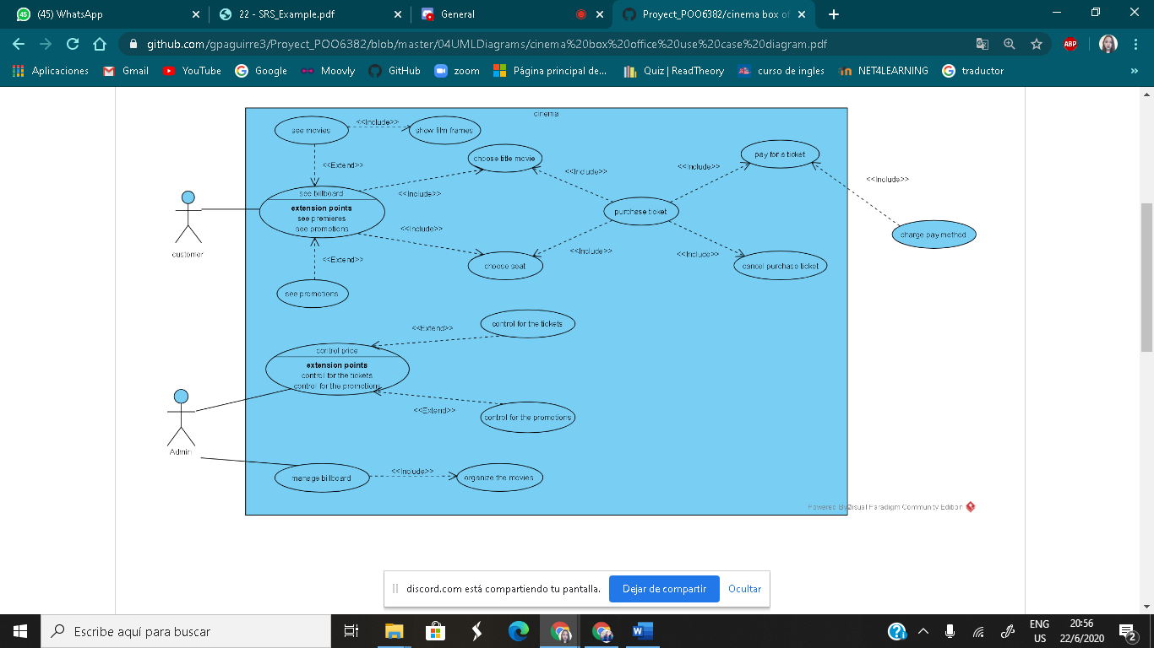

# User Features

|  |  |
| --- | --- |
| Type of user | User |
| Skills | Basic management of web portals. |
| Readiness level | Basic Education |
| Activities | Enter the System, select the movie, buy the ticket. |

# Development IDE (NetBeans)

NetBeans is a free integrated development environment, made primarily for the Java programming language. There are also a significant number of modules to extend it. NetBeans IDE1 is a free and free product with no restrictions on use.



# Scrum methodology

Scrum is a process, framework, or framework, used in teams working on complex projects; an agile working methodology that aims to deliver value in short periods of time, based on three pillars: transparency, inspection, and adaptation.

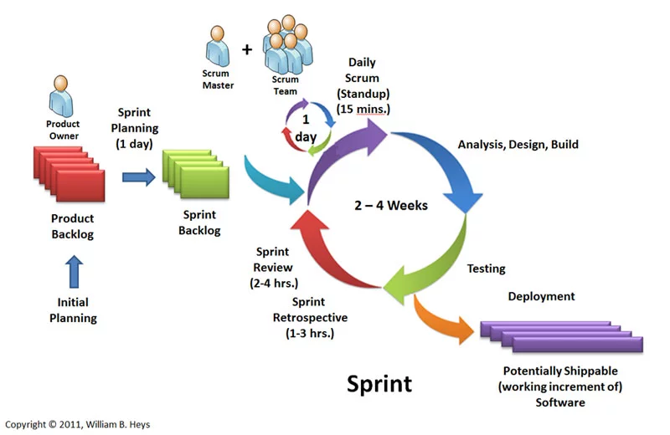

# **Restrictions**

1. Our program is designed in NetBeans.
2. The Program will have a system by which only the administrator will be able to enter movies and promotions.
3. The program will be run through the NetBeans or a command console.

# **Ideas to defend**

* Demonstrate the efficiency shown by the coded program in NetBeans, along with all its functionalities.
* Demonstrate the ease with which the program can be used and that it is easy to understand for the user.

# **Requirements**

* 1. **FUNCTIONAL REQUIREMENTS**:
     1. The program must have a login, which allows you to enter a username and a key for an administrator.
     2. The program must have a menu with the following features: option 1, billboard, which will allow us to observe the title of the movie. Option 2, movies, which will allow us to observe the title, duration, category, and price. Option 3 Premier Movie. which will allow us to observe the title and date of the film in prestreno. Option 4, Administrator, which will allow us to register (User, Password) and organize the list of movies.
     3. The program must keep a clear and organized record of all the options that have to do with the price to be paid. the payment method.
     4. The program must have an easy-to-understand interface for the user with clear instructions.
  2. **NON-FUNCTIONAL REQUIREMENTS:**
     1. The access permissions to the system may be changed only by the administrator, to organize and update the cinema billboard and that only authorized persons can access it.
     2. The system must have properly structured user manuals, so that the user can manage the program according to the established standards and does not make it difficult to use the program properly.

# **Personnel involved**

|  |  |
| --- | --- |
| Name | Gabriel Aguirre |
| Role | Project Manager, Analyst, Developer, Tester. |
| Professional category | Software Engineering Student |
| Responsibilities | Almost everything |
| Contact information | apaguirre3espe.edu.ec |
| Approval | Yes |

|  |  |
| --- | --- |
| Name | Josue Aleman |
| Role | Analyst, developer, tester. |
| Professional category | Software Engineering Student |
| Responsibilities | Code Development and Review |
| Contact information | jjalemanespe.edu.ec |
| Approval | Yes |

|  |  |
| --- | --- |
| Name | Jhoel Chicaiza |
| Role | Analyst, developer, tester, documentation |
| Professional category | Software Engineering Student |
| Responsibilities | Code Development and Review, help in documentation work |
| Contact information | Jdchicaiza9@espe.edu.ec |
| Approval | Yes |

|  |  |
| --- | --- |
| Name | Kevin Chuquimarca |
| Role | Analyst, developer, tester. |
| Professional category | Software Engineering Student |
| Responsibilities | Code Development and Review |
| Contact information | kchuquimarcaespe.edu.ec |
| Approval | Yes |

|  |  |
| --- | --- |
| Name | Alisson Clavijo |
| Role | Analyst, developer, tester, documentation |
| Professional category | Software Engineering Student |
| Responsibilities | Code Development and Review, help in documentation work |
| Contact information | anclavijo@espe.edu.ec |
| Approval | Yes |

# **Diagrams Case of Use**



# **Diagram of classesis**

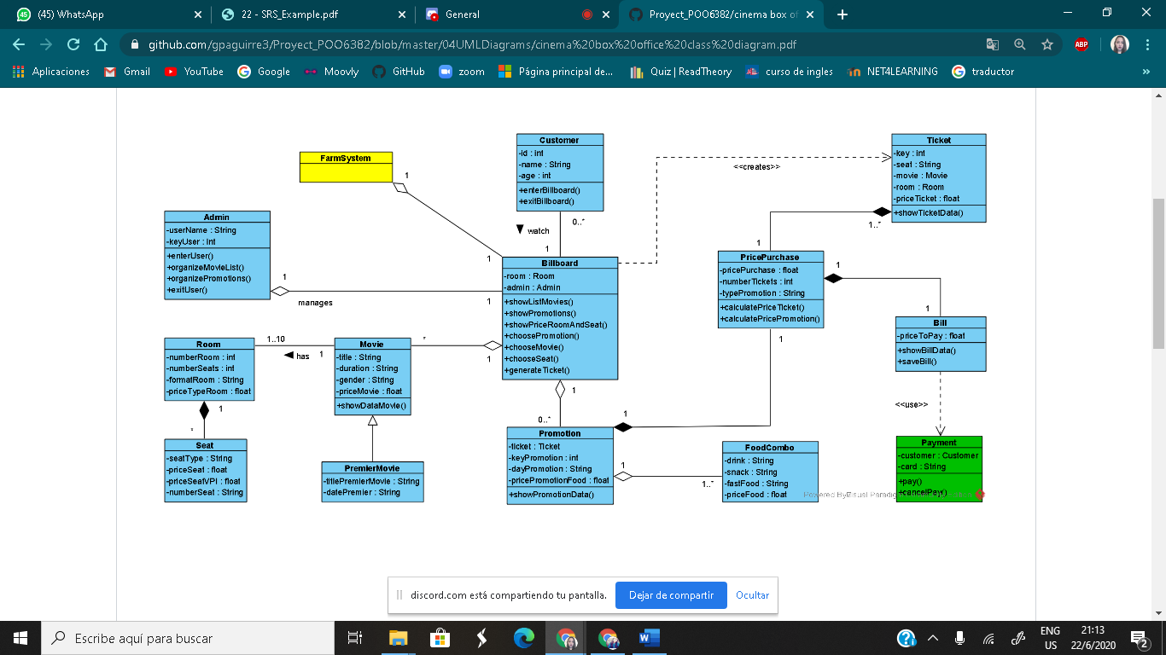

# **Expected results**

* Development of the system program source code, at the time of coding, we apply the knowledge acquired during the 1st partial.
* Tests were performed with input of flat files, with a lot of textual or numerical information to avoid inconveniences.

# **Viability**

## **Technical**

|  |  |  |  |
| --- | --- | --- | --- |
| Software | | | |
| Amount | Description | Unit Price | V. Total |
| 5 | Netbeans | 0.00 | 0.00 |
| 5 | Windows 10 Home | 120.00 | 600.00 |
| 2 | Microsoft Office | 76.00 | 152.00 |
|  | | Total | 752.00 |

|  |  |  |  |
| --- | --- | --- | --- |
| Administrative | | | |
| Amount | Description | Unit Price | V. Total |
| 0 | Paper Resma | 0.0 | 0.0 |
| 0 | Ink Cartridges | 0.0 | 0.0 |
| 1 | Material Extra | 18.00 | 18.00 |
|  | | Total | 18.00 |

|  |  |  |  |
| --- | --- | --- | --- |
| Hardware | | | |
| Amount | Description | Unit Price | V. Total |
| 1 | Core i3-6006computer,4 GB RAM ,1 Tera. | 500 | 500 |
| 1 | Core i3 computer, 6 GB RAM | 600 | 600 |
| 1 | Core i7 computer, 12Gb RAM, 1 Tera. | 700 | 700 |
| 1 | Core i3 computer, 4 Gb RAM | 800 | 800 |
| 1 | HP Pavilion x360 Convertible, Core i3-10110, 8 Gb RAM, 120 Gb. | 400 | 400 |
|  | | Total | 3000.00 |

* The hardware detailed in the table above is owned by the work computer.

|  |  |
| --- | --- |
| TOTAL BUDGET | |
| Hardware | 3000.00 |
| Software | 752.00 |
| Administrative | 18.00 |
| Total | 3770.00 |

## **Human**

### **Business Tutor**

Ing. Edison Lascano.

### **Students**

* Gabriel Aguirre
* Josue Aleman
* Jhoel Chicaiza
* Kevin Chuquimarca
* Alisson Clavijo

# **Bibliography**

*[1] World Wide Web Consortium, 2008, Web Accessibility Brief Guide.* [*http://www.w3c.es/divulgacion/guiasbreves/Accesibilidad*](http://www.w3c.es/divulgacion/guiasbreves/Accesibilidad)

*[2] Nielsen, J., 2003. Usability 101: Introduction to Usability.* [*http://www.useit.com/alertbox/20030825.html*](http://www.useit.com/alertbox/20030825.html)

*[3] PHP. DesarrolloWeb.com. Retrieved 8 May 2018, from* [*https://www.desarrolloweb.com/articulos/392.php*](https://www.desarrolloweb.com/articulos/392.php)

*[4] Alvarez, M. (2018). What is a CMS.* *DesarrolloWeb.com. Retrieved 8 May 2018, from*  [*https://desarrolloweb.com/articulos/que-es-un-cms.html*](https://desarrolloweb.com/articulos/que-es-un-cms.html)*Alvarez, M. (2018). What is it*

*Drupal.org. (2015). Drupal.org. Retrieved 8 May 2018, from* [*https://www.drupal.org/drupalorg*](https://www.drupal.org/drupalorg)