This document is stored in Box. The Box Sync Folder can be found at gtp/Box Sync/pfsense

That folder also contains numerous backups

The basic config of the network is as follows:

1. Follow default configuration
2. Check for system updates and update if necessary
3. Enable ssh on the system console and reboot (sshd_enable="YES" in the /etc/rc.conf)and then service sshd onestart
   1. To get on with ssh, ssh root@192.168.1.1
4. Set up 2nd LAN.
   1. Insert a usblan and plug in the cable
   2. From the UI, interface/assign – add
   3. Interface OPT1, enable and set the IP to 192.168.2.1, etc
   4. Start the DHCP Service for OPT1
   5. Firewall Rules OPT1 – add. See below
5. Disable DHCPv6 server
   1. Remove the ipv6 firewall rule on the LAN
6. Setup Captive Portal
   1. Logout - <https://forum.pfsense.org/index.php?topic=77143.0>

Update according to the following https://forum.pfsense.org/index.php?topic=77143.msg478165#msg478165…« **Reply #13 on:** January 21, 2015, 05:34:59 am »

* 1. <http://192.168.2.1:8002/index.php?zone=brr&redirurl=http%3A%2F%2Fcaptive.apple.com%2Fhotspot-detect.html>
  2. http://192.168.2.1:8002/index.php?zone=brr

To start sshd - /etc/rc.d/sshd onestart or set sshd=”YES” in /etc/rc.conf

Setting up FreeRadius

**FreeRadius configuration ($freeradius_config) files are located inside this directory / folder: *FreeBSD***: /usr/local/etc/raddb/

Also see here - <https://forums.freebsd.org/threads/929/>

And this - <https://forum.pfsense.org/index.php?topic=128923.0>

<https://doc.pfsense.org/index.php/Testing_FreeRADIUS>

1. Install free radius
2. Set up interface (192.168.2.1)
3. Set up NAS/Clients (192.168.2.1)
4. Set up users
5. Test (https://doc.pfsense.org/index.php/Testing_FreeRADIUS)

**Setting up Apache on my mac mini**

<https://medium.com/@JohnFoderaro/how-to-set-up-apache-in-macos-sierra-10-12-bca5a5dfffba>

/Users/gtp/Sites/index.html /Library/WebServer/Documents/index.html

The webserver is looking in /Library/WebServer/Documents/index.html for the server link.

The command to start, stop, and restart is…sudo apachectl restart

sudo ln /Users/gtp/Sites/index.html /Library/WebServer/Documents/index.html

ErrorLog "/private/var/log/apache2/error_log"

Instructions

<https://forum.pfsense.org/index.php?topic=108493.0>

1. I changed You must edit the file /usr/local/etc/pkg/repos/pfSense.conf and set the following value: (and also in FreeBSD.conf):

**Code:**[[Select]](javascript:void(0);)

FreeBSD: { enabled: yes }

1. y

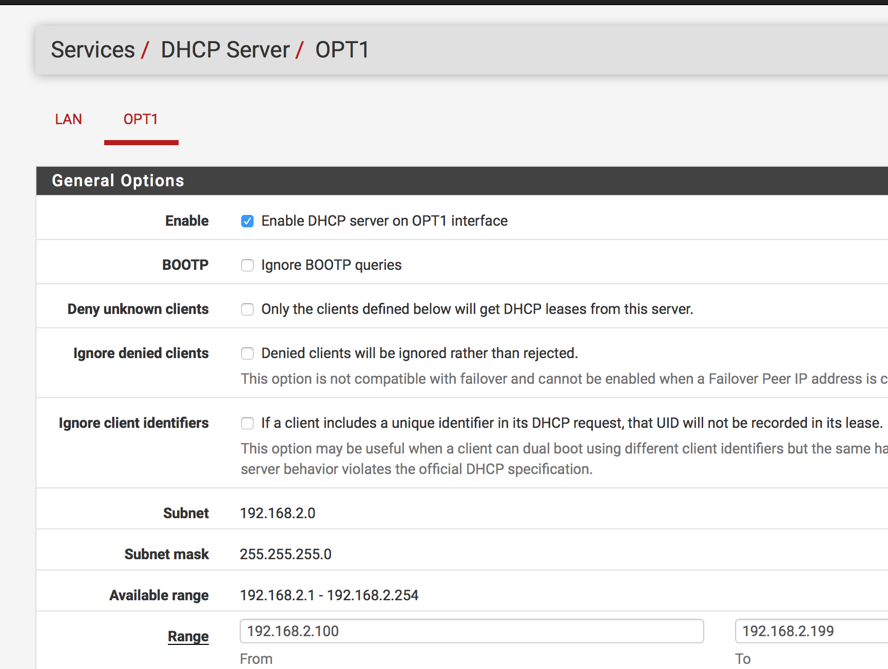

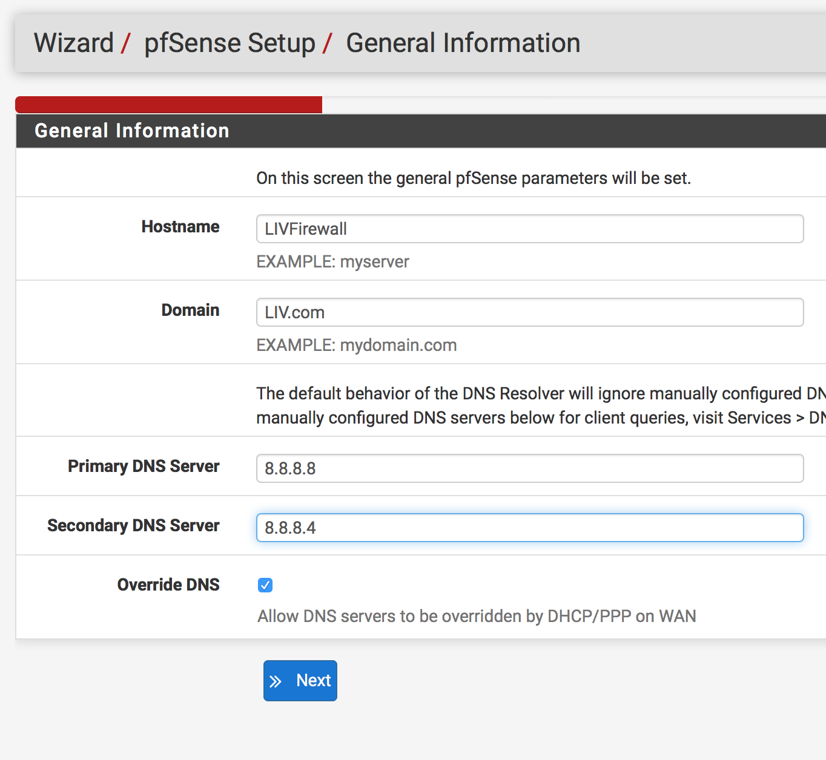

The following are screen shots showing the expected configuration

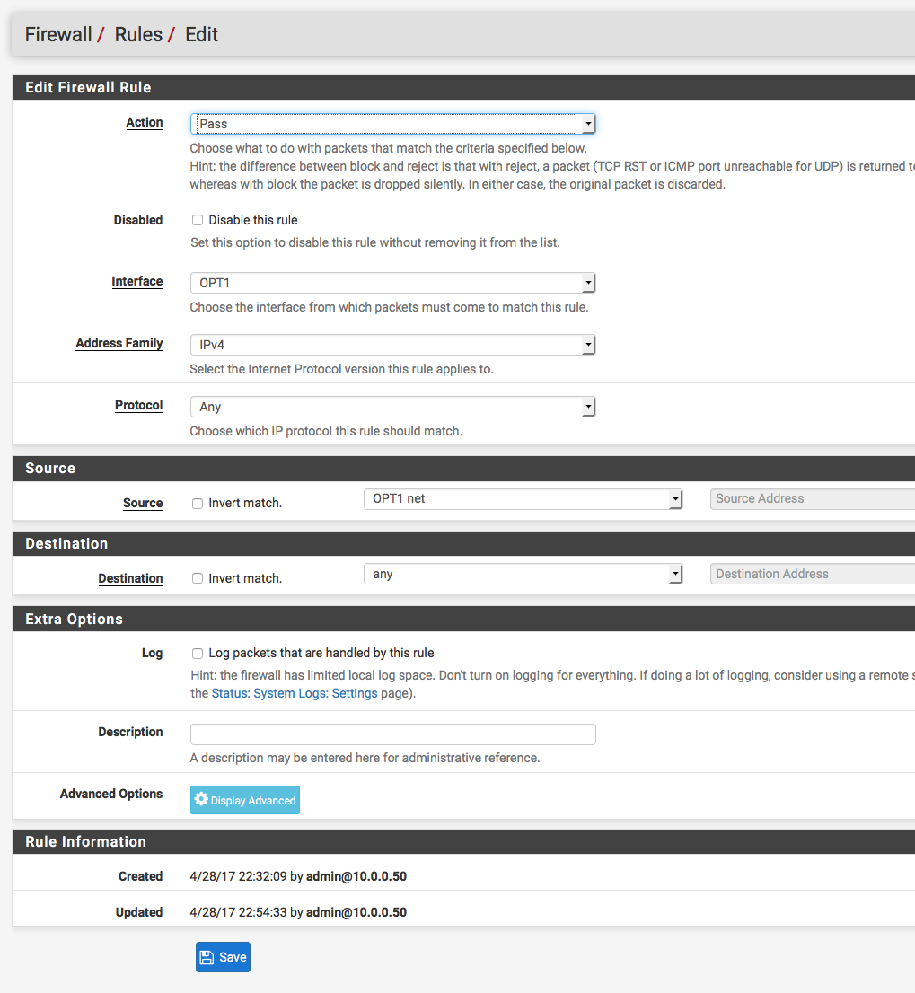

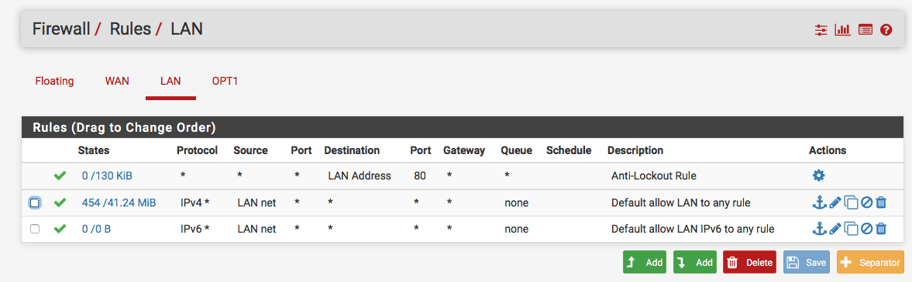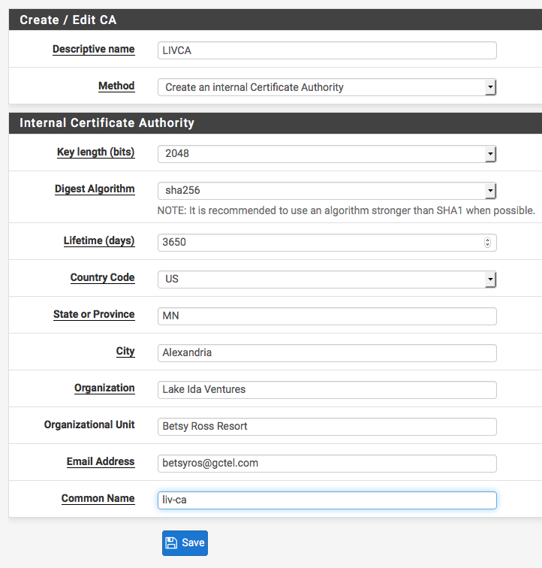

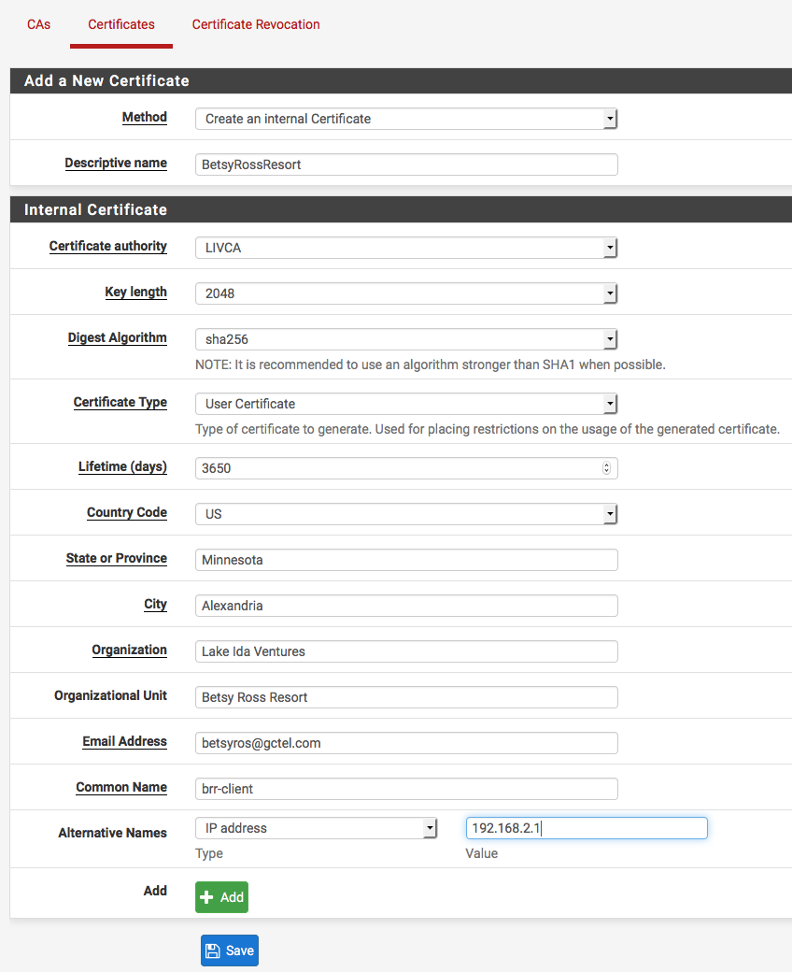

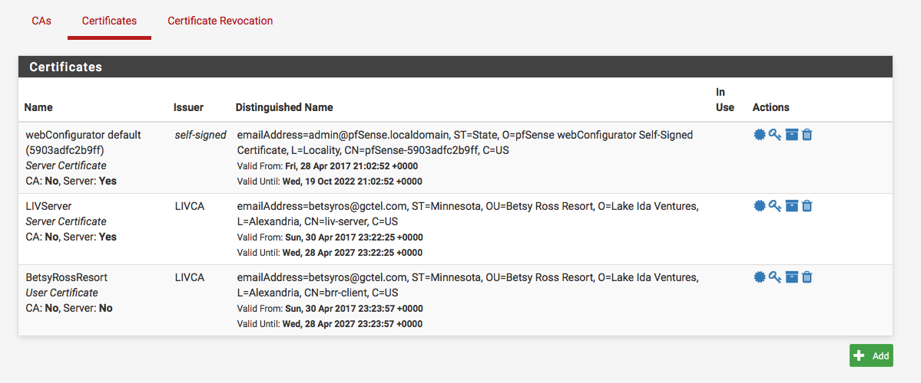

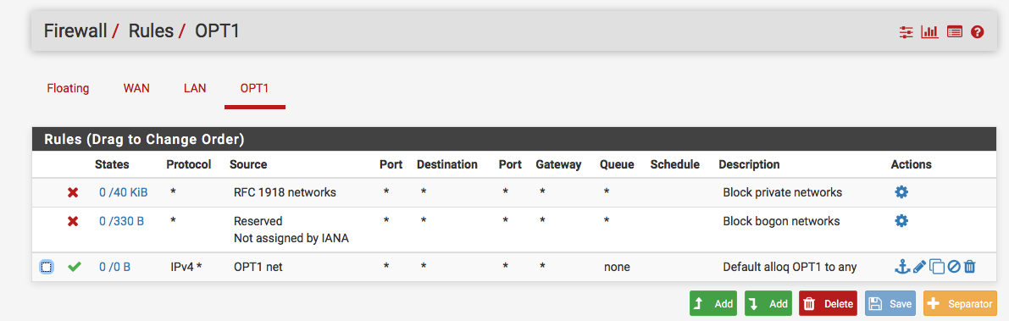

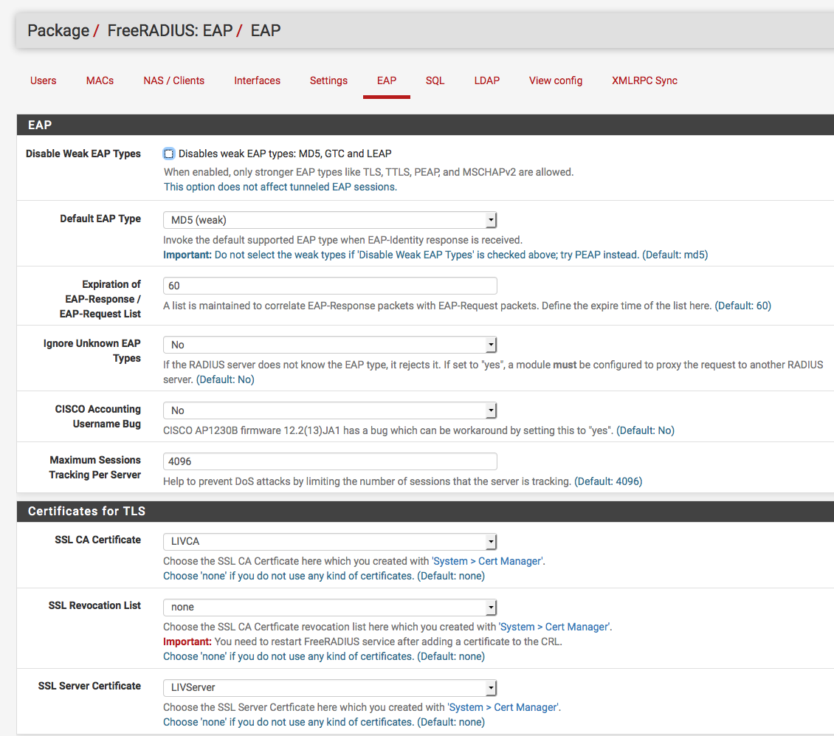

To enable ssh on the MyBookLive

<https://community.wd.com/t/what-are-the-steps-to-enable-ssh/55722/7>

1. Log into your MBL as normal.
2. When you see the MyBook Live Webpage with the "Settings / Users / Shares / ..." menu,
3. MODIFY the URL in your browser address bar by adding "ssh" to the end of the string.
4. It needs to be in lower case letters.
5. It should look something like this:
6. http://(something}/UI/ssh

Username: root

PW: welc0me (but it always says that…it’s really 5…j)

About changing the ssh pw: Good idea to keep SSH enabled. SSH to MBL; cmd fo change password:  passwd root Will be prompted for new password & confirmation. To "restore" password to default, just press the "reset" button for 5-6 secs.

Azure

https://lakeidaventures.visualstudio.com/_git/MyFirstProject