**FIGURE 1**

|  |  |  |
| --- | --- | --- |
| **Factor** | **DNA methylation** | **Gene expression** |
| 1 | 0.12 | 17.57 |
| 2 | 10.09 | 6.24 $·{10}^{-6}$ |
| 3 | 0.20 | 7.51 |
| 4 | 7.47 | 1.11 $·{10}^{-6}$ |
| 5 | 4.80 | 1.14 $·{10}^{-6}$ |
| 6 | 0.12 | 3.63 |
| 7 | 0.16 | 3.55 |
| 8 | 0.24 | 2.93 |
| 9 | 2.73 | 0.25 |
| 10 | 0.22 | 1.74 |
| 11 | 1.91 | 2.18 $·{10}^{-6}$ |
| 12 | 0.18 | 1.48 |
| 13 | 0.18 | 1.38 |
| 14 | 0.14 | 1.35 |
| 15 | 0.17 | 1.30 |
| 16 | 1.46 | 1.22 $·{10}^{-6}$ |
| 17 | 0.71 | 0.58 |
| 18 | 0.98 | 0.17 |
| 19 | 1.07 | 4.42 $·{10}^{-3}$ |
| 20 | 0.26 | 0.80 |
| 21 | 1.01 | 4.92 $·{10}^{-4}$ |
| 22 | 0.20 | 0.75 |
| 23 | $$9.49·{10}^{-2}$$ | 0.80 |
| 24 | 0.84 | 2.38 $·{10}^{-6}$ |
| 25 | 1.99 $·{10}^{-2}$ | 0.78 |
| 26 | 0.75 | 1.78 $·{10}^{-4}$ |
| 27 | 0.73 | 1.65 $·{10}^{-2}$ |
| 28 | 0.39 | 0.32 |
| 29 | 0.44 | 2.46 $·{10}^{-5}$ |
| 30 | 0.26 | 3.64 $·{10}^{-5}$ |
| **Total** | **37.87** | **45.48** |
| **83.35** | |

**B**

**A**

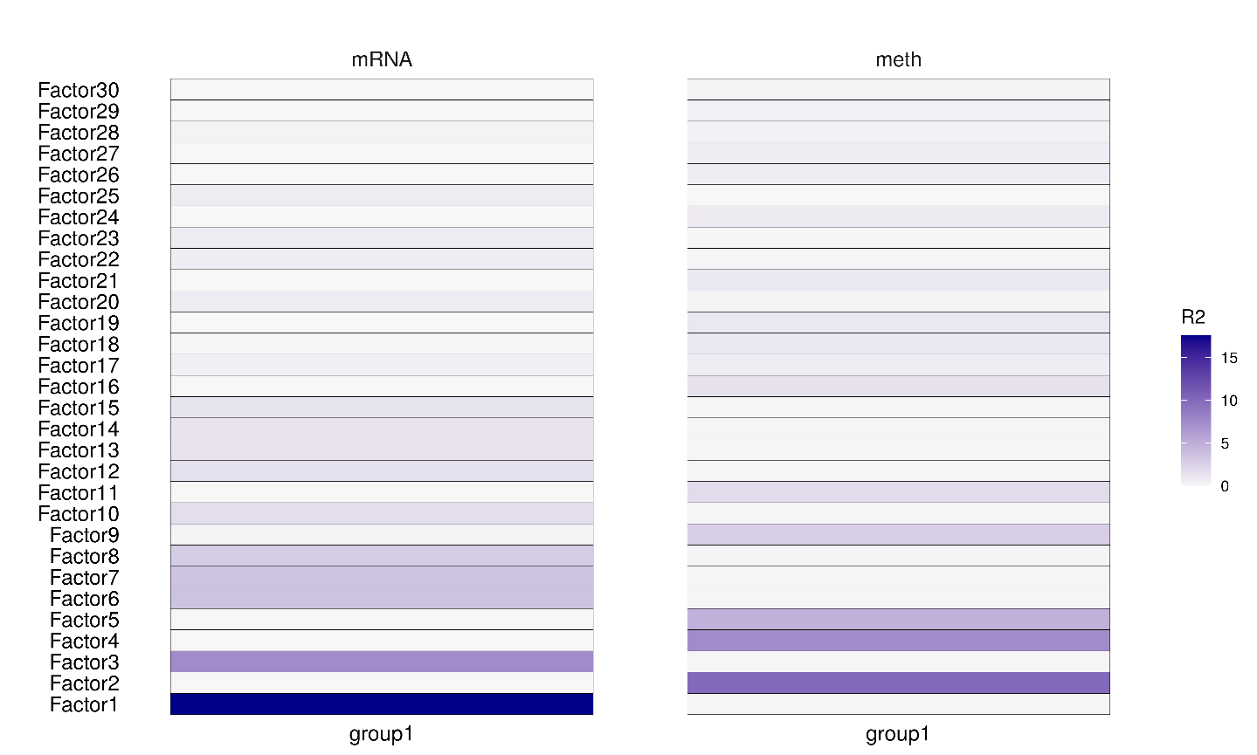

DNA methylation

Gene expression

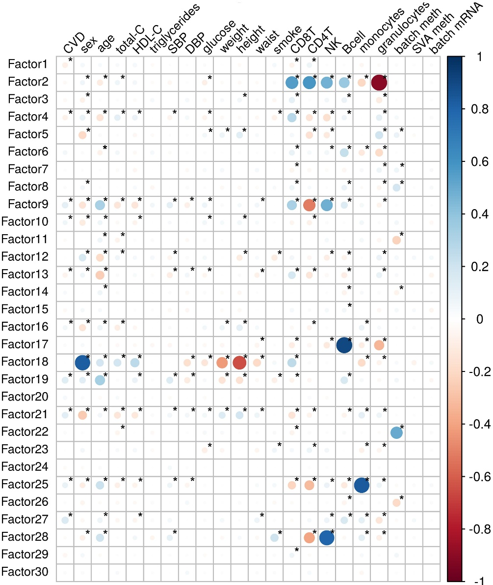**FIGURE 2**

**FIGURE 3**