EMU Rakes Details are as per chart below

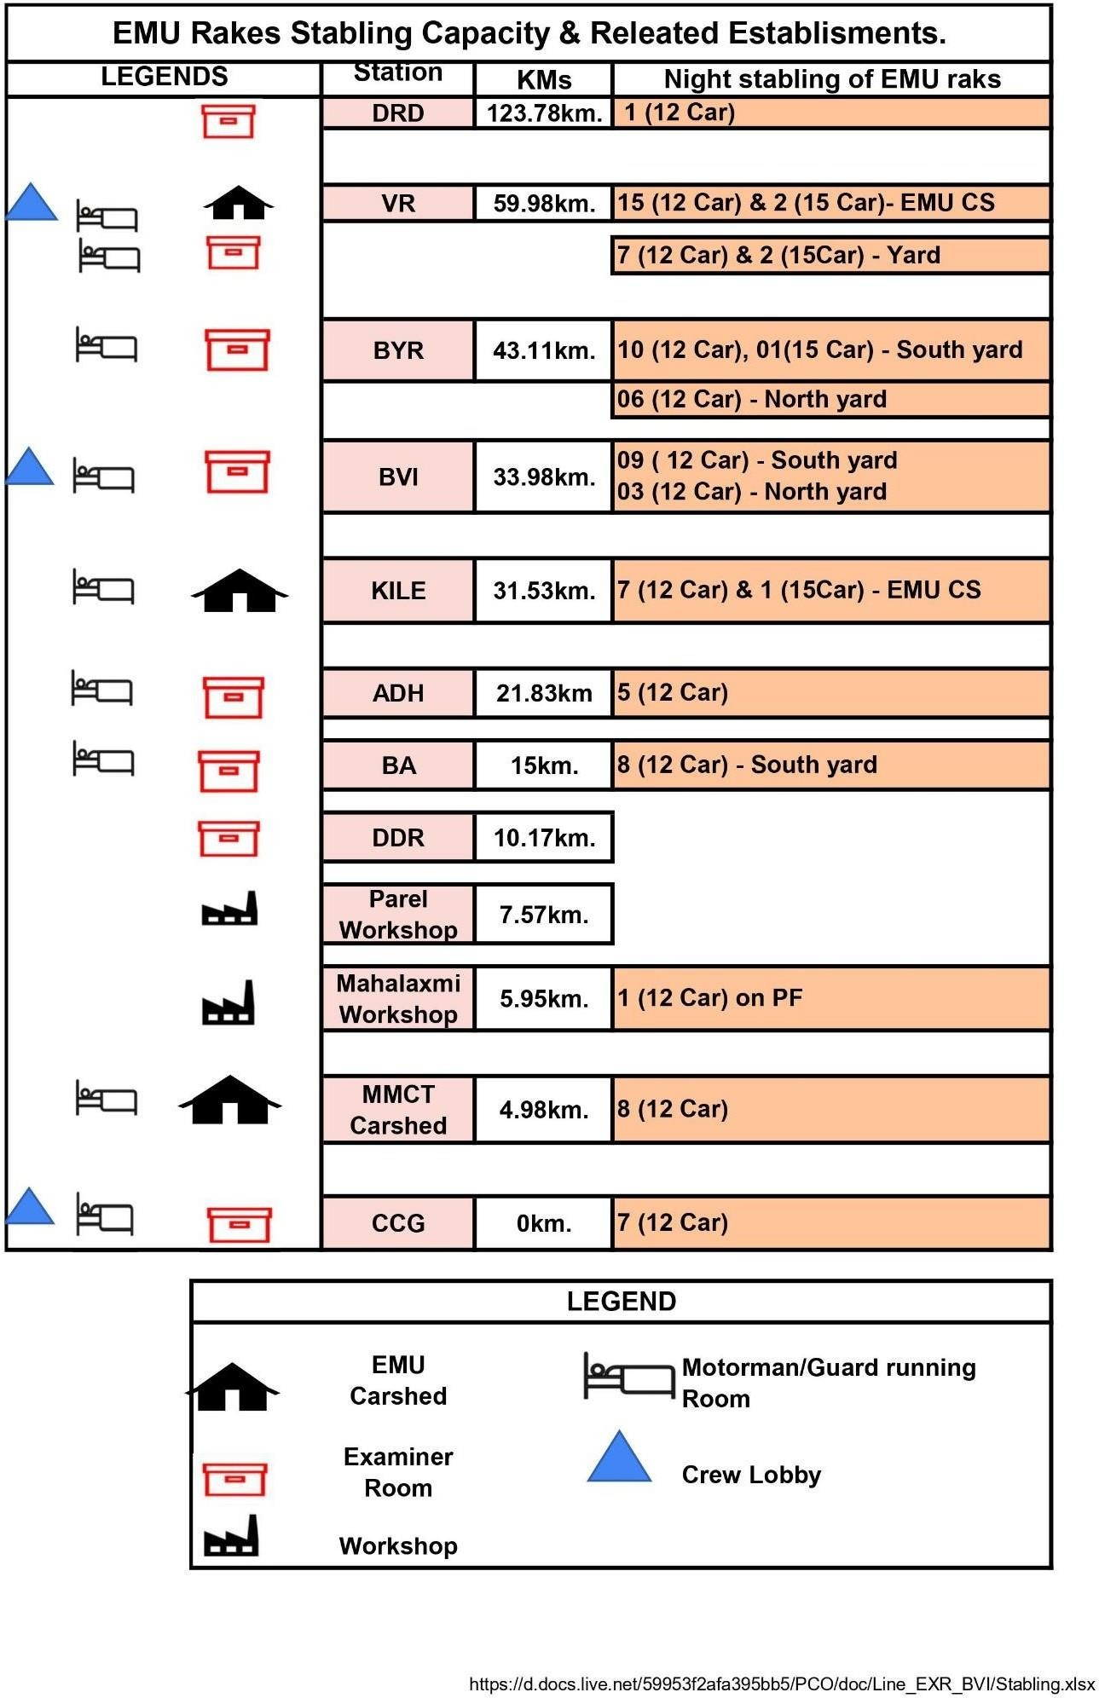

12