The most recent test of the CROC is for variable input pulse signal amplitudes. The goal is to verify that the absolute gain as a function of the 6-bit set gain does not change for different input amplitudes.

The steps I followed:
1) Send the signal from the generator to the oscilloscope and record the data to measure the input signal amplitude. This is a much better measurement than using the cursors and measure the signal on the screen of the oscilloscope. An example for an input signal of 5mV is shown in Figure 1. On the left there is the plot of the raw data. For each individual pulse I measure the base and the top level and I subtract the two to find the amplitude. On the right there is the histogram of the amplitude which I fit with a gaussian function. The fit is good based on the χ²/ndf and the mean value consistent with what is expected.
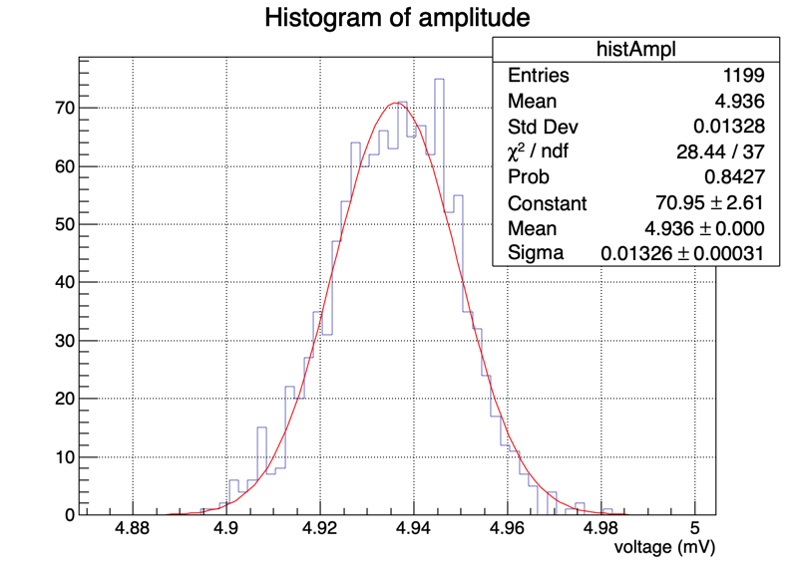
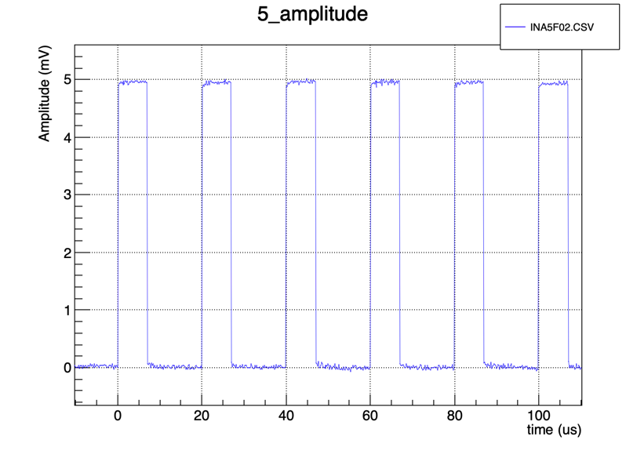
Figure 1. Generator pulse signal
2) After measuring the input amplitude, I split the generator signal on the oscilloscope and then I send it to the CROC test board, then follows the BEB_to_CROC board and finally the BEB3 ADC board. IN EVERY CONFIGURATION I AM VERY CAREFUL WITH THE IMPEDANCE OF THE OSCILLOSCOPE, meaning that when I have only the generator and the oscilloscope the impedance is 50Ω, while when I split the signal and send it to CROC the impedance is 1MΩ. As a matter of fact, including the oscilloscope in the CROC test setup introduces noise.
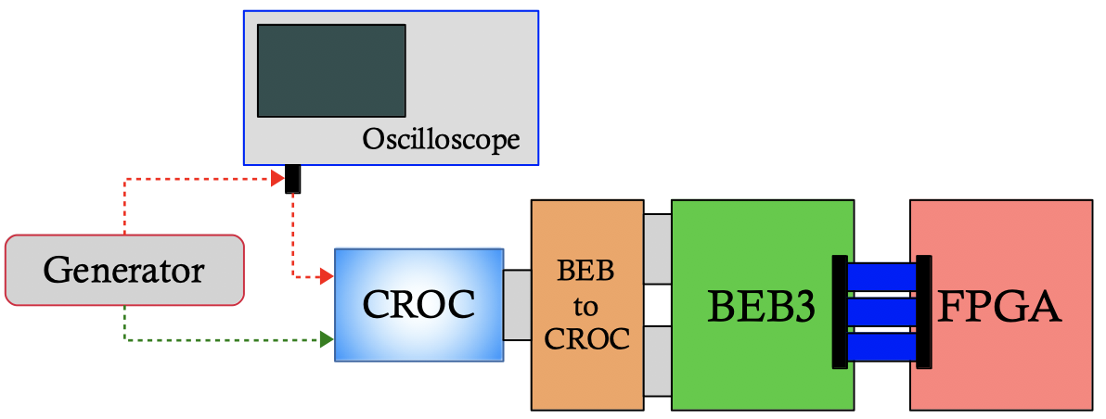
In Figure 2, there is the BEBoutput histogram for 5mV input signal of 2 measurements: with (left) and without (right) the oscilloscope in the setup. The measurements happened the one after the other and the analysis method is exactly the same, so any difference is due to the oscilloscope. Looking the CROC output with the oscilloscope integrated, it looks like the oscilloscope adds an oscillation to the signal. The reproducibility of the results is confirmed. As a result, since I know the input signal amplitude, I should send the signal directly from the generator to the CROC.
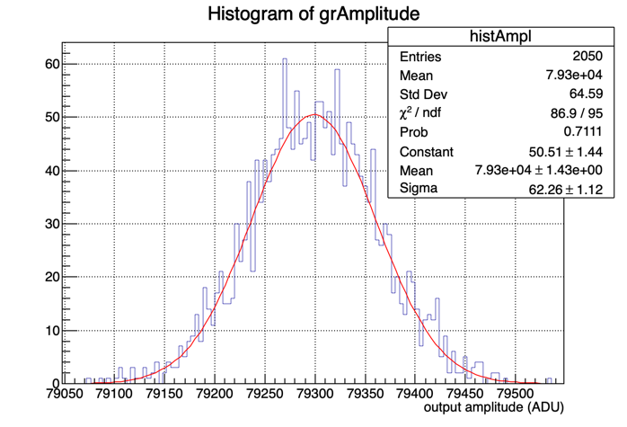
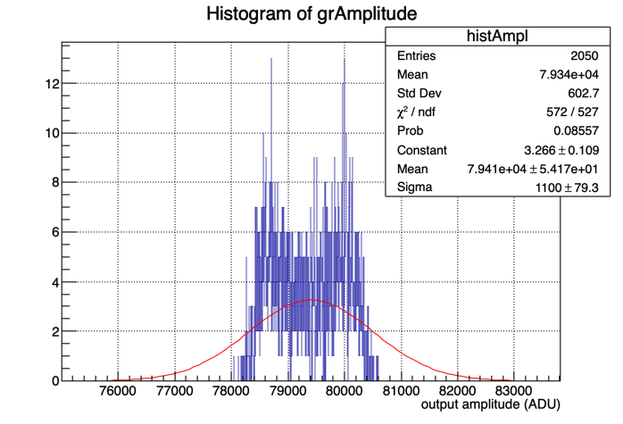
Figure 2. BEB output with(left) and without(right) the oscilloscope in the setup
3) Finally, it is possible to measure the absolute gain as a function of the 6-bit set gain for different input amplitude pulses. In Figure 3, there is the plot of the CROC gain calibration for 4 different input amplitudes. For each amplitude there is a different number of points and different set_gain values were chosen. The points in the middle left correspond to gain=CF1 (to integrate the CF1 points I consider CF1 as a set gain=1). The points seem to be in good agreement, yet there is something strange happening for the CF1 case. It looks like the CF1 gain depends on the input signal amplitude! This, in my opinion, is completely unexpected. I looked for any bugs in the analysis code but I did not find any. I tried to brainstorm any possible explanations but nothing. As a conclusion, the higher the input amplitude, the higher the absolute gain in CF1.
Figure 3. CROC gain calibration. Points on middle left of the plot correspond to gain=CF1

