# PERSONAL INFORMATION

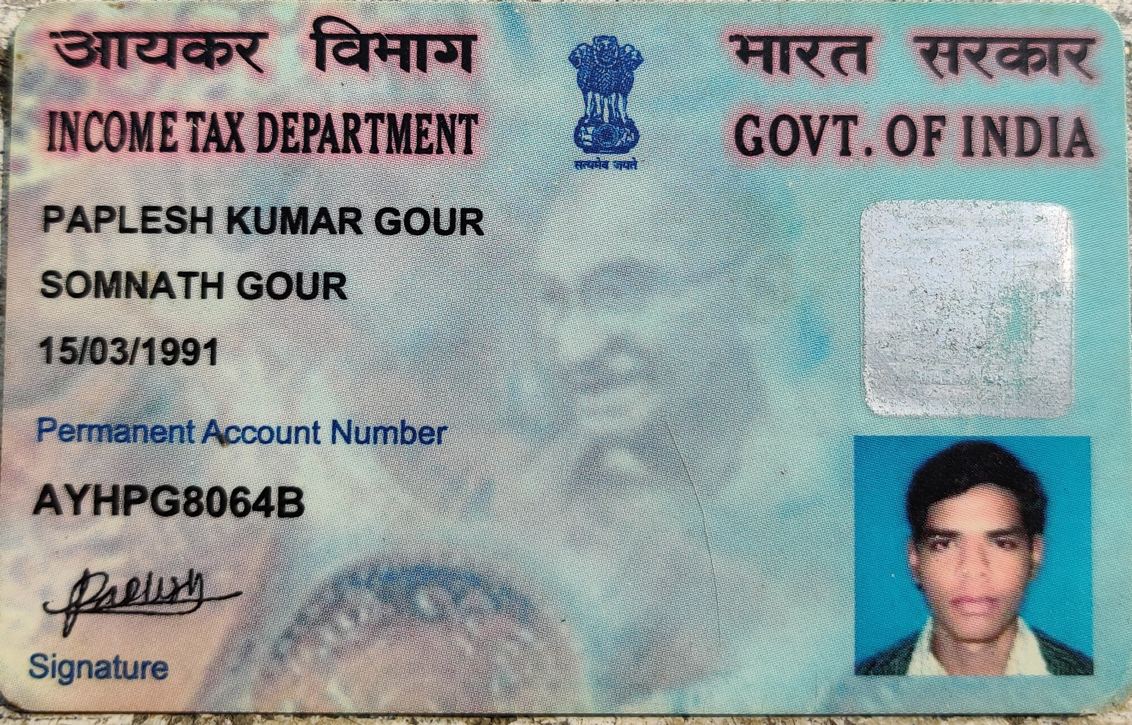

Photo Id Proof (**Passport, Aadhar Card, PAN**) with Clear Photograph with signature

|  |  |  |  |  |  |  |  |  |  |  |  |  |  |  |  |  |  |  |  |  |  |  |  |  |  |  |  |  |  |
| --- | --- | --- | --- | --- | --- | --- | --- | --- | --- | --- | --- | --- | --- | --- | --- | --- | --- | --- | --- | --- | --- | --- | --- | --- | --- | --- | --- | --- | --- |
| First Name Middle Name Last Name  Mr Paplesh Kumar Gour  (As in Passport) | | | | | | | | | | | | | | | | | | | | | |  | | | | | | | |
| Date of Birth | | | | | | | e-mail : gpaplesh@gmail.com | | | | | | | | | | | | | | |
| 1 | 5 | 0 | 3 | 1 | 9 | 9 | 1 |  | | | | | | | | | | | | | |
| Current Address : Ward-3 Near E-Comm Express Office, Hajipur Sironj Dist. Vidisha M.P. - 464228 | | | | | | | | | | | | | | | | | | | | | | | | | | | | | |
| City - Sironj | | | | | State – Madhya Pradesh | | | | Zip Code | | | | | | Phone (with STD code) | Office | |  | |  |  |  |  |  |  |  |  |  |  |
| 4 | 6 | 4 | 2 | 2 | 8 | Res. | | 9 | | 4 | 0 | 7 | 5 | 9 | 6 | 8 | 8 | 6 |  |
| Permanent Address : Ward-3 Near E-Comm Express Office, Hajipur Sironj Dist. Vidisha M.P. - 464228 | | | | | | | | | | | | | | | | | | | | | | | | | | | | | |
| City – Sironj | | | | | State – Madhya Pradesh | | | | PIN | | | | | | Phone (with STD  code) | |  | |  | |  |  |  |  |  |  |  |  |  |
| 4 | 6 | 4 | 2 | 2 | 8 | Mobile | | 9 | | 4 | | 0 | 7 | 5 | 9 | 6 | 8 | 8 | 6 |  |
| Name of Emergency Contact Person – Asha Patel | | | | | Relationship - Wife  Location - Sironj | | | | 4 | 6 | 4 | 2 | 2 | 8 | Emergency Contact Number | | 7 | | 3 | | 5 | 4 | 6 | 0 | 6 | 1 | 1 | 6 |  |

**EDUCATION**

(Begin with the most recent qualification and end with Std. X)

|  |  |  |  |  |  |  |
| --- | --- | --- | --- | --- | --- | --- |
| Course/Degree | Specialization | Name of Institute /University | | Location | Graduation (Month/Yr.) | Aggregate Marks (Percentage  or CGPA) |
| **10Th** | N/A | M.P. Board | | Vidisha (M.P.) | 2008 | 78.6% |
| **12th** | PCM | M.P. Board | | Sironj (M.P.) | 2010 | 65% |
| **Diploma (if**  **any)** |  |  | |  |  |  |
| **Graduation** | B.E. | RGPV University Bhopal | | Bhopal (M.P.) | 2015 | 70% |
| **Post-**  **Graduation** |  |  | |  |  |  |
| **Doctorate** |  |  | |  |  |  |
| **Educational Gaps** From (DD/MM/YY) : 01/07/2010  To (DD/MM/YY) : 01/07/2011 | | | **Reason –** 1 Year Gap forEntrance Exam Preparation for BE Admission | | | |

# TRAINING

|  |  |  |  |  |
| --- | --- | --- | --- | --- |
| Training/Development Programs attended | Institute / Organization | Location | Dates attended | |
| From | To |
| Oracle Digital Assistant – 56 Hours  MEAN Stack Angular/Node – 40 Hours  Java/Oracle – 6 Months  C/C++ – 8 Months | Oracle  Udemy  Naresh IT Hyderabad  Sharma Classes | Virtual  Virtual  Hyderabad  Bhopal | 2021  2021  2015  2013 | 2021  2021  2015  2014 |

**WORK EXPERIENCE**

**PRESENT / LAST EMPLOYMENT**

|  |  |  |  |
| --- | --- | --- | --- |
| Name of the Employer – **Deloitte Consulting India PVT LTD** | | | Address : 5th Floor RMZ Infinity, Phase IV, Sector 18, Gurugram, Haryana 122015, India  Phone : |
| Dates Employed From  20-Jul-2020 | | To  Currently Working |
| Your Designation - Consultant | Employee Code - **578409** | Responsibilities – Oracle SaaS Technical Consultant | |
| Reason For Leaving – Seeking new learning opportunities | | | Total CTC : - 1425000  Variable/Performance Bonus : 10% |

**PREVIOUS EMPLOYMENT DETAILS**

|  |  |  |  |  |  |  |  |  |
| --- | --- | --- | --- | --- | --- | --- | --- | --- |
| Name of the organization | Location | Designation | Employee Code | Duration | | Monthly Salary | | Reason for  Leaving |
| From | To | Starting | Final |
| **Cognizant Technology Solutions** | Kolkata | Senior Developer | **568603** | 26-May-2016 | 17-Apr-2020 | 22500 | 39950 | Personal Growth |
|  |  |  |  |  |  |  |  |  |

|  |  |
| --- | --- |
| **Employment Gaps** From (DD/MM/YY) : 26/06/2015  To (DD/MM/YY) : 26/05/2016 | **Reason:** Training and interview preparation and seeking Job opportunities through Walk in and Off campuses |

**MONTHLY EMOLUMENTS**

|  |  |
| --- | --- |
|  | 132757 |
|  | 1593084 |
|  | 2389626 (50% Hike) |

|  |  |  |  |  |  |
| --- | --- | --- | --- | --- | --- |
| Fixed Salary | | Variable / Perks | | Deferred benefits | |
| Basic | 41600 | Housing |  | PF, Pension, Gratuity  etc.(C) | 4992 |
| Bonus/Incentives |  | Company car |  | Monthly Gross (A+B+C) Current Annual Gross  **Expected Annual Gross** | |
| Allowances | 72207 | Furnishings |  |
| Others  (please specify) |  | Others  Annual Incentive 10% of CTC + 25k Wellbeing Subsidy | 13958 |
| Total (A) |  | Total (B) |  |

Do you have employee stock options?

Yes No

If yes, Net gain at current value

:

{(Current Market Price – Issue price) x No. of stocks}

**GOVERNMENT HIRE STATUS**

Yes

No

Do you have an immediate family member in a position as or a business relationship with any state (government)-working personnel?

Definitions:

* Immediate Family: Means the applicant’s
  + Spouse**\* /** Spouse equivalent**\***
  + Children
  + Parents
  + Any other relative providing financial support to the applicant
* Business Relationship: Means any relationship to or ownership of a proprietorship, partnership, firm, corporation, trust or other entity through which business is conducted and a state(government)-working personnel is an owner, director, officer, partner, beneficiary of the entity. Owner must be more than five percent of the business.

**\*Spouse**: A husband or wife, either by marriage or under common law, is considered a spouse

**\*Spouse Equivalent**: A cohabitant occupying a relationship generally equivalent to that of a spouse would be considered a spouse equivalent

|  |  |
| --- | --- |
| Name: | Relation: |
| Workplace: | Designation: |
| Currently Working Yes No | Sector: |

|  |  |
| --- | --- |
| Name: | Relation: |
| Workplace: | Designation: |
| Currently Working Yes No | Sector: |

# PROFESSIONAL REFERENCE

Give references under whom you have either worked or who know you professionally for at least 6 months.

|  |  |  |  |  |  |
| --- | --- | --- | --- | --- | --- |
| Name | Duration & Nature of  Association | Organization & Designation | e-mail | Phone (with STD code) | |
| Home | Office |
| Ujjwal Mistry | 4 Years - Team Lead | Deloitte - Senior Consultant | **Off: umistry@deloitte.com**  **Per: ujjwal.dchs@gmail.com** | 8777542297 |  |
| Kunal Sood | 1.5 Years - Colleague | Deloitte - Consultant | **Off: kusood@deloitte.com**  **Per: kunal.sood2727@gmail.com** | 9971125538 |  |
|  |  |  |  |  |  |

# ADDITIONAL DETAILS

|  |  |
| --- | --- |
| Nationality Indian Other/s Natioanl ID (eg SSN, Passport) : | If Others, Specify Nationality :  Do you have work permit to work in India? Yes No |
| Do you hold a valid Passport? Yes No (for Indian citizens only) | If Yes, Passport Number :  Expiry Date : |
| Have you been denied entry to Yes No any country? | If Yes, Details : |
| Have you worked on overseas Yes No assignments? | If yes, provide details on countries visited and type of Visas held |
| Have you attended any selection  process at any of PwC firm/SDC before? Yes No | If Yes, Division : Location :  Month/Year: Status : |
| Do you have any relative / friend  employed with PwC? Yes No | If Yes, his/her name : Division/Location : |
| Have you ever been arrested,  prosecuted or convicted for any Yes No criminal offense, other than minor  traffic offenses ?  In the last ten years, have you been convicted of or plead guilty to any offence?  In the last ten years have you been released from prison on a conviction? | If Yes, furnish details including type of offense and conviction  Yes ( ) No ( )  Yes ( ) No ( ) |
| Do you have any commitment to another employer or organization that might affect your employment with us? Yes No | |
| Any other information you would like us to know which may have significant bearing on our hiring decision: | |

I hereby declare that my statements on this application and on my resume or documents provided by me to PwC SDC are correct to the best of my knowledge. I acknowledge and agree that providing any false information may result in a decision not to hire me or if hired, may result in termination of my employment. I give consent to PwC SDC to institute and conduct a background check to verify the information furnished by me in this form.

Date: 05/05/2022 Place: Sironj Signature: