Team “Guava”
Георги Парлъков
Емил Димитров
Адриян Гуляшки
Борис Матев
Тодор Алексиев

Project “Snake”

Our take on the famous game

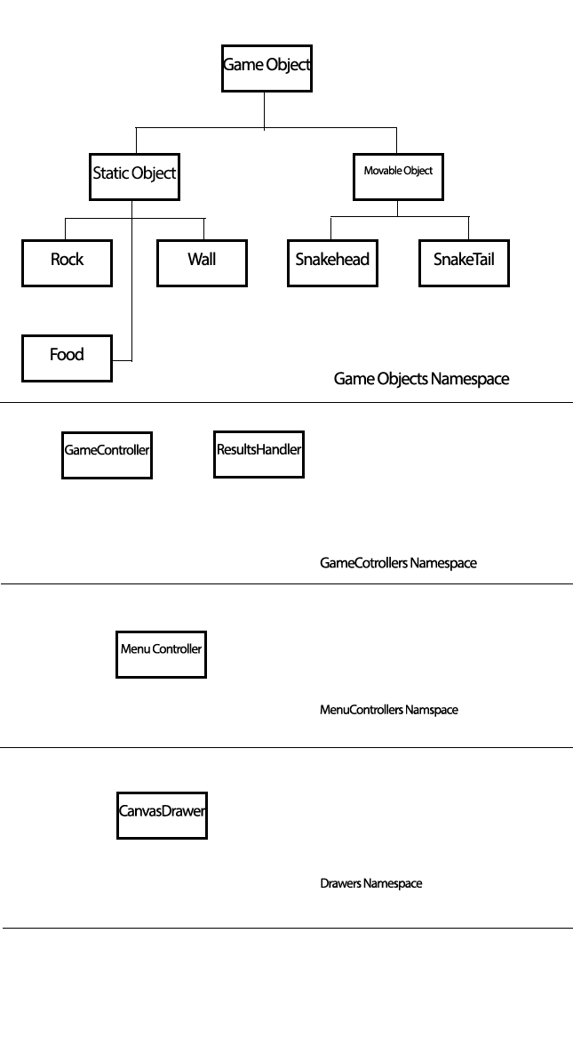

Game namespaces and objects

GameObjectsNS
- GameObject
  - Color – predefined string object
  - Coordinates
  - Update Object function – move, get eaten etc.

- MovingObject
  - headObject
    - speed / or direction
    - can collide with staticObjects, movingObjects
    - canHaveTail(has oldCoordinates field that will be given to tail)
  - tailingObject
    - following previous tail or head( takes Coordinates from previousElement.oldCoordinates)

- snakeObject
  - has head and tailing objects (inside an array like object)
  - update updates all its objects and moves them…. Or
- StaticObject
  - stoneObject
  - wallObject
  - foodObject

GameControllersNS
- gameController
  - speed of game (level diff….?) at construction time
  - listOfObjects
  - collisionDetector
  - drawer (canvas) - instance
  - userInteractor – handles user input
  - main game loop
    - collisionDetection
    - objectsUpdate
    - check if game over
    - spawn food?
    - objects draw
- menuController
  - creates buttons
  - gives eventlisteners
  - visualizes menu
  - maybe has background????
- (Snake Controller??? Here ??? where???)

CanvasDrawerNS
- canvasDrawer – takes an object and draws its representation on canvas
- menuDrawer – takes menu object
MenuNS(?? or inside GameObjects – menuObject)

GameFlow
- Draw menu(initialize controller (or maybe menuController) – initialize drawer, initialize menu object)
- Start menu….. process input ….. – highScore, startGame, difficultyLevel, about Team “Maragedik”, exit (byeBye)
- Start
  - startGame
    - instance of objectsFactory, initialize gameController if none
    - createGameField – walls, food, head ( with 2 tailingobjects)
    - startMainLoop -
  - highScore
    - clearCanvas
    - getScores
    - draw scores ( in a DOM element or using canvas drawer?)
    - goto 2. (goto is evil)
  - about
    - take information for team from facebook!!!! API
    - Take information about user’s facebook – using facebook API

  - Exit
    - Bye bye – close window

Main Loop
Main game loop :
- Collision detection
  - For each element in the elements collection check if collided and take action
- Objects Update
  - For each object update
- check if game over
  - if over take action
- spawn food?
  - Random generate food or when eaten…
- objects draw
  - draw all objects ( for each object in game objects collection execute

