**Spring Cloud Function Using as AWS Lambda Function**

To make spring function as AWS Lambda Function below steps follow:

We need to use below dependencies:

<dependency>

<groupId>org.springframework.cloud</groupId>

<artifactId>spring-cloud-function-adapter-aws</artifactId>

</dependency>

<dependency>

<groupId>com.amazonaws</groupId>

<artifactId>aws-lambda-java-core</artifactId>

<version>1.2.0</version>

</dependency>

Also we need to use below maven plugin to create shaded jar:

<build>

<plugins>

<plugin>

<groupId>org.apache.maven.plugins</groupId>

<artifactId>maven-shade-plugin</artifactId>

<version>2.3</version>

<configuration>

<createDependencyReducedPom>false</createDependencyReducedPom>

</configuration>

<executions>

<execution>

<phase>package</phase>

<goals>

<goal>shade</goal>

</goals>

</execution>

</executions>

</plugin>

<plugin>

<groupId>org.apache.maven.plugins</groupId>

<artifactId>maven-compiler-plugin</artifactId>

<version>2.3.2</version>

<configuration>

<source>1.8</source>

<target>1.8</target>

</configuration>

</plugin>

<plugin>

<groupId>org.apache.maven.plugins</groupId>

<artifactId>maven-jar-plugin</artifactId>

</plugin>

<plugin>

<groupId>org.springframework.boot</groupId>

<artifactId>spring-boot-maven-plugin</artifactId>

<dependencies>

<dependency>

<groupId>org.springframework.boot.experimental</groupId>

<artifactId>spring-boot-thin-layout</artifactId>

<version>1.0.7.RELEASE</version>

</dependency>

</dependencies>

</plugin>

</plugins>

</build>

Need to create a class which will extend SpringBootRequestHandler<E, O> this will handle event:

**public** **class** SpringAwsLambdaHandler **extends** SpringBootRequestHandler<String, String> {

}

Along with we need to create a class which will implements Function<T, K> where main logic/functionality will be implemented:

@Component

**public** **class** UpperCaseStringConverter **implements** Function<String, String> {

@Override

**public** String apply(String str) {

// **TODO** Auto-generated method stub

**return** str.toUpperCase();

}

}

Finally we need to mention in application.properties which will recognize functional class:

function.name=upperCaseStringConverter

Now we need to create AWS lambda function with runtime language Java 8:

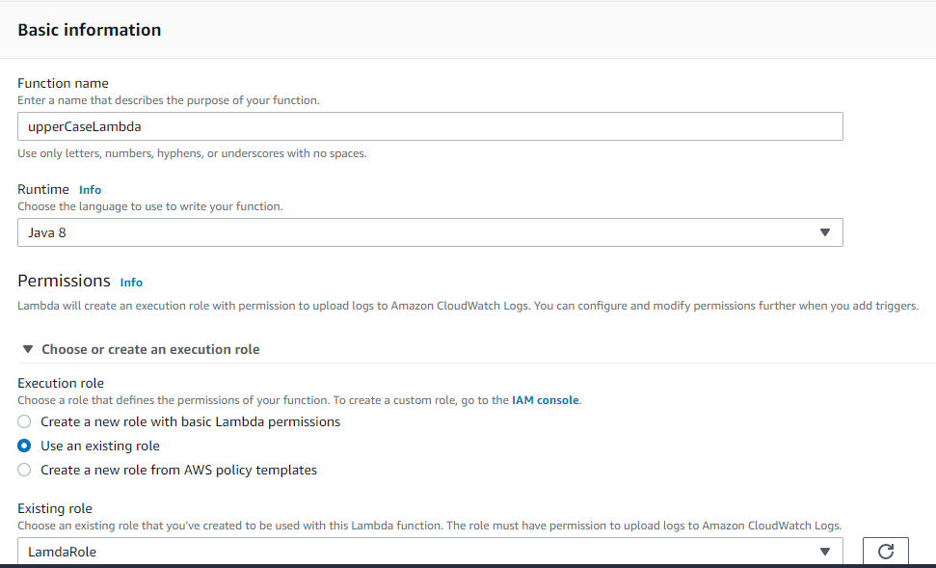

Click on Create function.

Now we need to take local build which will generate jar file and that needs to upload in function code and also We need to mention Handler like below format:

Either package.class-name::handler or package.class-name. For example, "com.Hello::myHandler" calls the myHandler method defined in Hello.java.

In that case: com.springboot.Handler.SpringAwsLambdaHandler

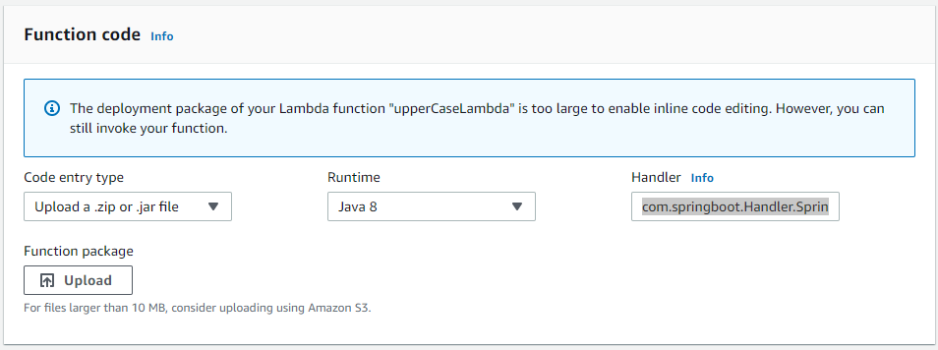

After saving we can run function with event where string will be available in json body.

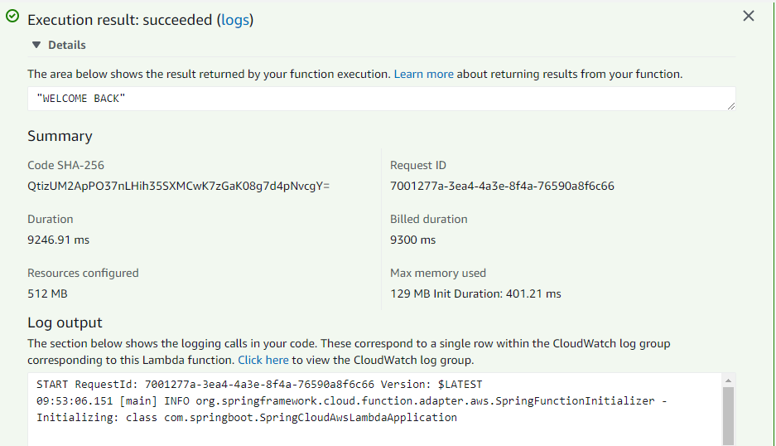

To check complete start up log of spring application we need to check in cloudwatch log.

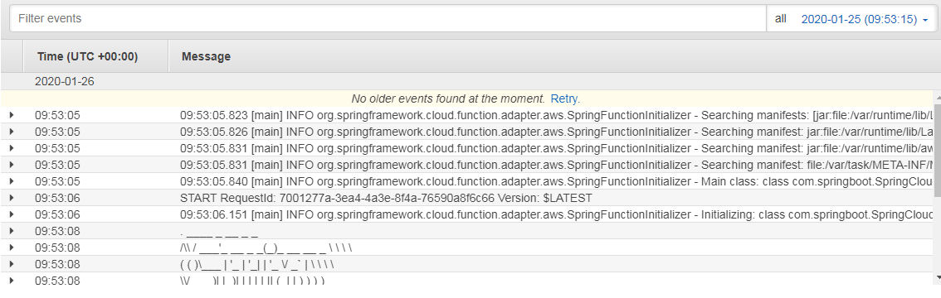

Code link and jar file in github:

<https://github.com/gpartha123/SpringCloudAWSLambda>