Package – collection of modules
Module – where the logics are written
Import –
Export –

React: -
is a application built using JavaScript library.
It is a single Page application.
It followed component based structure.

React Advantage: -
React applications are very very fast e.g. - Instagram
It handles complex data in single handling
Prerequisit: -
- HTML / CSS
- JAVASCRIPT

NPM – Node Package Manager.
It contains packages that are required to run application
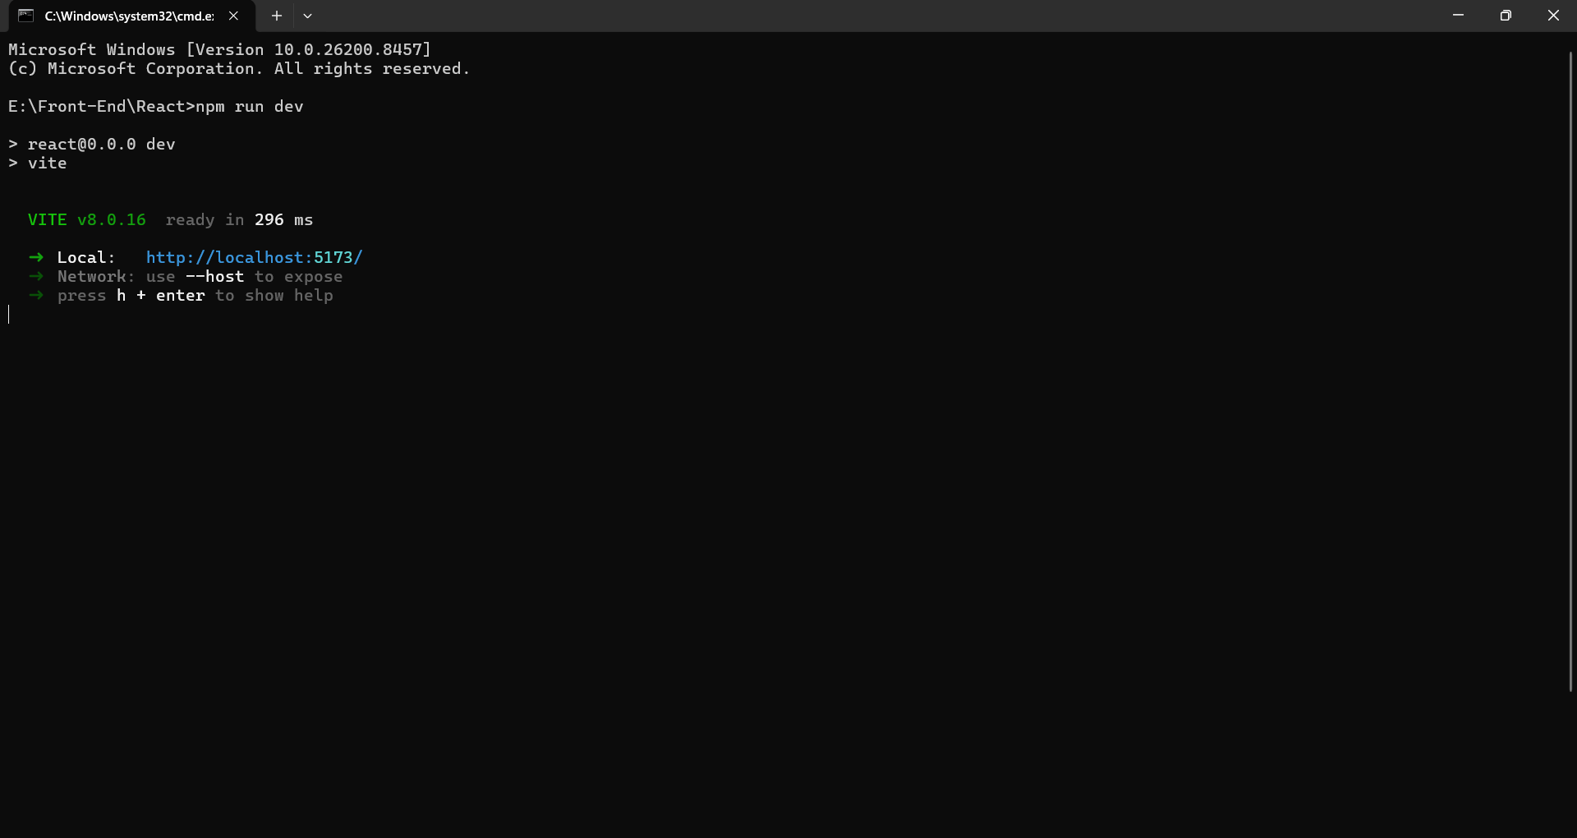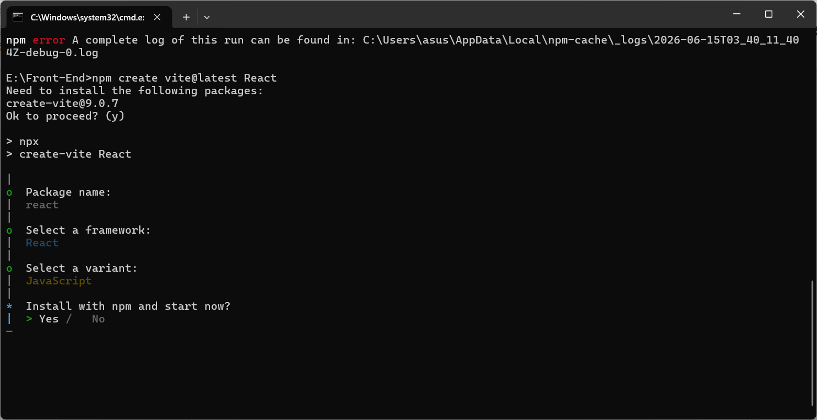
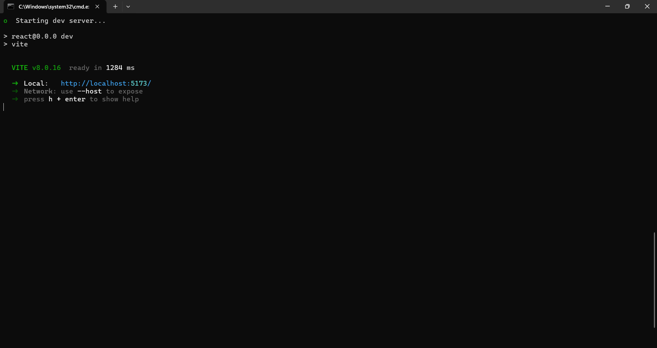

What is the use of package.json in your react application?
- It contains the dependency that are required for my react project.

In case we don’t have node modules// run – “npm install”

What does node modules contains?
- Node modules it contains installed dependencies of react application

What does node modules Public folder?
- contains static files of the project

What does node modules SRC?
- code/place where you will add code.

What is Render?
Call out the component

.jsx => JavaScript xml / Extended Javascript
Always start with jsx code Capital letter “A” (Hello.jsx / Greeting.jsx)

Component Based Structure: -
- Fuctional Component
- Class Component
Fucntional Component: -

Props: -
Passing the data from one component to another component.
{ } = unexpression

Class Component: -

What is state?
It is data in the component.

What is setstate?
Is used to update the state in the class component

Interview Question
React
Props
Types of components
State
Set state
Difference between state vs props ?
Virtual DOM
Is memory copy of real DOM, it will take update compare both DOM

