INTRODUCTION TO DEVOPS

Development and operations

Is an extension of agile development environments that aims to enhance the process of software delivery as a whole

Agility: The Three pillars

* DevOps
  + Cultural change
  + Automated pipeline
  + Infrastructure as code
  + Immutable infrastructure
* Microservices
  + Loose coupling/binding
  + RESTful APIs
  + Designs to resist failures
  + Test by breaking/fail fast
* Containers
  + Portability
  + Developer centric
  + Ecosystem enabler
  + Fast startup

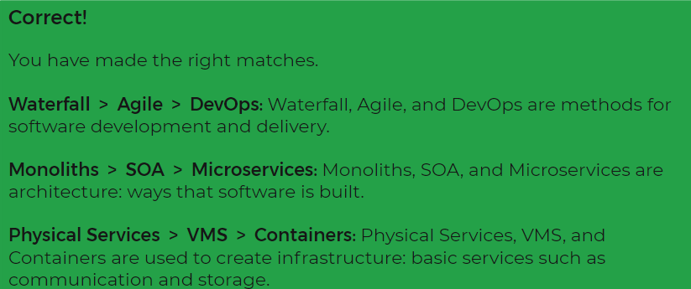

Extreme Programming (XP)

Is an agile software development framework that aims to produce higher quality software, and higher quality of life for the development team. XP is the most specific of the agile frameworks regarding appropriate engineering practices for software development.

Social coding

a software development practice that emphasizes formal and informal collaboration.