**Project: Narrative Visualization**

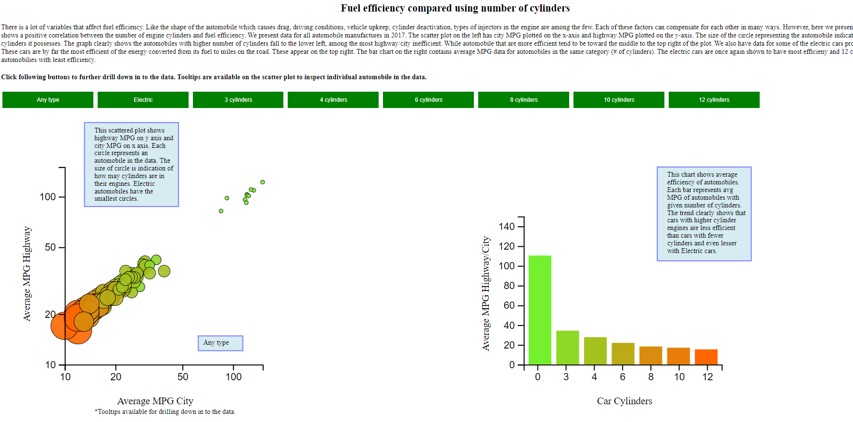

**Messaging**: The message the visualization tries to communicate is fuel efficiency is inversely correlated with number of cylinders in the automobiles. Both charts show trends that vehicles with fewer cylinder engines on average perform better on highway and city. While electric vehicles (considered 0 cylinders) are the most efficient of all.

**Narrative Structure**: The visualization follows a drop-down story where first summary is provided on the top that gives the user an overview of message that the visualization that follows is trying to convey. The data is then plotted on 2 charts and presented as an overview with annotations for each chart. A further drill down is allowed from the beginning where the user can click on buttons laid out in row above the charts to filter the data and analyze the different groupings based on number of cylinders in the engines. The user can also hover over the circles to get further details about the make, cylinder, fuel, MPG highway and MPG city in the tooltip.

**Visual Structure**: The information is arranged top to bottom and left to right. On the top, the user is greeted with a title of the page. This sets up the user for what to expect in the visualization. Then a summary is presented with Author driven content that gives the user the background reason for the comparison and a glaring negative correlation found in the data. Moving further down, a row of buttons is presented to the user with caption that states these can be clicked for further filtering of the data.

Now moving left to right, there are two charts presented where average MPG city is on the x-axis and average MPG highway is on the y-axis. One showing the scattered plot with circles plotted for each automobile. The size of the circle indicates the number of cylinders in the engine of the automobiles. These circles are given colors that are consistent between the two charts. Moving to the right the second chart shows average MPG for automobile categorized by the cylinders in their engines. When the button on the top row is clicked, the scattered plot on the left is filtered to show vehicles that fit the parameter selected. The corresponding bar is highlighted in the right chart letting the user compare the bar to other bars in the chart. The color consistency help connect the two charts.

**Scenes**: Clicking the buttons on the top row brings out different scenes within the same 2 charts. They are ordered going from most efficient automobiles to least efficient. Clicking on the buttons leads to filtering on the scattered plot where only automobiles in that category are shown. The bar on the second chart is also highlighted to draw user’s attention to the size of the avg bar compared to other bars on the chart.

**Annotations**: There are fixed annotations on the charts which give the user a quick overview of what is plotted on the chart. As the user switches scenes, a dynamic annotation at the bottom changes with the button press to remind user what data is being viewed. If user has selected to view “6 cylinder” automobiles, the annotation at the bottom right of the first chart will show the filtering chosen. This ensures the user is aware the data being shown on the chart only relates to 6-cylinder automobiles.

**Parameters**: When loading the visualization initially, default parameter of “Any type” of engine is used. User can change these parameters by clicking on the buttons provided in the top row. This parameter is used to filter/highlight data on the chart.

**Triggers**: Button click triggers a JavaScript click event. Based on the parameter of the button clicked, the event is used to remove unmatched automobiles from the scatter plot and highlight the corresponding bar on the bar chart. User is informed that buttons are available for further filtering in the caption just above the buttons.